HW 7 Allen Elijah

# CSS Book

Vocab

* W3C – World Wide Web Consortium
* CSS WG – CSS Working Group, make standards for CSS
* Spec Editors – Advance standards for the common good. Come from many different companies to meet at the W3C
* CSS 3 – actually refers to CSS level 3 specs, and some level 1 specs
* HSLA -- Hue-saturation-lightness-alpha (for css colors)
* currentColor – gets the color of the text
* CSS has a variable with more on the way

Notes:

* CSS 3 does not actually exist
* Ems, rems make things more scalable
* Human eyes perceive things differently, usually wrong. Make sure to account for this in your css designs
* Use shorthand notation

# Website Template

## My Chosen Template

I used React and Material UI for my template. The reasons I did this are described below. I chose React.js as the framework because its what I am going to be doing most of my front-end development. Material UI is a standard library for React UI components that offers complete customization, I have heard it is a really good so I figure its time to use it.

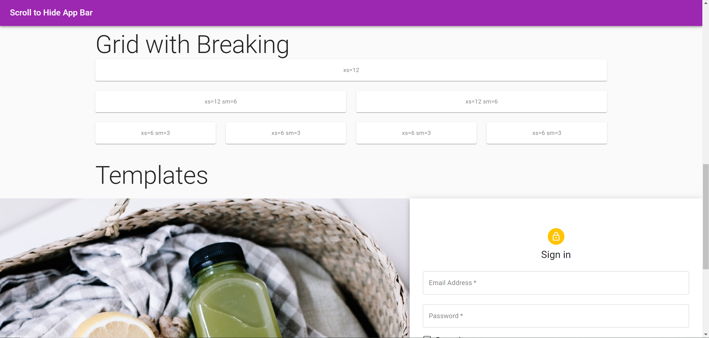

## Important Aspects

### Scalable

React offers a scalable approach to single page applications. This means I can use this template as my starting point and then grow very quickly from there. I eventually plan to update this template with Firebase and ReactRouter for more specific web app needs.

### Industry Standard

Material UI is used all over the place, as such I can expect having this skill as an asset in relating to other developers. As I intent to increase my react and UI skills, Material UI will be the perfect areas to gain expertise.

### Mobile First

Many people do not have a computer, but almost everyone, even children have mobile devices. Therefor, the best way to impact the most people is to appeal to mobile devices first. Material UI follows this concept

### Ease of Maintenance

Because Material UI is used so widely, there are many resources (including great documentation) to help me.