# To do

* Separate root endophytes from EM. Check 2018 paper and FUNguild output.
* Grissino-Mayer et al. 1995 reference

# To keep consistent

* Use a space on either side of =, <, or >.
* Two decimal points
* FA before FU
* SCM before PM

# Environment

* Are there significant differences between climate and soil between ranges?
* Between burned and unburned sites?

Soil: Seems to differ by both range and burn status, but range has a stronger difference (based on cluster dendrogram and multiple linear regression.

* Based on model fitting (see output below) a model including range only with site as a random factor is the best model.

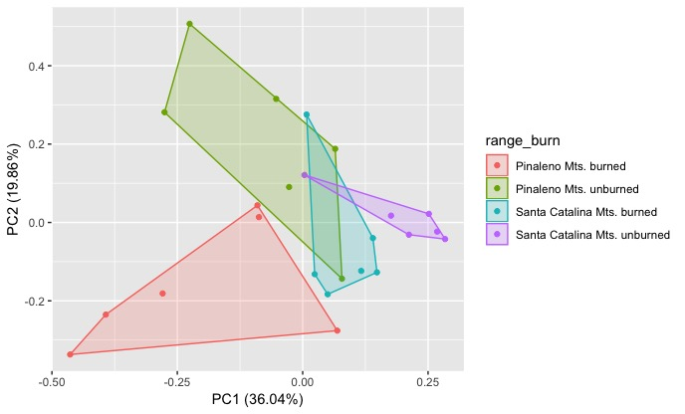



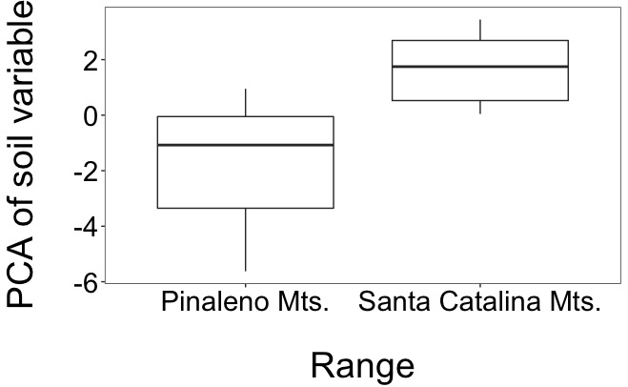

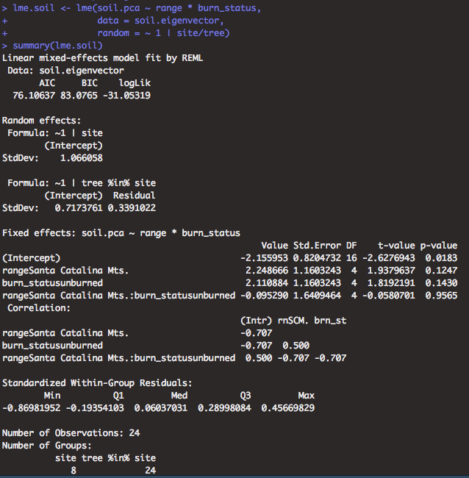

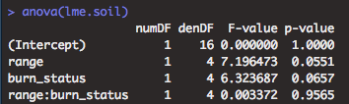

Climate: mainly precipitation is driving differences between ranges in climate.

* Precipitation and temperature are co-correlated

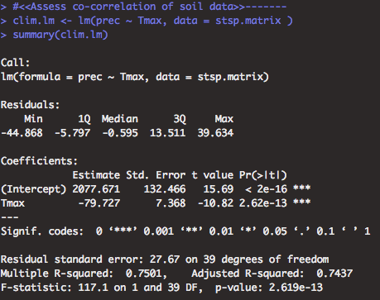

* 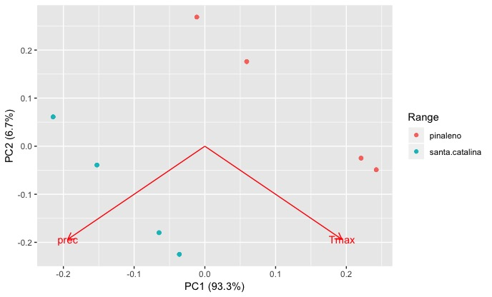

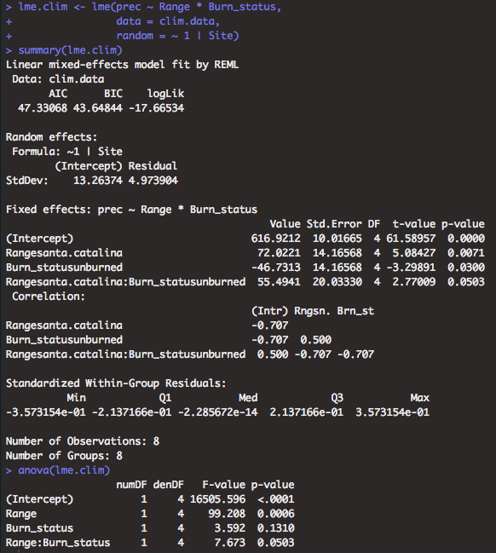

* Do soil differences correspond to differences in forest type?
  + Unable to assess as the there are some plant communities with only 1 site (i.e. no repetition).
  + Assess using PCA instead

# Diversity

* Species richness with singletons
  + Ran model to assess whether random effects should be included in model
    - Yes, included site as a random factor
    - Including tree as a random variable did not improve the model
  + Model showed that neither range nor burn status improved the model, neither was significant
  + On that note just burn status was marginally significant, so I included it in the model only.

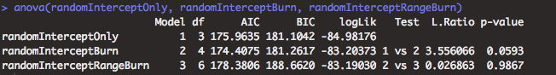

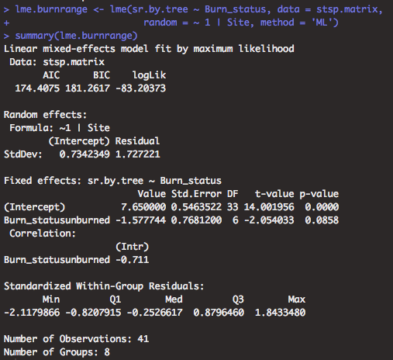

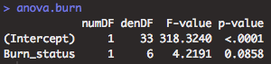

* Species richness without singletons
  + Ran model to assess whether random effects should be included in model
    - Yes, included site as a random factor
  + Model showed that burn status only improved model

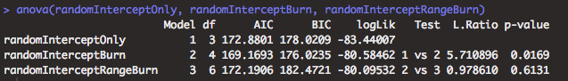

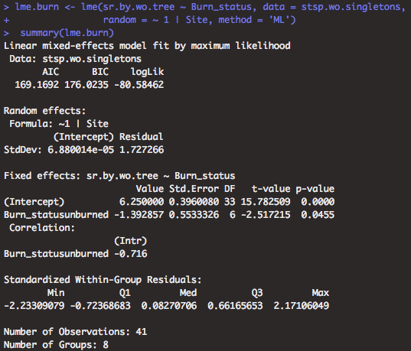

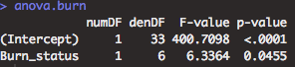

* Diversity with singletons and without singletons
  + Ran model to assess whether random effects should be included in model
    - No, Use a generalized least squares model instead as a linear mixed effects model does not improve the model at all.
  + Not significant for both FA and Shannon’s.

Shannon’s diversity

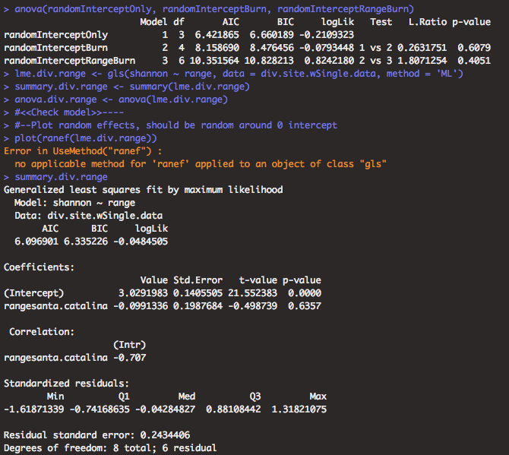

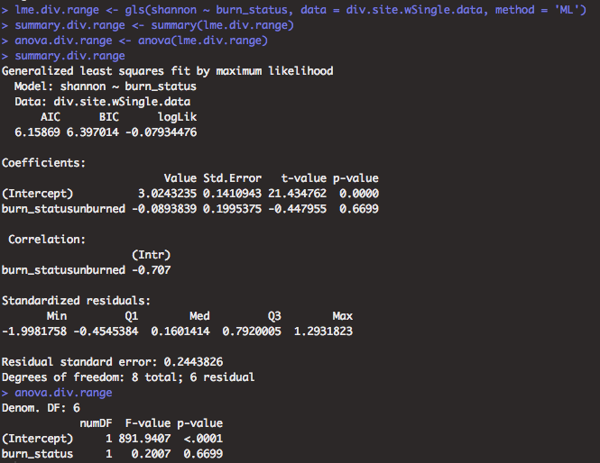

Fisher’s alpha

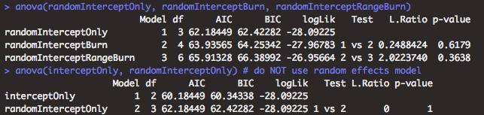

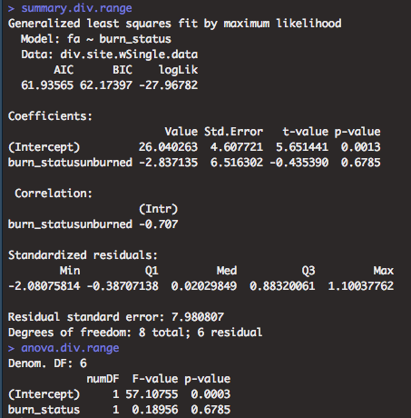

# Community

|  |  |  |  |  |  |  |  |
| --- | --- | --- | --- | --- | --- | --- | --- |
| anosim.res | stress.nmds | F.betadisper | df.betadisper.1 | df.betadisper.2 | p.betadisper | r | p |
| jaccard.all | 0.2148 | 0.1281 | 1 | 36 | 0.7225 | 0.0766 | 0.036 |
| morisita.all | 0.205 | 4.2081 | 1 | 37 | 0.0474 | NA | NA |
| jaccard.p | 0.149 | 1.2687 | 1 | 16 | 0.2766 | 0.5291 | 0.001 |
| morisita.p | 0.1632 | 0.0014 | 1 | 16 | 0.971 | 0.5372 | 0.001 |
| jaccard.scm | 0.2253 | 1.5477 | 1 | 18 | 0.2294 | 0.1233 | 0.059 |
| morisita.scm | 0.2285 | 2.7737 | 1 | 18 | 0.1131 | 0.1252 | 0.03 |
| morisita.fa | 0.1915 | 2.6116 | 1 | 18 | 0.1235 | 0.3368 | 0.001 |
| morisita.fu | 0.1523 | 2.7737 | 1 | 18 | 0.1131 | 0.1252 | 0.03 |

* Morisita horn all, NMDS stress = 0.205348; PERMANOVA

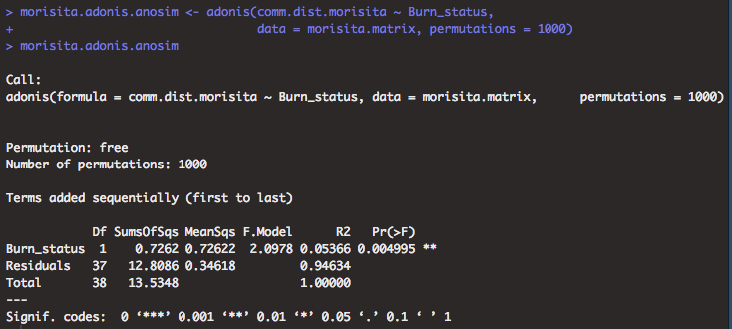

PERMANOVA analyses assessing fire history and range

|  |  |  |  |  |  |  |  |  |  |
| --- | --- | --- | --- | --- | --- | --- | --- | --- | --- |
| test | F.model.burn | r2.burn | p.burn | F.model.range | r2.range | p.range | F.model.burn/range | r2.burn/range | p.burn/range |
| jaccard | 1.5993 | 0.0391 | 0.015 | 2.5042 | 0.0613 | 0.001 | 2.7582 | 0.0675 | 0.001 |
| morisita | 2.3509 | 0.0537 | 0.003 | 3.2541 | 0.0743 | 0.001 | 3.20982 | 0.0733 | 0.001 |

# Taxonomy

* Made file of representative OTU sequences at 97% sequence similarity for UNITE taxonomic analysis
  + dereplicated_otu97.csv in ‘data_output/’
  + made a fasta file with the otu name and sequence called dereplicated_otu97.fasta
* Downloaded the UNITE USEARCH database version 8
  + <https://plutof.ut.ee/#/doi/10.15156/BIO/786345>
  + **When using this resource, please cite it as follows:**  
    UNITE Community (2019): UNITE USEARCH/UTAX release for Fungi. Version 18.11.2018. UNITE Community. [**https://doi.org/10.15156/BIO/786345**](https://doi.org/10.15156/BIO/786345)
* usearch -sintax data_output/dereplicated_otu97.fasta -db ~/../../Volumes/Cenococcum/UNITE/utax_reference_dataset_02.02.2019.fasta -tabbedout unite/reads.sintax -strand both -sintax_cutoff 0.8

00:00 1.5Mb 0.1% Reading /Users/eabowman/../../Volumes/Cenococcum/UNITE/utax_reference_dataset_0200:01 52Mb 19.5% Reading /Users/eabowman/../../Volumes/Cenococcum/UNITE/utax_reference_dataset_0200:01 119Mb 100.0% Reading /Users/eabowman/../../Volumes/Cenococcum/UNITE/utax_reference_dataset_02.02.2019.fasta

00:01 86Mb 0.1% Masking (fastnucleo)

00:03 86Mb 100.0% Masking (fastnucleo)

00:05 87Mb 100.0% Word stats

00:05 87Mb 100.0% Alloc rows

00:08 264Mb 100.0% Build index

00:10 275Mb 100.0% Initialize taxonomy data

00:10 277Mb 100.0% Building name table

00:10 277Mb 39004 names, tax levels min 1, avg 5.8, max 7

WARNING: 3 taxonomy nodes have >1 parent

00:13 279Mb 100.0% Processing

* Created Funguild.R script to add taxonomic data to site by species matrix
  + Saved as OTU97_withTax.csv
* Ran above file on Funguild online site
  + Output file FUNguild/OTU97_withTax.guilds.txt

|  |  |  |  |
| --- | --- | --- | --- |
| tests | chi.stat | df | p.value |
| burn.range.class | 44.4790943 | 12 | 0.00001 |
| burn.class | 3.59195026 | 4 | 0.46403551 |
| range.class | 5.66975832 | 4 | 0.22520566 |
| burn.range.genus | 34.9397397 | 17 | 0.00633553 |
| burn.genus | 30.0031003 | 17 | 0.02632273 |
| range.genus | 34.9397397 | 17 | 0.00633553 |

# Indicator species

* OTU based
  + Fire history

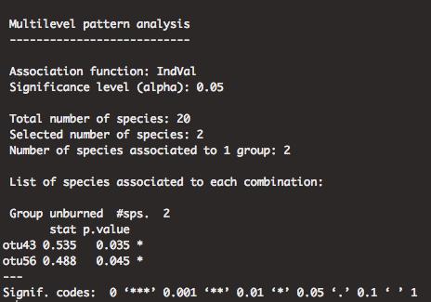

* + Range

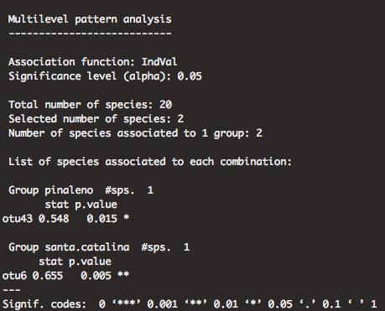

* + Santa Catalina Mts.

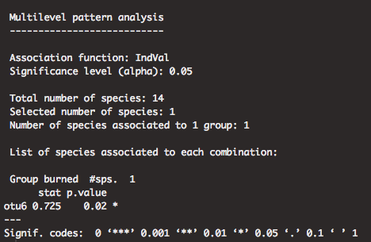

* + Pinaleno Mts.

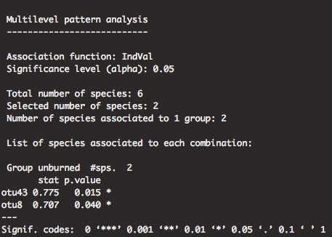

# Figures

## Tables

* Table 1: site data
  + Need to add information on weather and plant community
* Table 2: Soil data
* Table 3: diversity

## Figures

* Fig. 1: map of range and sites
* Fig. 2: Species richness and diversity
* Fig. 3: community composition: by range
* Fig. 4: community composition overall
* Fig. 5: Taxonomy???? How to best show this?

Supplementary figures

* Fig. S1: climate data
* Fig. S2: soil data
* Fig. S3: Shannon diversity