R Notebook

## Here is my heading

I can keep adding text just like I’m writing a paper or something.

This is an R Notebook. You can use it to take notes and run code. For example, you can write your name on the line below. Try it:

# You can write code in chunks that look like this.  
# This chunk uses some code from base R to plot a data set.  
# To run the code click the Green play button to the right. Try it!  
plot(cars)

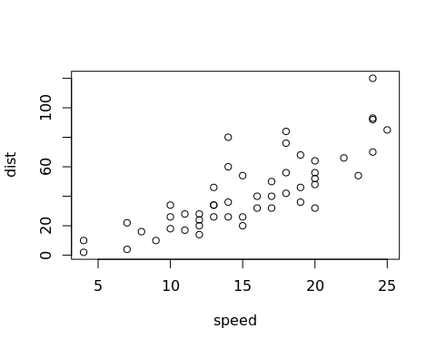

Good job! The results of a code chunk will appear beneath the chunk. You can click the x above the results to make them go away, but let’s not do that.

You can open a new R Notebook by going to **File > New File > R Notebook**.

# Adding chunks

To add a new chunk, press *Ctrl+Option+I* (*Cmd+Alt+I* on Macs), or click the *Insert* button at the top of this document, then select *R*. Try making a code chunk below:

Good job! For now, you should place all of your R code inside of code chunks.

# You can click the downward facing arrow to the left of the play button to run  
# every chunk above the current code chunk. This is useful if the code in your  
# chunk depends on the code in previous chunks. For example, if you use an  
# object or data set made in a previous chunk.

# HTML version

When you save the notebook, an HTML file containing the code and output will be saved alongside it. This makes a nice, polished report of your work to share.

Click the *Preview* button at the top of this document or press *Cmd+Shift+K* (*Ctrl+Shift+K* on Windows) to preview the HTML file. Try clicking *Preview* now.

# Packages

You can immediately run any function from base R within a notebook, But if you’d like to run a function that comes in an R package, you will need to first load the package in the notebook.

Do you remember how to run the core tidyverse packages? Load them in the chunk below:

# I've already installed the tidyverse package(s) on this server  
# So all you need to do is load it

Good job! You’ll need to reload your packages every time you begin a new notebook.