How to add collaborators to a GitHub Repository :

You can add collaborators for a project to work from the same code repository.

First navigate to the projects setting’s page: ‘Settings’

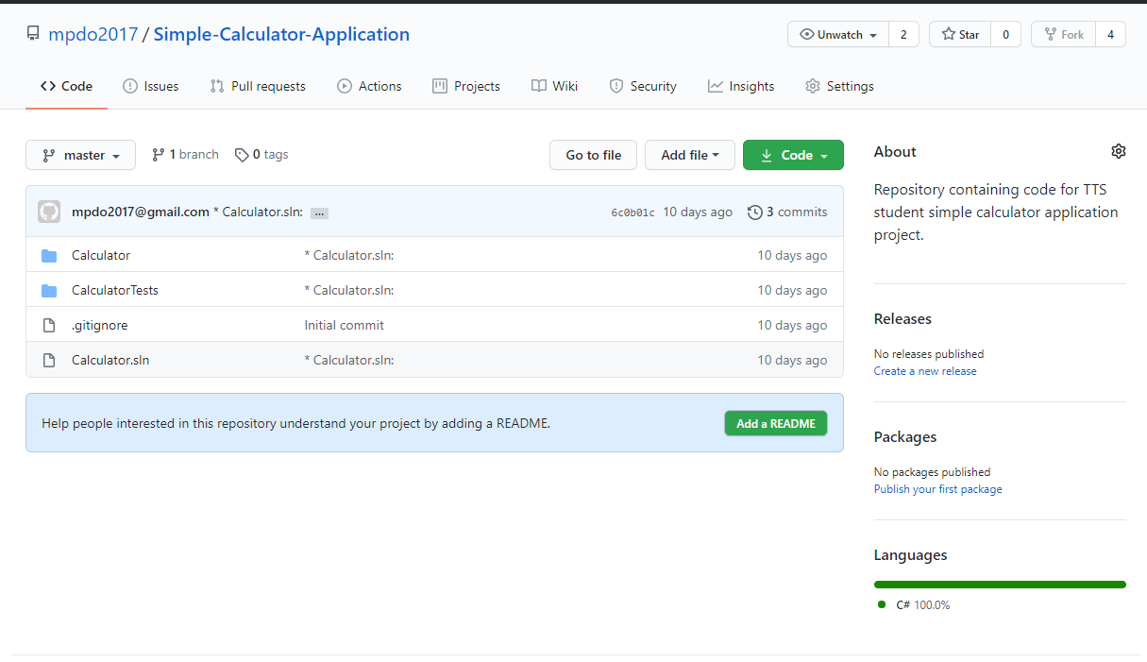

Then on the Settings page navigate to the access management page: ‘Manage access’

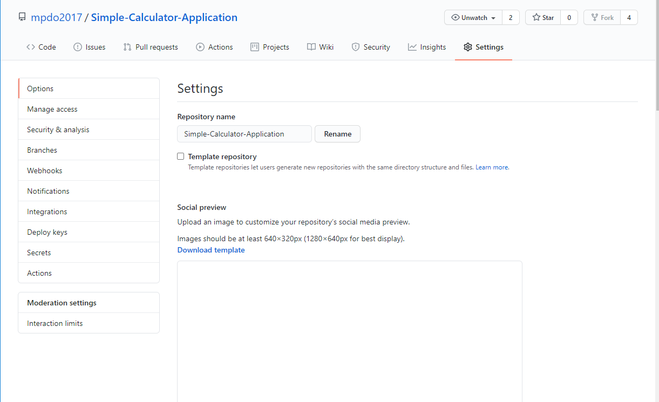

You can either select ‘Invite a collaborator’ or Search for one if they have a GitHub account username.

