**SUPPLEMENTARY ANALYSES AND FIGURES**

**Seagrass (*Zostera marina*) transplant experiment reveals microbial community selectivity and resistance to environmental change**

Authors: Emily M. Adamczyk, Mary I. O’Connor, Laura Wegener Parfrey

**Analyses without the 76 samples that were run at 32 PCR cycles**For extra precaution, we removed the 76 contaminated samples that were run at 32 PCR cycles (n = 175; Table S5) and ran the same analyses and produced the same figures to compare results. The results presented here are the same figures and tables found in the main text and supplementary information, and their caption names are the same. Analyzing results with and without samples amplified with 32 cycles did not change results.

**TABLES AND FIGURES IN MAIN TEXT**

**Table 1.** Bray-Curtis PERMANOVA pairwise comparisons between the original meadows for the natural seagrass microbial communities (Day 1). PB = Pruth Bay, PP = Pruth Pocket, SS = Choked Sand Spit, WO = Choked Wolf.

**Table 2.** Bray-Curtis PERMANOVA pairwise comparisons between treatments that were replanted and transplanted to the same region (Day 5).

**Table 3.** Enriched taxa on each seagrass treatment identified by IndVal analysis (IndVal >0.6) in comparison to water. Bolded taxa present in 70% of all samples (Fidelity 0.7) were considered enriched bacteria taxa on each treatment. Taxon refers to Order; Genus, except in the case of uncultured genera which are labeled as Order; Family^. Spec: Specificity compared to water; Fid: Fidelity, or Prevalence.

**Table 4.** Bray-Curtis two-way PERMANOVA with marginal effects for original and destination sites and an interaction term. A separate PERMANOVA was run for each treatment. Day 5 samples were used.

**Figure 3.** Non-metric multidimensional scaling (NMDS) plot using Bray-Curtis dissimilarity. Initial microbial communities on natural seagrass leaves from their original site (Day 1).

**Figure 4.** Non-metric multidimensional scaling (NMDS) plot using Bray-Curtis dissimilarity. Final microbial communities (Day 5) on natural seagrass, sterilized seagrass, and artificial seagrass leaves that were replanted to their original meadow or transplanted to the same region.

**Figure 5.** Relative abundance barplots of the top 15 most abundant microbial genera for **(A)** natural seagrass sampled on Day 1, **(B)** natural seagrass sampled on Day 5, **(C)** sterilized seagrass sampled on Day 5, and **(D)** artificial seagrass sampled on Day 5. Each column represents one sample and they are grouped by original site for **(A)** and by destination site for **(B-D)**. Transplant location indicates the meadow of origin 🡪 and destination (i.e., PB 🡪 PP means the shoot originated in Pruth Bay and was transplanted to Pruth Pocket). “Replant” indicates shoots that were replanted in the same location. For the final sampling timepoint, asterisks indicate taxa that were enriched (frequency of 70%) on only natural seagrass and sterilized seagrass shoots, indicating they are taxa specific to seagrass.

**Figure 6.** Microbial taxonomic similarity among treatments represented in non-metric multidimensional scaling (NMDS) plots using Bray-Curtis dissimilarity. Final microbial communities (Day 5) on **(A)** natural seagrass, **(B)** sterilized seagrass, and **(C)** artificial seagrass leaves. Colours indicate the sample’s original site, and shapes indicate the site to which samples were replanted or transplanted.

**TABLES AND FIGURES IN SUPPLEMENTARY INFORMATION**

**Table S6.** Bray-Curtis PERMANOVA pairwise comparisons between treatments that were replanted and transplanted to the same region and final water samples (Day 5).

**Table S7.** Top 15 taxa with the highest frequencies for natural seagrass leaves and the corresponding frequencies for the other treatments, as identified by frequency analysis. Taxon is the most specific taxonomy level reliably assigned; all taxa are order; family; genus unless otherwise specified. Taxa that are present in70% of all samples in each treatment are bolded. Asterisks indicate taxa that are enriched in natural and sterilized seagrass treatments only**.**

**Figure S1.** Relative abundance barplot of the top 15 most abundant microbial genera for sterilized seagrass sampled on Day 1**.** Each column represents one sample, and they are grouped by original site.

**Figure S2.** Non-metric multidimensional scaling (NMDS) plot using Bray-Curtis dissimilarity. Final microbial communities (Day 5) on natural seagrass, sterilized seagrass, and artificial seagrass leaves that were replanted to their original meadow or transplanted to the same region, and water microbial communities that were collected on the last day of the experiment.

**Figure S3.** Non-metric multidimensional scaling (NMDS) plot using Bray-Curtis dissimilarity. Microbial communities on natural seagrass shoots for each location and time point. Colours indicate the sample’s original site and shapes indicate whether the samples were replanted, transplanted to the same region, or transplanted to a different region.

**Figure S5.** Growth of second youngest seagrass leaf for natural seagrass shoot compared to Bray-Curtis dissimilarity (Day 1 vs Day 5). There is no relationship between growth and community turnover.

**Table 1.** Bray-Curtis PERMANOVA pairwise comparisons between the original meadows for the natural seagrass microbial communities (Day 1). PB = Pruth Bay, PP = Pruth Pocket, SS = Choked Sand Spit, WO = Choked Wolf.

|  |  |  |  |  |  |
| --- | --- | --- | --- | --- | --- |
| Meadows | Df | Sums of squares | F model | R2 | P adjusted |
| PB vs PP | 1 | 1.732 | 9.750 | 0.379 | 0.003 |
| PB vs SS | 1 | 2.220 | 12.129 | 0.447 | 0.003 |
| PB vs WO | 1 | 2.148 | 12.394 | 0.470 | 0.003 |
| PP vs SS | 1 | 1.210 | 5.429 | 0.295 | 0.004 |
| PP vs WO | 1 | 1.177 | 5.474 | 0.313 | 0.003 |
| SS vs WO | 1 | 0.422 | 1.869 | 0.145 | 0.026 |

**Table 2.** Bray-Curtis PERMANOVA pairwise comparisons between treatments that were replanted and transplanted to the same region (Day 5).

|  |  |  |  |  |  |  |
| --- | --- | --- | --- | --- | --- | --- |
| Region | Treatments | Df | Sums of squares | F model | R2 | P adjusted |
| Pruth and Choked Passage | ASU vs sterilized seagrass | 1 | 0.752 | 2.604 | 0.067 | 0.038 |
|  | ASU vs natural seagrass | 1 | 0.865 | 2.846 | 0.075 | 0.027 |
|  | Natural vs sterilized seagrass | 1 | 0.581 | 2.047 | 0.050 | 0.044 |
| Pruth only | ASU vs sterilized seagrass | 1 | 0.747 | 3.484 | 0.188 | 0.003 |
|  | ASU vs natural seagrass | 1 | 0.870 | 3.737 | 0.199 | 0.003 |
|  | Natural vs sterilized seagrass | 1 | 0.617 | 2.917 | 0.139 | 0.003 |
| Choked Passage only | ASU vs sterilized seagrass | 1 | 0.534 | 3.193 | 0.144 | 0.004 |
|  | ASU vs natural seagrass | 1 | 0.544 | 2.932 | 0.140 | 0.003 |
|  | Natural vs sterilized seagrass | 1 | 0.418 | 2.447 | 0.114 | 0.006 |

**Table 3.** Enriched taxa on each seagrass treatment identified by IndVal analysis (IndVal >0.6) in comparison to water. Bolded taxa present in 70% of all samples (Fidelity 0.7) were considered enriched bacteria taxa on each treatment. Taxon refers to Order; Genus, except in the case of uncultured genera which are labeled as Order; Family^. Spec: Specificity compared to water; Fid: Fidelity, or Prevalence.

|  |  |  |  |  |  |  |  |  |  |
| --- | --- | --- | --- | --- | --- | --- | --- | --- | --- |
|  | Natural | | | Sterilized | | | Artificial | | |
| **Taxon** | Spec | Fid | IndVal | Spec | Fid | IndVal | Spec | Fid | IndVal |
| Alteromonadales; Colwellia | 1 | 0.49 | 0.89 | **1** | **0.88** | **0.94** | **1** | **0.74** | **0.82** |
| Chitinophagales; Lewinella | **0.94** | **0.74** | **0.84** | 0.92 | 0.65 | 0.78 | - | - | - |
| Ectothiorhodospirales; Ectothiorhodospiraceae^ | - | - | - | **0.96** | **0.74** | **0.85** | **0.98** | **0.74** | **0.85** |
| Flavobacteriales; Dokdonia | **1** | **0.72** | **0.85** | 1 | 0.67 | 0.82 | 1 | 0.66 | 0.81 |
| Rhodobacterales; Pacificibacter | **0.98** | **0.92** | **0.95** | **1** | **1** | **1** | **0.98** | **0.77** | **0.87** |
| Arenicellales; Arenicella | 0.97 | 0.62 | 0.77 | 0.99 | 0.67 | 0.82 | **0.99** | **0.71** | **0.84** |
| Betaproteobacteriales; Methylophilus | **0.99** | **0.77** | **0.87** | **0.99** | **0.93** | **0.96** | - | - | - |
| Betaproteobacteriales; Methylotenera | **1** | **0.92** | **0.96** | **0.99** | **0.86** | **0.93** | - | - | - |
| Nitrosococcales; Methylophagaceae^ | 1 | 0.64 | 0.8 | **1** | **0.73** | **0.85** | - | - | - |
| Cellvibrionales; Cellvibrionaceae^ | 0.99 | 0.62 | 0.78 | **1** | **0.81** | **0.90** | - | - | - |
| Chitinophagales; Saprospiraceae^ | **0.97** | **1** | **0.99** | - | - | - | - | - | - |
| Thiohalorhabdales; Granulosicoccus | **0.98** | **1** | **0.99** | - | - | - | **0.94** | **0.86** | **0.90** |
| Verrucomicrobiales; DEV007^ | **0.98** | **0.74** | **0.85** | - | - | - | - | - | - |
| Rickettsiales; Rickettsia | 0.97 | 0.64 | 0.79 | - | - | - | - | - | - |
| Thiotrichales; Leucothrix | - | - | - | **0.98** | **0.95** | **0.96** | - | - | - |
| Alteromonadales; Pseudoalteromonas | - | - | - | **0.92** | **0.84** | **0.88** | **0.87** | **0.74** | **0.80** |
| Alteromonadales; Alteromonas | - | - | - | 1 | 0.53 | 0.73 | 0.98 | 0.54 | 0.73 |
| Alteromonadales; Thalassotalea | - | - | - | 0.98 | 0.49 | 0.7 | 1 | 0.57 | 0.75 |
| Rhodobacterales; Donghicola | 1 | 0.54 | 0.73 | 1 | 0.67 | 0.82 | - | - | - |
| Cytophagales; Candidatus_Amoebophilus | 1 | 0.62 | 0.78 | - | - | - | 1 | 0.46 | 0.68 |
| Flavobacteriales; Aurantivirga | - | - | - | - | - | - | 1 | 0.43 | 0.66 |

**Table 4.** Bray-Curtis two-way PERMANOVA with marginal effects for original and destination sites and an interaction term. A separate PERMANOVA was run for each treatment. Day 5 samples were used.

|  |  |  |  |  |  |  |
| --- | --- | --- | --- | --- | --- | --- |
| Treatment | Variables | Df | Sums of squares | F model | R2 | P-value |
| Natural seagrass | Original site | 3 | 2.837 | 5.631 | 0.27 | 0.001 |
| Destination site | 3 | 1.872 | 3.714 | 1.778 | 0.001 |
| Original * Destination site | 9 | 1.955 | 1.294 | 0.186 | 0.034 |
| Sterilized seagrass | Original site | 3 | 1.061 | 2.382 | 0.097 | 0.003 |
| Destination site | 3 | 4.689 | 10.533 | 0.428 | 0.001 |
| Original * Destination site | 9 | 1.195 | 0.895 | 0.109 | 0.676 |
| Artificial seagrass | Original site | 3 | 0.853 | 1.961 | 0.066 | 0.012 |
| Destination site | 3 | 5.250 | 12.065 | 0.481 | 0.001 |
| Original * Destination site | 9 | 1.566 | 1.200 | 0.120 | 0.162 |

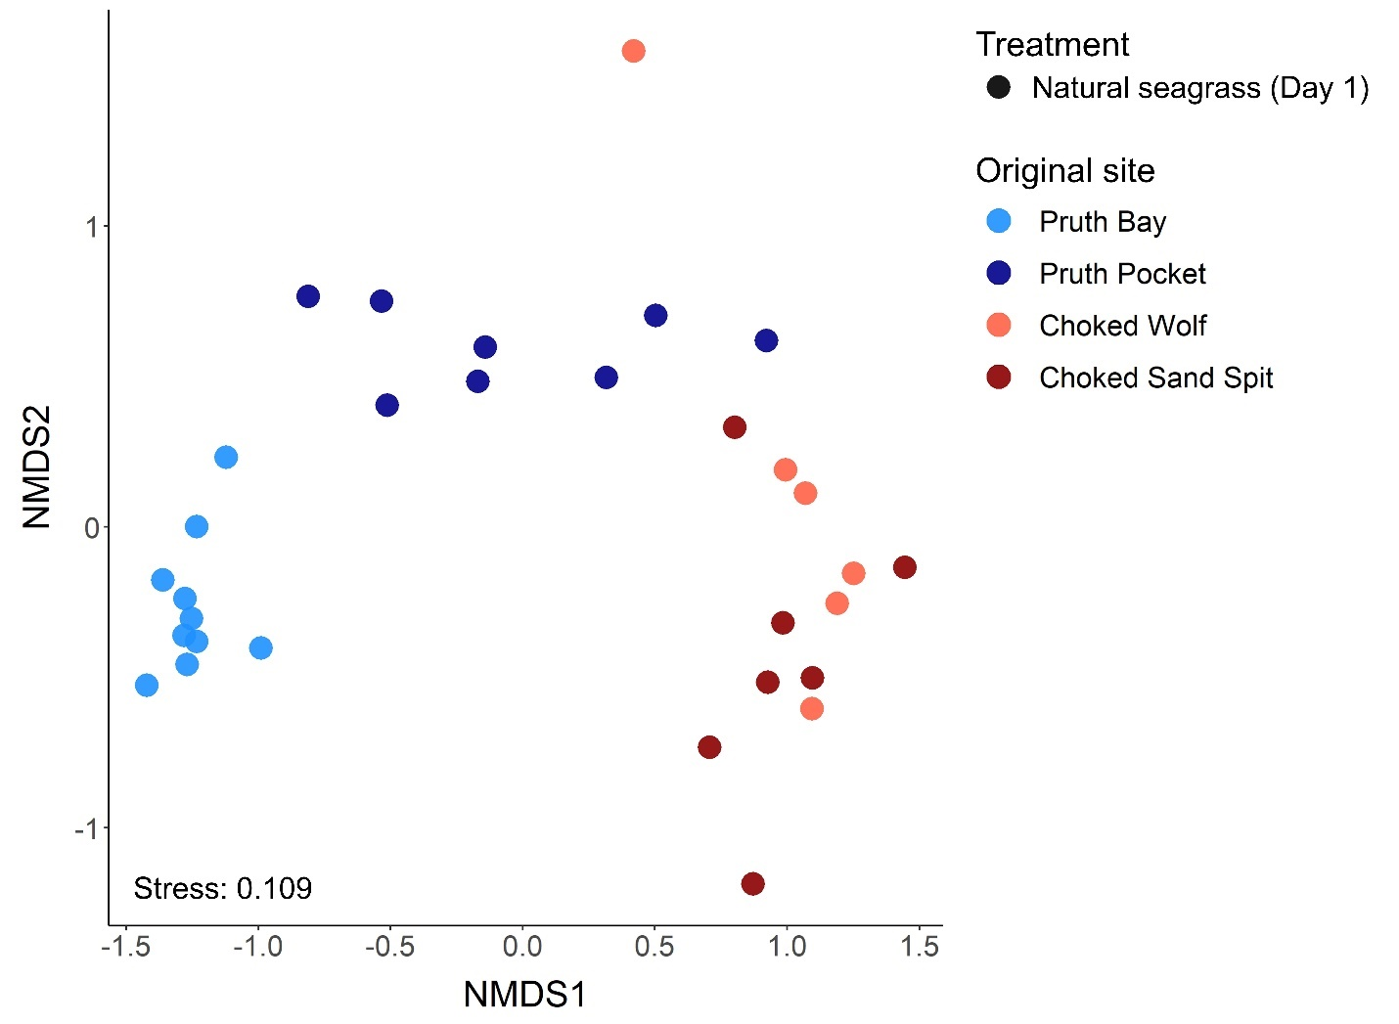

**Figure 3.** Non-metric multidimensional scaling (NMDS) plot using Bray-Curtis dissimilarity. Initial microbial communities on natural seagrass leaves from their original site (Day 1).

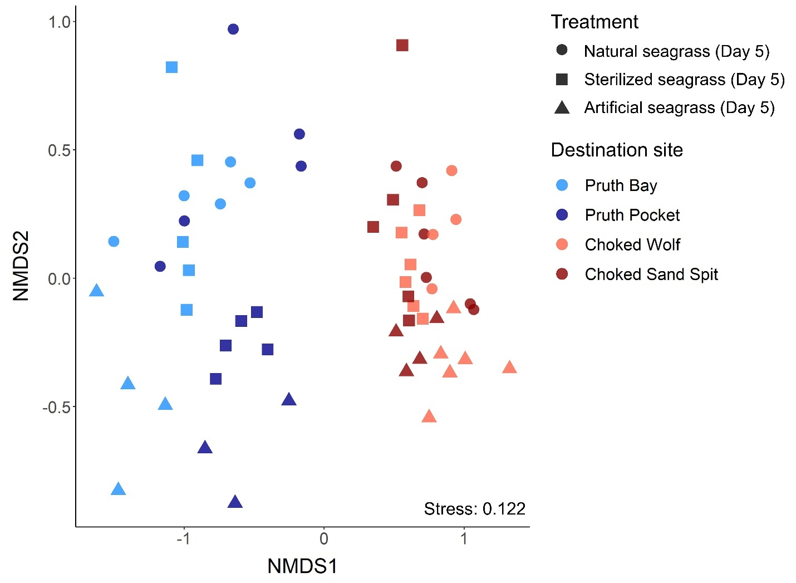

**Figure 4.** Non-metric multidimensional scaling (NMDS) plot using Bray-Curtis dissimilarity. Final microbial communities (Day 5) on natural seagrass, sterilized seagrass, and artificial seagrass leaves that were replanted to their original meadow or transplanted to the same region.

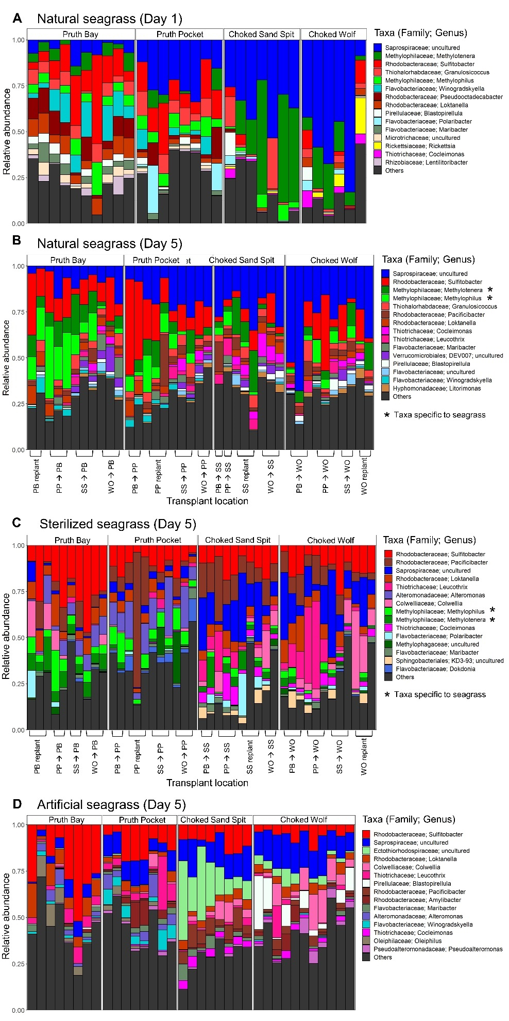

**Figure 5.** Relative abundance barplots of the top 15 most abundant microbial genera for **(A)** natural seagrass sampled on Day 1, **(B)** natural seagrass sampled on Day 5, **(C)** sterilized seagrass sampled on Day 5, and **(D)** artificial seagrass sampled on Day 5. Each column represents one sample and they are grouped by original site for **(A)** and by destination site for **(B-D)**. Transplant location indicates the meadow of origin 🡪 and destination (i.e., PB 🡪 PP means the shoot originated in Pruth Bay and was transplanted to Pruth Pocket). “Replant” indicates shoots that were replanted in the same location. For the final sampling timepoint, asterisks indicate taxa that were enriched (frequency of 70%) on only natural seagrass and sterilized seagrass shoots, indicating they are taxa specific to seagrass.

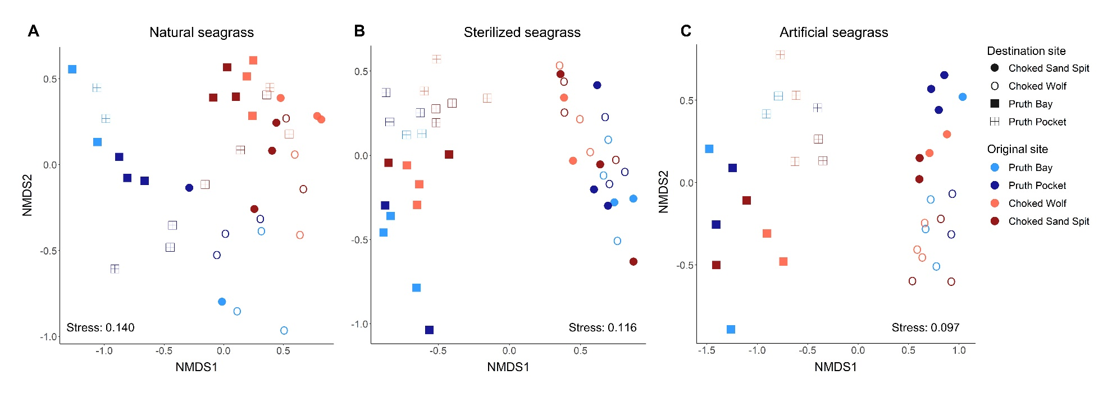

**Figure 6.** Microbial taxonomic similarity among treatments represented in non-metric multidimensional scaling (NMDS) plots using Bray-Curtis dissimilarity. Final microbial communities (Day 5) on **(A)** natural seagrass, **(B)** sterilized seagrass, and **(C)** artificial seagrass leaves. Colours indicate the sample’s original site, and shapes indicate the site to which samples were replanted or transplanted.

**Table S6.** Bray-Curtis PERMANOVA pairwise comparisons between treatments that were replanted and transplanted to the same region and final water samples (Day 5).

|  |  |  |  |  |  |
| --- | --- | --- | --- | --- | --- |
| Treatments | Df | Sums of squares | F model | R2 | P-adjusted |
| ASU vs sterilized seagrass | 1 | 0.752 | 2.604 | 0.067 | 0.022 |
| ASU vs natural seagrass | 1 | 0.865 | 2.846 | 0.075 | 0.022 |
| ASU vs water | 1 | 2.494 | 8.954 | 0.272 | 0.004 |
| Sterilized seagrass vs natural seagrass | 1 | 0.581 | 2.047 | 0.050 | 0.038 |
| Sterilized seagrass vs water | 1 | 2.814 | 11.053 | 0.283 | 0.004 |
| Natural seagrass vs water | 1 | 2.690 | 9.861 | 0.268 | 0.004 |

**Table S7.** Top 15 taxa with the highest frequencies for natural seagrass leaves and the corresponding frequencies for the other treatments, as identified by frequency analysis. Taxon is the most specific taxonomy level reliably assigned; all taxa are order; family; genus unless otherwise specified. Taxa that are present in70% of all samples in each treatment are bolded. Asterisks indicate taxa that are enriched in natural and sterilized seagrass treatments only**.**

|  |  |  |  |  |
| --- | --- | --- | --- | --- |
| Taxon | Natural frequency | Sterilized frequency | Artificial frequency | Water frequency |
| Chitinophagales; Saprospiraceae; uncultured | **0.986** | **1.000** | **1.000** | 0.625 |
| Thiohalorhabdales; Thiohalorhabdaceae; Granulosicoccus | **0.943** | **0.767** | **0.800** | 0.375 |
| Rhodobacterales; Rhodobacteraceae; Sulfitobacter | **0.886** | **1.000** | **1.000** | **0.938** |
| Betaproteobacteriales; Methylophilaceae; Methylotenera* | **0.857** | **0.860** | 0.314 | 0.188 |
| Rhodobacterales; Rhodobacteraceae; Loktanella | **0.843** | **1.000** | **0.971** | 0.313 |
| Pirellulales; Pirellulaceae; Blastopirellula | **0.786** | **0.535** | 0.486 | **0.813** |
| Flavobacteriales; Flavobacteriaceae; Maribacter | **0.757** | **0.930** | **0.886** | 0.438 |
| Betaproteobacteriales; Methylophilaceae; Methylophilus* | **0.743** | **0.930** | 0.429 | 0.125 |
| Thiotrichales; Thiotrichaceae; Leucothrix | **0.714** | **0.953** | **0.886** | 0.313 |
| Rhodobacterales; Rhodobacteraceae; Pacificibacter | **0.700** | **1.000** | **0.771** | 0.063 |
| Flavobacteriales; Flavobacteriaceae; Winogradskyella | 0.686 | 0.535 | 0.600 | 0.500 |
| Caulobacterales; Hyphomonadaceae; Litorimonas | 0.657 | **0.744** | **0.857** | 0.125 |
| Verrucomicrobiales; Rubritaleaceae; Roseibacillus | 0.643 | 0.302 | 0.314 | **0.875** |
| Thiotrichales; Thiotrichaceae; Cocleimonas | 0.614 | **0.721** | **0.714** | 0.500 |
| Chitinophagales; Saprospiraceae; Lewinella | 0.600 | 0.628 | 0.514 | 0.188 |

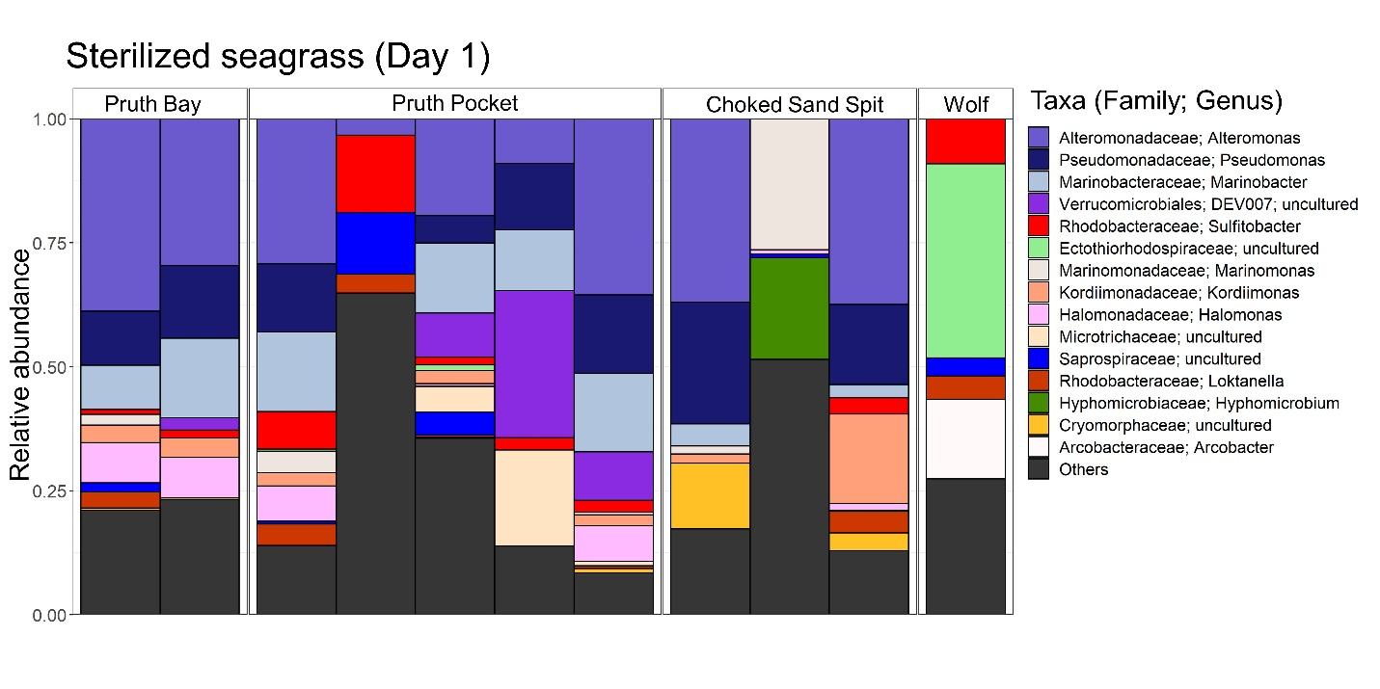

**Figure S1.** Relative abundance barplot of the top 15 most abundant microbial genera for sterilized seagrass sampled on Day 1**.** Each column represents one sample, and they are grouped by original site.

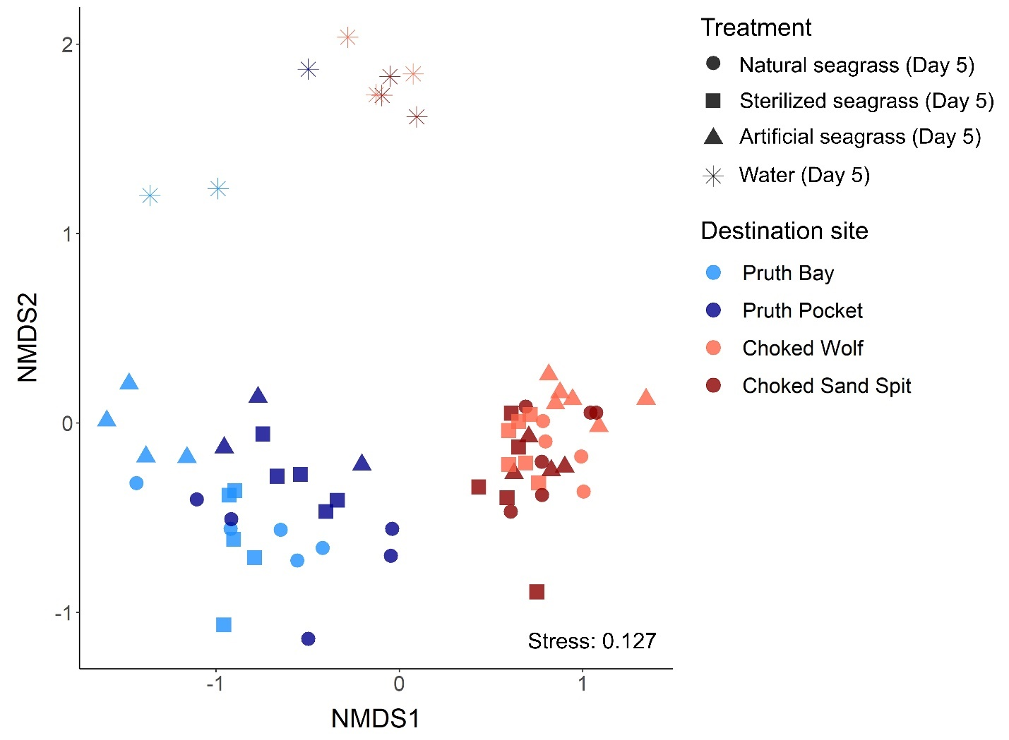

**Figure S2.** Non-metric multidimensional scaling (NMDS) plot using Bray-Curtis dissimilarity. Final microbial communities (Day 5) on natural seagrass, sterilized seagrass, and artificial seagrass leaves that were replanted to their original meadow or transplanted to the same region, and water microbial communities that were collected on the last day of the experiment.

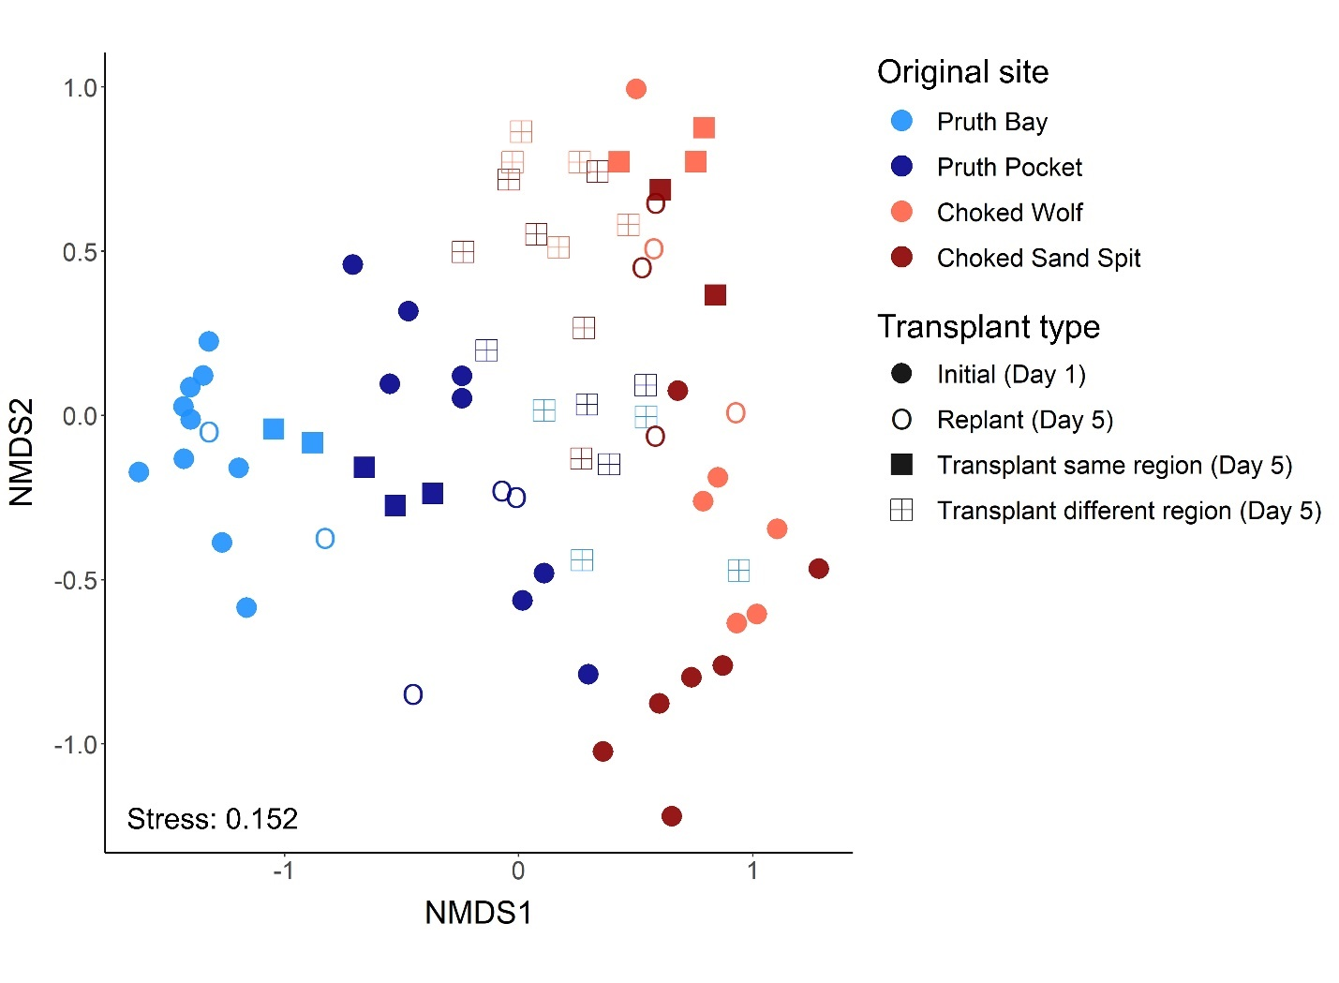

**Figure S3.** Non-metric multidimensional scaling (NMDS) plot using Bray-Curtis dissimilarity. Microbial communities on natural seagrass shoots for each location and time point. Colours indicate the sample’s original site and shapes indicate whether the samples were replanted, transplanted to the same region, or transplanted to a different region.

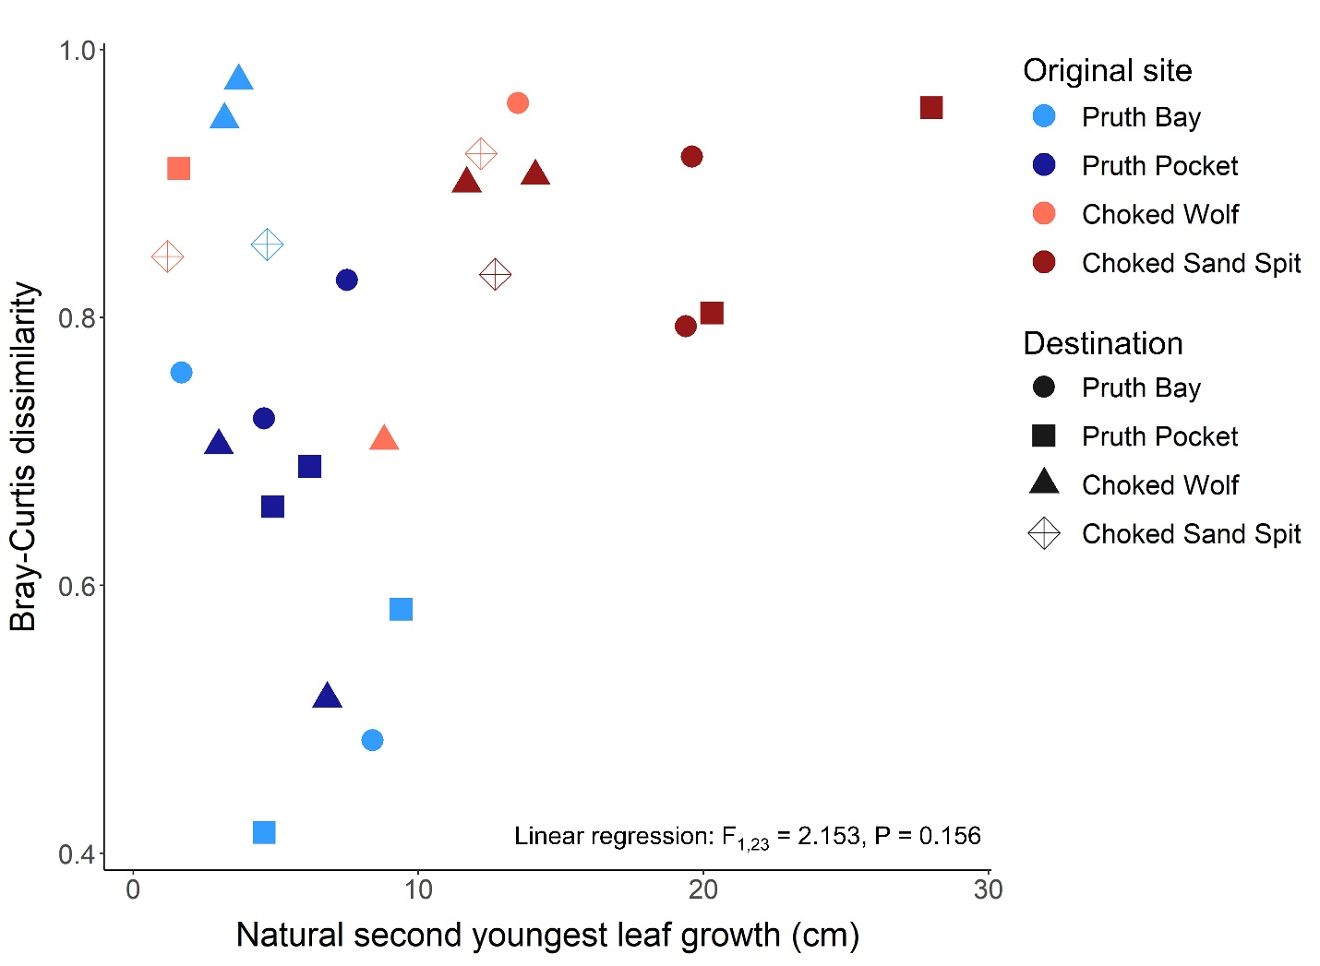

**Figure S5.** Growth of second youngest seagrass leaf for natural seagrass shoot compared to Bray-Curtis dissimilarity (Day 1 vs Day 5). There is no relationship between growth and community turnover.