Project 2 Part 2

# Answer each of the following questions in BLUE colored font.

## Project:

* 1. Include name of the team members.

Donnie Sengstack

Ashley Eads

* 1. Who is responsible for what? 1-2 sentences against each team member.

For Part 2 of Project 2, Ashley is responsible for creating the mega table and getting the data loaded into the mega table. Donnie is in charge of decomposing the mega table and writing create table statements for the decomposed tables. The two will work together on creating a UML diagram.

* 1. How are you sharing codebase? 1-2 sentences.

Donnie and Ashley will share code and addition files for the project in a GitHub repository that they have created.

## Database:

* 1. By this assignment submission date, you should have your raw data set imported in MySQL server in a megatable. You should also have started working on decomposition. Include screenshots of CREATE TABLE statements that you have completed/working on. This includes your megatable (required) and any other tables that you have designed. Include screenshot of any other relevant code blocks. Clearly label the screenshots.

We have finished loading the raw data into a mega table in MySQL. We loaded in three files containing raw data into the mega tables and you can see that in the screenshots below.

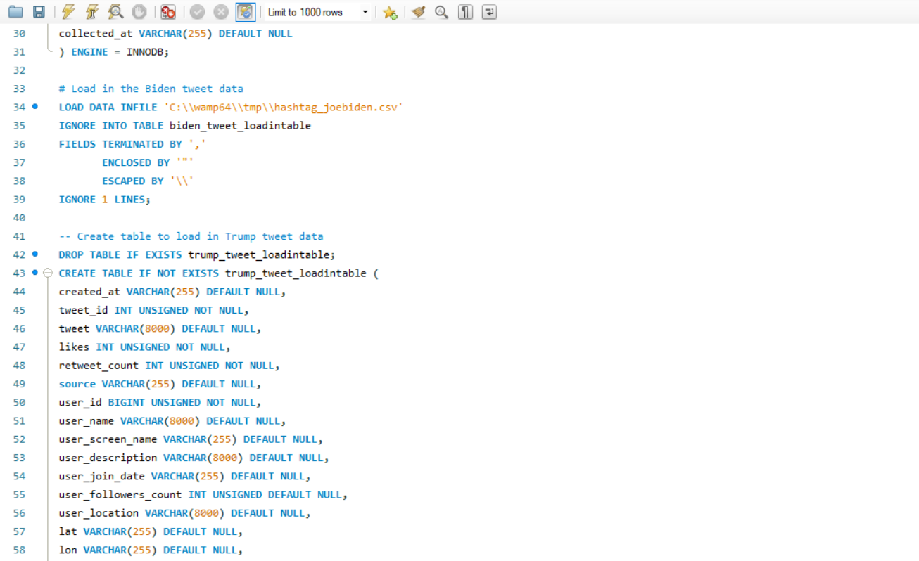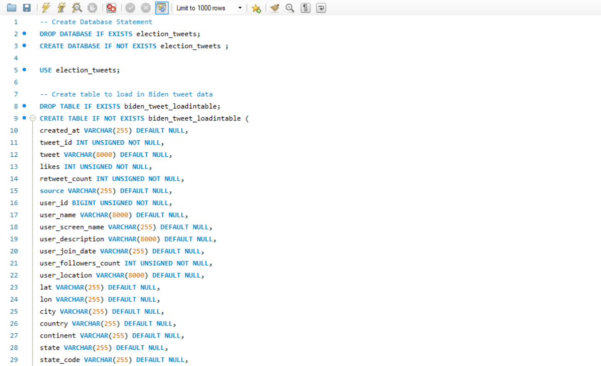

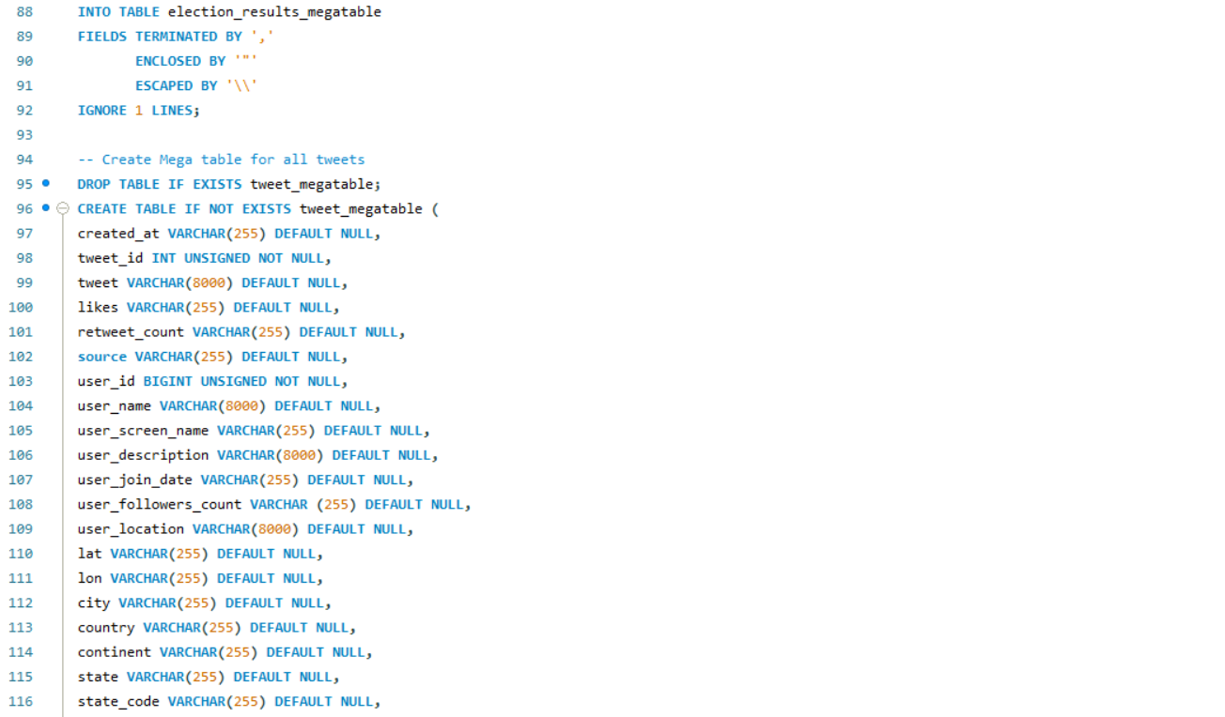

After loading the raw data into mega tables, we then combined the two mega tables containing tweets into one mega table. To create the mega table for all tweet data we used the code below. 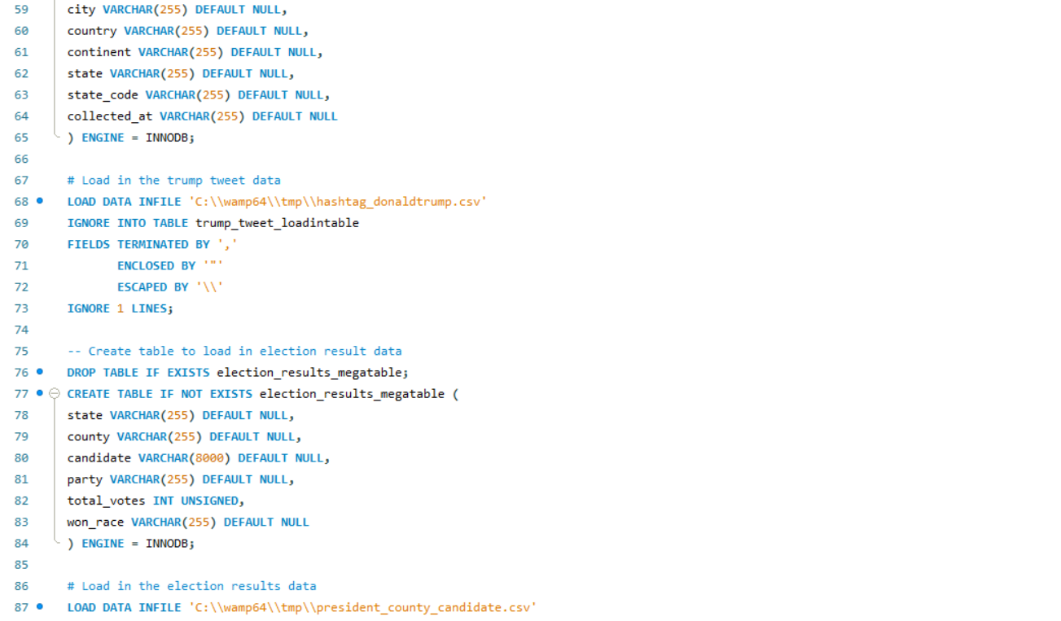

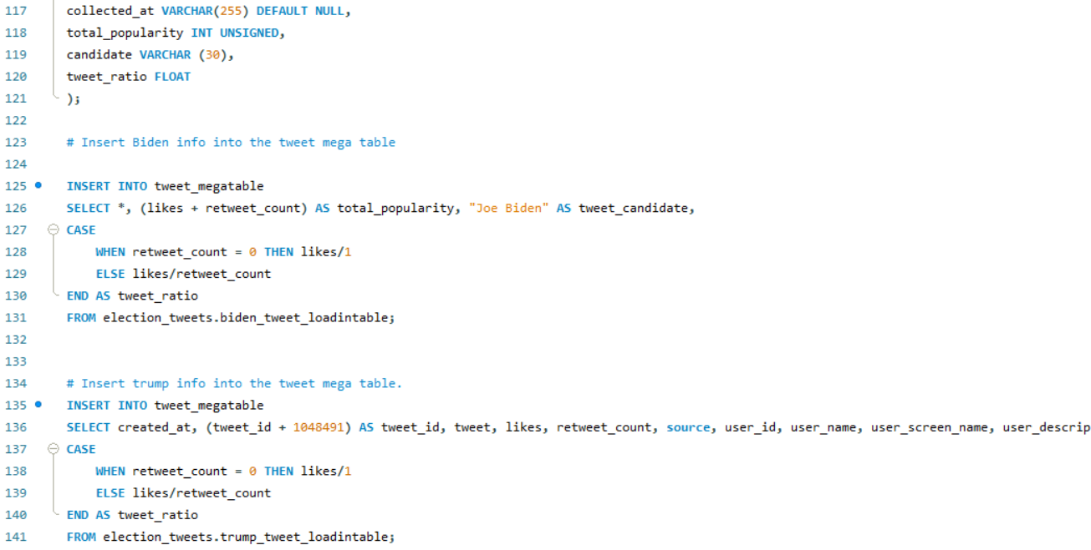

After that we decomposed the tweet data into third normal form to make sure each attribute was dependent on the table’s primary key, the whole key, and nothing but the key. To do that we used the code below.

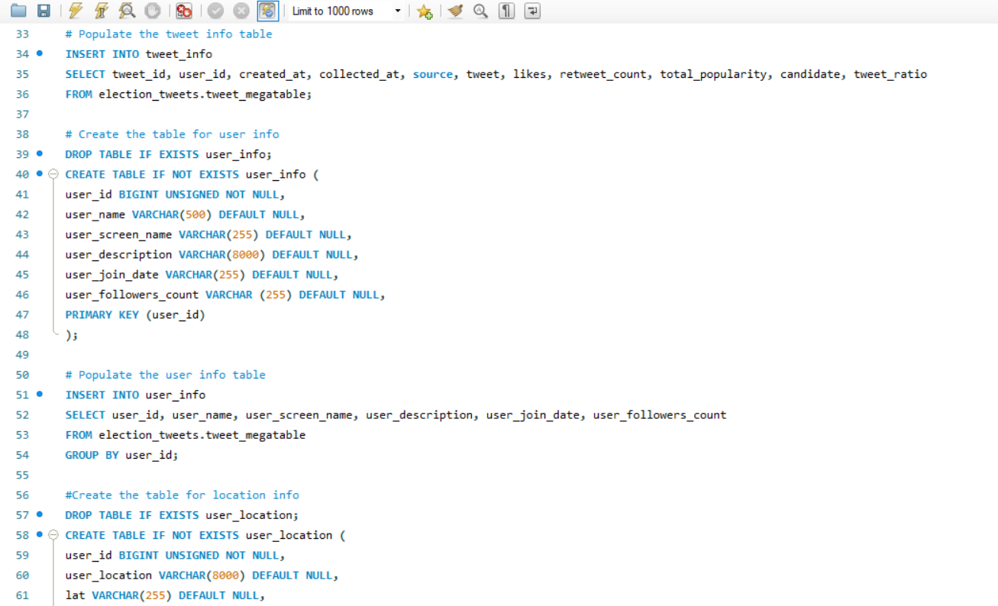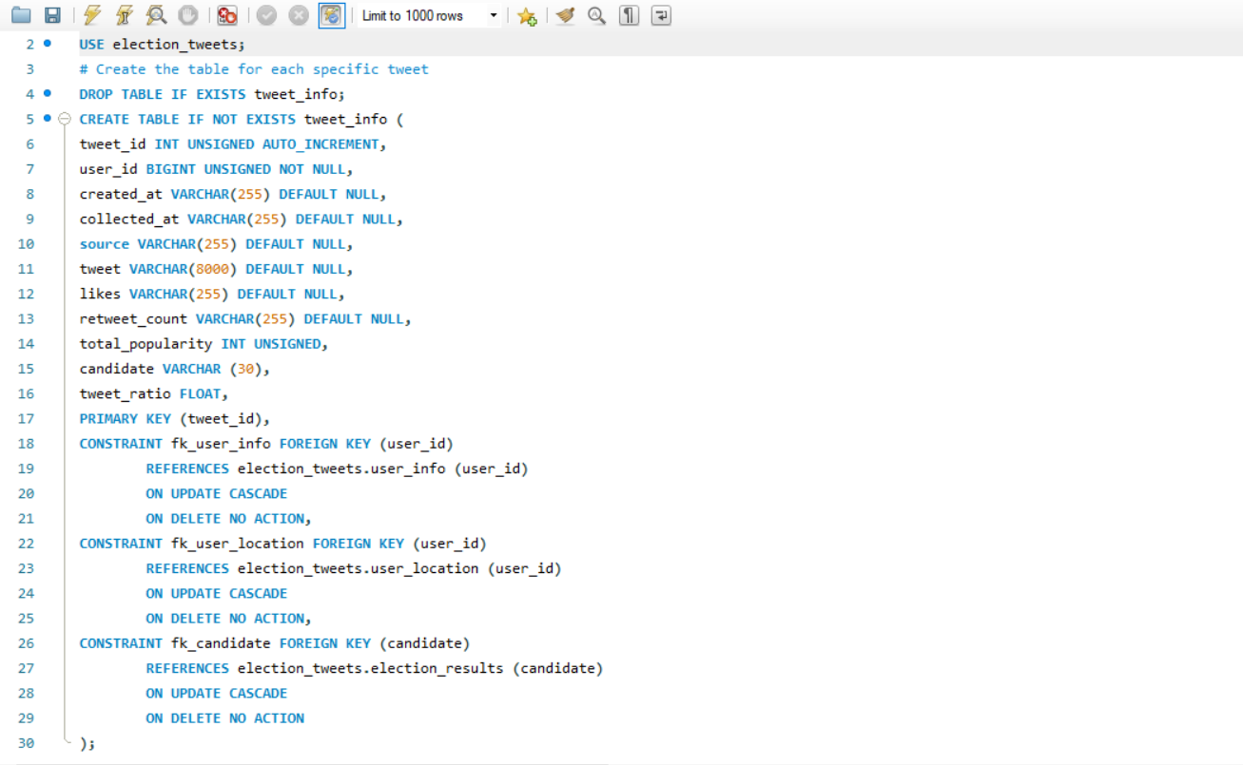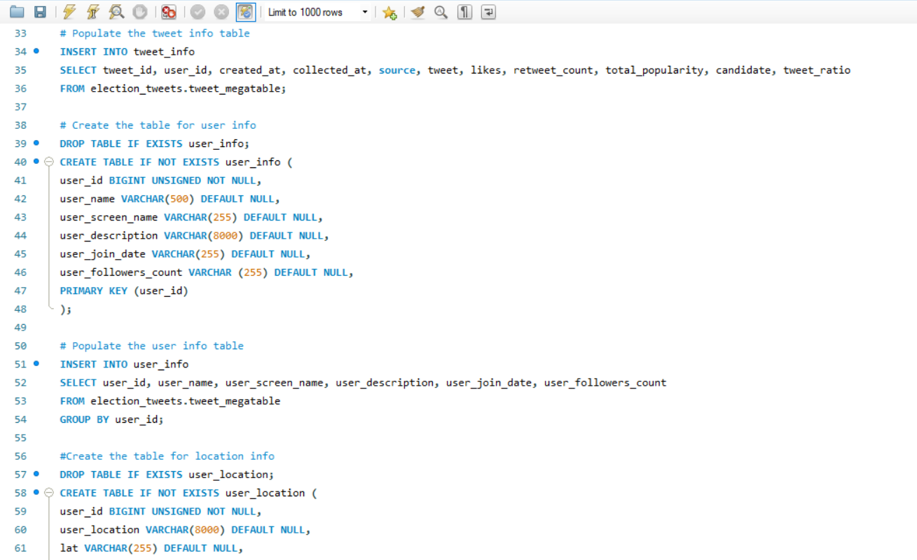

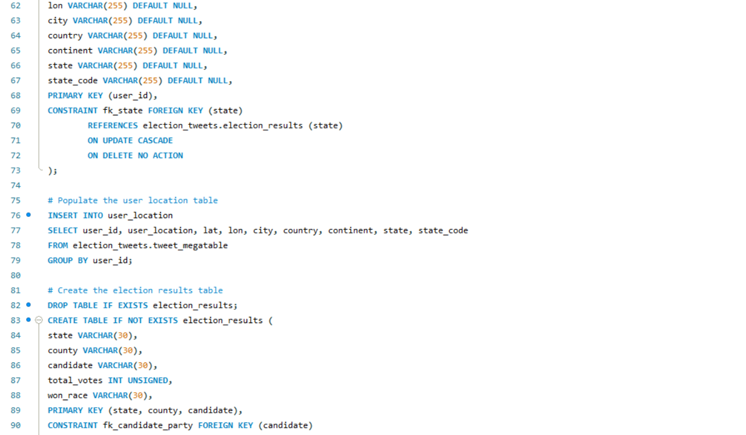

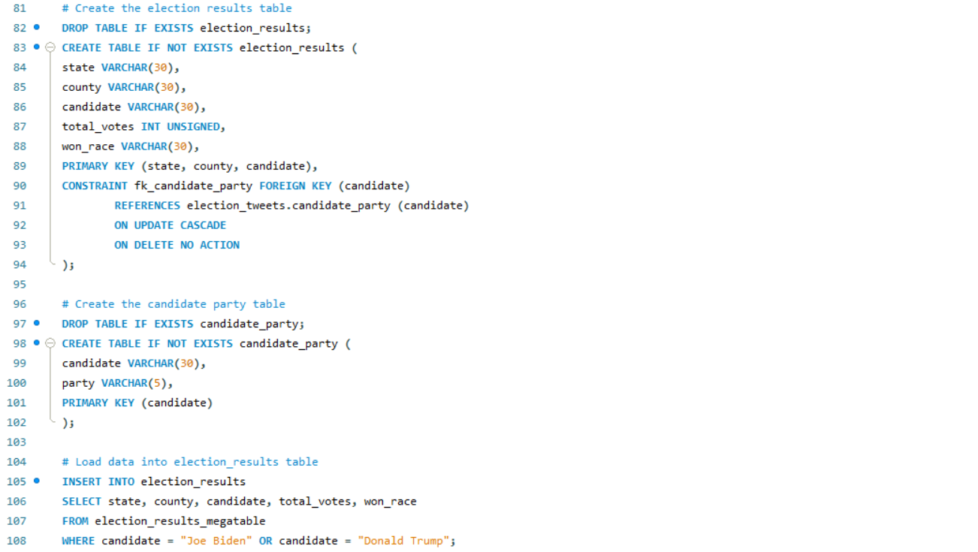The mega table containing election result data also needed one more decomposition to get to 3NF. I did that in the code below.

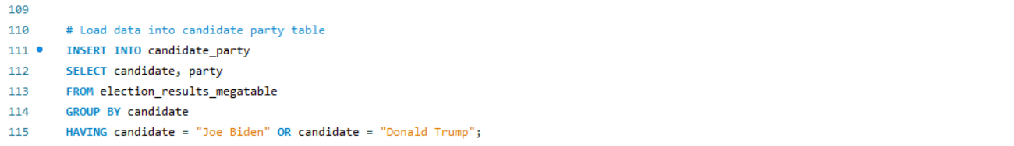

* 1. In terms of percentage how much you think you have completed on database side of the project? Describe the completed work in 2-3 sentences. Describe roadblocks, if any.

At this point in the project, we are finished with creating our databases and decomposing the tables into 3rd normal form. We have loaded the data into mega tables then decomposed those tables into 3rd normal form. All we have left to do is create our views, stored procedures, and triggers. I would say we are around 60% of the way done with the database side.

## Front end:

* 1. By this assignment submission date, you should have decided on the front-end application programming language and have a successful connection established between the front end and the project database. Attach a screenshot of the browser showing a successful connection displaying some data from any table of your project (can be megatable). Clearly label the screenshots.

We have made the decision to use Tableau for our front-end application and we have been able to establish a successful connection between our application and the project database. Below is a screenshot of our browser showing a successful connection where our application is displaying the election_results table from the database.

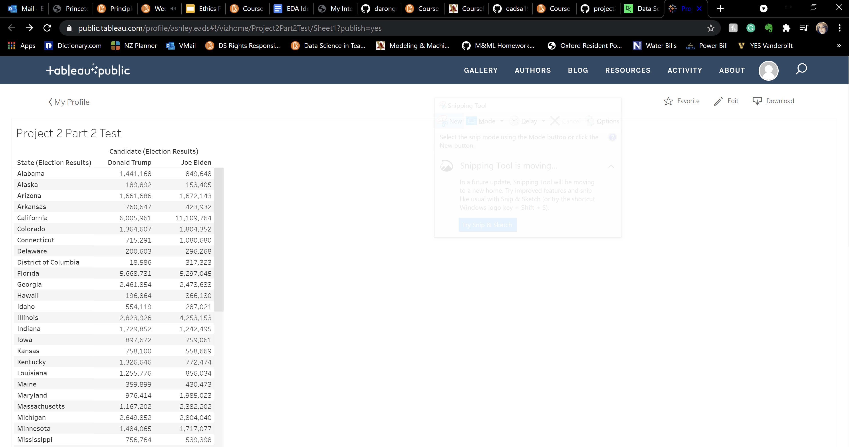

* 1. Which front end application programming language are you working with? Has anyone from team has prior knowledge of working with front end? Has anyone from team has prior knowledge of working with the chosen front end application programming language. 2-3 sentences.

For this project we are going to use Tableau for our front-end application. Neither of us have prior knowledge of working with front end. Ashley does have prior experience working with Tableau which will be very helpful when it comes to formatting our front end.

* 1. What is the status of front-end application? In terms of percentage how much you think you have completed on front-end side of the project?

At this point in the project, we have completed a good chunk of the front-end application. We still need to do some additional formatting to make data presentation on the front-end look nice, but we believe we are around 60% of the way done.

## Next deliverable

* What are your next steps? In a week time what do you plan to complete? Define clear goals.

Our next steps on the database side are to create views, stored procedures, and triggers. We need to create these views, stored procedures, and triggers in a week’s time in order to make sure that our database cane interact with our front-end application. As far as the front end is concerned, In a week’s time we need to

# Submission:

Complete this document and save it as pdf. You must submit a PDF file named **p2-part2-lastname1-lastname2.pdf** (For example if I submit this document with John Smith, I would name it p2-part2-singh-smith.pdf). Submit your files on Brightspace.

You must include your name and your partner name in the Brightspace submission text box.

Each member of the team must make the submission of same file.

# Grading:

This Assignment will be graded on the following criteria:

1. Completeness of document.
2. Completeness of required components at this stage of project.
3. Clear evidence of work completed.

*NO grading will be done on file/s sent through email or not uploaded to Brightspace.*