Project 2 Part 3

# Answer each of the following questions in BLUE colored font.

## Project:

* 1. Include name of the team members.

Donnie Sengstack

Ashley Eads

* 1. What is the general status of the project? Describe the roadblocks (if you have any) 3-4 sentences.

As of right now our project is coming along quite well. We have our database and front end connected with fully normalized tables. We had a hard time coming up with stored procedures, views, and triggers that might provide insight about the 2020 election to front end users. We feel that we were able to come up with a few good ones and now we just need to write our full report and record our presentation.

## Database:

* 1. By this assignment submission date, you should have your decomposition completed with all the tables ready in database. You should have also implemented many of the advanced features. Clearly label the screenshots.
     1. Include the UML screenshot.

As seen in the screenshot below, we have completed our UML diagrams with decomposed tables.

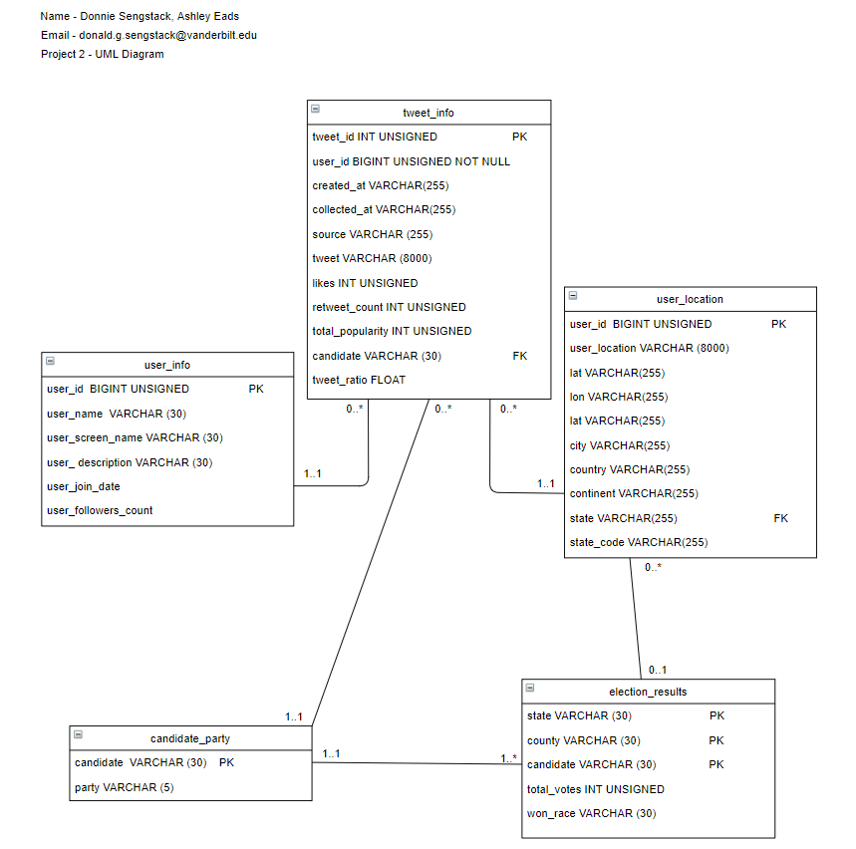

* + 1. Include the screenshots of decomposed tables.

I put the screenshots of the code for the decomposed tables in the project 2 part 2 document and I will include them again here. Once we had all of our data loaded into two different mega tables, we decomposed the mega table containing tweet data into third normal form first to make sure each attribute was dependent on the table’s primary key, the whole key, and nothing but the key. To do that we used the code below.

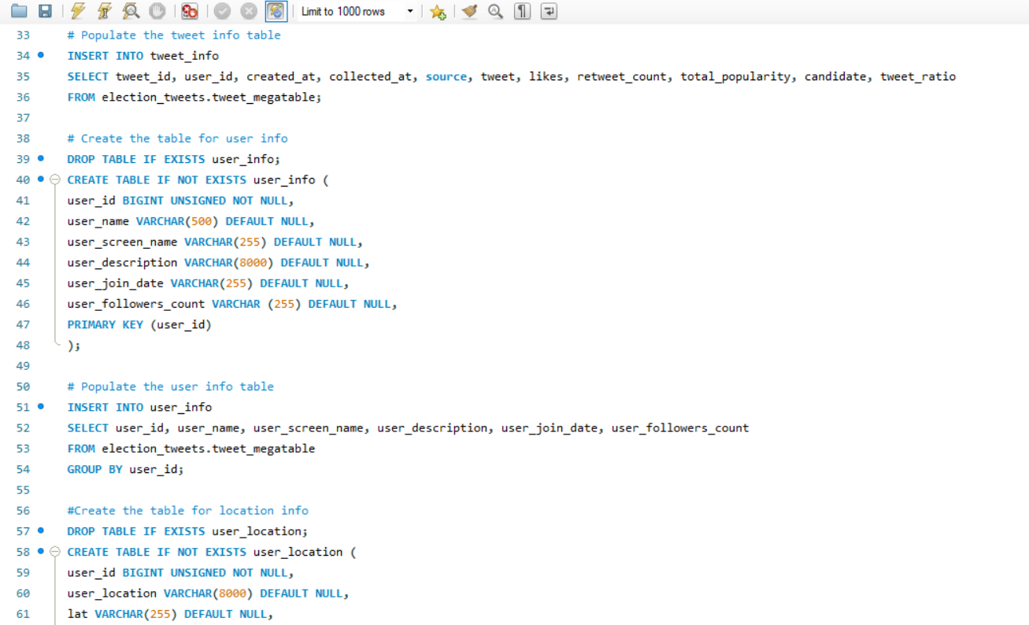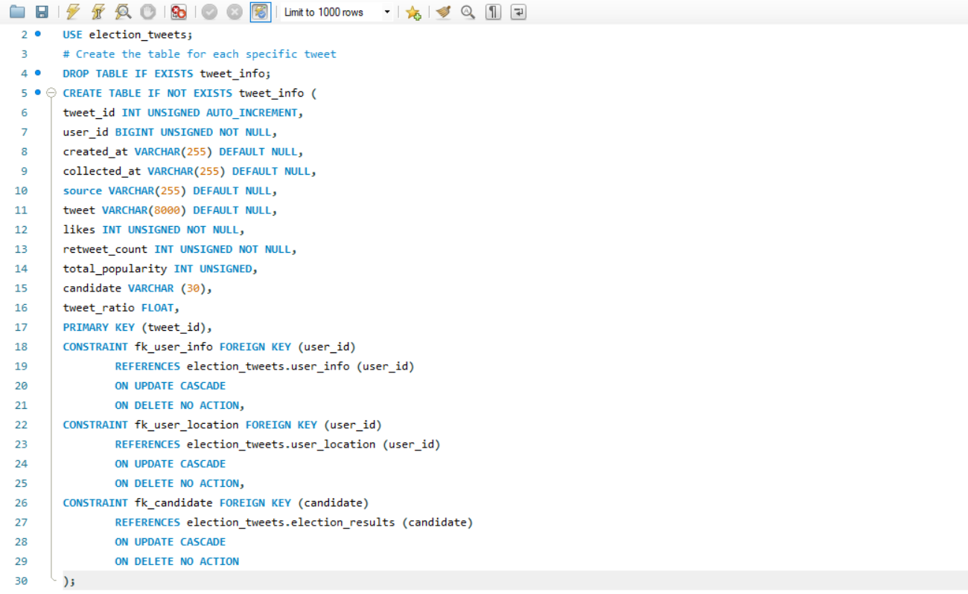

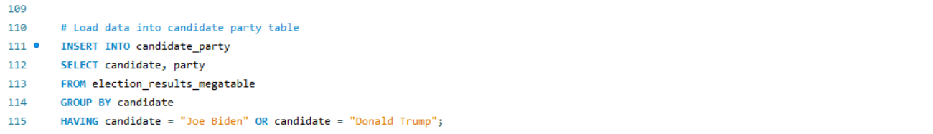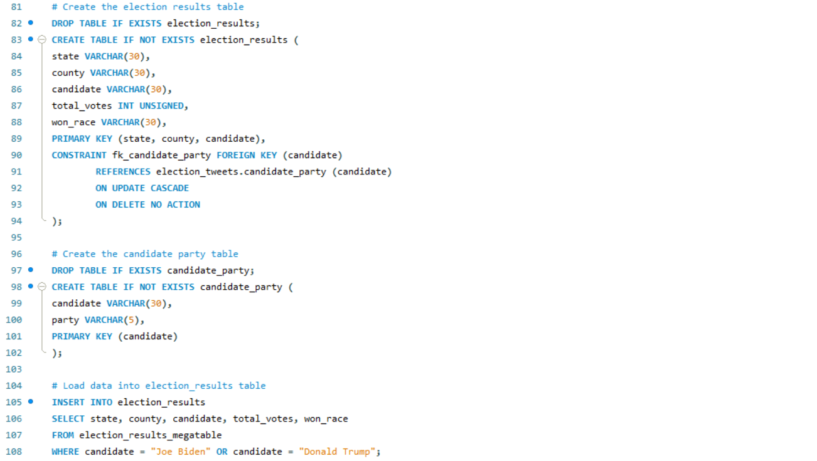The mega table containing election result data also needed one more decomposition to get to 3NF. I did that in the code below 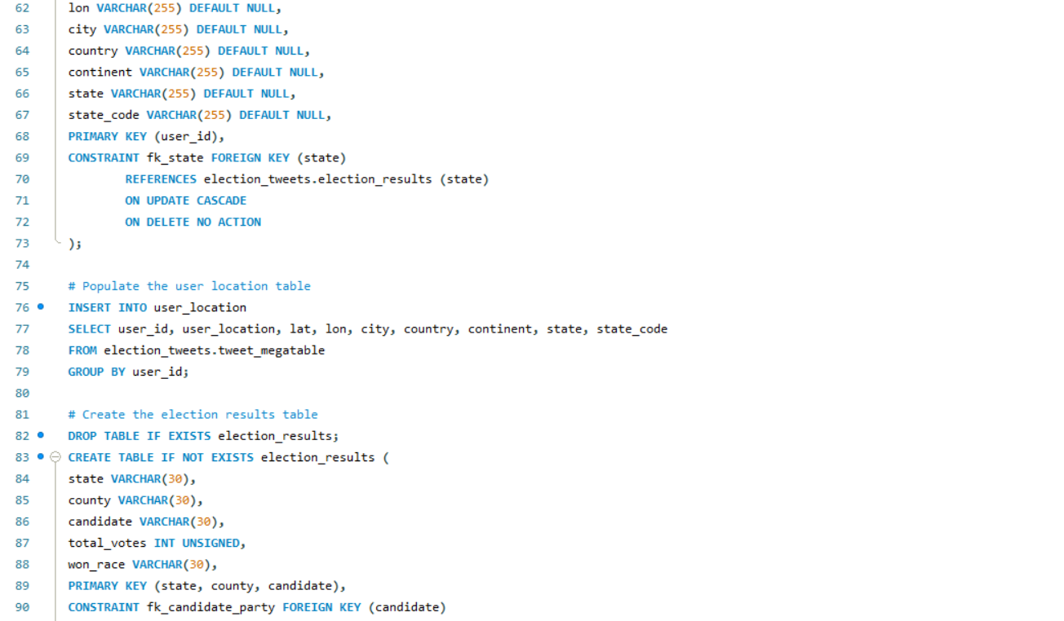

* + 1. Include screenshots of your implementation of some advanced features (Stored procedures, views, triggers etc.)

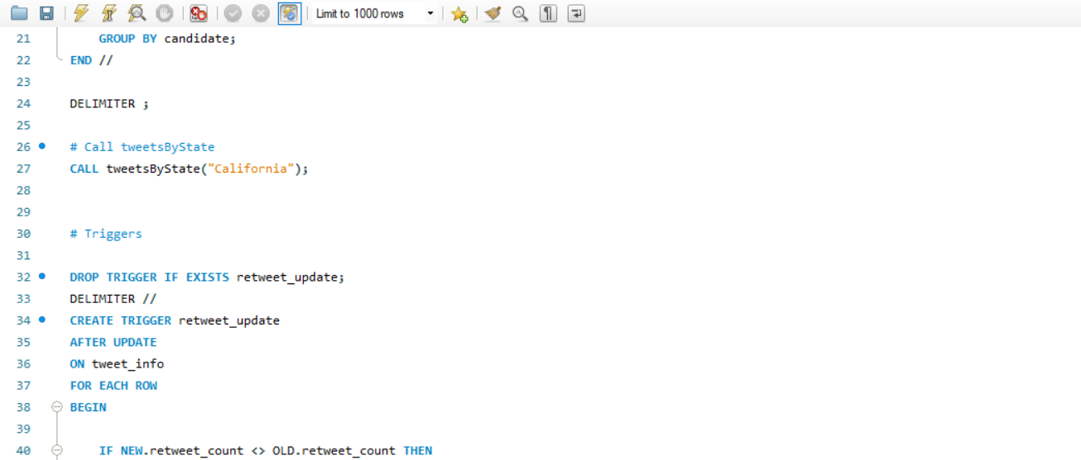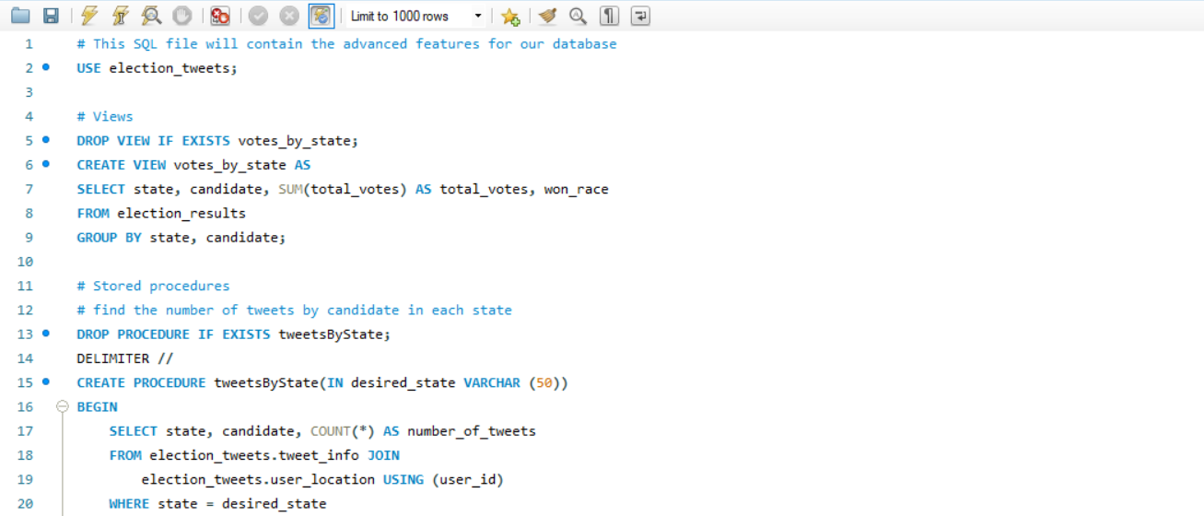At this point it the project we have also implemented some advanced features into our database. We have created views, stored procedures, and triggers which can be seen in the code below.

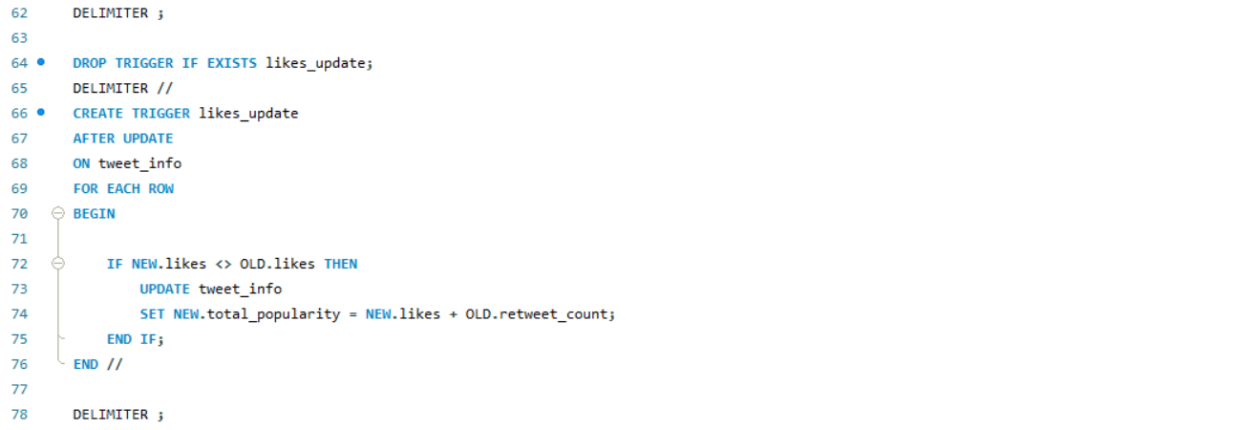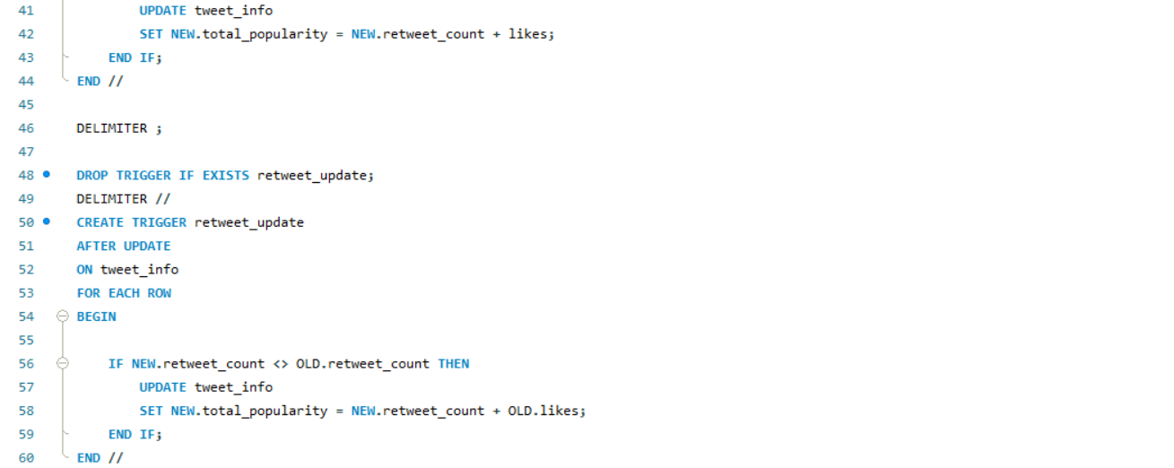

* 1. In terms of percentage how much you think you have completed on database side of the project? Describe the completed work in 2-3 sentences. Describe roadblocks, if any.

At this point in the project, we believe that we have finished approximately 90% of the database side of the project. All of our main code is written, but it may require some additional tweaks or advanced features before we turn it in for final submission.

## Front end:

* 1. By this assignment submission date, you should have a working interface showing data from the database in live connection. You should also have multiple UI pages. Clearly label the screenshots.
     1. Attach screenshots of the browser showing different UI pages. (At least 2 excluding home page)

Attached below are screenshot of three of the pages from our Tableau front end application, one showing a table of the number of tweets from different sources, another showing a table of the number of votes each candidate got by state, and the last showing a map of the distribution of votes across each state by candidate.

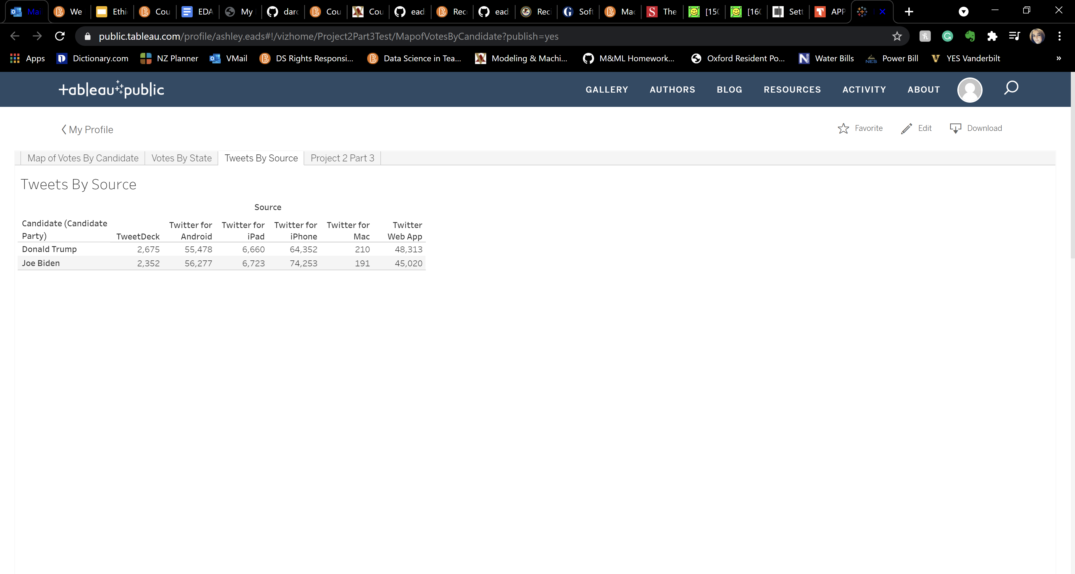

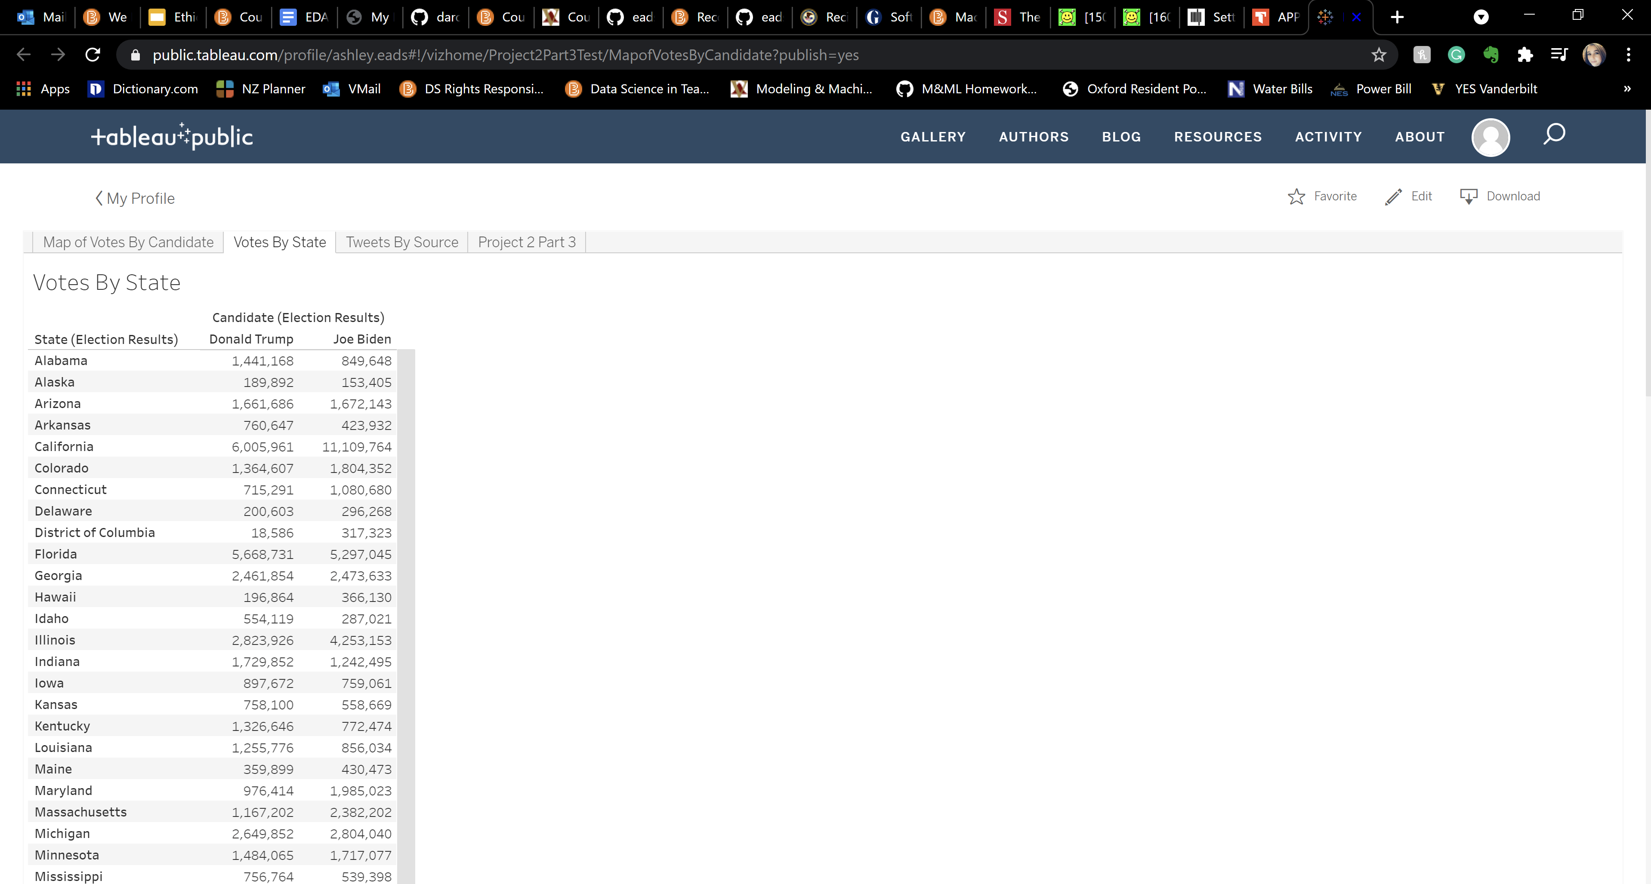

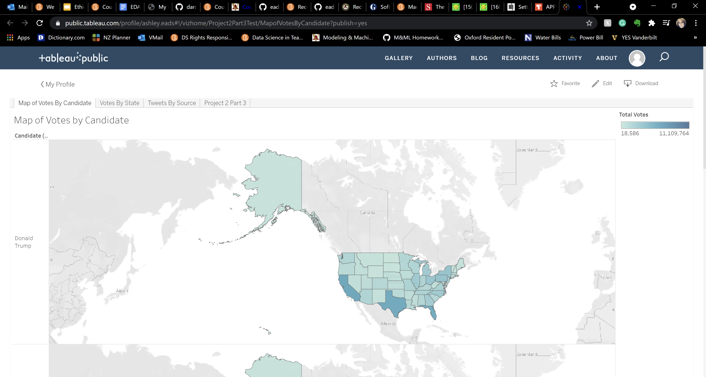

* + 1. Attach screenshots of relevant part of your front-end code showing calls to the database. This can be embedded SQL statements or calls to procedures etc.

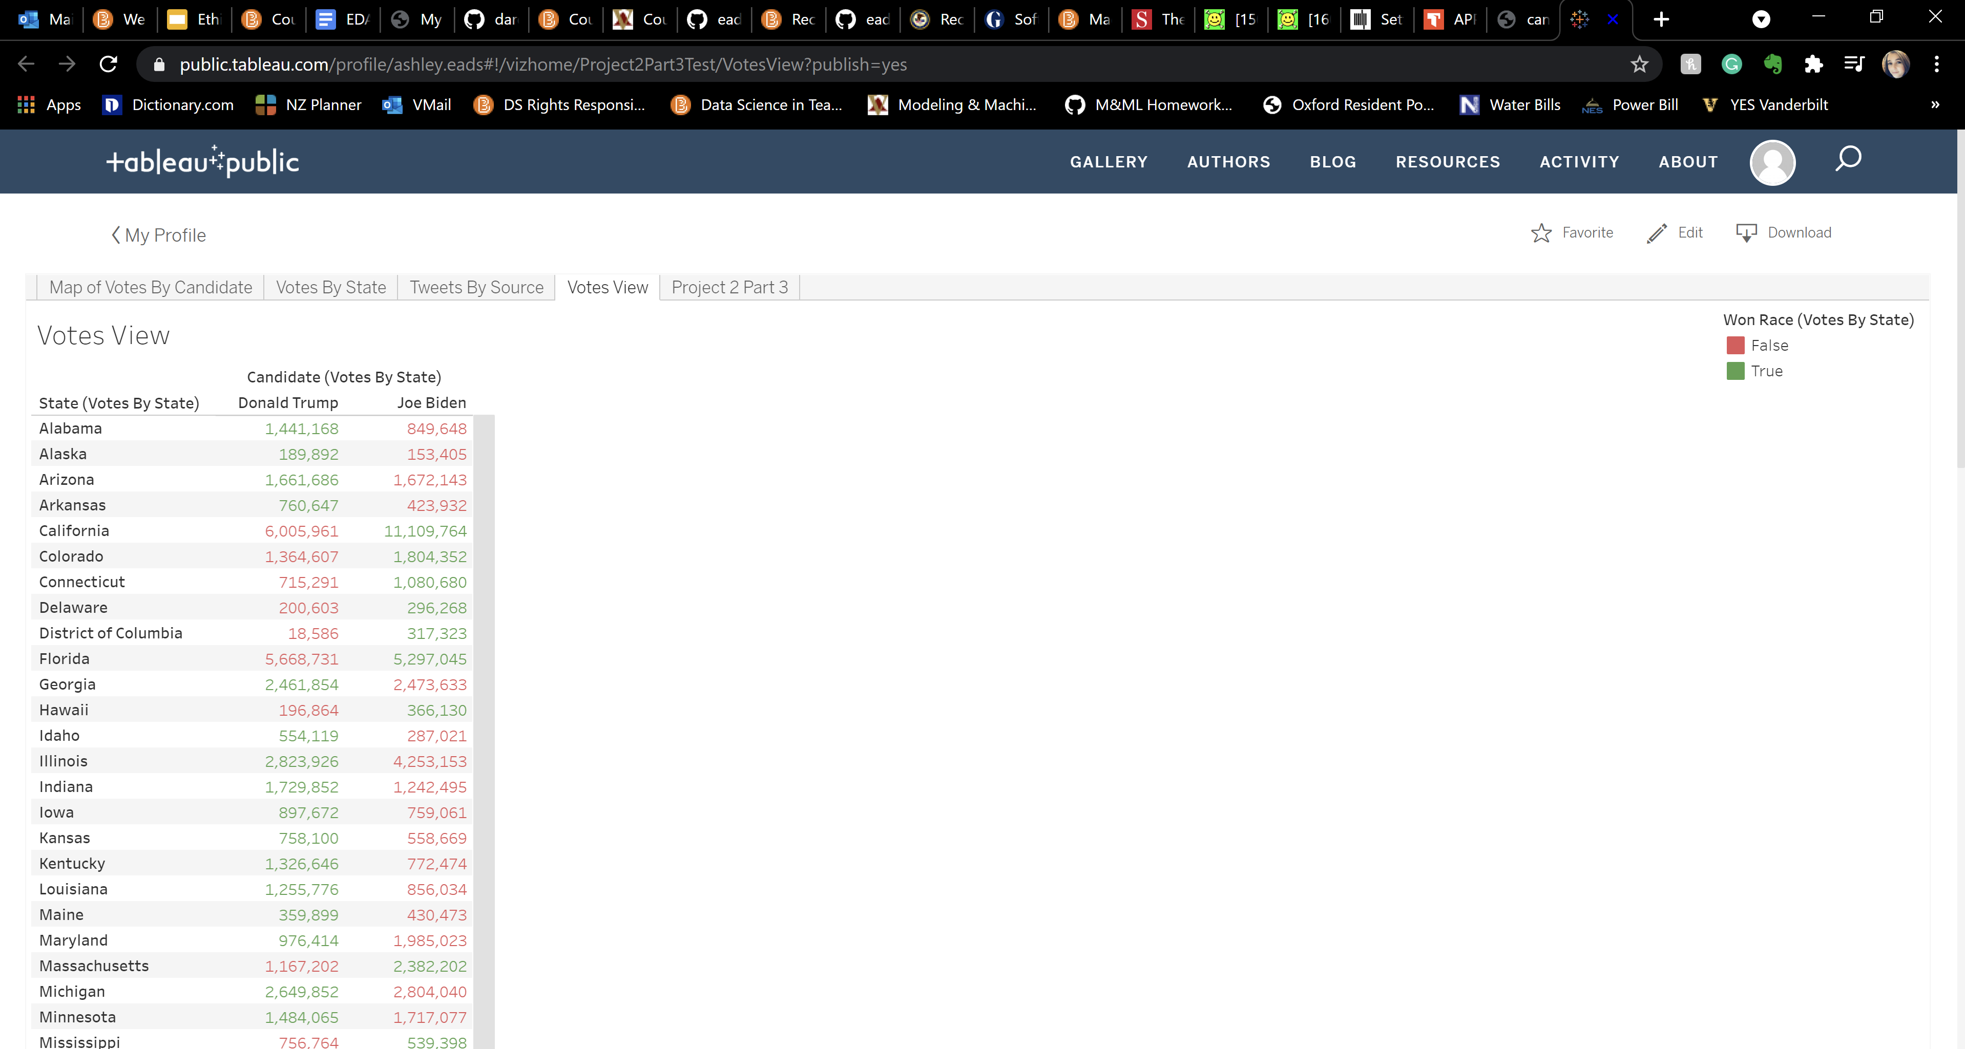

This is a screenshot of the view called Votes By State, which takes the State column from the candidate_party table and candidate column from the election_results table and displays the total votes from each state for each candidate color-coded by which candidate won each state.

* + 1. Have you implemented any DML components (INSERT, UPDATE, DELETE) yet in your project (Note that you must have DML components in the final version of your project).

We have not figure out a way to implement any DML components into our Tableau interface yet, but we are asking around to see if any of the second years who used Tableau in this project last year have any advice on how we can include INSERTs, UPDATEs, or DELETEs in our final submission of the project.

* 1. What is the status of front-end application? In terms of percentage how much do you think, you have completed on front-end side of the project? Describe what is completed and what is left. 2-3 sentences.

written document. The front-end application is becoming a lot more complicated than we originally anticipated. We figured out how to include multiple pages and views in our final product, but we do not know how to include DML, stored procedures, or any other advanced features in the final Tableau application. We will ask the second years how they did it in their project last year and if they have any advice on how we could implement those features in our final product. Contrary to what we thought last week, the front-end side of the project is about 45% done, especially if we have to come up with another way to add DML into the final output of the application outside of Tableau.

## Report and demo video

* Have you started working on your report? If yes, how much is completed (percentage)

We have begun working on our report and we would say that at this point we are confident that we have at least 25% done. A lot of the report will simply be taking all of the processes we have already done and effectively communicating them in a written document.

* Which tool you are planning to use to create a demo video of your application?

We are going to create our demo video by using Zoom and sharing our screen.

## Final Submission

* The final submission of Project will be due on 4/26/2020 at 12 noon.

# Submission:

Complete this document and save it as pdf. You must submit a PDF file named **p2-part3-lastname1-lastname2.pdf** (For example if I submit this document with John Smith, I would name it p2-part3-singh-smith.pdf). Submit your files on Brightspace.

You must include your name and your partner name in the Brightspace submission text box.

Each member of the team must make the submission of same file.

# Grading:

This Assignment will be graded on the following criteria:

1. Completeness of document.
2. Completeness of required components at this stage of project.
3. Clear evidence of work completed.

*NO grading will be done on file/s sent through email or not uploaded to Brightspace.*