ESC3332 Global Dynamics WEEK 3

Using the script from the first Prac and modify to plot the oceanic geotherm and the “cold” and “warm” continental geotherms that match the data (from Afonso and Ranalli, 2003).

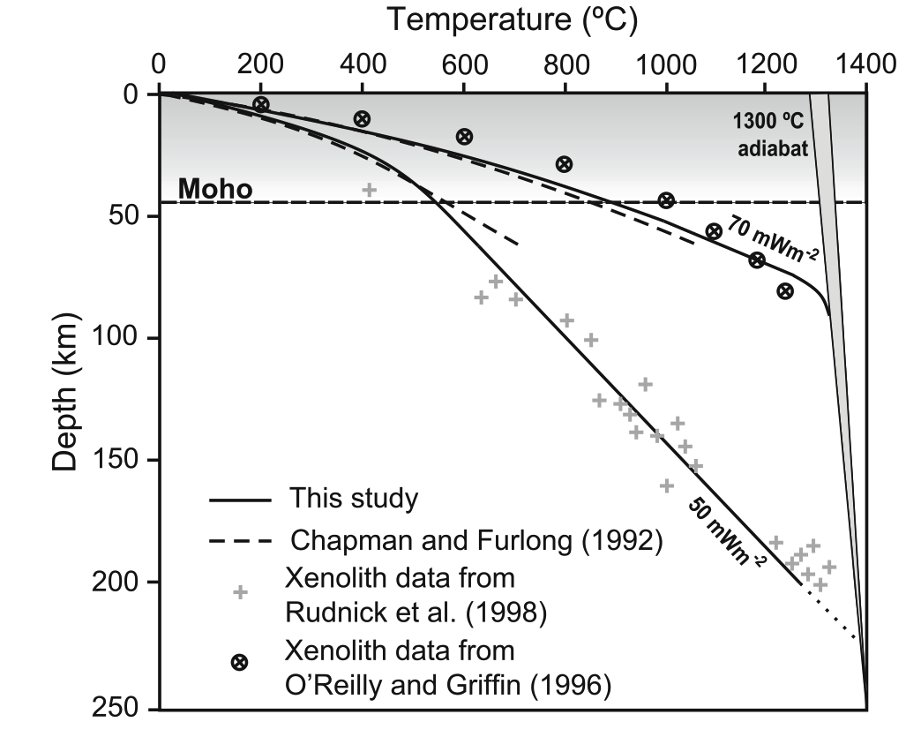

Modify the linear temperature distribution T(y) = gradient(T) \* y into an oceanic Half Space Cooling Model with different ages (between 10 and 80 Myr)



where ** = 1 mm2 s-1, *Tm* and *T*0 are mantle and surface temperature, respectively.

Plot the continental geotherms:



Use *k* = 3.35 W m-1 K-1 and heat flux from the mantle *qm* = 10 - 60 mW m-2 (vary this value to match the observable). The length scale at which the radiogenic heat decays is the radiogenic crust thickness *hr* = 30 Km and *H*0 = 5 µW m–3.

Answer the following questions:

1. How does the oceanic lithosphere thickness vary with cooling time (age)?

Make a plot of thickness (using the isotherm by T = 0.8 \* Tm) vs. age

1. How does the thermal thickness of the continental lithosphere vary with *qm*?
2. Calculate the equivalent heat flux for continental and oceanic lithospheres using Fourier’s law q = k ∆T/∆y. Note that when the geotherm is not linear, the heat flux might be better calculated close to the surface where the gradient is steepest.
3. Recalling average heat flux of 78mW m-2 and 56 mW m-2 for oceanic and continental domains, respectively, does your calculation agree with these values?