Assignment#2:
Task#1:
Task 1(a) and 1(b) included in the following screenshot:
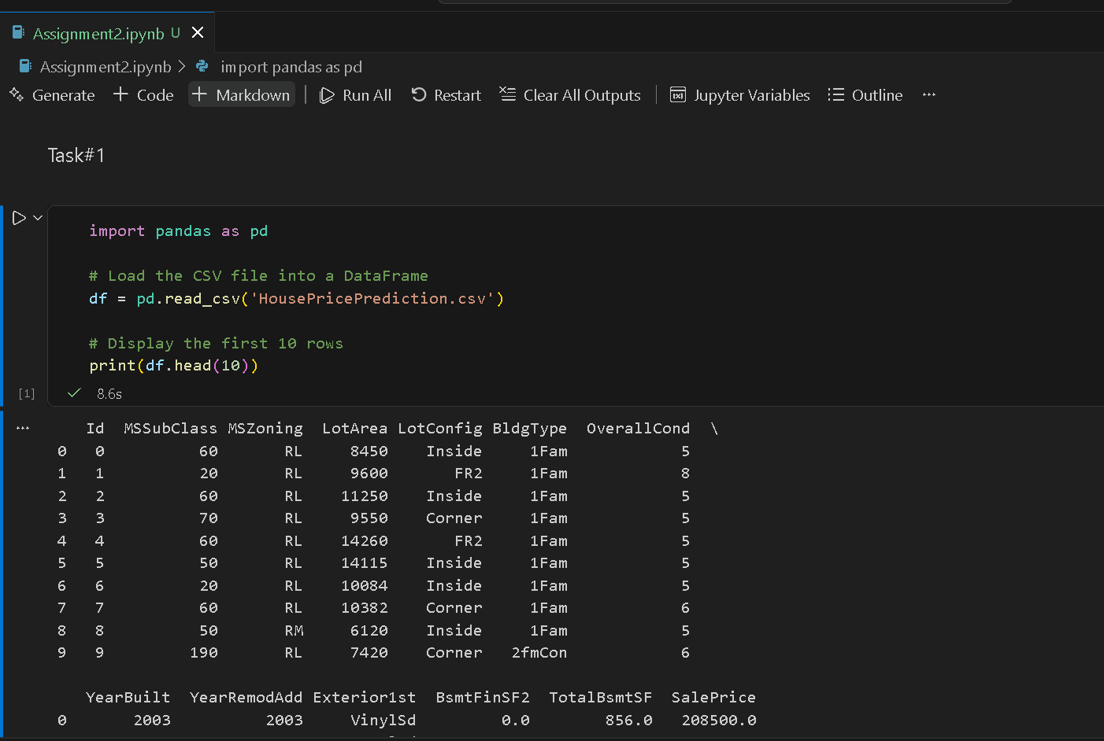

Task#2(a):
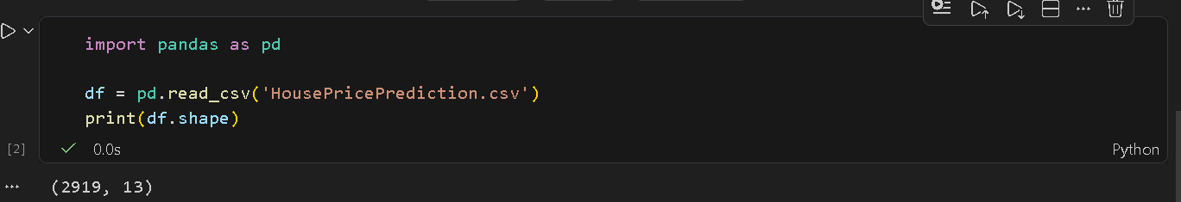

Task2(b):
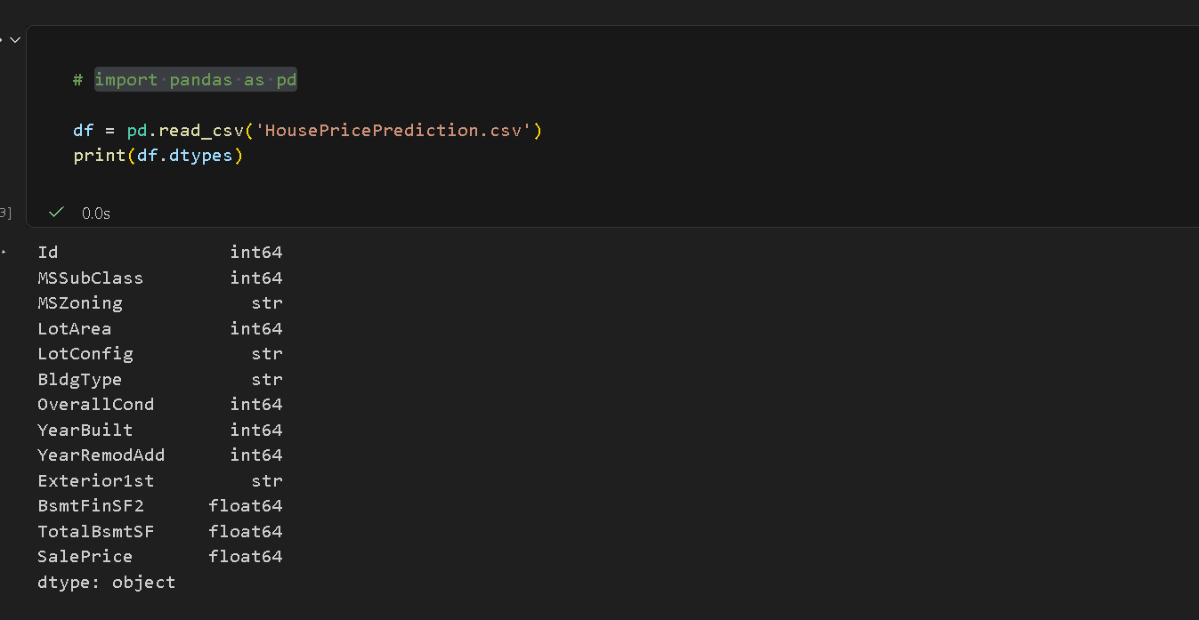

Task2(c):
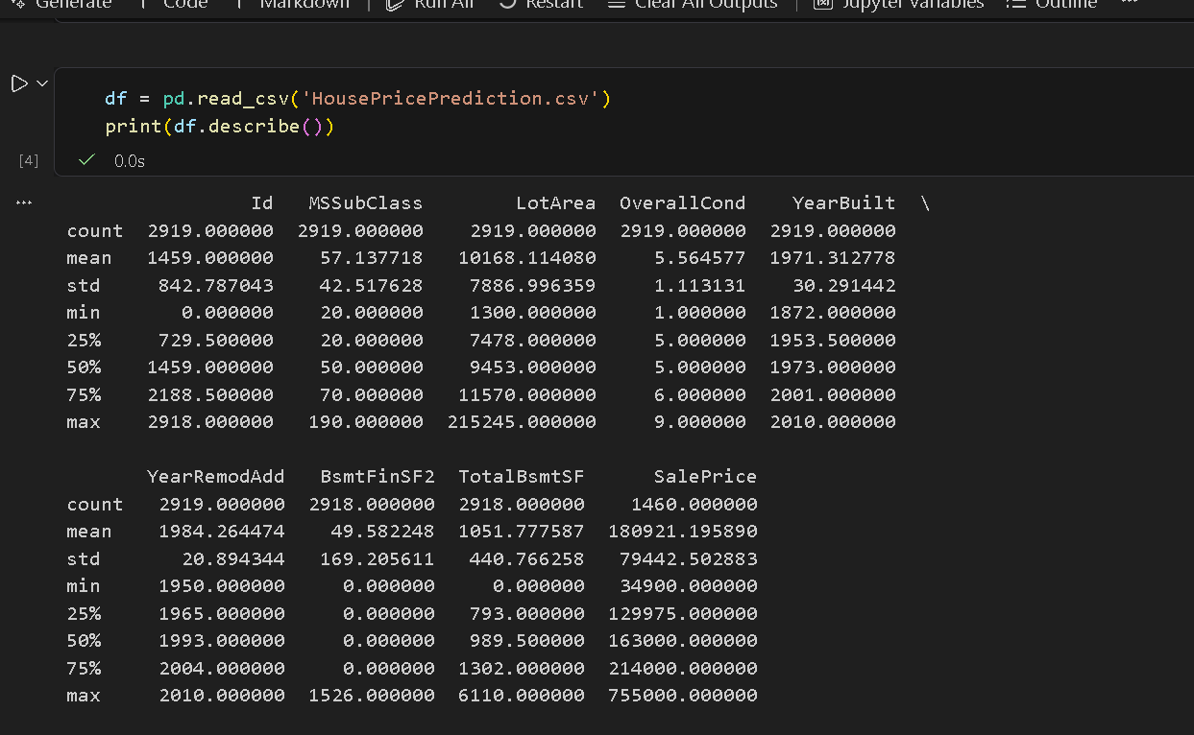

Solution for tasks a,b,c:
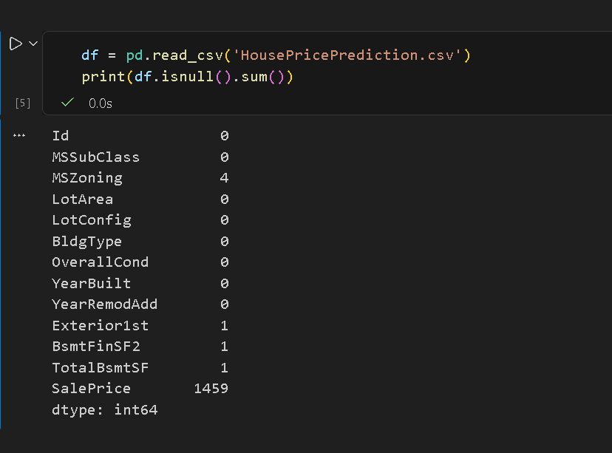

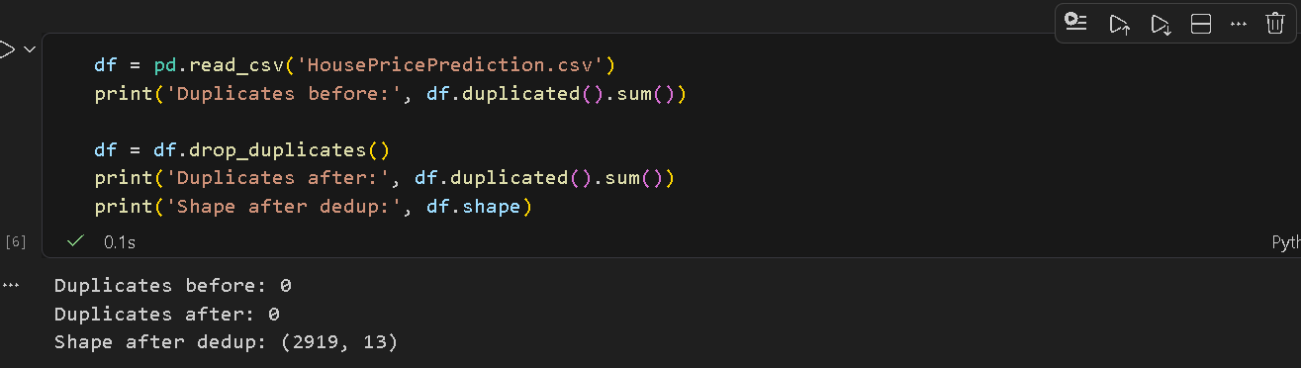

Task#4:
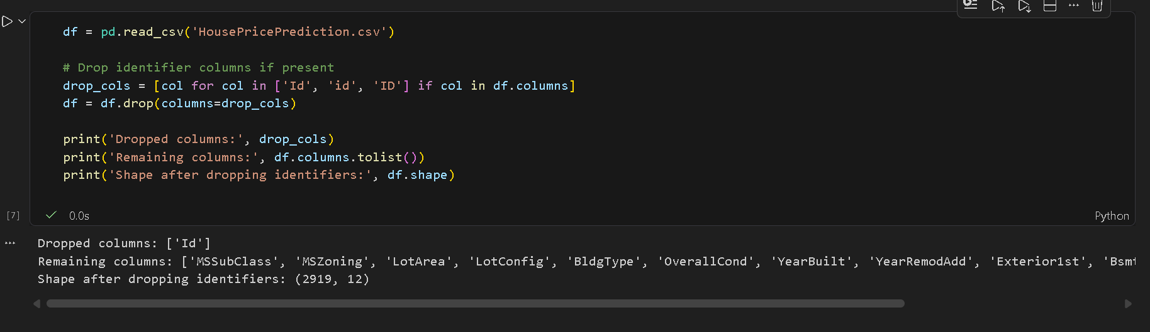

Task#5:
complete output wasn’t possible in one screenshot
