DOCTORAL THESIS CONCEPT — WORKING VERSION
Development of a Human Digital Twin Prototype Based on Multimodal Artificial Intelligence for Longitudinal Assessment and Prediction of Functional Recovery in Knee Rehabilitation
PhD in Deep Tech with a focus on Artificial Intelligence and Emerging Technologies — UNMSM
Scope note. This document describes the current research concept and uses a hypothetical case to show how the prototype could work. The numerical values, trajectories, and associations in Juan’s case are examples only; they are not clinical recommendations or real experimental results.

1. Brief thesis description
The thesis proposes a Human Digital Twin prototype for knee rehabilitation. It will combine multimodal patient information—clinical, functional, biomechanical, subjective, and lifestyle data—and update it at every visit. Its main function will be to estimate the patient’s functional recovery trajectory under the real treatment defined by the physiotherapist, compare observed and expected progress, and identify patterns or associations that may help the professional better understand the rehabilitation process.
Role of the health professional: the physiotherapist keeps the clinical decision-making role. The system does not prescribe treatment or replace the professional; it works as a longitudinal and predictive support tool.

2. What would the prototype do?
1. Create the patient’s initial representation. Record clinical and functional data from the first assessment.
2. Include the real treatment plan. The treatment defined by the physiotherapist is recorded as context for the prediction.
3. Estimate a functional trajectory. The system calculates how the patient’s functional score could change over the following weeks.
4. Update at every visit. Each new measurement updates the patient representation and recalibrates the future trajectory.
5. Compare prediction with observed progress. The system shows whether the patient is progressing as expected, above expectations, or below expectations.
6. Explain patterns associated with deviations. It combines longitudinal variables to identify factors that may be related to trajectory changes, without claiming causality.
7. Generate a final longitudinal summary. At the end of the rehabilitation period, it produces a report of progress, milestones, deviations, and associated factors.

3. Complete illustrative case: Juan
Hypothetical patient: Juan, 57 years old, starts rehabilitation two weeks after knee surgery. The physiotherapist performs the initial assessment, defines the treatment, and uses the prototype to support the monitoring of functional progress for seven weeks.

3.1. Initial data recorded
Data type | Examples of variables
Clinical data | diagnosis, relevant medical history, pain, swelling, range of motion, strength, and stability.
Functional data | walking, going up/down stairs, balance, daily activities, and weight-bearing capacity.
Biomechanical data | joint angles, symmetry, and movement pattern; these could be obtained through clinical assessment and, if available, motion capture.
Subjective data | perceived pain, confidence in putting weight on the leg, fear of movement, and perceived improvement.
Adherence | completion of home exercises, attendance at sessions, and activity level.
Lifestyle and context | sleep, working hours, stress, daily activity, and relevant habits.
Nutrition (candidate data type) | eating habits and, if allowed by the protocol, variables related to nutritional status.

3.2. Treatment defined by the physiotherapist
The professional defines the initial treatment plan using clinical judgment. The prototype records this plan as part of the follow-up context. The prediction is not “how Juan will progress without treatment,” but “how Juan could progress under his current condition and the treatment he is actually receiving.”. Longitudinal chart of the case:
Figure 1. Observed progress and updated predictive trajectories S1–S7.
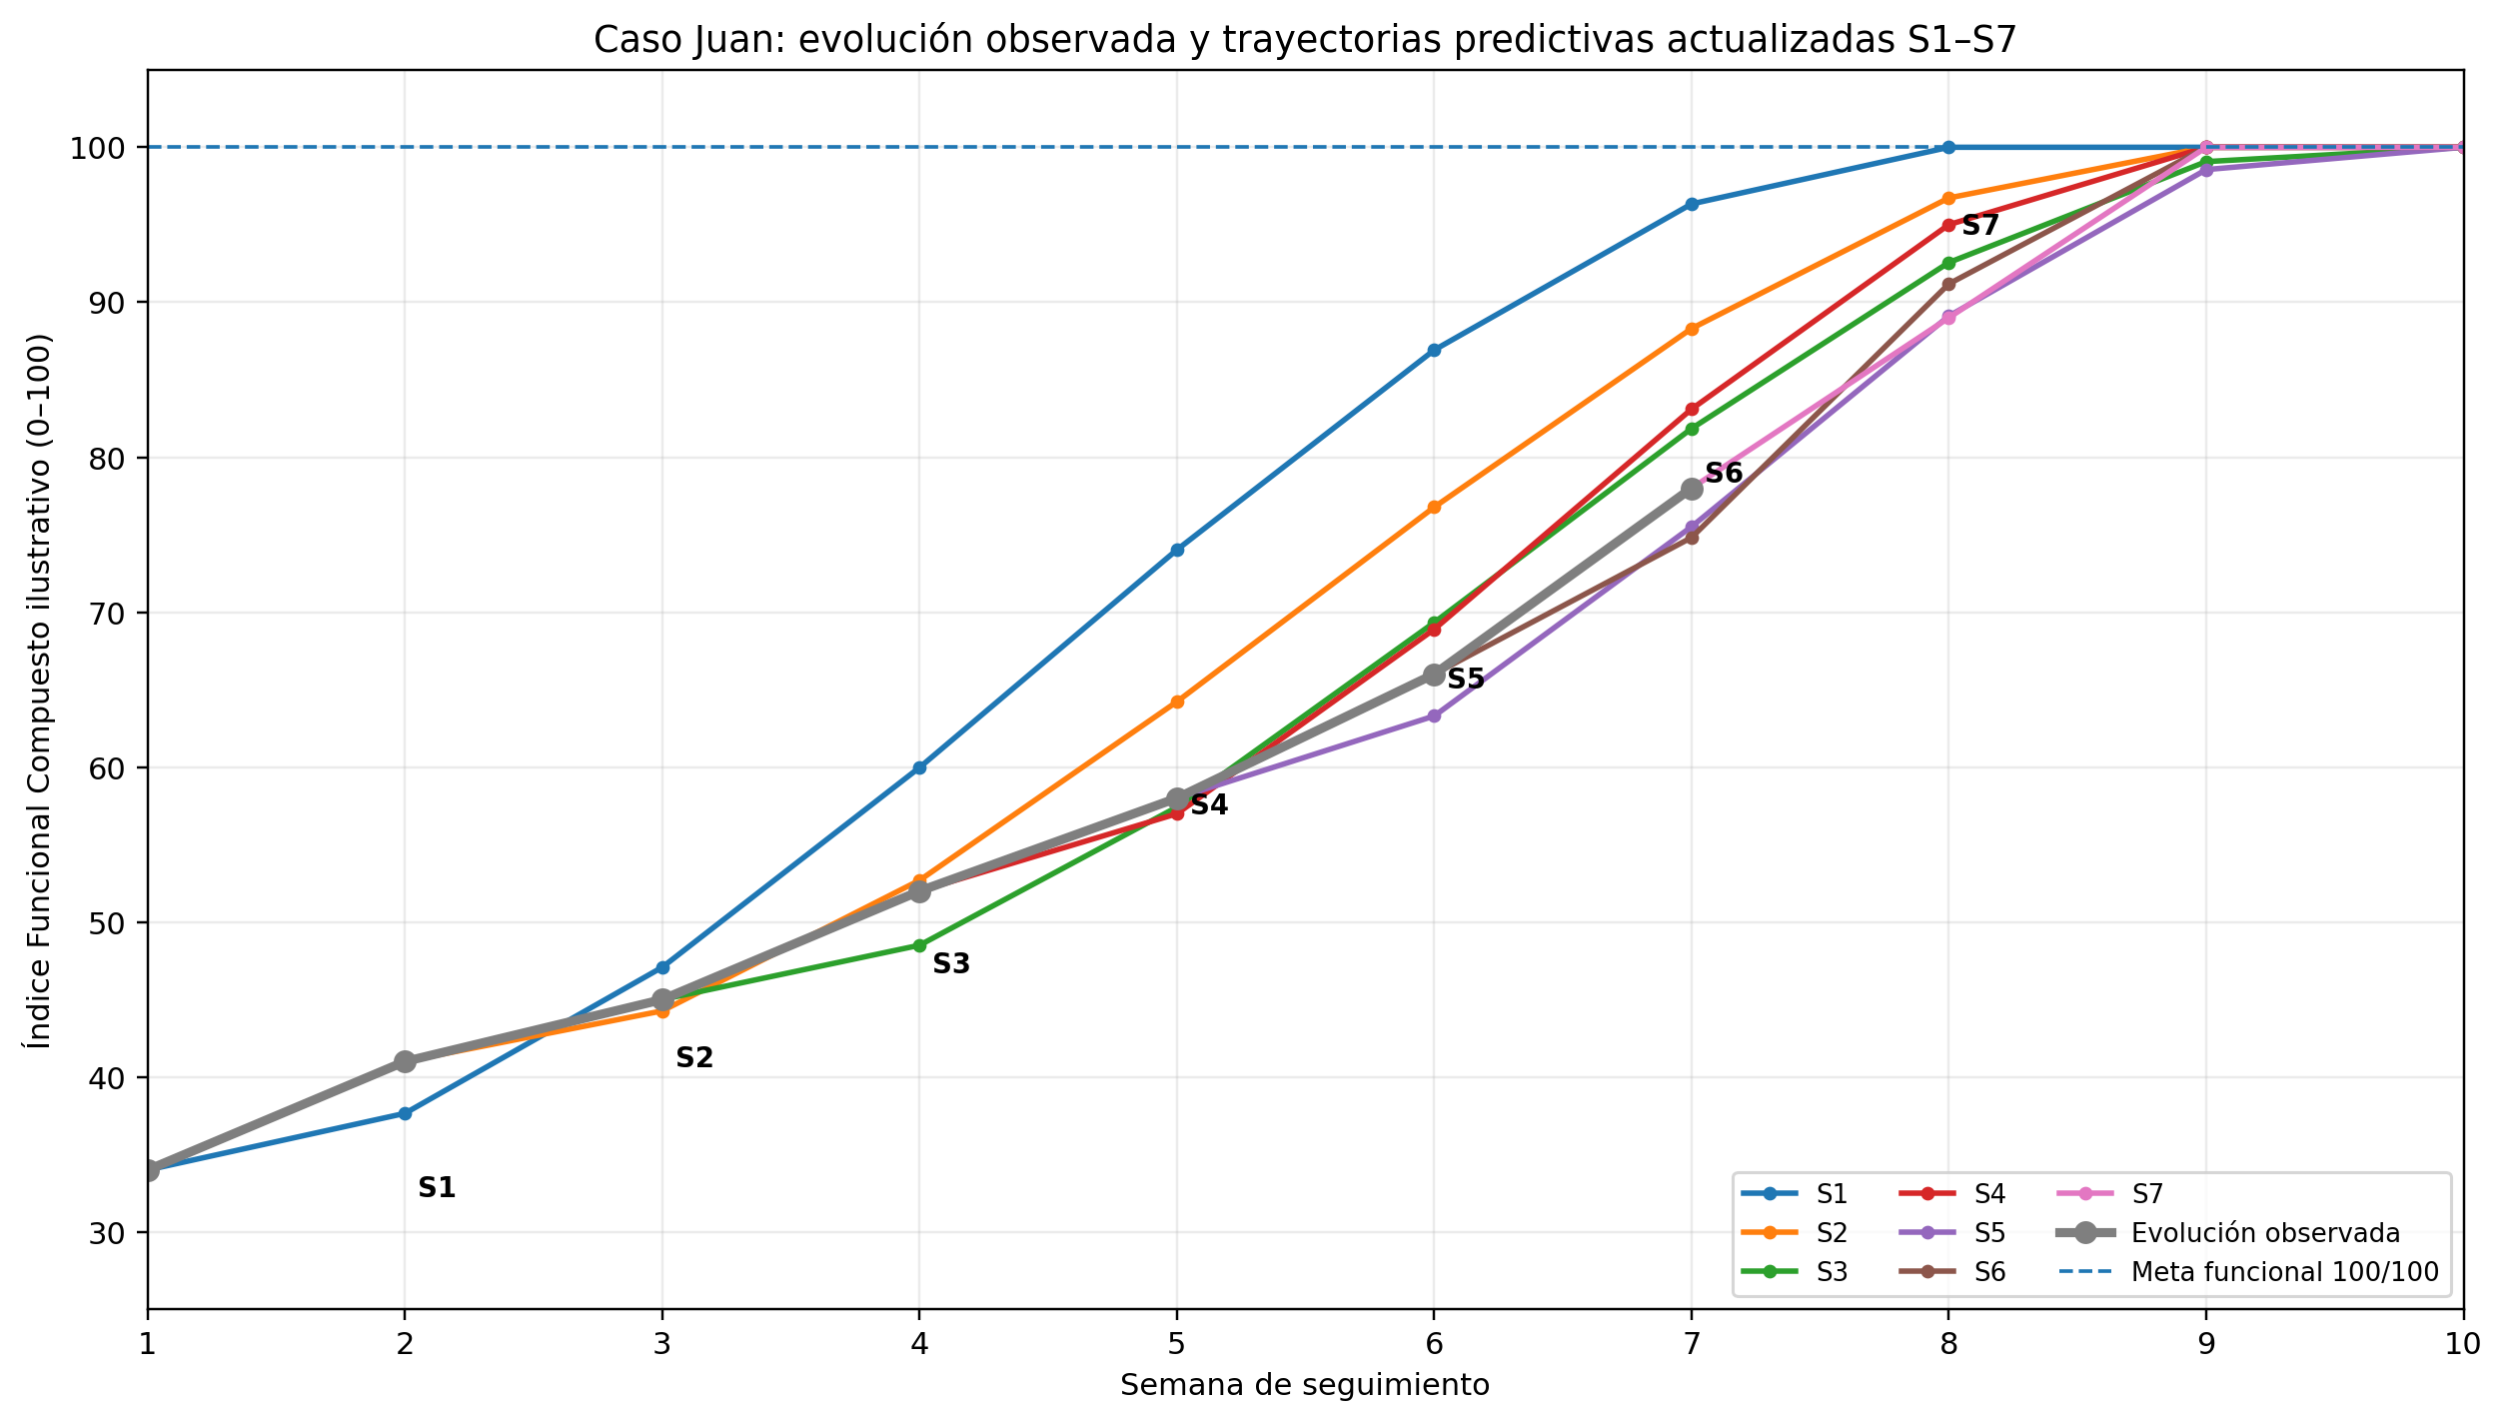
S1–S7 represent predictions recalculated at each session. The “Observed progress” line represents the actual scores recorded up to week 7.

4. Week-by-week interpretation
Week 1 — Initial session (S1)
Juan starts with an illustrative Composite Functional Index of 34/100. Using his initial data and prescribed treatment, the system estimates a trajectory that could reach the functional goal around week 8. This S1 curve becomes the initial reference for later visits.
Week 2 — First update (S2)
The actual score rises to 41/100, slightly below the S1 trajectory. The system recalculates the curve and moves expected recovery to a later week. This is not interpreted as failure; it is recorded as an early deviation that needs follow-up.
Week 3 — Physical improvement with functional avoidance (S3)
Pain decreases and mobility improves, but Juan still avoids fully loading the leg. Questionnaires and functional tests show fear of weight bearing. The system detects a mismatch: some physical indicators improve, but function does not improve at the same rate. This is reported as possible avoidance behavior associated with the slower trajectory, without claiming causality.
Week 4 — Activity peaks and functional rebound (S4)
Juan walks more and gains confidence, but longitudinal records show that high-activity days are often followed by more pain and lower function the next day. The system identifies a temporal relationship between load peaks and later changes. The physiotherapist can use this information to understand the patient’s real tolerance.
Week 5 — Pain medication and apparent improvement during the visit (S5)
Juan often takes pain medication before the visit. During the assessment he shows less pain and better performance, but later records show more stiffness and lower function after high-activity days. The system indicates that the clinic measurement may look better than his usual functional behavior and shows a possible mismatch between observed pain, load, and recovery.
Week 6 — Compensatory biomechanical pattern (S6)
Knee mobility improves, but biomechanical data show that Juan still shifts part of his weight to the opposite leg and changes his walking pattern. The model detects that improved range of motion is not accompanied by symmetric movement recovery. This combined pattern—better mobility but still altered symmetry—may be difficult to notice when variables are viewed separately.
Week 7 — Functional consolidation (S7)
The actual score reaches 78/100. Pain, mobility, strength, confidence, and symmetry begin to improve more consistently. The new S7 trajectory estimates that the functional goal could be reached around weeks 9–10 if the trend continues. Greater consistency across data types increases the system’s confidence in the projection, although the prediction remains probabilistic.

5. Example of a final longitudinal report generated by the system
57-year-old patient in knee rehabilitation, followed for seven weeks. Overall progress was positive but not linear. In the first weeks, improvements in pain and mobility did not always produce proportional functional improvement. Factors associated with deviations included fear of weight bearing, changes in daily load, sleep and adherence, changes after activity peaks, and differences between performance during clinic visits and usual functional behavior. In the middle phase, taking pain medication before some assessments coincided with better pain measurements than at other times. Improved range of motion also came before recovery of walking symmetry, showing that one clinical variable alone did not fully describe functional status. By week 7, pain, mobility, strength, confidence, and symmetry improved more consistently. The functional score increased from 34/100 to 78/100. The later projection estimated that the functional goal could be approached around weeks 9–10 if the trend continued. This estimate was not verified during the observed period. The report is longitudinal and predictive support, not a treatment prescription.

6. Value provided by the prototype
• Turn separate assessments into a longitudinal patient representation.
• Visually show the difference between expected and actual progress.
• Update the prediction whenever new data are added.
• Combine data types to detect patterns that may be missed when analyzed separately.
• Show which variables are associated with trajectory changes without confusing association with causality.
• Generate a longitudinal summary that can be reused by the professional and, with proper governance and consent, in future research.
• Gradually create a structured database that can support later stages of the Human Digital Twin.

7. Scope of this first doctoral stage
This first version does NOT aim to automatically recommend treatments or replace the physiotherapist’s decision. Its purpose is to build and evaluate a longitudinal prototype that represents the patient, predicts the functional trajectory, and helps interpret deviations using multimodal information. Later stages—simulation of treatment scenarios, optimization, or generation of candidate plans—are future extensions that will require more data and validation.

