NATIONAL UNIVERSITY OF SAN MARCOS
Doctoral Program in Deep Technologies (Deep Tech)
COURSE: RESEARCH METHODS AND SCIENTIFIC INTEGRITY IN ARTIFICIAL INTELLIGENCE AND ADVANCED TECHNOLOGIES

REPRODUCIBILITY AUDIT OF A SCIENTIFIC ARTICLE
Partial reproduction of “Bag of Tricks for Efficient Text Classification” (fastText) on AG News
Revised version to complete institutional details and verify submission requirements
Student: Edward Alexander Fuentes Aliaga
Student ID: 26207276
Instructor: Dr. Loveleen Gaur
Arequipa, October 2026

Executive Summary
We examined the reproducibility of one experiment from Joulin et al. (2017), using the fastText model to classify AG News articles. We obtained the authors’ code, compiled it in Google Colab, checked the dataset integrity and class distribution, reproduced the normalization from the official script, and trained the model using the published settings.
Main result: our documented run achieved P@1 = 0.925 on 7,600 news articles, or 92.5% correct predictions. This matches the result reported to one decimal place for fastText with bigrams (Table 1). Training took 11.2 seconds in our environment (four threads). This time is NOT directly comparable with the times in the paper, which used different implementations and computing conditions. The result supports reproducibility of the accuracy figure in one run and on one dataset. It is NOT a full reproduction of all tables in the paper or proof of stability across random seeds. The repository we consulted was archived in 2024, and its binary equivalence with the 2017 implementation has not been established.
The audit found good practices: public code, reproduction instructions, a separate test set, and learning-rate selection using validation. We also found reporting limits: we did not find random seeds or variation across runs for the AG News result, significance tests, or confidence intervals. The exact validation split used for tuning was not fully described. Our ratings apply only to the materials reviewed; we do not assume unproven errors.

1. Study Identification
Field | Information
Title | Bag of Tricks for Efficient Text Classification
Authors | Armand Joulin; Edouard Grave; Piotr Bojanowski; Tomas Mikolov
Publication | EACL 2017, volume 2 (short papers), pp. 427–431
Area | Artificial intelligence / natural language processing / text classification
Paper | https://aclanthology.org/E17-2068/
Original code | https://github.com/facebookresearch/fastText
Script used | classification-results.sh
Dataset | AG News: 120,000 training records and 7,600 test records; four categories

2. Objective and Scope
Objective: determine whether the published fastText accuracy on AG News can be reproduced using the available materials, and audit the experimental design using the Session 6 criteria: random seeds, data splits, leakage, validation, statistical analysis, generalization, computing environment, and access to code.
Scope: only the “fastText, h=10, bigram” row and the “AG” column in Table 1. The paper also covers seven other text classification datasets and a separate large-scale label prediction task. These were not reproduced in this work.

3. Experimental Procedure
• Environment: Google Colab with Python 3.13.16, Linux, Git 2.43.0, and G++ 13.3.0. The authors’ code was cloned at commit 1142dc4c4ecbc19cc16eee5cdd28472e689267e6 (public repository archived in March 2024; exact equivalence with the code used for the 2017 paper was not certified).
• Compilation: We ran make -j2 on the original repository. The exit code was 0, and the executable worked.
• Data: AG News CSV files came from a public mirror referenced by TorchText. We verified their MD5 checksums, 120,000 training records, 7,600 test records, and four equally sized classes. We did not use the old download link from the original fastText script directly.
• Preprocessing: We used the myshuf and normalize_text functions taken from the official script, including lowercasing, punctuation handling, labels, and shuffling. The Perl shuffle function (myshuf) does not set an explicit random seed, so the order of news articles may differ between runs.
• Training: We ran fasttext supervised with dimension 10, learning rate 0.25, bigrams, minCount 1, bucket 10,000,000, 5 epochs, and 4 threads.
• Evaluation: We used fasttext test on the reserved test set. We did not create another test split or tune the model using test answers.

4. Results and Comparison
Metric | Published | Reproduced
AG News dataset | 120,000 train / 7,600 test (dataset protocol) | 120,000 train / 7,600 test, MD5 verified
Accuracy | 92.5% (Table 1, h=10 + bigram) | 92.5% (P@1=0.925, N=7,600)
Time | Table 2: 1 s per epoch, on the authors’ CPU | 11.2 s total, Colab CPU; not directly comparable
Number of runs | Not specified for this Table 1 value | One documented run

The numerical match must be interpreted carefully: two accuracy values rounded to one decimal place can hide small differences. We do not claim that all predictions were identical or that we reproduced the computing time of the 2017 environment. The paper describes CPU times with 20 threads, while the public recipe used here has four threads. Also, the original and current hardware differ.

5. Reproducibility Audit — Scorecard
We applied the nine criteria from Session 6 and gave a descriptive rating. “Not reported” means the information was not found in the audited materials; it does not mean the authors never performed the activity.
Criterion | Rating | Summary of evidence
Random seeds and multiple runs | Not reported | No explicit seeds or mean ± SD for the 92.5% AG News result; the original shuffle has no fixed seed.
Data splits | Partial | Separate train/test files; we reproduced 120,000/7,600; details of their original creation are missing.
Data leakage | Partial | The script does not appear to use test data to choose parameters; duplicates and overlap between files were not fully checked.
Tuning separate from test | Partial | Validation was used to choose the learning rate; the subset size and seed were not specified.
Statistical test | Not reported | No inferential test or p-value was found for the AG News comparison.
Effect size and CI | Partial | 92.5% with bigrams vs. 91.5% without: descriptive gain of 1.0 percentage point; no CI.
External generalization | Partial | The paper includes other benchmarks; we reproduced only AG News, without testing generalization outside that dataset.
Computing details | Partial | CPU/thread count is documented, but the full historical environment is not; times are not comparable.
Code and data | Partial | Public code and script are archived; we used a TorchText-documented mirror with verified MD5; original archive not compared.

6. Findings and Recommendations
• Random seeds: Publish seed identifiers and results from several runs (mean and standard deviation). Without evidence, we cannot assume that the authors trained only once.
• Validation: The paper (§3.1, p. 428) explains that learning rates were selected by validation from 0.05, 0.1, 0.25, and 0.5. The script confirms that a subset of training data was used. We recommend reporting its exact size, randomness, and evaluation metrics used to select 0.25.
• Statistics: Add confidence intervals and suitable tests when making statistical claims. In Table 1, adding bigrams increases reported accuracy from 91.5% to 92.5%, a descriptive difference without a stated uncertainty estimate.
• Data origin and computing: Keep verifiable links and checksums, and document CPU, software versions, and randomness. Distinguish the executable from the audited commit from the historical implementation, and do not directly compare CPU times obtained with different thread counts.

7. Conclusions
The audit shows that a reader can download and compile the public code and, in one AG News run, reproduce the 92.5% accuracy reported in fastText Table 1. This is positive evidence that one specific metric can be reproduced to the published decimal precision, using our documented adapted procedure.
Some details were not fully reported in the materials examined: stability across seeds, the exact hyperparameter selection procedure, and statistical inference. Therefore, our overall assessment is “partial reproducibility of the paper, with successful reproduction of the audited AG News experiment.” We did not assess the overall quality of the research or reproduce its other datasets.

8. Limits of Reproduction and Pending Checks
Historical version: We cloned the official public repository at an identifiable commit, but did not reconstruct the exact laboratory code from 2017. Our matching result does not guarantee that internal code versions were identical.
Data source: The 120,000 and 7,600 rows had MD5 checksums matching those published by TorchText 0.18.0. We did not compare them byte by byte with the old tar.gz archive linked by the fastText script.
Scope: We evaluated one configuration once, on AG News. We did not reproduce the seven other classification datasets or the YFCC100M label prediction study.
Statistical inference and leakage: We did not measure variation across seeds, confidence intervals, p-values, or perform a full audit of duplicates and data contamination. These limits do not invalidate our measured accuracy; they limit the strength of our conclusion.

9. Three Priority Improvements
Priority 1 — Statistical stability: report the random seeds and repeat training under controlled conditions, giving the mean and standard deviation and, when appropriate, confidence intervals.
Priority 2 — Method transparency: publish the validation split and seed used to choose the learning rate, along with clear leakage and duplicate checks.
Priority 3 — Full reproduction: preserve the exact historical code version, dependencies, and CPU specifications, and provide a permanent link and checksums for the datasets used to publish the tables.
Traceability note: Statements about learning-rate selection, AG News results, and timings come from Joulin et al. (2017), Section 3.1 and Tables 1–2. Random ordering, normalization, and runtime parameters come from classification-results.sh. Our measurements are documented in notebook E07 and screenshots E01–E06.

References
Joulin, A., Grave, E., Bojanowski, P., and Mikolov, T. (2017). Bag of Tricks for Efficient Text Classification. Proceedings of EACL, 427–431. https://aclanthology.org/E17-2068/
Facebook Research. (n.d.). fastText: Code repository and classification-results.sh script. https://github.com/facebookresearch/fastText
Zhang, X., Zhao, J., and LeCun, Y. (2015). Character-level Convolutional Networks for Text Classification. Advances in Neural Information Processing Systems 28. https://arxiv.org/abs/1509.01626
PyTorch / TorchText. (2024). AG_NEWS dataset: Loading code and integrity references. https://docs.pytorch.org/text/stable/_modules/torchtext/datasets/ag_news.html
UNMSM. (2026). Session 6 — Experimental Best Practices: Research Methods lecture notes (course material).

Evidence Appendices
Screenshots E01–E06 come from Google Colab runs and are included as documentary evidence. E07 is the complete notebook we received, with executed cells and saved outputs. The .bin model and CSV files are not stored inside the notebook and must be regenerated when it runs with an internet connection.
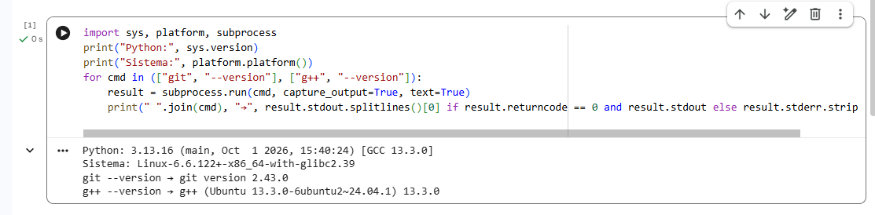
Figure E01. Google Colab environment details.
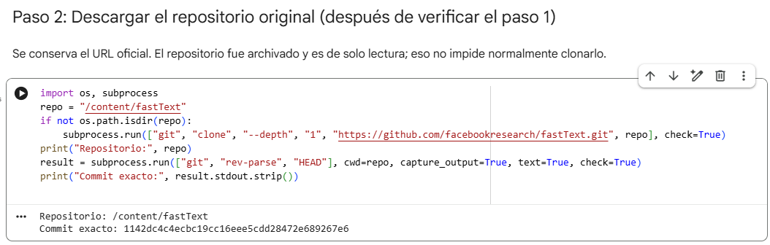
Figure E02. Cloning the authors’ repository and recording the commit.

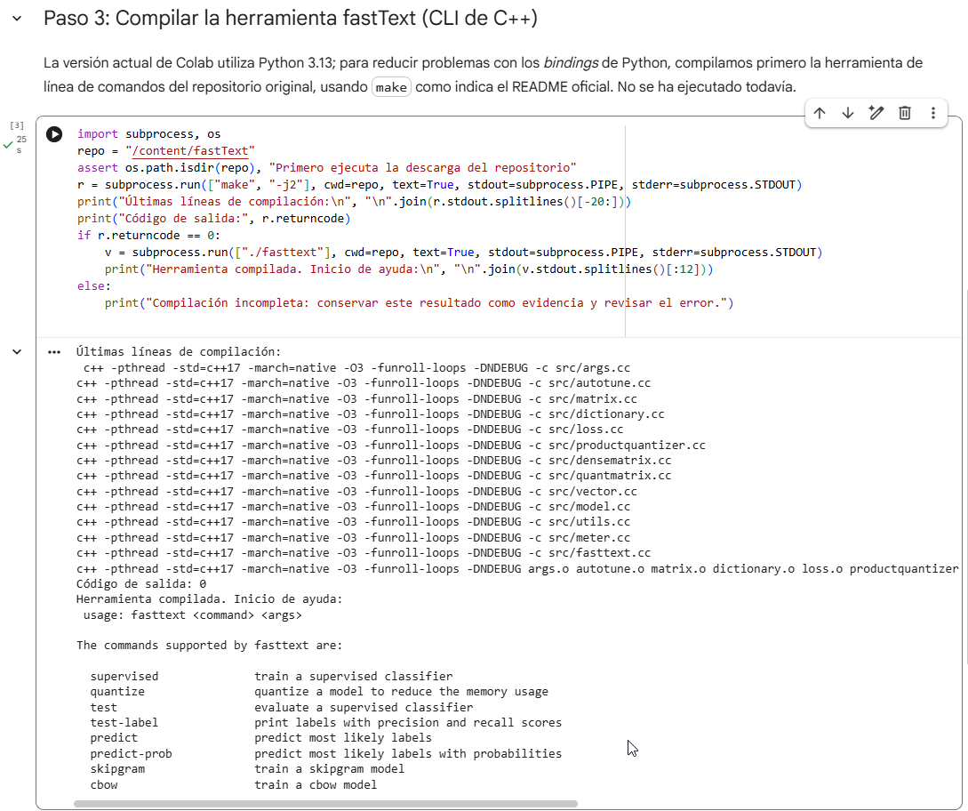
Figure E03. Compiling the fastText executable, exit code 0.

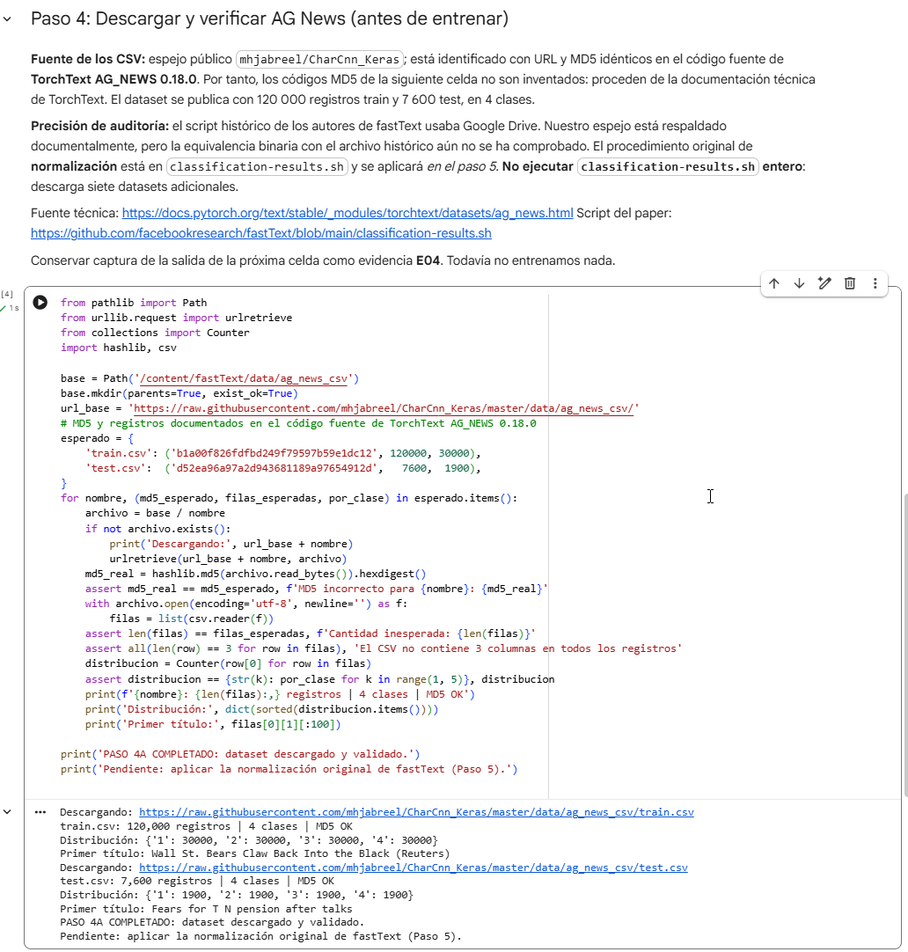
Figure E04. AG News dataset: MD5 integrity, sizes, and class distribution.

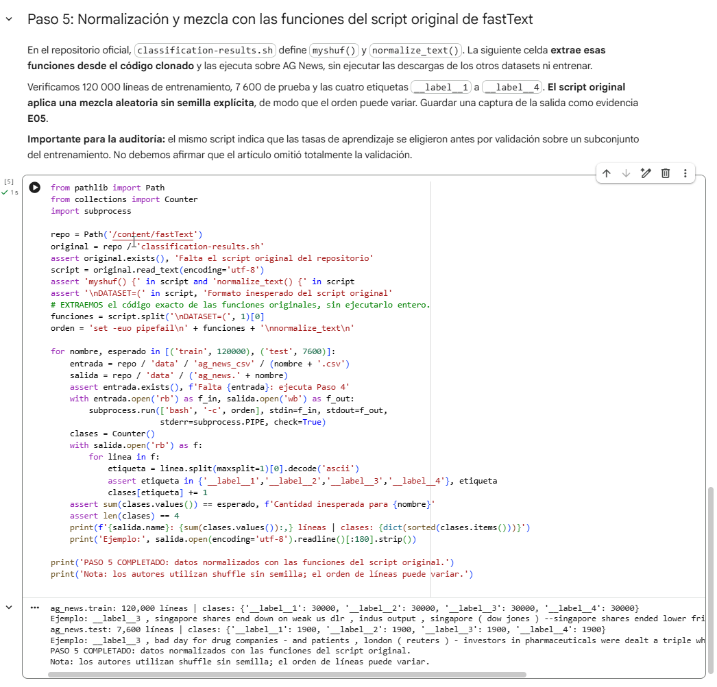
Figure E05. Preprocessing with functions from the authors’ script.

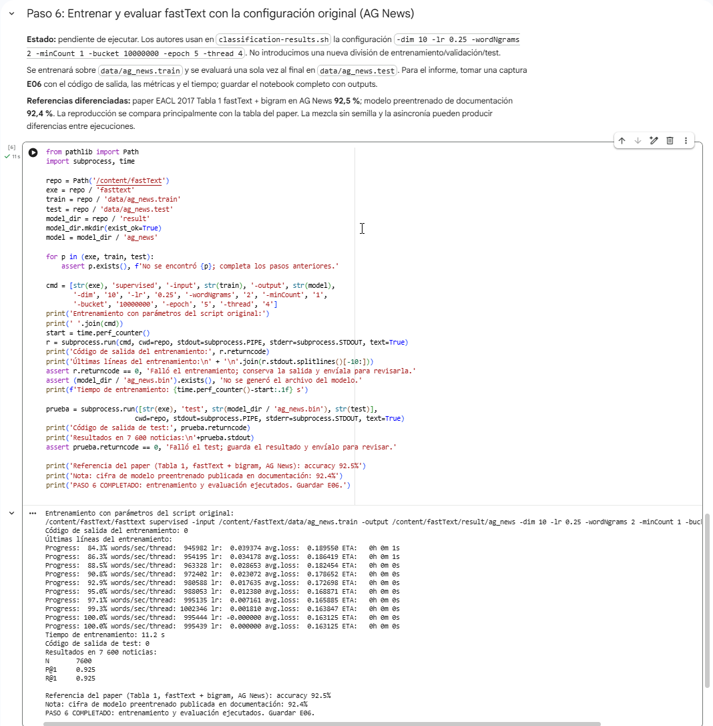
Figure E06. Training and testing output: P@1 = 0.925, N = 7,600.
E07. Original executed notebook: FastText_AGNews_Reproducibility_Audit.ipynb; SHA-256 ceeaf7a52f464a6b2d372c450ffddd36c6f19daa4e499b7a4d616ae959e47685.

