C Annex – R scripts

BOX C.1: Exploring data

Many tools exist for looking at data, but two of the most commonly used are Microsoft Excel and R. In terms of spatial data R can be used, but some spatial data can also be visualized using GIS packages such as QGIS.
In Excel the kind of plots shown in Figure An3.1 and Figure An3.2 are easily created using the Area plot functionality. To do this:
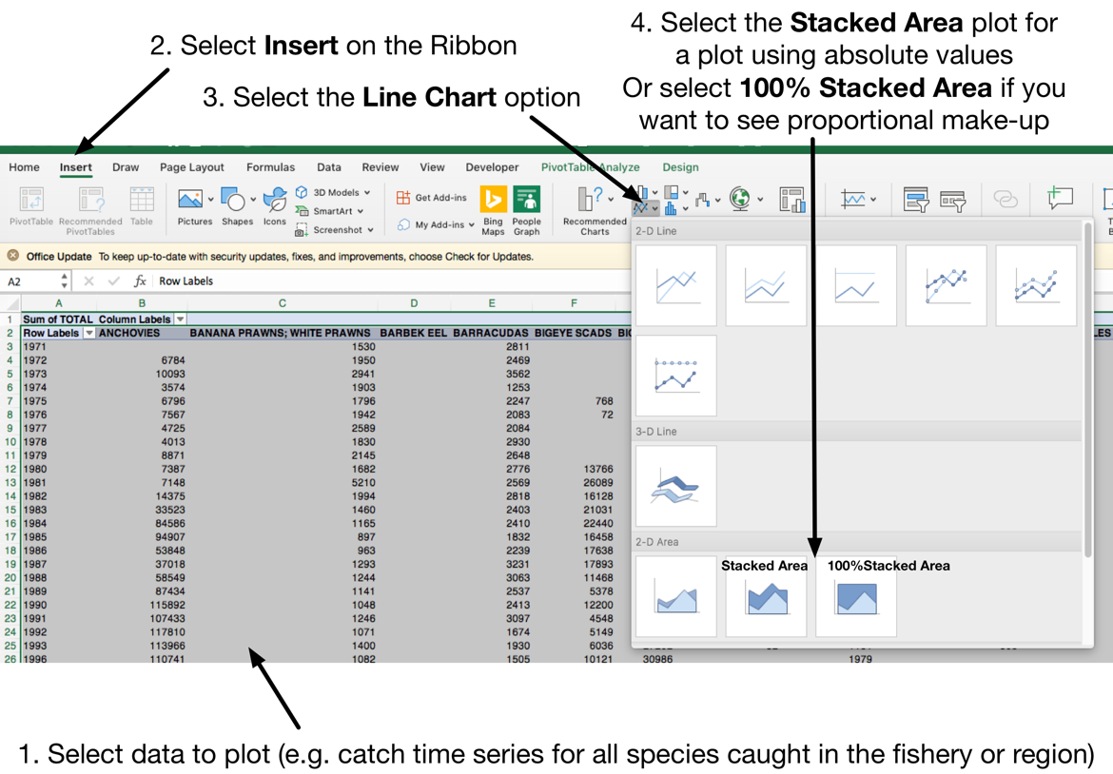
- Start with Data formatted like
Year | Column 1 | Column 2 | …. | Column X

where the columns are catch per species or effort per gear.

- Select the data to be plotted
- Insert an area plot by first selecting Insert Line Chart and then selecting the kind of Area plot desired as shown below.

R is a very versatile language for working with data, though it can require a little more effort than Excel for basic data presentation it does present more options for data exploration. We are assuming that anyone reading this section is relatively new to R and so we are providing simple scripts to show the steps needed to plot and work with data. There are however very many professional packages and sophisticated data handling approaches so we encourage the interested reader to look into what are the latest tools available. As you become more familiar with R you will likely consider these scripts simplistic, but they have the benefit of being relatively easy to follow, please feel free to tailor your own scripts to whatever you feel is the best approach.

To plot a stacked bar plot (essentially creating an area plot)
- Clean up the data space in R so that it is a fresh start. Then load in relevant libraries needed in processing the data
# Clean up the R space
rm(list=ls())

# Load Libraries
library(tidyverse)
library(devtools)
library(ggplot2)
library(RColourBrewer)

- Start with files formatted like
RawCatchData.csv
Year | Gear | Area | Species | Group | Yield

and
RawEffortData.csv
Year | Gear | Area | Effort

- Load the data. We have chosen to use read.table so that you can specify yourself whether you are using a true csv file with commas between the values in a row (comma delimited) or whether you are using a tab delimited. If you are sure you are using a true csv that is comma delimited then read.csv or read_csv is also a good choice.

GoTCatchData <-read.table("RawCatchData.csv", header=TRUE, sep = ",")
GoTEffortData <-read.table("RawEffortData.csv ", header=TRUE, sep = ",")

These loaded datasets are known as dataframes

- Summarise the data. To summarise the data pipe (%>%) the original data through a group_by(), which lists which variables (columns) to use when grouping the data, and then through summarise() which shows what actions to take. summarise() has a lot of useful functions (options) to choose from such as sum(), mean(), median(), min(), max(), quantile(), sd() which is the standard deviation and n() which is count. The format of the summarise90 call is
summarise( NewVariableName = function(DataColumnName))
You can do more than one thing at a time. For example
summarise( NewSum = sum(ColName), NewMean = mean(ColName))
As multiple R libraries have a summarise() function included, to avoid confusion some people like to make the call to the tidyverse (a useful R package for handling data) version by writing dplyr::summarise. So to summarise the catch and effort loaded in above we would use:

# Total catch per species per gear per year (i.e. sum over areas)
SumCatchSp <- RawCatchData %>%
group_by(Year, Gear, Species) %>%
dplyr::summarise(TotalYieldSp = sum(Yield))

# Total catch per gear per year (i.e. sum over areas and species)
SumCatchGear <- RawCatchData %>%
group_by(Year, Gear) %>%
dplyr::summarise(TotalYieldGear = sum(Yield), MeanYieldGear = mean(Yield), StdDevYieldGear = sd(Yield))
# Total catch per year (i.e. sum over areas, gears and species)
SumTotalCatch <- RawCatchData %>%
group_by(Year) %>%
dplyr::summarise(TotalYield = sum(Yield))

# Total effort per gear per year (i.e. sum over areas)
SumEffortGear <- RawCatchData %>%
group_by(Year, Gear) %>%
dplyr::summarise(TotalEffortGear = sum(Effort))

For large datasets with many species you may want to group the species based on the kinds of functional groups listed earlier (e.g. Demersal fish, Pelagic fish, Cephalopods etc). To do this you would summarise the data per Group instead of Species:

SumCatchGroup <- RawCatchData %>%
group_by(Year, Gear, Group) %>%
dplyr::summarise(TotalYieldGroup = sum(Yield))

- Do any simple data transformations that are necessary. For example to create a raw CPUE (literally catch divided by effort with no further standardisation)

SumCPUE <- merge(SumCatchGear, SumEffort, by=c("Year","Gear "))
SumCPUE$CPUE <- (SumCPUE$TotalYieldGear / SumCPUE$TotalEffortGear)

The first line merges the two data frames together into one – joining them based on Year (y) and Gear (g). The second line then calculates CPUE as
$${CPUE}_{y,g}= \frac{{Catch}_{y,g}}{{Effort}_{y,g}}$$

Also calculate the Coefficient of Variation (CV) for catch. Effort could be done in the same way
SumCatchGear$CV <- (SumCatchGear$StdDevYieldGear / SumCatchGear$MeanYieldGear) * 100.0

- Plot the results. A number of powerful plotting options exist in R. For demonstration purposes we have chosen to use ggplot2 but if you are more familiar with another approach please use that. In the examples below we have put in bold the things that differ between the different scripts

# First create a mapping of the gear names to use in the plots
GearLabel <- c("Name1", " Name2", " Name3", …. , " NameY")
gear_names <- as_labeller(c(`GearCode1` = "Name1", ` GearCode2` = "Name3", …. , `GearCodeY` = "NameY"))

# Plot total catch per species per year – one stacked on top of the other – Using the BrownGreen colour palette
colourCount = length(unique(SumCatchSp$Species)) # So that the colour key matches the number of species
ggplot(data = SumCatchSp, aes(x = Year, y = TotalYieldSp, fill = Species)) + # This says what data set to look at and then what to use as the x and y data
geom_bar(colour = "black", stat="identity", size = 0.1) + # This indicates it will be a bar plot with black line edge
scale_fill_manual(values = colourRampPalette(brewer.pal(12, "BrBG"))(colourCount)) + # This says what colour palette to use
theme_bw() + # This sets the background colour and axes format etc
labs(x="Years", y = "Tonnes", fill = "Species\n") + # This sets the axis and legend titles
theme(axis.text=element_text(size=16,face="bold"), axis.title=element_text(size=20,face="bold"),
legend.title=element_text(size=18,face="bold"), legend.text = element_text(size=16)) # Font sizes

# Plot total catch per group per year – one stacked on top of the other. If you prefer a true area plot use geom_area() instead of geom_bar()
colourCount = length(unique(SumCatchGroup$Group))
ggplot(data = SumCatchGroup, aes(x = Year, y = TotalYieldGroup, fill = Group)) +
geom_bar(colour = "black", stat="identity", size = 0.1) +
scale_fill_manual(values = colourRampPalette(brewer.pal(12, "BrBG"))(colourCount)) +
theme_bw() +
labs(x="Years", y = "Tonnes", fill = "Major Groups\n") +
theme(axis.text=element_text(size=16,face="bold"), axis.title=element_text(size=20,face="bold"),
legend.title=element_text(size=18,face="bold"), legend.text = element_text(size=16))

# Plot proportion of total catch per group per year
colourCount = length(unique(SumCatchGroup$Group))
ggplot(data = SumCatchGroup, aes(x = Year, y = TotalYieldGroup, fill = Group)) +
geom_bar(colour = "black", position="fill", stat="identity", size = 0.1) +
scale_fill_manual(values = colourRampPalette(brewer.pal(12, "BrBG"))(colourCount)) +
theme_bw() +
labs(x="Years", y = "Proportional catch composition", fill = "Major Groups\n") +

theme(axis.text=element_text(size=16,face="bold"), axis.title=element_text(size=20,face="bold"),
legend.title=element_text(size=18,face="bold"), legend.text = element_text(size=16))
# Plot total effort per gear per year (not a colourCount isn’t needed if the number of things being plotted (e.g. gears) is less than the default colour palette

ggplot(data = SumEffortGear, aes(x = Year, y = TotalEffortGear, fill = Gear)) +
geom_bar(colour = "black", stat="identity", size = 0.1) +
scale_fill_brewer(palette="PiYG" , labels = GearLabel) + # Using the PinkGreen colour palette and replacing codes with labels
theme_bw() +
labs(x="Years", y = "Effort", fill = "Major gears\n") +
theme(axis.text=element_text(size=16,face="bold"), axis.title=element_text(size=20,face="bold"),
legend.title=element_text(size=18,face="bold"), legend.text = element_text(size=16))

# Plot total effort per gear per year – with each gear plotted in it’s own small plot
ggplot(data = SumEffortGear, aes(x = Year, y = TotalEffortGear, fill = Gear)) +
geom_bar(colour = "black", stat="identity", size = 0.1) +
facet_wrap(Gear~., scales="free", ncol = 2, labeller = gear_names) + # So each gear is in own plot panel
scale_fill_brewer(palette="PiYG", labels = GearLabel) +

theme_bw() +
labs(x="Years", y = "Effort", fill = "Major gears\n") +
theme(axis.text=element_text(size=16,face="bold"), axis.title=element_text(size=20,face="bold"),
legend.title=element_text(size=18,face="bold"), legend.text = element_text(size=16))

# Plot total CPUE per year – Using the PurpleOrange colour palette
ggplot(data = SumCPUE, aes(x = Year, y = CPUE, fill = Gear)) +
geom_bar(colour = "black", stat="identity", size = 0.1) +
scale_fill_brewer(palette="PuOr", labels = GearLabel) +
theme_bw() +
labs(x="Years", y = "CPUE", fill = "Major gears\n") +
theme(axis.text=element_text(size=16,face="bold"), axis.title=element_text(size=20,face="bold"),
legend.title=element_text(size=18,face="bold"), legend.text = element_text(size=16))

# Plot CV of catch per gear per year – Using a manually defined colour palette
manual_palette <- c("#551A8B", "#8968CD", "#AB82FF", "#FF8C00", "#CD6600", "#8B4500")
ggplot(data = SumCatchGear, aes(x = Year, y = CV, colour = Gear)) + geom_line() +
facet_wrap(Gear~., scales="free", ncol = 2, labeller = gear_names) +

scale_colour_manual(values=manual_palette, name="Gear") +
theme_bw() + labs(x="Years", y = "CV of Catch") + ylim(0, 650) + # ylim lets you set the limits of the y axis
theme(axis.text=element_text(size=16,face="bold"), axis.title=element_text(size=20,face="bold"),
legend.title=element_text(size=18,face="bold"), legend.text = element_text(size=16))

Note that if you want to print to a file rather than to the screen use the plotting commands above but with these extra couple of lines of script (in bold):
colourCount = length(unique(SumCatchSp$Species)).
png('Total_Catch_Per_SpeciesGroup.png', 1200, 800)
ggplot(data = SumCatchSp, aes(x = Year, y = TotalYieldSp, fill = Species)) +
geom_bar(colour = "black", stat="identity", size = 0.1) +
scale_fill_manual(values = colourRampPalette(brewer.pal(12, "BrBG"))(colourCount)) + theme_bw() +
labs(x="Years", y = "Tonnes") +
theme(axis.text=element_text(size=16,face="bold"), axis.title=element_text(size=20,face="bold"),
legend.title=element_text(size=18,face="bold"), legend.text = element_text(size=16))

dev.off()

BOX C.2: Cluster analyses

This R script allows you to run simple cluster analyses of the form shown in the main txt.
# Clean up the R space
rm(list=ls())

# Load Libraries
library(tidyverse)
library(devtools)
library(ggplot2)
library(RColourBrewer)
library(factoextra)
library (FactoMineR)
library(corrplot)
library(ape)

First start by loading in catch data with years as the columns and species as the rows.
# Load data from csv file
YR_as_col <- read.table(‘CatchDataFile.csv',sep=",",header=T,row.names=1)

Then perform the clustering

# Clustering using Euclidean distance measure and the Ward Hierarchical cluster approach.
# Look up hclust to see what other clustering options are available.
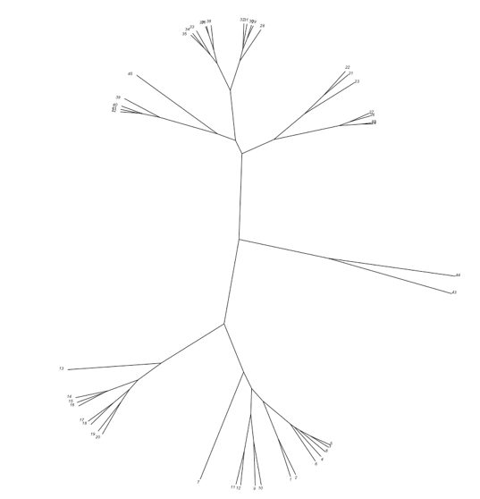
dd <- dist(scale(YR_as_col), method = "euclidean")
hc <- hclust(dd, method = "ward.D2")
# Plot the dendrogram – this one flows down the page
plot(hc, hang = -1, cex = 0.6) # Put the labels at the same height: hang = -1

# To plot flowing across the page use
hcd <- as.dendrogram(hc)
nodePar <- list(lab.cex = 0.6, pch = c(NA, 19), cex = 0.7, col = "blue")
par(cex=0.5) # Customized plot; remove labels
plot(hcd, xlab = "Height", nodePar = nodePar, horiz = TRUE)

# You can also plot unrooted ones that flow as branches across the page
plot(as.phylo(hc), type = "unrooted", cex = 0.6, no.margin = TRUE)

# Lastly you can plot it as a circular arc or fan
par(cex=0.8)
plot(as.phylo(hc), type = "fan")
colours = c("red", "blue", "green", "black", "yellow", "purple", "grey", "brown", "magenta", "cyan", "violetred", "tomato")
clus = cutree(hc, 12) # Identify the clusters based on cutting the tree at a specific height
plot(as.phylo(hc), type = "fan", tip.colour = colours[clus],label.offset = 1, cex = 0.7). # Colour the names of each tip based on the clusters formed

BOX C.3: Principal component analyses

This R script allows you to reproduce the kind of PCA analysis discussed in the main text

# Start by preparing the R space
rm(list=ls())

## Libraries
# Data handling and table reshaping

library(tidyverse)
library(reshape2)
library(devtools)
# Plotting
library(ggplot2)
library(RColourBrewer)
library(ggbiplot)
library("plot3D")
library(plotly)
# PCA and Clustering
library(factoextra)
library (FactoMineR)
library(corrplot)
library(ape)

# Set up data for PCA – with Year as rows and columns as species
CatchData <-read.table("CatchData.csv", header=TRUE, sep = ",")

DataSum <- CatchData %>%
group_by(Year, PCA_CLASSIF) %>%
dplyr::summarise(TotalYield = sum(Yield))
SP_as_col <- dcast(DataSum, Year ~ PCA_CLASSIF, value.var = "TotalYieldGrp", fill = 0)

# PCA calculations - using spectral decomposition approach via the princomp approach
# Create string of column names to tell function which columns to use in the analysis
dimC <- dim(SP_as_col)
pc.f <- formula(paste("~", paste(names(SP_as_col)[2:dimC[2]], collapse = "+")))

# PCA calculations - using spectral decomposition approach via the princomp approach
pl.pca <- princomp(pc.f, cor=TRUE, data=SP_as_col)

# Print out PCA loadings
pl.pca$loadings

# Print PCA summary – showing variance explained
summary(pl.pca)

# If you would rather use singular value decomposition instead for the PCA then the command is
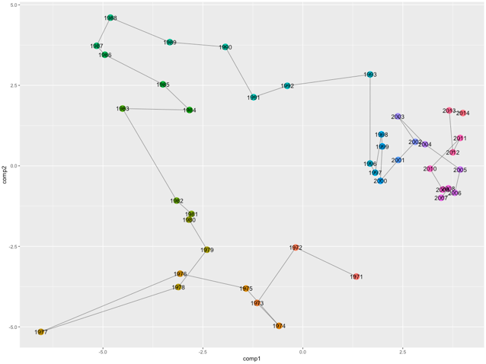
pl.pca <- prcomp(SP_as_col, scale = TRUE)

# Regardless of the method used plot the variance explained
fviz_eig(pl.pca)

## Create a plot of the PCA space – 2D
PoV <- pl.pca$sdev^2/sum(pl.pca$sdev^2) # Variance explained (so can put it on the axis labels)

# Sort labels to put on the plot
row.names(pl.pca$scores) <- SP_as_col$Year
pcx <- pl.pca$scores[,1]
pcy <- pl.pca$scores[,2]
pcz <- pl.pca$scores[,3]
pcxlab <- paste("PC1 (", round(PoV[1] * 100, 2), "%)")
pcylab <- paste("PC2 (", round(PoV[2] * 100, 2), "%)")
pczlab <- paste("PC3 (", round(PoV[3] * 100, 2), "%)")

# Plot the results
df <- data.frame(comp1=pl.pca$scores[,1], comp2=pl.pca$scores[,2])
ggplot(data = df, aes(x=comp1, y=comp2, group=1)) +
geom_point(size=5, aes(colour=rownames(pl.pca$scores))) +
geom_path(size = 0.2) +
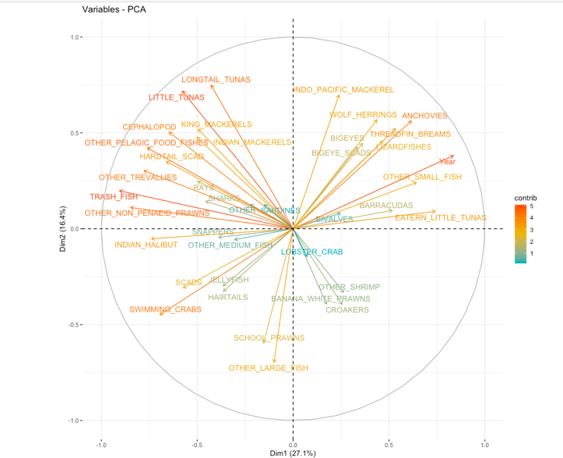
geom_text(label=rownames(pl.pca$scores)) +
theme(legend.position="none")

# An alternative way of making a plot of the 2D space is
fviz_pca_ind(pl.pca,
col.ind = "contrib", # Colour by congtribution
gradient.cols = c("#00AFBB", "#E7B800", "#FC4E07"),
repel = TRUE, # Avoid text overlapping
#label=SP_as_col$Year
) + labs(title ="PCA", x = "PC1", y = "PC2")

# To put the vectors of the variables on to the biplot

fviz_pca_var(pl.pca,
col.var = "contrib", # Colour by contributions to the PC
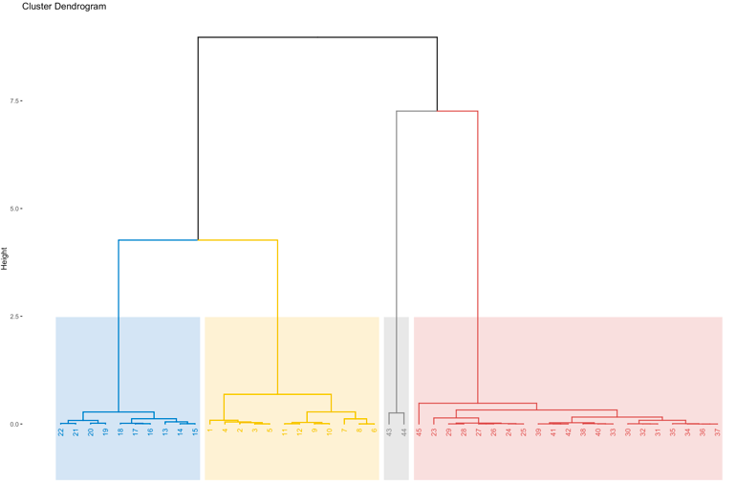
gradient.cols = c("#00AFBB", "#E7B800", "#FC4E07"),
repel = TRUE # Avoid text overlapping
)

# Compute hierarchical clustering on principal components
res.pca <- PCA(SP_as_col, ncp = 3, graph = FALSE)
res.hcpc <- HCPC(res.pca, graph = FALSE)

# Plot the resulting dendrogram
fviz_dend(res.hcpc,
cex = 0.7, # Label size
palette = "jco", # Colour palette see ?ggpubr::ggpar
rect = TRUE, rect_fill = TRUE, # Add rectangle around groups
rect_border = "jco", # Rectangle colour
labels_track_height = 0.8 # Augment the room for labels
)
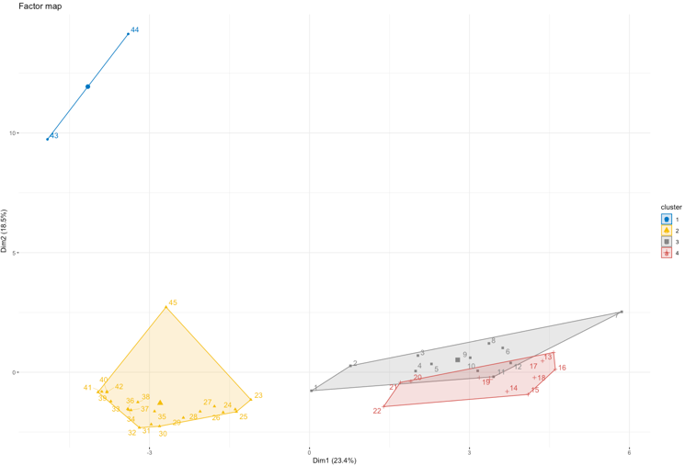
# Now replot the PCA space with those clusters marked
fviz_cluster(res.hcpc,
repel = TRUE, # Avoid label overlapping
show.clust.cent = TRUE, # Show cluster centers
palette = "jco", # Colour palette see ?ggpubr::ggpar
ggtheme = theme_minimal(),
main = "Factor map"
)

## Create a plot of the PCA space – 3D
# Plot simply as points in 3D space
scatter3D(pcx, pcy, pcz, bty = "g", pch = 20, cex = 2,
col = gg.col(100), theta = 150, phi = 0, main = "PCA Scores", xlab = pcxlab,
ylab =pcylab, zlab = pczlab)
text3D(pcx, pcy, pcz, labels = rownames(pl.pca$scores), add = TRUE, colkey = FALSE, cex = 0.7)

# 3D plot with connected line showing path through time
scatter3D(pcx, pcy, pcz, bty = "g", type = "b", pch = 20, cex = 2,
col = gg.col(100), theta = 150, phi = 0, lwd = 4, main = "PCA Scores", xlab = pcxlab,
ylab =pcylab, zlab = pczlab)
text3D(pcx, pcy, pcz, labels = rownames(pl.pca$scores), add = TRUE, colkey = FALSE, cex = 0.7)

# Plot3D with plotly
# Which allows interaction with the plot, you can spin it, zoom and hover over data points and see the associated data values)
manual_palette <- c("#551A8B", "#8968CD", "#AB82FF", "#FF8C00", "#CD6600", "#8B4500")
df3D <- data.frame(comp1=pl.pca$scores[,1],
comp2=pl.pca$scores[,2],
comp3=pl.pca$scores[,3])
fig <- plot_ly(df3D, x = ~comp1, y = ~comp2, z = ~comp3, colour = ~comp3, mode = 'lines+markers',
# Hover text:
text = ~rownames(pl.pca$scores))
fig <- fig %>% add_markers()
fig <- fig %>% add_text(textposition = "top right")
fig <- fig %>% layout(scene = list(xaxis = list(title = pcxlab),

yaxis = list(title = pcylab),
zaxis = list(title = pczlab)),
annotations = list(
x = 1.13,
y = 1.05,
text = 'PC3 Score',
showarrow = FALSE
))
fig # Plot the final figure

## Correlation analysis
M <-cor(SP_as_col, method="pearson") # For Pearson correlation
M <-cor(SP_as_col, method="spearman") # For Spearman correlation

# Plot resulting correlations
corrplot(M, type="upper", order="hclust", col=brewer.pal(n=8, name="RdYlBu"), tl.col="black", tl.cex=0.4)

D References used in the Technical guidance

Ainsworth, C. H. 2011. Quantifying Species Abundance Trends in the Northern Gulf of California Using Local Ecological Knowledge. Marine and Coastal Fisheries, 3, 190-218.
Anh, P. V., Laender, F. D., Everaert, G., Vinh, C. T. & Goethals, P. 2014. An integrated food web model to test the impact of fisheries management scenarios on the coastal ecosystem of Vietnam. Ocean & Coastal Management, 92, 74--86.
Ainsworth, C. H. & Walters, C. J. 2015. Ten common mistakes made in Ecopath with Ecosim modelling. Ecological Modelling, 308, 14-17.
Banse, K. & Mosher, S. 1980. Adult Body Mass and Annual Production/Biomass Relationships of Field Populations. Ecological Monographs, 50, 355-379.
Bates, D., McHler, M., Bolker, B. & Walker, S. 2015. Fitting Linear Mixed-Effects Models Usinglme4. Journal of Statistical Software, 67.
Blueweiss, L., Fox, H., Kudzma, V., Nakashima, D., Peters, R. & Sams, S. 1978. Relationships between body size and some life history parameters. Oecologia, 37, 257-272.
Branch, T. A., Watson, R., Fulton, E., Jennings, S., McGilliard, C. R., Pablico, G. T., Ricard, D. & Tracey, S. R. 2010. The trophic fingerprint of marine fisheries. Nature, 468, 431-435.
Briton, F., Shannon, L., Barrier, N., Verley, P. & Shin, Y.-J. 2019. Reference levels of ecosystem indicators at multispecies maximum sustainable yield. ICES Journal of Marine Science, 76, 2070-2081.
Cobb, C. W. & Douglas, P. H. 1928. A theory of production. The American Economic Review, 18, 139-165.
Christensen, V. 1992. Network analysis of trophic interactions in aquatic ecosystems. Copenhagen, Denmark. Copenhagen, Denmark.
SEAFDEC 2005. Handbook on Collecting Fishery Statistics for Inland and Coastal Fisheries, Southeast Asian Fisheries Development Center.
Gao, J., Barzel, B. & Barabsi, A.-L. 2016. Universal resilience patterns in complex networks. Nature, 530, 307-312.
Garcia, S. M., Kolding, J., Rice, J., Rochet, M. J., Zhou, S., Arimoto, T., Beyer, J. E., Borges, L., Bundy, A., Dunn, D., Fulton, E., Hall, M., Heino, M., Law, R., Makino, M., Rijnsdorp, A. D., Simard, F. & Smith, A. D. M. 2012. Reconsidering the consequences of selective fisheries. Science, 335, 1045-1047.
Hilborn, R. & Walters, C. J. 1992. Quantitative Fisheries Stock Assessment: Choice, Dynamics and Uncertainty, New York/London, Chapman and Hall.
Iverson, R. L. 1990. Control of marine fish production. Limnology and Oceanography, 35, 1593-1604.
Heymans, J. J., Coll, M., Link, J. S., Mackinson, S., Steenbeek, J., Walters, C. & Christensen, V. 2016. Best practice in Ecopath with Ecosim food-web models for ecosystem-based management. Ecological Modelling, 331, 173-184.
Link, J. S. 2010. Adding rigor to ecological network models by evaluating a set of pre-balance diagnostics: A plea for PREBAL. Ecological Modelling, 221, 1580-1591.
Link, J. S. 2018. System-level optimal yield: increased value, less risk, improved stability, and better fisheries. Canadian Journal of Fisheries and Aquatic Sciences, 75, 1-16.
Link, J. S. & Watson, R. A. 2019. Global ecosystem overfishing: Clear delineation within real limits to production. Science Advances, 5, eaav0474.
Marquet, P. A., Quiñones, R. A., Abades, S., Labra, F., Tognelli, M., Arim, M. & Rivadeneira, M. 2005. Scaling and power-laws in ecological systems. Journal of Experimental Biology, 208, 1749-1769.
Moiseev, P. A. 1994. Present fish productivity and bioproduction potential of the world aquatic habitats, Rome, Food and Agriculture Organization of the United Nations.
Olsen, E., Fay, G., Gaichas, S., Gamble, R., Lucey, S. & Link, J. S. 2016. Ecosystem model skill assessment. Yes We Can! PLoS ONE, 11, 1-24.
Polacheck, T., Hilborn, R. & Punt, A. E. 1993. Fitting surplus production models: comparing methods and measuring uncertainty. Canadian Journal of Fisheries and Aquatic Sciences, 50, 2597-2607.
Phoonsawat, R., Supongpan, M. & Christensen, V. 2009. Introducing ecosystem-based management in the Gulf of Thailand. IRD Project no. 003711
Punt, A. E. 1990. Is B1 = K an appropriate assumption when applying an observation error production-model estimator to catch-effort data. South African Journal of Marine Science, 9, 249-259.
Punt, A. E. & Szuwalski, C. 2012. How well can FMSY and BMSY be estimated using empirical measures of surplus production? Fisheries Research, 134-136, 113-124.
Rice, J. C. 2005. Implementation of the Ecosystem Approach to Fisheries Management - asynchronous co-evolution at the interface between science and policy. Marine Ecology Progress Series, 300, 265-270.
Rousseau, Y., Watson, R. A., Blanchard, J. L. & Fulton, E. A. 2019. Evolution of global marine fishing fleets and the response of fished resources. Proceedings of the National Academy of Sciences, 116, 12238-12243.
Ryther, J. H. 1969. Photosynthesis and Fish Production in the Sea. Science, 166, 72-76.
Shannon, L., Coll, M., Bundy, A., Gascuel, D., Heymans, J. J., Kleisner, K., Lynam, C. P., Piroddi, C., Tam, J., Travers-Trolet, M. & Shin, Y. 2014. Trophic level-based indicators to track fishing impacts across marine ecosystems. Marine Ecology Progress Series, 512, 115-140.
Stow, C.A., Jolliff, J., McGillicuddy, D.J. Jr., Doney, S.C., Allen, J.I., Friedrichs, M.A.M., Rose, K.A. & Wallhead, P. 2009. Skill assessment for coupled biological/physical models of marine systems. Journal of Marine Systems, 76: 4–15.
Worm, B., Hilborn, R., Baum, J., Branch, T., Collie, J., Costello, C., Fogarty, M., Fulton, E., Hutchings, J., Jennings, S., Jensen, O., Lotze, H., Mace, P., McClanahan, T., Minto, C., Palumbi, S., Parma, A., Ricard, D., Rosenberg, A., Watson, R. & Zeller, D. 2009. Rebuilding global fisheries. Science, 325, 578-585.

