Midi Control Surface Client

As of ARStudio v. 3.6.2, control surface support has been modified to make use of the Mackie HUI and Mackie Control protocol. This has been tested with the Behringer BCF2000 operating in Baby HUI emulation mode, with the Behringer X-Touch Compact operating in Mackie Control emulation mode, and with the Behringer X-Touch Mini also operating in Mackie Control emulation mode.

This is what the control layout looks like on the BCF2000:

This is what the control layout looks like on the X-Touch Compact:

This is what the control layout looks like on the X-Touch Mini:
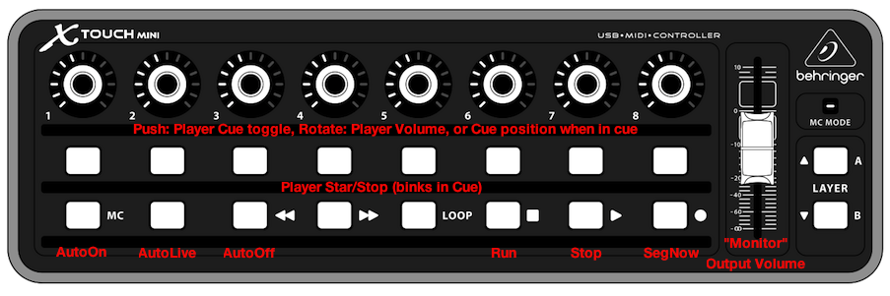
In ARStudio preferences, select the Control Surface Tab and select the midi in and midi out ports which the control surface is connected through, enter the midi channel to used, and click Apply. All done. The control surface will spring to life.

NOTE: The old custom configuration for the BCF2000, which required a sysex upload to configure the control surface, has been eliminated from ARStudio. Select "BCF2000 (Baby HUI mode)" from the ARStudio control surface list and make sure the BCF2000 is powered up in Baby HUI emulation mode. See the BCF2000 users manual for details on placing the unit in various emulation modes.

© 2006 - 2019 Ethan Funk

