# **Onpage Audit - http://daebelectronics.com.au/**

1. Why Company logo saying “**DaebElectrical**” and domain **daebelectronics**.com.au
2. Remove Canonical Issue – Website opening with and without **www**

**daebelectronics.com.au**

**www.daebelectronics.com.au**

1. ChangeImage Alt for Company Logo to “Daeb Electrical”



1. Company logo is linked with <http://daebelectronics.com.au/index.php?route=common/home>

Need to replace this link with <http://daebelectronics.com.au/>

1. “Store Location” and “Contact Us” in Top of the page is landing into same page. <http://daebelectronics.com.au/index.php?route=information/contact>

Can we have a **“Help”**link on Top with some general faqs.

See this site <http://www.dicksmith.com.au/help-centre>

1. Can we have “Track My Order” Link on Top of the page
2. Newsletter submit button is not working



1. All links in footer should link with relavent with pages



1. All 3 Homepage banner links are going into into not found, should link with related product pages.
2. SMO Icon should be linked with related social media pages.
3. Why all main category pages are black. Eg - <http://daebelectronics.com.au/index.php?route=product/category&path=9>

* Either we can add list all sub category products in this page. Eg - <http://www.dicksmith.com.au/audio-mp3>
* Or all main categories links land into their respective 1st sub category pages.

1. Integrate Thank you Page with Contact us form
2. All internal pages have Dynamic URL. We need to rewrite urls according to products in order to make urls search engine friendly and to increase click thru rates.
3. In every click we can see **1 new product**is coming into display that should change with**4 new set of products**. For reference see these sites<http://www.amazon.com/> or <http://www.flipkart.com/>

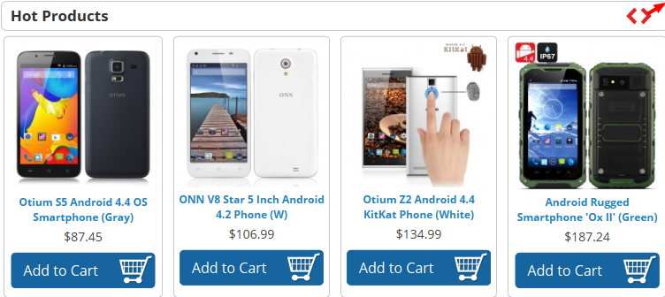

Same with other 2 product showcase.

1. This section contains dummy text in homepage.



1. Fix W3C validations

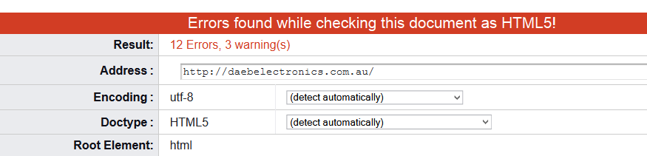

1. We can Add Feedback section into homepage. For reference - <http://www.flipkart.com/>
2. On Product Pages – whenever a user click on “Write a Review” link, should land into login page in order to login and write a review.
3. Address needs to be updated into this page <http://daebelectronics.com.au/index.php?route=information/contact>
4. Map also needs to be updated according to Address in this page

<http://daebelectronics.com.au/index.php?route=information/contact>

1. All Product images are blur in product pages except first one Check this <http://daebelectronics.com.au/index.php?route=product/product&path=9_10&product_id=15781&sort=p.model&order=ASC>
2. Robots.txt and sitemap.xml files are missing.
3. Need to add customized 404 error page.
4. Website load time is slow on mobile view
5. Website needs to beoptimized for mobile visitors.