- when I go to Specialist Management (the left menu) and I click on Specialist List, I get this
You Have No Permission! Back to Dashboard
http://agileradiology.com/admin/user/user_list
why?
also the file type management!
I get the same error
I have some restriction, I can not upload image
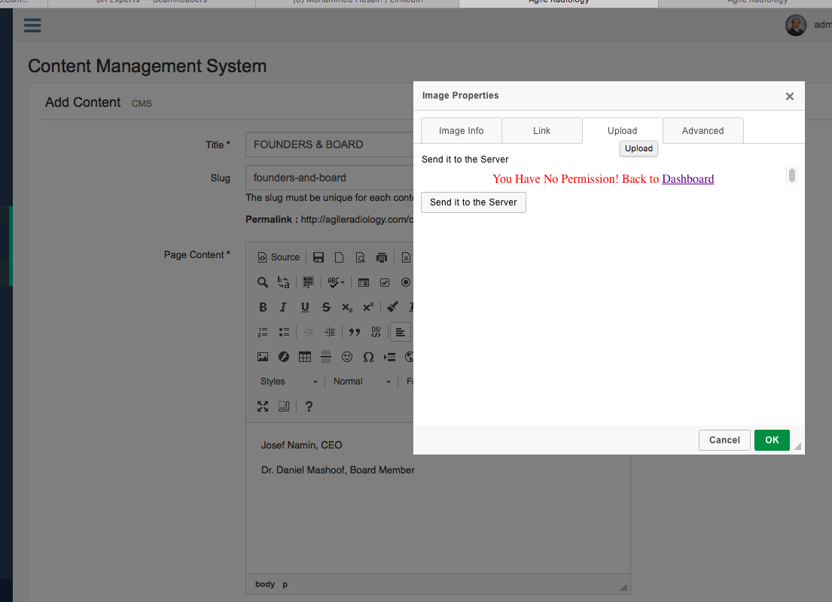
I need to enter my image there

I am also trying to embed a video clip and I can not
<iframe width="560" height="315" src="https://www.youtube.com/embed/0pM0sc9xroM?ecver=1" frameborder="0" allowfullscreen></iframe>

I tried to put it at the beginning of Overview page, and I clicked on Source and then pasted this but not working, how can I embed a video?
Solution Of issues
- All Permission issues are fixed.
- Image upload technique :

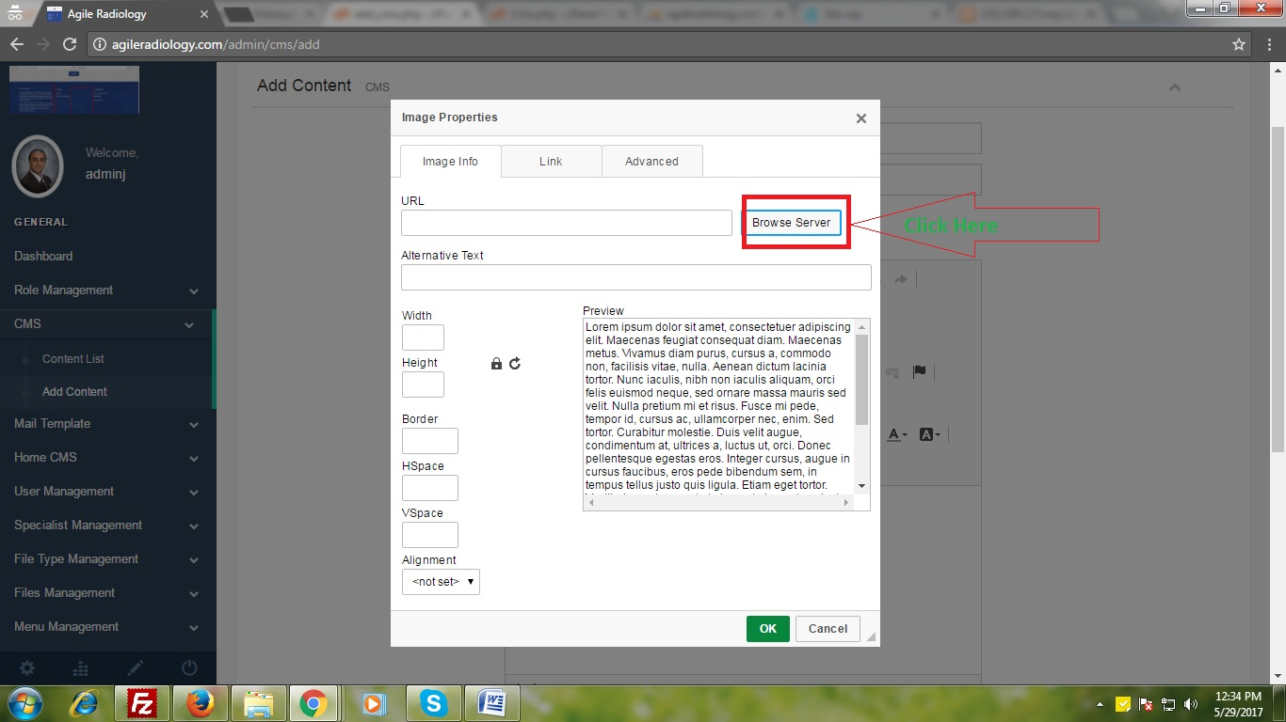

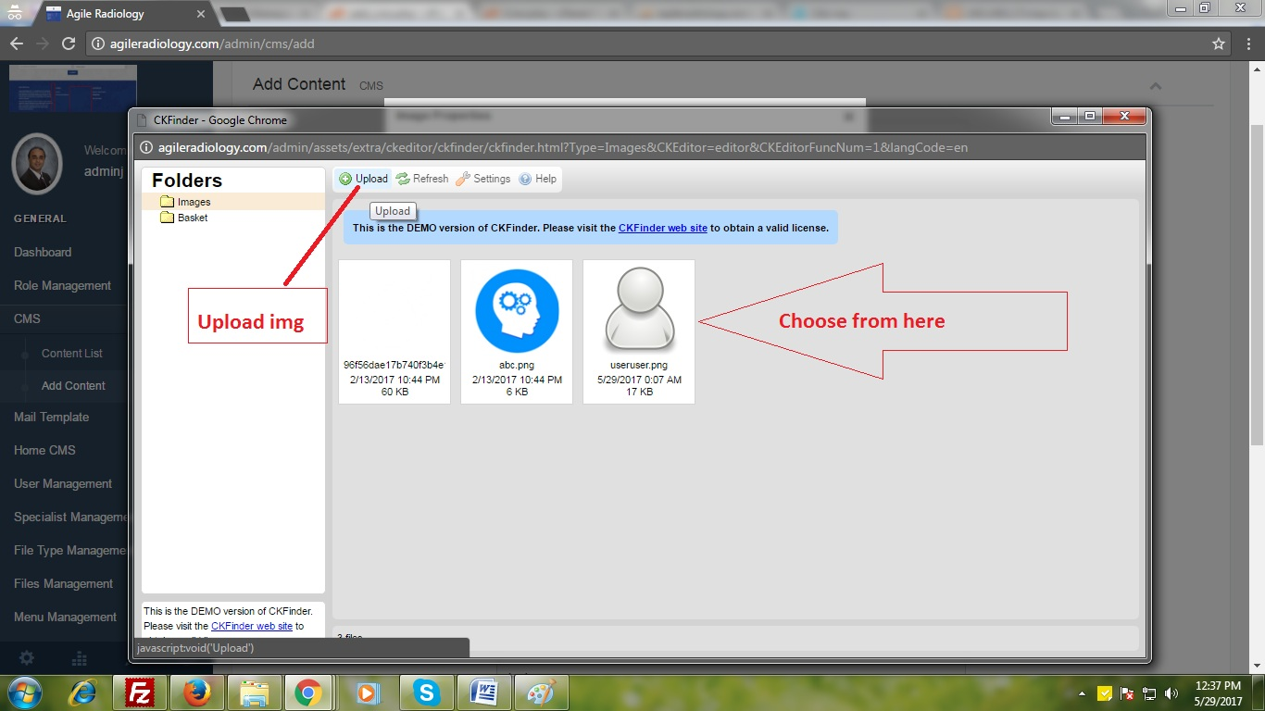
- Plesae change after pasting video url or iframe (before iframe start <p> tag into <div> and after close of iframe tag </p> tag into </div>)
