1.修改link.lds

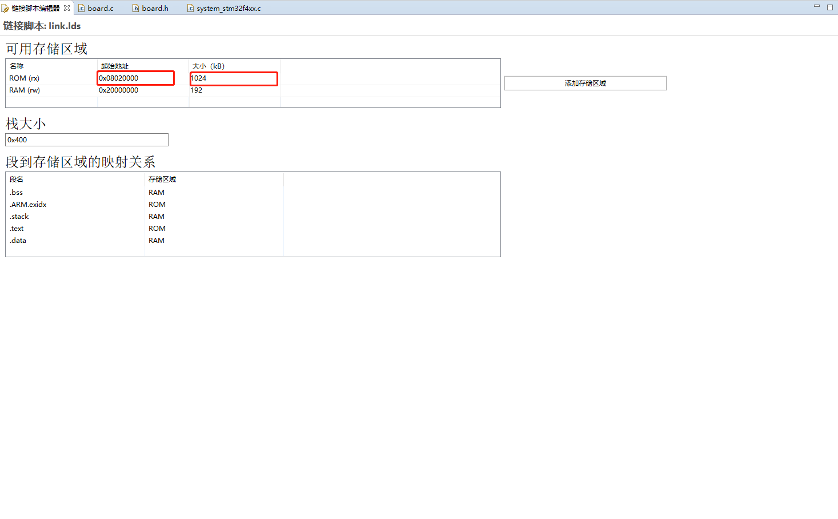

2.在board.c文件下增加代码

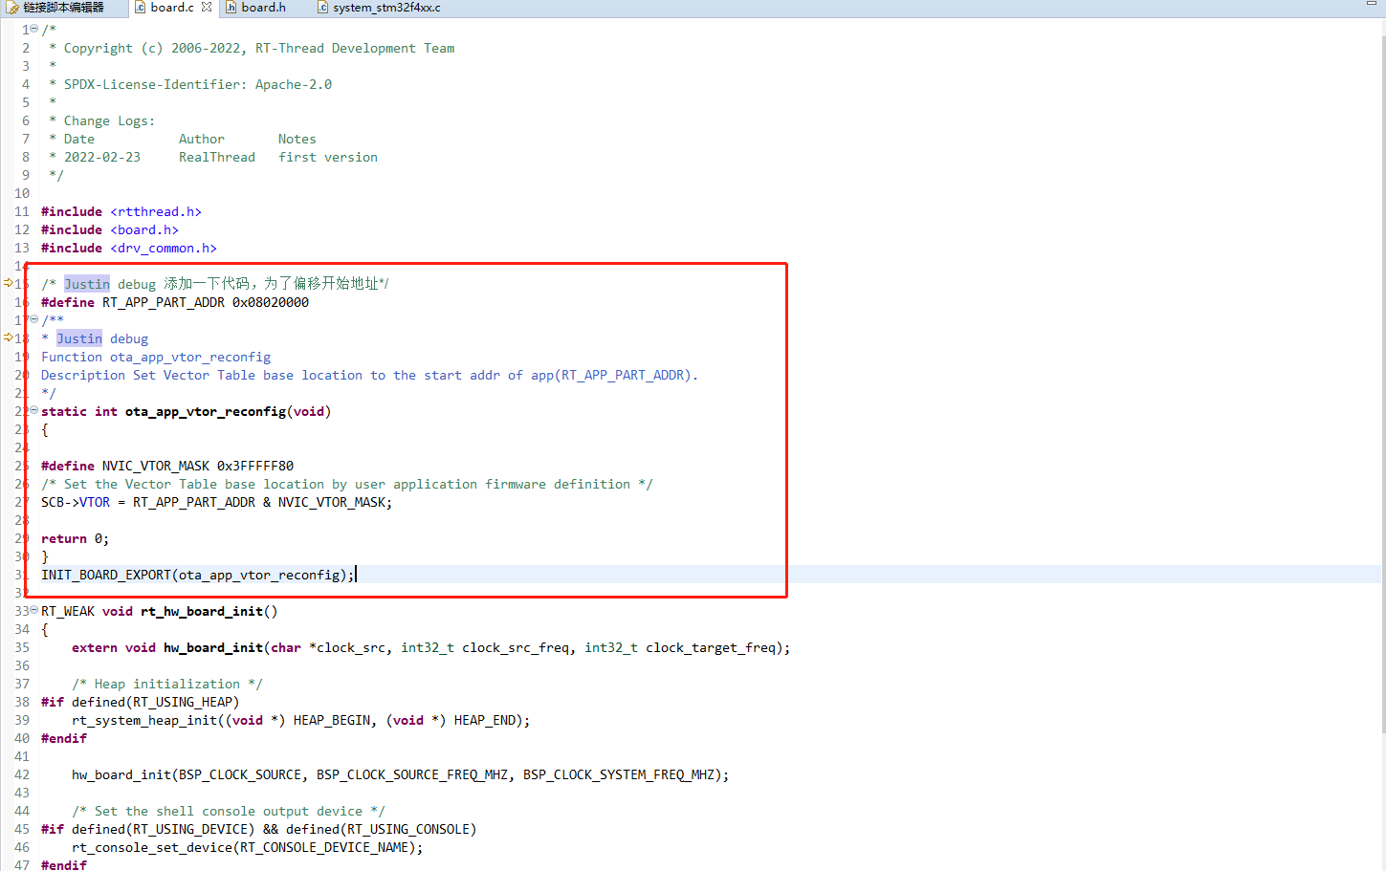

/* Justin debug 添加一下代码，为了偏移开始地址*/

**#define** RT_APP_PART_ADDR 0x08020000

/**

* Justin debug

Function ota_app_vtor_reconfig

Description Set Vector Table base location to the start addr of app(RT_APP_PART_ADDR).

*/

**static** **int** **ota_app_vtor_reconfig**(**void**)

{

**#define** NVIC_VTOR_MASK 0x3FFFFF80

/* Set the Vector Table base location by user application firmware definition */

SCB->VTOR = RT_APP_PART_ADDR & NVIC_VTOR_MASK;

**return** 0;

}

INIT_BOARD_EXPORT(ota_app_vtor_reconfig);

3.修改board.h

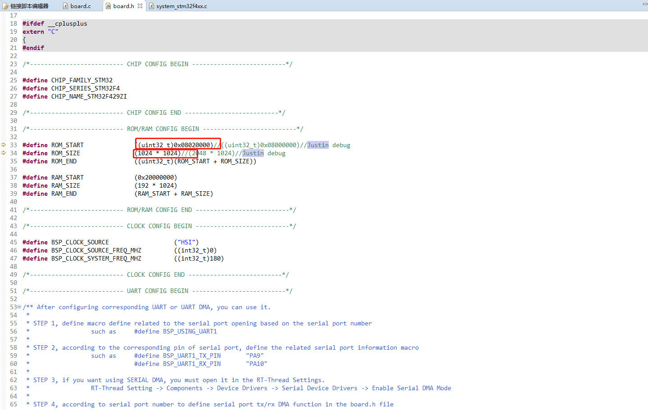

4.修改system_stm32f4xx.c

