The Experiment Report of Machine Learning



December 14, 2017

Grade:

 Undergraduate

Student ID：

201720144993

Supervisor:

Qingyao Wu

Author:

Shaojia hong

**SUBJECT:**SOFTWARE ENGINEERING

**SCHOOL:** SCHOOL OF SOFTWARE ENGINEERING

[1]

Linear Regression, Linear Classiﬁcation and Gradient Descent

Abstract—The experiment is to further understand of linear regression and linear classification and gradient descent.

# INTRODUCTION

## Linear Regression

Linear regression describes the linear relationship between a predictor variable, plotted on the x-axis, and a response variable,plotted on the y-axis,the target is to learn a hypothesis or model f : X  Y and we should to get the best model f.

## Linear Classification

Linear Classification is a Classification that given training data (xi, yi) for i = 1 . . . n, with ∈ and  ∈ {−1, 1}, learn a classfier f(x) such that  and  for a correct classification.and we should get the best classfier f(x).

In order to further understand of linear regression,linear classification and gradient descent.we do some experiments under small scale data set. And to realize the process of optimization and adjusting parameters.

# METHODS AND THEORY

## Linear Regression

### Experimental environment

Python3 and at least the following Python packages are included such as [sklearn](http://scikit-learn.org/stable/" \t "https://www.zybuluo.com/chenyaofo/note/_blank)，[numpy](http://www.numpy.org/" \t "https://www.zybuluo.com/chenyaofo/note/_blank)，[jupyter](http://jupyter.org/" \t "https://www.zybuluo.com/chenyaofo/note/_blank)，[matplotlib](https://matplotlib.org/" \t "https://www.zybuluo.com/chenyaofo/note/_blank).

It is recommended to install anaconda3 directly, which has built in the above Python packages.The experimental code and drawing are all done on jupyter.

### Steps

The step of Linear regression and gradient Descent：

1. Load the experiment data. You can use load_svmlight_file  function in sklearn library.
2. Devide dataset. You should divide dataset into training set and validation set using train_test_split function. Test set is not required in this experiment.
3. Initialize linear model parameters. You can choose to set all parameter into zero, initialize it randomly or with normal distribution.
4. Choose loss function and derivation: Find more detail in PPT.
5. Calculate gradient G toward loss function from all samples.
6. Denote the opposite direction of gradient  G as D.
7. Update model:  W= W+η*D,η is learning rate, a hyper-parameter that we can adjust.
8. Get the loss L_train under the training set and  L_validation by validating under validation set.
9. Repeated step 5 to 8 for several times, and drawing graph of  L_train as well as  L_validation with the number of iterations.

### Formula

Target function is that



Loss function is that



we use these two formula to update w and find the best w to minimize the J

## Linear Classification

### Experimental environment

Python3 and at least the following Python packages are included such as [sklearn](http://scikit-learn.org/stable/" \t "https://www.zybuluo.com/chenyaofo/note/_blank)，[numpy](http://www.numpy.org/" \t "https://www.zybuluo.com/chenyaofo/note/_blank)，[jupyter](http://jupyter.org/" \t "https://www.zybuluo.com/chenyaofo/note/_blank)，[matplotlib](https://matplotlib.org/" \t "https://www.zybuluo.com/chenyaofo/note/_blank).

It is recommended to install anaconda3 directly, which has built in the above Python packages.The experimental code and drawing are all done on jupyter.

### Steps

The step of Linear Classification and Gradient Descent：

1. Load the experiment data.
2. Divide dataset into training set and validation set.
3. Initialize SVM model parameters. You can choose to set all parameter into zero, initialize it randomly or with normal distribution.
4. Choose loss function and derivation: Find more detail in PPT.
5. Calculate gradient G toward loss function from all samples.
6. Denote the opposite direction of gradient  G as D.
7. Update model:  W= W+η*D,η is learning rate, a hyper-parameter that we can adjust.
8. Select the appropriate threshold, mark the sample whose predict scores greater than the threshold as positive, on the contrary as negative. Get the loss  L_train under the train set and  L_validation by validating under validation set.
9. Repeated step 5 to 8 for several times, and drawing graph of  L_train as well as  L_validatioin with the number of iterations.

### Formula

Target function is that







Loss function is that



we use these two formula to update w and find the best w to minimize the J

# Experiment

## Linear Regression

### Dataset

We use two data sets,

The Linear Regression experiments uses [Housing](https://www.csie.ntu.edu.tw/~cjlin/libsvmtools/datasets/regression.html" \l "housing" \t "https://www.zybuluo.com/chenyaofo/note/_blank) in [LIBSVM Data](https://www.csie.ntu.edu.tw/~cjlin/libsvmtools/datasets/" \t "https://www.zybuluo.com/chenyaofo/note/_blank), including 506 samples and each sample has 13 features.And divided it into training set and verification set.

I get 4/5 of data as training sets and 1/5 of data is verification set.

### Parameter

|  |  |
| --- | --- |
| Learn_rate | 0.001 |
| maxIteration | 10000 |

### 

### Implementation

Using two above formula target funtion and loss function to update w,and use array save the loss value,and show the train loss and test loss using matplotlib

## Linear Classfication

### Dataset

The Linear classification experiments uses [australian](https://www.csie.ntu.edu.tw/~cjlin/libsvmtools/datasets/binary.html" \l "australian" \t "https://www.zybuluo.com/chenyaofo/note/_blank) in [LIBSVM Data](https://www.csie.ntu.edu.tw/~cjlin/libsvmtools/datasets/" \t "https://www.zybuluo.com/chenyaofo/note/_blank), including 690 samples and each sample has 14 features.

And divided it into training set and verification set.I get 3/4 of data as training sets and 1/4 of data is verification set.

### Parameter

|  |  |
| --- | --- |
| Learn_rate | 0.05 |
| maxIteration | 500 |

### Implementation

Using two above formula target funtion and loss function to update w,and use array save the loss value,and show the train loss and test loss using matplotlib

# conclusion

## Results analysis

Linear regression:

Through the adjustment of parameters, we can get a better regression results.

The loss result is showed as follow

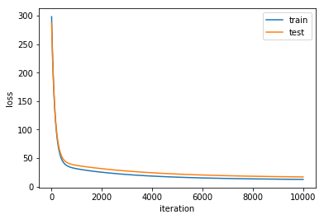

Fig 1 Linear regression loss

Linear classification:

Through the adjustment of multiple hyper-parameters,we can get a better SVM model

The loss result is showed as follow

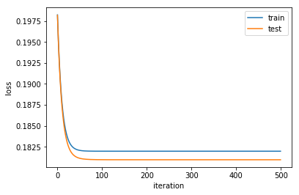

Fig 2 Linear classification loss

## Summary

Through this experiment,I further understood the principle of linear regression ,linear classification and gradient descent. By learning the gradient descent method, we can further understand the important content of the gradient learning, and realize the process of optimizing and adjusting the parameters.

1.