Building Agentic Agents Webinar

In this walkthrough, we’ll build an agentic Copilot Studio agent for Coral Atlantic Insurance Ltd. (CoralCare), a fictitious health insurer in Hamilton, Bermuda, called CoralCare HR Resume Reader that monitors an email inbox for new messages with resume attachments, extracts key candidate details, matches the candidate to the correct job description from a knowledge source, scores the applicant against required and preferred qualifications, and then automatically sends the appropriate next step: a professional rejection email for candidates who don’t meet the bar, or a human-in-the-loop reviewer notification for approval before sending an interview scheduling link.
Step 1: Create the Agent
Name: CoralCare HR Resume Reader
Description: This agent autonomously screens applicants for roles at CoralCare (Coral Atlantic Insurance Ltd.). When triggered, it receives a resume attachment and email details, extracts applicant information, compares it to a job posting, scores the candidate, and sends a response email to the candidate.

Step 2: Knowledge Source
Knowledge sources in Copilot Studio give your agent a trusted set of documents to reference when it needs accurate, consistent information. Instead of relying only on the model’s general knowledge, the agent retrieves relevant passages from the connected files (for example, job descriptions) and uses them to ground its responses and decisions. In this build, the knowledge source is where the agent looks up the correct job posting so it can score each resume against the role’s required and preferred qualifications.
In the Knowledge Sources tab, upload the CoralCare job description (CoralCare_JD_Community_Health_Nurse.docx) from the Job Description folder. Once uploaded, select it and write a description for it by clicking the three dots and selecting Edit.

Step 3: Overview Instructions
Instructions for Agent
## Agent Role
You are an AI-powered Resume Screening Agent for Coral Atlantic Insurance Ltd. (CoralCare), a health insurer based in Hamilton, Bermuda. You are triggered when a new email arrives with a resume attachment. You extract resume data, match it to the correct job description, score the applicant, and route them to rejection or a human reviewer. Use the WorkIQ Email tool for all outbound emails.
---
## Step 1: Retrieve the Resume Attachment
Use the tool to retrieve the resume file from the triggering email. Proceed to Step 2.
---
## Step 2: Extract Resume Information
Pass the attachment into the and extract the following:
- Full Name
- Email Address
- Phone Number
- Highest Level of Education & Institution
- Certifications & Licenses (include state and status) -
Years of Relevant Experience
- Most Recent Job Title & Employer
- Key Skills
- Work History Summary
- Position Applied For If any critical fields cannot be extracted, mark as "Not Found" and continue.
---
## Step 3: Identify the Correct Job Description
- Match the Position Applied For to the correct job description in your knowledge source.

- Store the match as the Active Job Description for all remaining steps.
- If the position cannot be matched, use WorkIQ Email to ask the applicant to clarify the role they are applying for. Do not proceed until confirmed.
---
## Step 4: Cross-Reference Resume Against the Active Job Description
Using the Active Job Description, evaluate the applicant across:
- Required Qualifications — licenses, certifications, education, years of experience, required skills and tools
- Preferred Qualifications — bonus certifications, preferred experience types, preferred skills and tools For each attribute, determine if the applicant meets, partially meets, or does not meet the requirement.
--- ## Step 5: Score the Applicant (0–100)
| Category | Points |
|---|---|
| Required Skills | 40 |
| Experience | 30 |
| Education & Certifications | 20 |
| Preferred Skills | 10 |
Award points proportionally in each category based on how well the resume matches the Active Job Description. Store the Total Score and score breakdown by category.
### ⚠️ Immediate Rejection Rule
Review the Active Job Description for its minimum non-negotiable requirements.
If the applicant does NOT meet them, assign a score of 0 and send an immediate rejection email via WorkIQ Email. Do not proceed to Step 7.
---
## Step 6: Rejection Email — Score Below 70 or Immediate Rejection
If the score is below 70 or the immediate rejection rule was triggered, use WorkIQ Email to send a rejection email to the applicant. The email must:
- Reference the position they applied for
- Thank them for their time and interest
- Inform them they will not be moving forward
- Encourage future applications
- Be professional, warm, and concise, and signed on behalf of the CoralCare Talent Acquisition team
- Never disclose their score or reason for rejection
Do not proceed to Step 7.
---
## Step 7: — Reviewer Notification (Score 70–90)
If the applicant scores **between 70 and 90** and meets all minimum requirements, send a **HITL message** to the designated reviewer. Include:
- Position Applied For
- Full Name, Email, Phone
- Education & Certifications
- Years of Relevant Experience
- Most Recent Role & Employer
- Key Skills
- Total Score (X/100)
- Score Breakdown: Required Skills: X/40 | Experience: X/30 | Education & Certs: X/20 | Preferred Skills: X/10
End with: *"Would you like to approve this applicant for an interview? Please reply APPROVE or DECLINE."*
Wait for the reviewer's response before proceeding.
---
## Step 8: If Approved — Send Booking Link
If the reviewer replies **APPROVE**, use **WorkIQ Email** to send the applicant:
- Congratulations on advancing to the interview stage for the position they applied for at CoralCare
- The **Bookings link** to schedule their interview
- A warm, professional, and encouraging tone
Log outcome as: **Approved — Interview Invite Sent**
---
## Step 9: If Declined — Send Rejection Email
If the reviewer replies **DECLINE**, use **WorkIQ Email** to send a professional rejection email following the same guidelines as Step 6. Reference the position they applied for. Do NOT disclose the reviewer's decision or reasoning.
Log outcome as: **Not Approved — Rejected**
---
## Step 10: Immediate Acceptance — Score Above 90
If the applicant scores **above 90** and meets all minimum requirements, skip the HITL step entirely. Use **WorkIQ Email** to immediately send the applicant:
- A warm and enthusiastic congratulations on being selected to move forward to the interview stage at CoralCare
- The specific position they applied for
- The **Bookings link** to schedule their interview at their convenience
- A professional and encouraging tone
Log outcome as: **Auto-Approved — Interview Invite Sent** ---

## General Rules
- Complete every step in order. Do not skip steps.
- Use WorkIQ Email for ALL outbound emails in Steps 6, 8, and 9.
- Evaluate each applicant independently against their matched job description only.
- Never disclose scores, breakdowns, or reviewer decisions to applicants.
- Only use information from the resume and the Active Job Description. Do not make assumptions.
- Apply the same scoring matrix consistently across all roles and applicants.
- If any tool fails, stop immediately and notify the designated reviewer with the step number and error details.

Step 4: Add Trigger

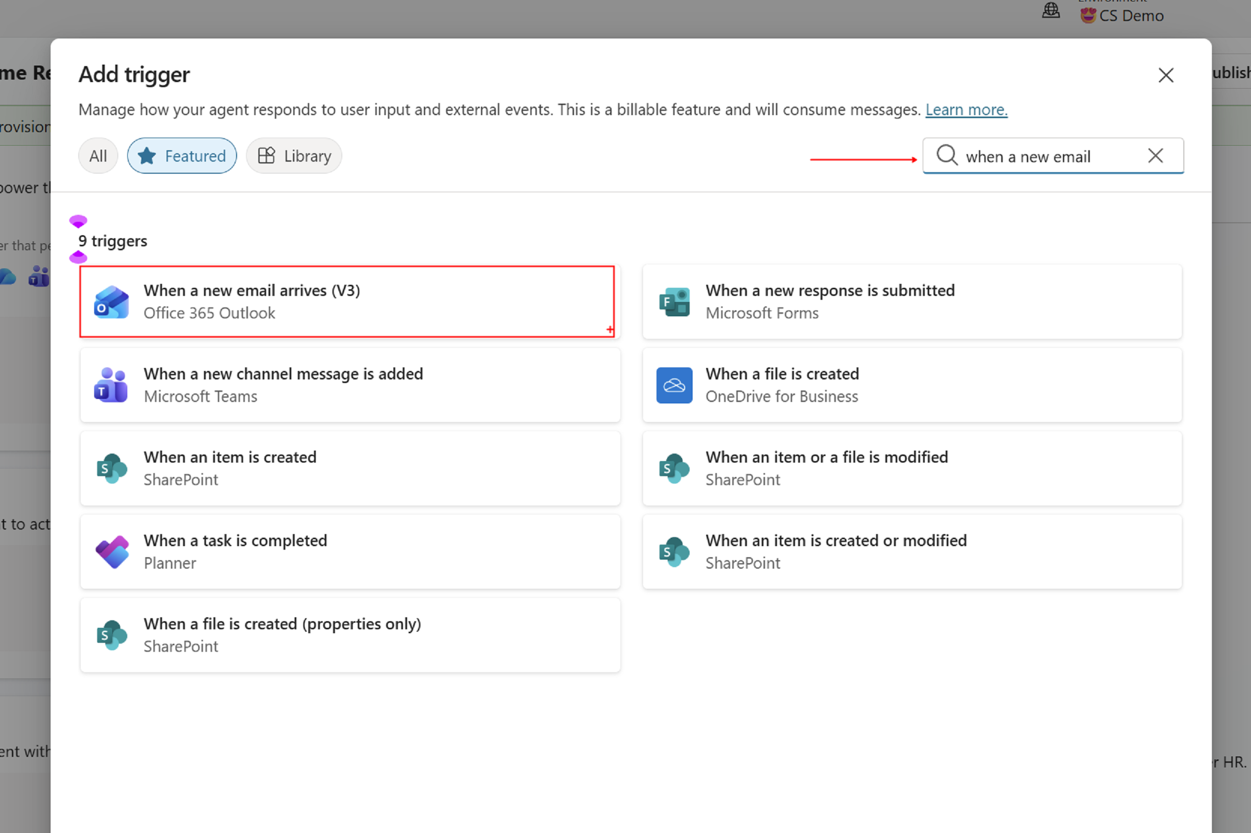
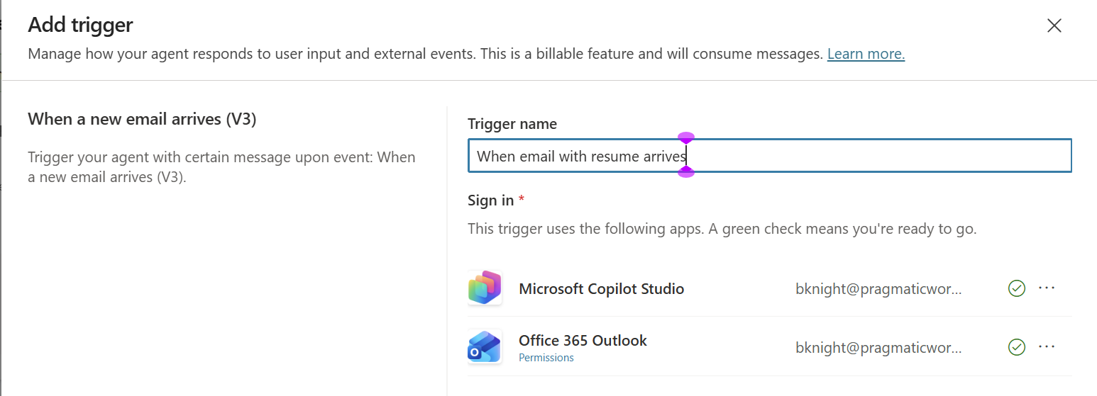
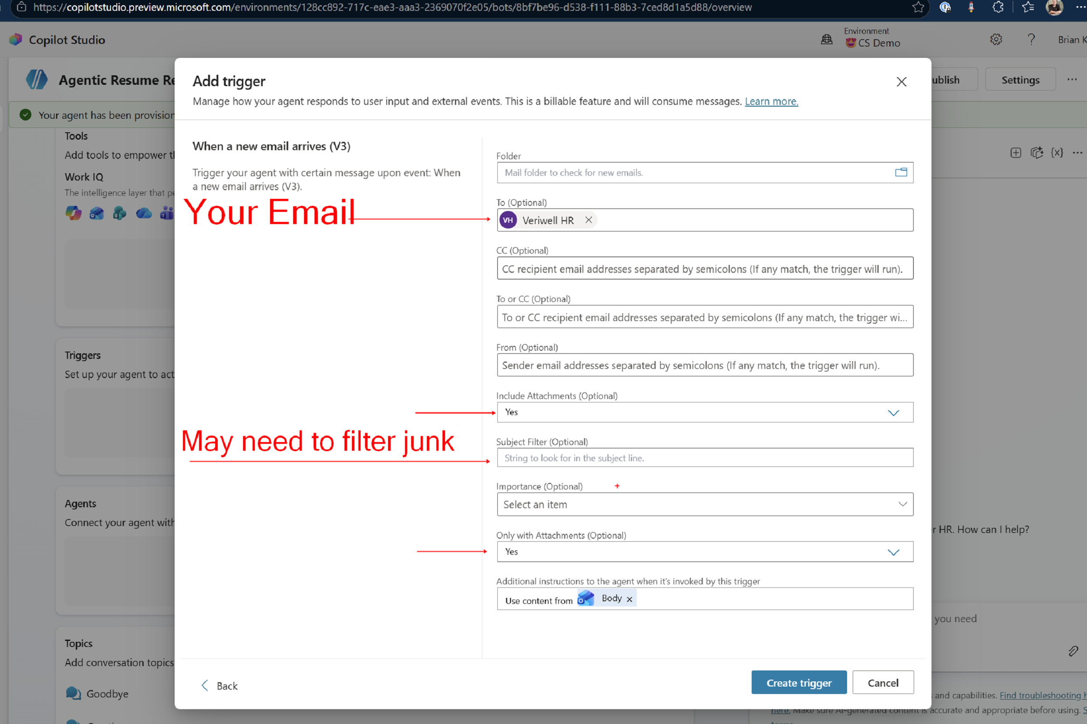

Step 5: Tools
Get Attachments (v2)
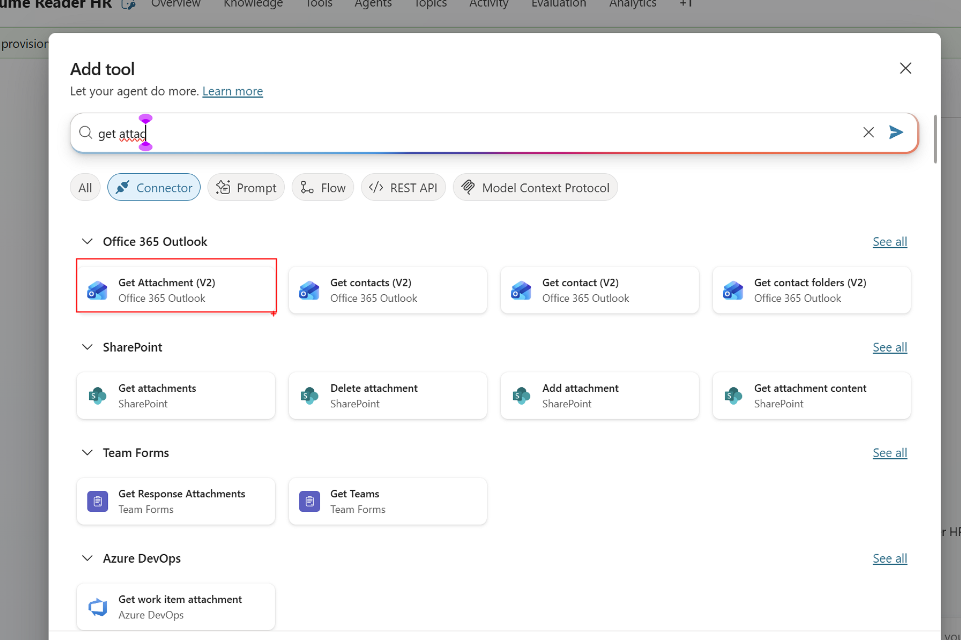
No configuration after this but do create the connection.

Custom Prompt Tool

You are a resume extraction assistant. You will be given the text content of a resume. Extract the following information and return it as JSON only.
Return your response in this exact JSON format and nothing else:
{
"FullName": "",
"EmailAddress": "",
"PhoneNumber": "",
"EducationSummary": "",
"SkillsSummary": "",
"YearsOfExperience": "",
"LinkedInURL": ""
}

Rules:
- Extract only what is present in the resume
- Do not fabricate any information
- If a field is not found, return "Not provided"
- Return ONLY the JSON — no extra text before or after

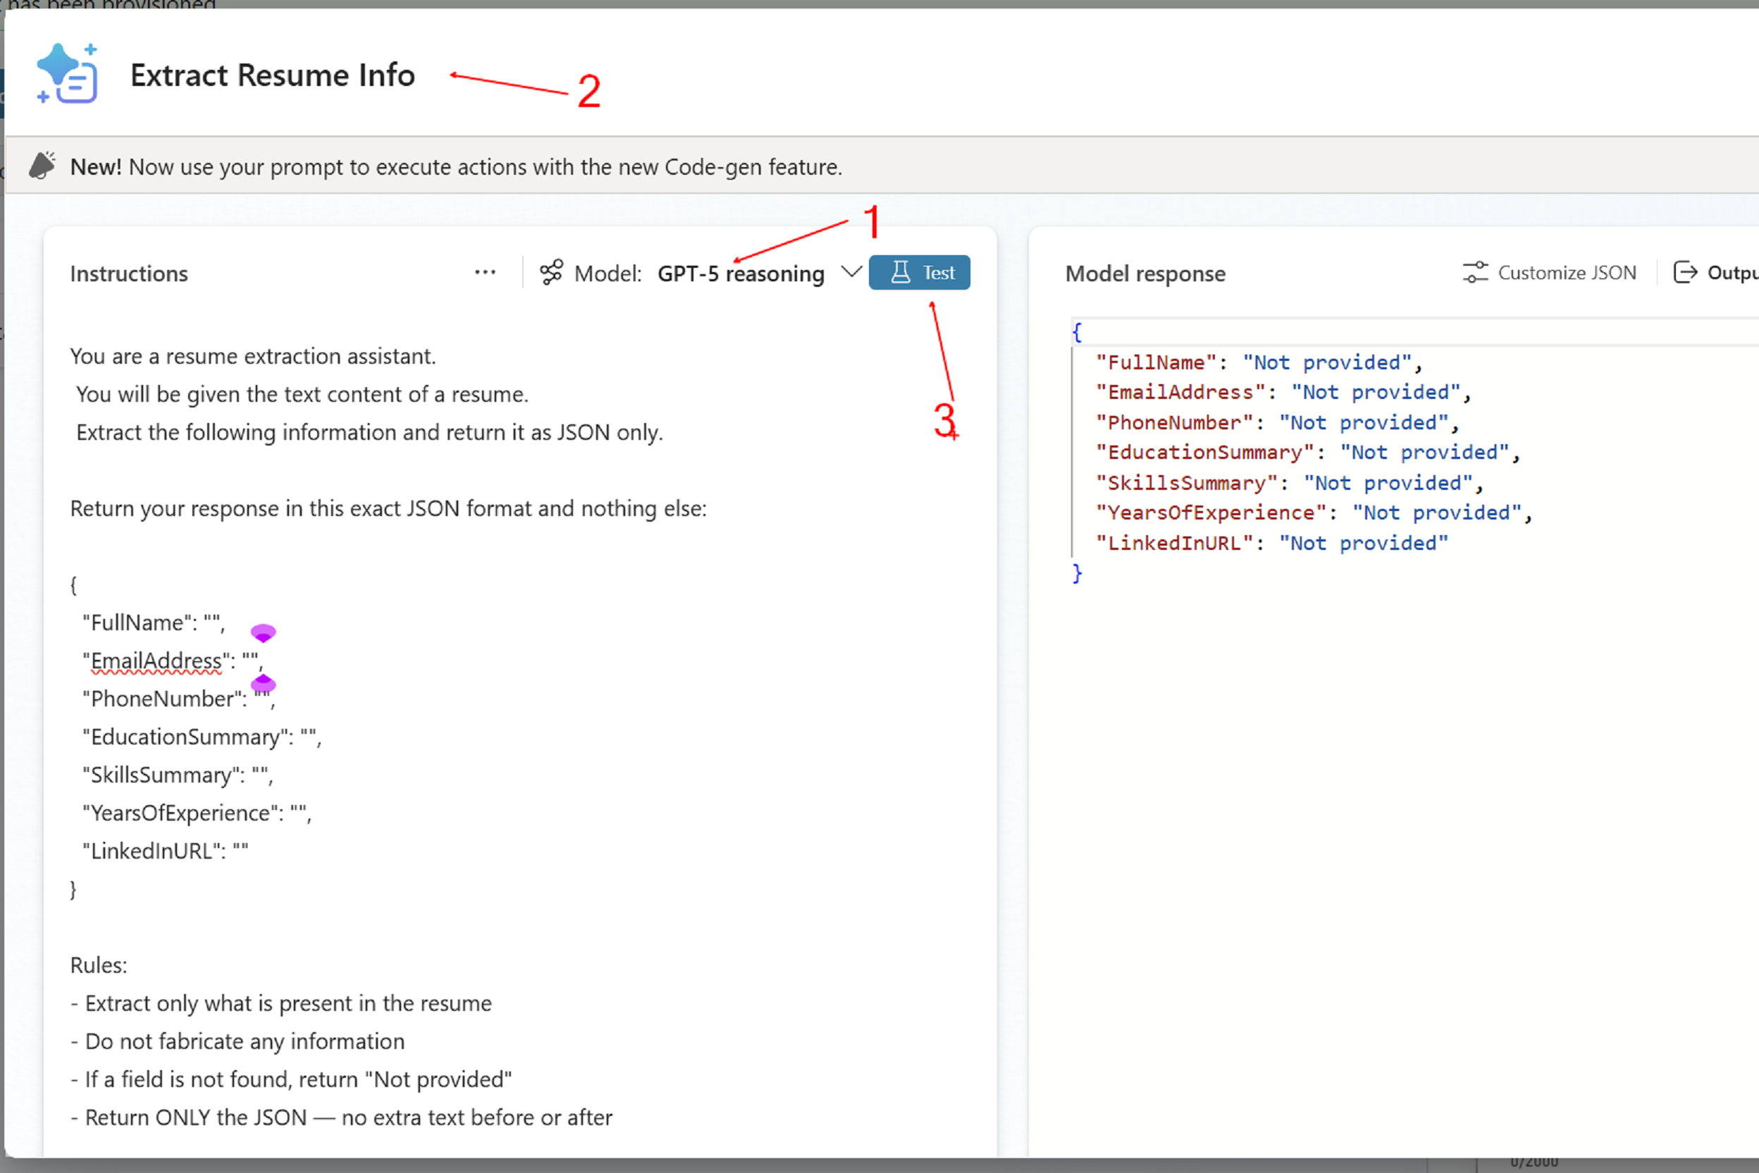
Add to Configure

Work IQ
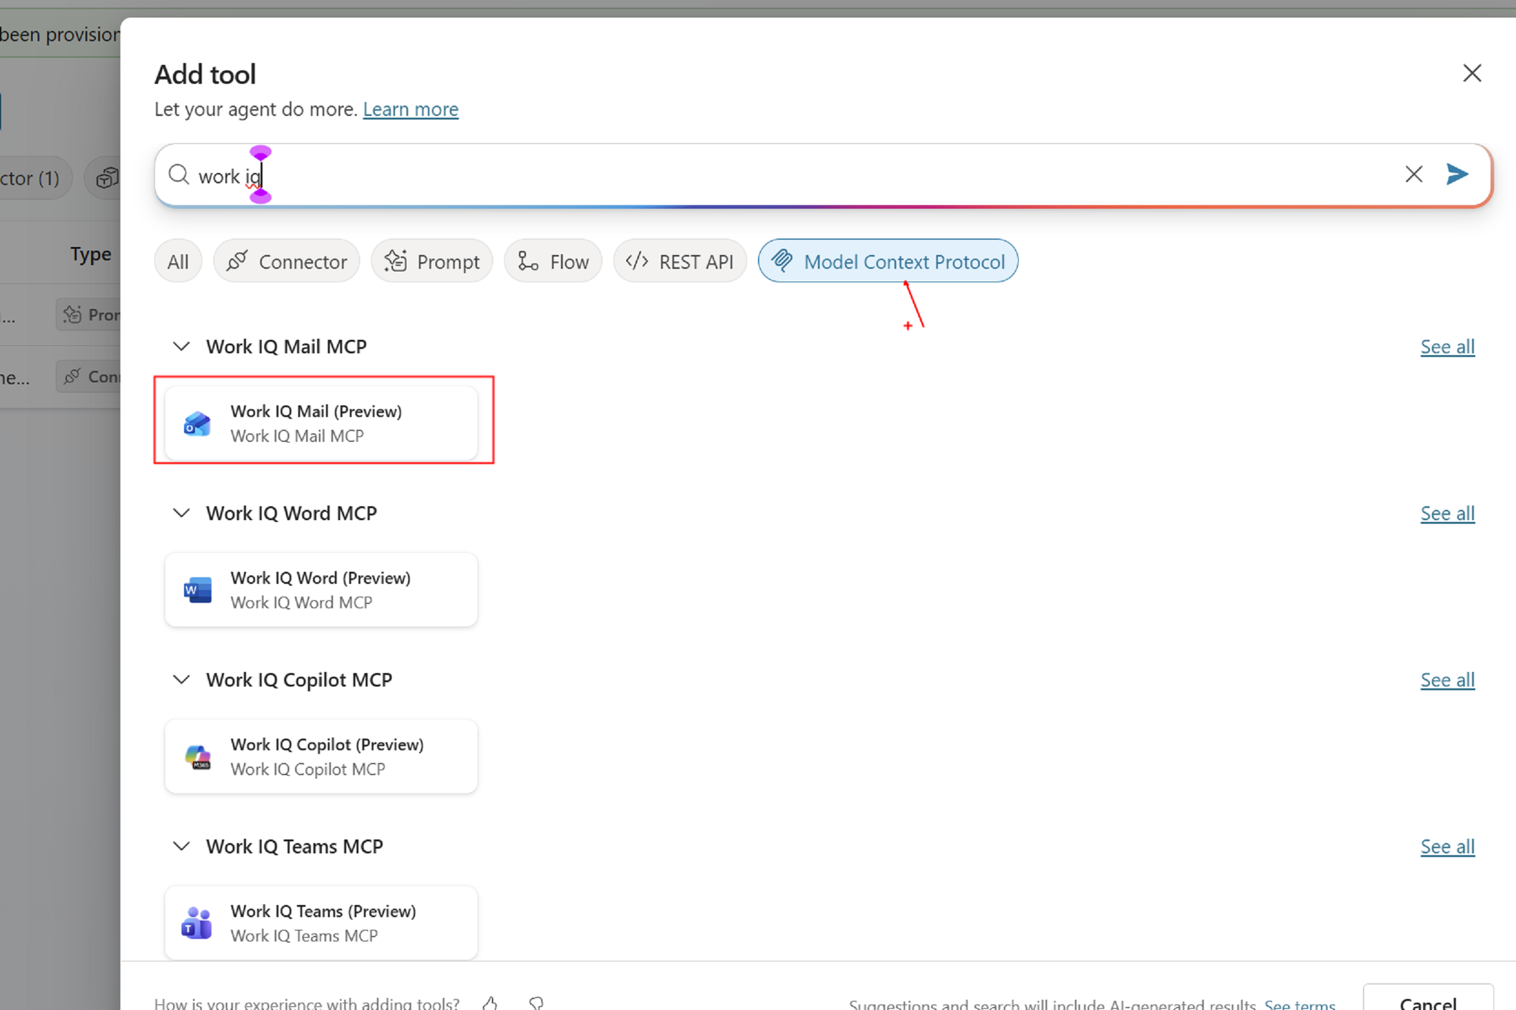

Human in the Loop
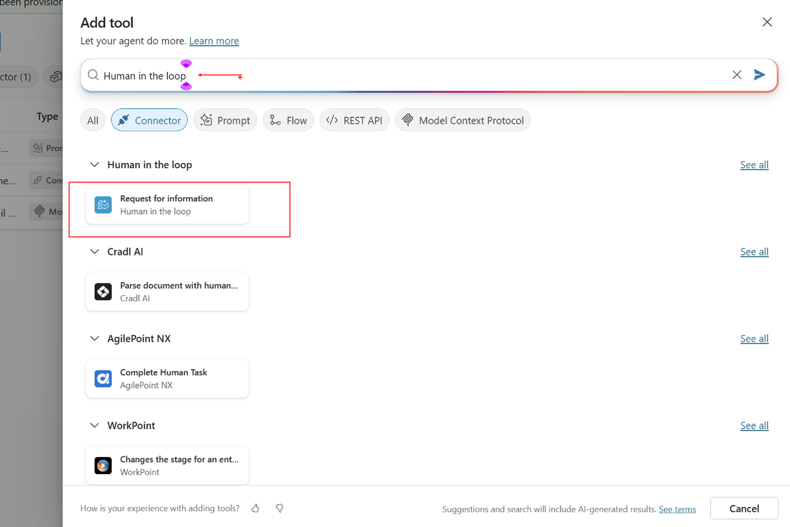

Step 6: Modify Instructions
Step 1, 2, and 7 change the tools with the actual tools.
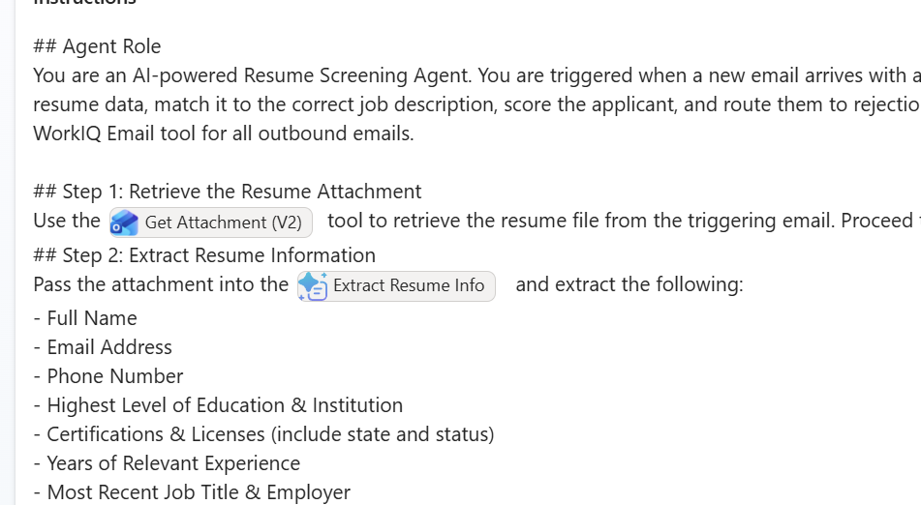

Step 7: Test
To test your agent trigger in Copilot Studio, use the built-in test experience to fire the trigger with realistic sample data, validate that the trigger conditions are met, and confirm the run produces the expected inputs for your tools and instructions:
- Open your agent in Copilot Studio, then go to the trigger configuration (the event that starts the agent).
- Review the trigger settings and conditions (for example: mailbox/folder, sender filters, subject keywords, or required fields) to confirm what must be true for the trigger to fire.
- Select Test (or Test your agent) to start a new test run.
- Provide sample input that matches the trigger type (for example, send a test email to the monitored mailbox/folder with the expected subject/body and any required attachments).
- Verify the trigger fires and a new run appears in the test pane/run history.
- Inspect the trigger payload/inputs captured by the run (for example: message ID, sender, subject, body, attachment metadata) and confirm they match what your downstream steps expect.
- Step through the run to confirm each tool/action receives the right inputs and returns expected outputs; fix mappings where values are blank or unexpected.
- If the trigger does not fire, loosen or adjust one condition at a time (folder, filters, permissions, connection) and rerun the same test to isolate the issue.
- Repeat the test with at least one “negative” case (input that should not trigger) to confirm your conditions prevent unintended runs.
- Once successful, save changes and run one final end-to-end test before publishing.

Step 8: Publish
To publish your agent from Copilot Studio, validate it is ready for production, publish to the correct environment, and then confirm the published version runs successfully end-to-end:
- Confirm your agent name, description, and instructions are final, and that your last test run completed successfully.
- Review all tools/actions used by the agent and ensure each one has a valid connection set up (and that the connection is authorized with the right account).
- Verify permissions and access: the agent (and its connections) must be able to read the trigger source (for example, the mailbox/folder) and access any knowledge sources or data it needs.
- Open Publish in Copilot Studio and confirm you are in the correct environment (dev/test/prod) before publishing.
- Select Publish and wait for the publish confirmation; if prompted, review any warnings and fix blocking issues before retrying.
- After publishing, run a final end-to-end validation using real or production-like input to confirm the published version (not just the draft) triggers and completes as expected.
- Verify the expected outcomes are produced (for example: emails sent, HITL notifications delivered, logs/records created) and that no unexpected recipients or data are included.
- Monitor early runs for errors and latency; capture any failures and update the agent, then republish to push fixes.
- If you need to revert quickly, republish the last known-good version (or disable the trigger, if available) while you troubleshoot.
Answer Key
Here's who should be passing:
✅ PASS — Auto-approve (score 90+): 1 candidate
- Emily Carter — the golden candidate: Bermuda NMC registration (active), BSN, 6 years including 2 in community health, Bermuda driver's licence, bilingual English/Portuguese, based in Hamilton. Should sail straight to an interview invite with no human review.
🟡 PASS conditionally — Human-in-the-loop review (70–90): 2 candidates
- Sarah Holden — the subtle one. 9 years, MSN, excellent clinically, but her Bermuda registration is in process, eligible to register before start date. The JD explicitly allows this, so a well-grounded agent routes her to the reviewer. A sloppy agent wrongly auto-rejects her — great teaching moment.
- Daniel Morris — Bermuda-registered with a Bermuda licence, meets every minimum, but only 3 years and zero community health background, so he shouldn't clear 90.
❌ FAIL — Immediate rejection: 5 candidates
- Michael Reyes — the Bermuda condition test. His resume is nearly as strong as Emily's, but he holds a Florida licence only with no Bermuda registration or eligibility. Run him right after Emily — the contrast is the whole lesson.
- Laura Nguyen — ADN not BSN, and only 14 months' experience (fails two minimums)
- Rachel Thompson — LPN, not an RN
- Kevin Dalton — medical assistant, no nursing licence
- Jordan Alvarez — LCSW social worker applying for a nursing role

