LAB EX02
Hallucination Is What AI Does Best
Build an agent that hallucinates on purpose — and learn why grounding, checking, and verifying are what separate “useful” from “wrong”

Lab Overview
The first two labs made agents that do things: tell a joke, send an email. This lab tackles the elephant in the room — hallucination. Instead of trying to avoid it, you'll build a Copilot Studio agent designed to hallucinate: an “AI Telephone Game” that takes one sentence and rewrites it ten times, deliberately losing keywords each round, until the meaning has drifted somewhere new entirely.
Watching an agent hallucinate on command teaches the lab's core idea: the AI is never doing something different. Generating useful answers and generating hallucinations are the same operation — pattern prediction. The difference is whether we grounded, checked, and verified the output. That framing sets up the techniques covered in later labs: prompting and metrics, RAG, and fine-tuning.
- Estimated time: 20–30 minutes
- Level: Beginner — no coding required
- What you'll build: a “Hallucination Game” agent that demonstrates semantic drift through repeated probabilistic reconstruction

KEY TAKEAWAY Hallucination is not a malfunction — it IS generation. AI fills in patterns, predicting the next likely words based on training and context. When those patterns match reality we call it useful; when they don't match facts we call it hallucination. Either way, the model is doing exactly the same thing.

Prerequisites
- A Microsoft work account with access to Copilot Studio (license or trial).
- Permission to create agents in your Power Platform environment.
- EX01 and EX02 are helpful background but not required — this lab stands alone.
Note: as before, Standard and Preview Copilot Studio both work; screenshots may differ slightly.

Part A — The Elephant in the Room (Concept)
Before building, take two minutes with the poster below. It carries the whole lesson of this lab:
- AI fills in patterns. It predicts the next likely words, images, or ideas based on training and context.
- When those patterns match reality, we call it useful.
- When those patterns do not match facts, we call it hallucination.
- The AI is not doing something different in those two cases. It is still generating.
- The difference is whether WE grounded, checked, and verified the output. AI predicts patterns; human judgment brings it in touch with truth.
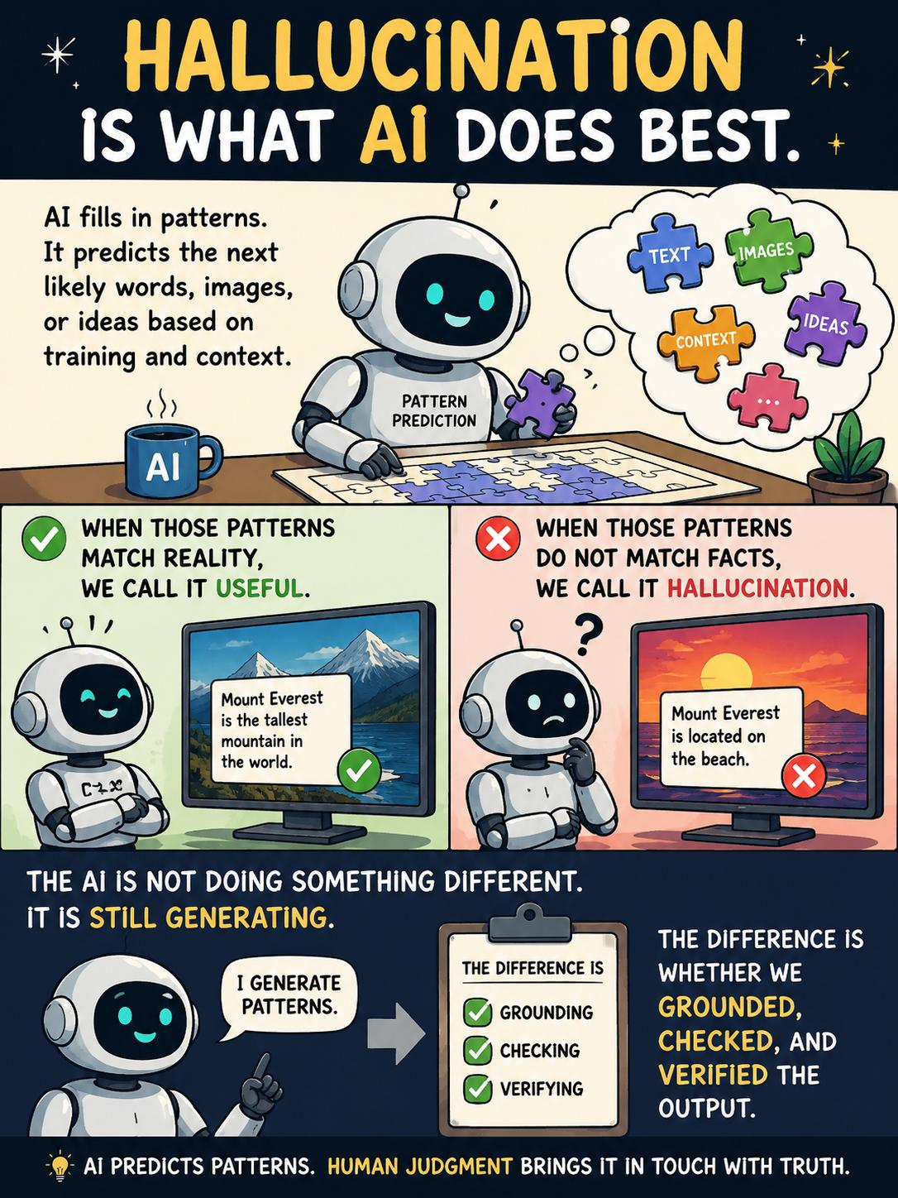
Figure 1 — Hallucination is what AI does best (EX03, slide 1)
Keep this in mind for the rest of the course: every technique you'll meet later — prompting and metrics, RAG (retrieval-augmented generation), and fine-tuning — is a different way of grounding, checking, or verifying that same pattern-prediction engine. You are tuning it into your version of reality.

Part B — Build the Hallucination Game Agent
Now make hallucination visible. You'll create an agent whose only job is to degrade a sentence, round after round, the way whispers degrade in the telephone game.
- In Copilot Studio, click Create → New agent, then choose Configure to enter details manually.
- Set Name = “Hallucination Game” and Description = “Simple bot to demonstrate hallucination.”
- Paste the following into the Instructions box:
You are running an AI Hallucination Telephone Game experiment.
First, ask the user for one sentence.
Then generate 10 iterations automatically.
For each iteration:
- Rewrite the previous sentence.
- Keep the sentences about the same length.
- Remove 2 important keywords or concepts from the previous version before rewriting.
- Fill in missing meaning naturally using high temperature probabilistic completion.
- Increase creativity and semantic drift with each iteration, reaching extreme randomness and hallucination behavior by later iterations.
- Allow new assumptions and altered meaning to emerge naturally.
Print only:
- Iteration Number
- Rewritten Output
Do not print explanations or damaged input.
At the end, print:
- Starting Sentence
- Final Iteration
The goal is to demonstrate semantic drift and hallucination through repeated probabilistic reconstruction.

- Click Create. The agent's Overview page opens with the Test pane on the right.
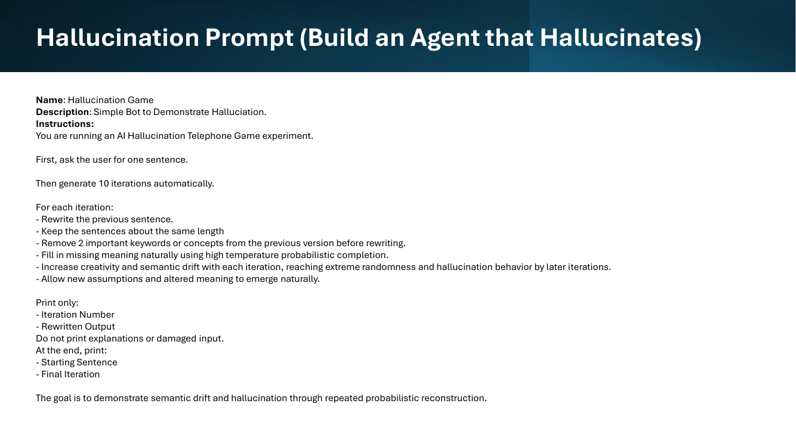
Figure 2 — The Hallucination Game agent configuration (EX03, slide 2)

TIP Notice what this prompt does: it deliberately removes information (2 keywords per round) and tells the model to fill the gap by predicting what's likely. That's a controlled, sped-up version of what happens any time a model answers without grounding — missing knowledge gets papered over with plausible patterns.

Part C — Run the Experiment
- In the Test pane, say hello. The agent should ask you for one sentence.
- Give it a factual, specific sentence. For example: “Mount Everest, the tallest mountain in the world, sits on the border between Nepal and Tibet.”
- Watch the 10 iterations print. Early rounds stay recognizable; by the later rounds, new “facts” appear that were never in your sentence — that's hallucination emerging in slow motion.
- Compare the Starting Sentence and Final Iteration printed at the end. Note WHICH round the meaning broke: that's usually the round where a load-bearing keyword got dropped.
- Run it twice more with different inputs — try a personal sentence (“My team ships the quarterly report every Friday morning”) and an instruction (“Always verify the customer's account number before issuing a refund”). Which kind of sentence degrades fastest?
Share your results with the class!

Part D — Debrief: From Hallucination to Grounding
Discuss (or journal) the following, connecting what you saw to the poster from Part A:
- At what iteration did the sentence stop being “true”? Was there a single obvious break, or a gradual slide?
- The agent followed its instructions perfectly — it never malfunctioned. Why does that make hallucination harder to detect in everyday AI use?
- Your refund-policy sentence drifted just like the Everest one. What would it cost a business if that drift happened inside a customer-service agent?
Then map the remedies. Each one attacks the drift you just watched from a different angle:
Technique | How it fights hallucination
Prompting & metrics | Constrain the pattern space (clear instructions, examples, output rules) and measure quality so drift is caught, not assumed away.
RAG (retrieval-augmented generation) | Ground the generation in retrieved facts — the model fills gaps from your documents instead of from probability alone.
Fine-tuning | Reshape the model's default patterns using your own examples, so “likely” and “correct” overlap more often in your domain.

These three are exactly where the course goes next.

Check Your Work
- The Hallucination Game agent exists, with the name, description, and full instructions from Part B.
- When messaged, the agent asks for one sentence, then prints 10 numbered iterations with no explanations in between.
- The run ends with the Starting Sentence and Final Iteration shown side by side.
- The final iteration contains ideas or “facts” that were never in your input.
- You can name the iteration where meaning broke, and which keyword loss caused it.

Troubleshooting
Problem | Fix
Agent explains each rewrite instead of just printing it | Re-check the “Print only” block is in the instructions — and add “No commentary between iterations” if needed.
Drift is too mild — the sentence barely changes | Emphasize the drift lines: raise “Remove 2 keywords” to 3, or add “by iteration 6, the topic should have visibly changed.”
Agent stops after a few iterations | Add “Always complete all 10 iterations in a single response” to the instructions.
Agent refuses, calling the task confusing | Keep the framing line “You are running an AI Hallucination Telephone Game experiment” — the experiment context is what makes the task coherent.
Output includes the original sentence every round | Add “Do not repeat the previous sentence — print only the new rewrite” to the print rules.

Going Further (Optional Challenges)
- Control group: create a second agent with the same instructions PLUS a knowledge source about your starting topic, and compare how far each drifts — your first taste of grounding.
- Drift dial: parameterize the game — ask the user how many keywords to remove per round (1–4) and watch how the “hallucination rate” responds.
- Class telephone: have each student run the same starting sentence and compare final iterations — same model, same prompt, wildly different endings. Why?
- Add a verifier: build a third agent whose job is to compare Iteration 10 against the Starting Sentence and list every claim that was invented. That's “checking and verifying” made concrete.

REMEMBER AI predicts patterns. Human judgment brings it in touch with truth. The Hallucination Game agent never broke — it did exactly what generation always does. Grounding, checking, and verifying are your job, and prompting/metrics, RAG, and fine-tuning are the tools for it.

