DHARANKUMAR RAMALINGAM

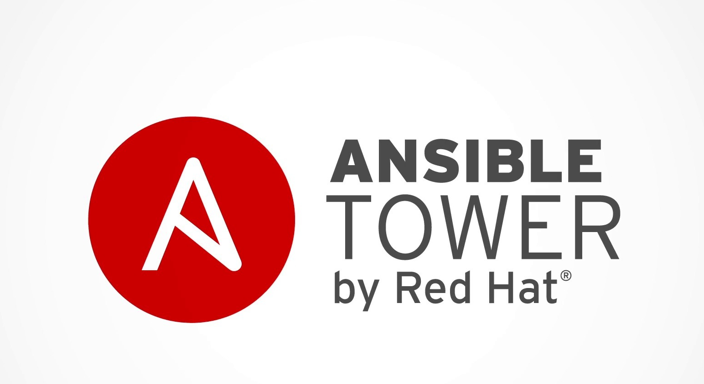

Email ID: dharanec31@gmail.com Phone no: +91 8095360629

Career objective
Seeking for a proactive position in a turbulent and dynamic organization where I can utilize my best professional skills and experience for the furtherance of the consortium.

EXPERIENCE SUMMARY
Management Responsibilities

- Responsible for managing a team of 7-10 members.
- Delivering Weekly status report (WSR) and Client satisfactory report (CSR) on weekly & monthly basis respectively.
- Handled Technical discussion for gathering new project requirements and Operational stability with various stakeholders for existing projects.
- Proposed and implemented many strategic solutions to improve the infrastructure level stability which reduced BAU efforts on daily incident management and overall health factors.
- Represented team and team members in various “Townhalls” for our best achievements and contributions.
- Handled and prepared Revenue forecasting to forecast and analyze the team size for better team management and efficient delivery.
- Business proposals are part of my management responsibilities which involves both Technical & Financial proposals.
- Mentor and Career counsellor for more than 5 members to guide them towards learning of new skills and concepts.
- Part of handling sign-off from other vendors for pre-handled projects/enhancements with operational hand-over.
- Involved in P2BAU transition from various external vendors.
- Involved in designing Service catalogue and framed protocols for Handling Critical Incidents and Problem records.

Technical Responsibilities

- Automation Lead and Ansible Tower Admin who predominantly works on configuring & deploying playbooks from GITHUB via Ansible and governing the automation enhancements via AIOPS.
- Over 11+ years of experience as a certified IT infrastructure engineer and architect, with wide range of skillset in Microsoft Virtualization (Hyper-V).
- Expertise in configuring and troubleshooting Failover Clustering technology.
- Consultant for infrastructure (Virtualization - Hyper-V) related changes and upgrades to improvise the environment.
- Experience in working on Active Directory services for User management, group creation, access handling, computer account management.
- Working and troubleshooting server level issues in System center 2012 R2 Products (SCVMM)
- Expertise in high-level & low-level planning and executing DR activities from Infrastructure perspective.
- Managing and virtualizing Dell PowerEdge R720/730/730xd and HP G7/G8/G9/G10 Blade servers.
- Handling and troubleshooting server level issues in System center 2012 R2, 2016 Products (SCVMM).
- Well versed in troubleshooting Failover cluster manager issues, Hyper-V, SCVMM, Remote connections, Network access, storage issues (Disk pool offline, VHDx offline, Mount point).
- Trained in VMware vSphere [v6.0]: Install, Configure and Manage
- Certified in ITIL FOUNDATION 2011 V.3 course.
- Well versed in handling P1 tickets and provide L3 support on Hyper-V environment (Windows Virtualization) with RCA on various critical Problem records.
- Expert in raising and implementing Change records, Problem records which complies with ITIL standards.
- Good problem-solving skills and open to adopt new technologies.
- Good Communication and Interpersonal skills and consistently recognized for organizational skill, attention to details and client appreciation.

TECHNICAL EXPERTISE
Server Operating Systems | Windows 2008 R2/2012R2/2016/2019
Automation Tools | Ansible, AIOPS, GITHUB
Virtualization Tools | Microsoft Hyper-V, VMWare (Trained), APP-V 4.6,5.0
System Center Tools | SCCM 2012R2, SCOM, SCORCH, SCVMM
Cloud Technologies | Windows Azure
Application and Troubleshooting tools | Installshield, Installrite, Picturetaker, Change BASE,PStools

PROFESSIONAL DETAILS
Company Name | Dates | Designation
Kyndryl India Pvt LTD (Formerly IBM India Pvt LTD) | April 2021 to Present | Lead II, Account Technical Services
Tata Consultancy Services Pvt Ltd | Dec 2017 to April 2021 | IT Analyst
Accenture Services Pvt Ltd | May 2015 to Dec 2017 | Software Engineer
Accenture Services Pvt Ltd | July 2013 to April 2015 | Associate Software Engineer

CERTIFICATIONS
- 74-409 Server Virtualization with Windows Server Hyper-V and System Center
- 70-533 Implementing Microsoft Azure Infrastructure Solutions
- ITIL Foundation 2011 V.3

EDUCATION DETAILS
Institution: Sona College of Technology, Salem
Year: 2009 -2013
Major/Dept: Electronics and Communication Engineering
CGPA: 8.2

RELEVANT PROFESSIONAL EXPERIENCE IN CHRONOLOGICAL ORDER

Company Name: Kyndryl India Pvt LTD

Project : Auditing Forum
Duration : April 2021 to till date
Role : Ansible Tower Admin, Hyper-V Admin, Windows Admin, DR specialist and Advisor.
Tools Worked : Microsoft Hyper-V, SCVMM, PowerShell, Service Now, AD, DNS

Roles and Responsibilities

- Automation engineer handling RedHat Ansible Tower by configuring, deploying and executing playbooks for performing various automation and remediation for the infra support.
- Deployed and executed Health scan playbooks for collecting hardware, software and subsystem related information which assists Infra team to forecast any outdated/out of warranty software and hardware.
- SRM (Server Resource Management) pend to end deployment which included planning, installing agents on endpoints/servers/Hyper-V hosts and executed playbook for fetching datafiles from endpoints to SRM console which is a potential tool responsible for preparing capacity & availability reports.
- High level troubleshooting on SRM agents & scripts to meet the expectation on Hyper-V nodes with optimized reports.
- Analyzing reports generated from Ansible and engaging appropriate teams to remediate issues on repeated incidents, User ID management, Server Licensing, SSL certificates.
- As part of Automation, have implemented Automated Patching, Event remediation for specific alerts via Ansible.
- Level 3 support & Hyper-V SPOC, responsible for remediating all the Hyper-V bound incidents using Service Now.
- Lead Consultant and SME for Microsoft Virtualization and Infra support on server administration (Windows Virtualization – Hyper-V).
- Lead and SPOC for Disaster Recovery activity which happens all through the year for all the clusters across the environment.
- Took an initiative and handled TLS and CIPER vulnerability remediation which was highly appreciated by client.

- Troubleshooting major issues in Hyper-V environment like WINRM, WMI, No Logon Servers, CSV offline, host down in cluster, dynamic MAC, VM failed state, VMM template deployment, Split Brain on clusters, etc.
- Privileged Account creation and managing by Active Directory Services.
- Assisted various network team activities and Linux build servers.
- Worked on providing RCA for various issues which impacted business.
- Physical server builds using MDT for Gen 7, Gen 8 and Gen 10 servers.

Company Name: Tata Consultancy Services Pvt Ltd

Project : Auditing Forum
Duration : Dec 2017 to April 2021
Role : Hyper-V Admin, Windows Admin
Tools Worked : Microsoft Hyper-V, SCVMM, PowerShell, Service Now, AD, DNS

Roles and Responsibilities

- Level-3 support team Hyper-V SPOC and responsible for remediating all the Hyper-v bound incidents using Service Now.
- Primary contact as well as Lead for Disaster Recovery activity which happens all through the year for all the clusters across the environment.
- Took an initiative and handled TLS and CIPER vulnerability remediation which was highly appreciated by client.
- Troubleshooting major issues in Hyper-V environment like WINRM, WMI, No Logon Servers, CSV offline, host down in cluster, dynamic MAC, VM failed state, VMM template deployment, etc.
- RCA handler for various issues which impacted business.

Company Name: Accenture Solutions Pvt Ltd

Project : Internal
Duration : Oct 2014 to Dec 2017
Role : Virtualization Administrator, Storage Administrator.
Tools Worked : Microsoft Hyper-V, NetApp Storage, Nimble Storage,
SCVMM, SCOM, PowerShell, SCORCH and Microsoft Azure.

Roles and Responsibilities

- Level 3 support and P1 issue handling for Datacenter Hosted services (Hyper-V, Failover Cluster and Storage).
- Responsible for configuring Physical Servers such as HP Gen7/Gen8 Blade and DELL Power Edge R720/730/730xd Servers through ILOM and IDRAC console and deploying Windows Server 2008R2/2012R2 Hyper-V Server Virtualization.
- Implementing, Configuring and Managing Microsoft Windows Server 2008R2/2012R2 Hyper-V role and Failover Cluster role.
- Configuring and managing System Center Virtual Machine Manager 2008R2/2012R2.
- Expert in troubleshooting server related issues like unexpected reboot, network settings, Firewall, storage (CSV, Standalone).
- Performed Remote desktop Gateway Services and Scale out File server in our production and dev Environment.
Duration : Jul 2013 to Oct 2014
Role : As a part of Application Packaging Factory worked for below,

Project 1 : Screen Tester, MSI Packaging.
Project 2 : APP-V, MSI Packaging.
Project 3 : Screen Tester, APP-V, MSI Packaging.

Tools Worked : Install shield, Microsoft App-V, Picture take.

Roles and Responsibilities

- Application Re-Packaging using AdminStudio/Install Shield and testing of customer supplied builds, creating MSI and MST, testing of MS security patches. Building the package as per customer specification and testing in lab environment.
- Coordinating work in offshore model for packaging, managing various activities and processes in Desktop Engineering like Information gathering for application packaging, quality check of applications, and Integration with builds.
- Troubleshooting the issues using tools like Process monitor, Picture taker, Install rite and have a good exposure on resolving application issues at pre-packaging, re-packaging and post packaging stages.

PERSONAL DATA

Name : Dharankumar Ramalingam
Date of birth : 31 July 1991
Current Location : Bangalore
Email : dharanec31@gmail.com
Contact : +91 8095360629

