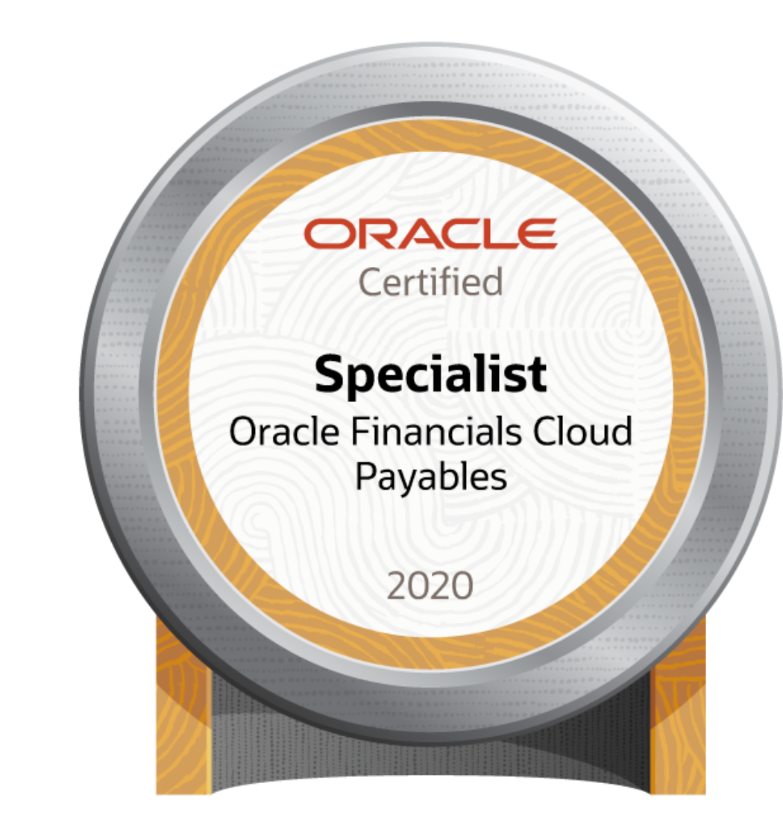

Name: | Karthik Sravan Thadakamalla
Phone: | +1- 404 981 7635/470-294-4085/+91 9866436689
Linkdin Profile: | www.linkedin.com/in/karthik-sravan-t
Email | karthik.thadakamalla@gmail.com
Educational Qualifications: | Bachelor of engineering (Computer Science) (2001 – 2005)
Certification: | Oracle Financial payables Cloud & General Ledger, SQL, PLSQL
Experience: | Hitachi Consulting (03-Feb-20006 to 13-Mar-2015)  Wipro Limited (26-Mar-2015 to 12-Dec-2021)  TCS:(13-Dec-2021 to till date)
Experience Summary

- Over 15 years of IT experience as an Oracle Apps techno-functional expert, specializing in implementation, upgrades, support, and customization of Oracle EBS technologies. Proven track record as a solution architect, techno-functional lead, and Oracle technical consultant for clients across various geographies, with a strong command of AGILE methodologies.
- 7+ years of onsite work experience, delivering successful results in diverse global environments.
- Led and executed several Oracle ERP implementations, upgrades, and enhancements, covering the complete end-to-end lifecycle in 11i and R12 versions.
- Extensive experience across a variety of Oracle E-Business Suite modules, including:
  - SCM Modules: Order Management, Inventory, Accounts Receivables
  - Financial Modules: Accounts Payables, General Ledger, Purchasing, Shipping (WSH), Cash Management, Project Management
  - Manufacturing Modules: Work in Process (WIP), Bill of Materials (BOM), Service Contracts, and HCM (HR) modules
  - Implemented various customizations across these modules.
- Hands-on experience in implementing key business process flows, including Payment Batch, Order-to-Cash (O2C), and Procure-to-Pay (P2P).
- Expertise in application design and architecture, ensuring seamless system integration and optimization.
- Proficient in preparing comprehensive documentation following AIM methodology (MD50, MD70, MD120, and TE50s).
- Advanced technical skills in Oracle Forms/Reports 10G, SQL/PLSQL, XSD Payment Templates, XML/BI Publisher Reports, CEMLI Components, BNE Integrators, Oracle Workflows, UNIX Scripting, Alerts, Data Conversions, RICE Components, APIs, OAF Form Personalizations, and Discoverer Reports.
- Solid experience with Oracle E-Business Suite flows, such as Design to Release, Demand to Build, Order to Cash (O2C), and Procure to Pay (P2P).
- Hands-on experience in HCM Cloud implementations.
- Expertise in data mapping and conversions from legacy systems to Oracle.
- Oracle Certified Implementation Specialist in Oracle Financial Cloud (Payables, General Ledger) and Oracle Certified Professional in SQL/PLSQL.
- Strong background in UNIX/Shell scripting.
- Experience in providing integration solutions and architectural designs for linking business applications with external systems.
- Demonstrated leadership in guiding teams through system implementation and enhancement projects.

United Airlines

Description | United Airlines, Inc. (commonly referred to as United), is a major American airline headquartered at the Willis Tower in Chicago, Illinois. United operates a large domestic and international route network spanning cities large and small across the United States and all six inhabited continents. Tcs has Ongoing relationship with United to Support Oracle ERP Financial modules.
Work Location | Chicago, il, USA
Role | Developer
Skills | Oracle apps Techno functional consultant.  Modules: Purchasing, Payables, Receivables, General Ledger, Project accounting and cash management.  Technical Expertise: Oracle Sql/Plsql packages procedures and functions, Materialized Views, Forms, Reports, Workflows, BNE templates, Form personalization’s, Unix scripts Publisher reports & XSL templates.
Environment | Application R12.2.9 and oracle database Environment 19C
Contribution | - Analyzing applications, processes, architecture, integrations and provide recommendations for improvements.  - Developed Several XML Publisher Reports in ETEXT/RTF/EXCEL formats Using XML Publisher in AP and AR modules.  - Developed Shell Scripts to submit concurrent jobs & send mails.  - Payment templates XSL templated for payment process.  - Conduct CRP, SIT, and UAT sessions to validate system functionality and ensure user acceptance and prod Migration for developed objects through SNOW.  - Form/OAF personalization’s on Expense Forms.  - Developed WEBADI Integrators for data load.  - Workflow customizations for time out issues. Sql/plsql Scripts .  - Audit Reports in multiple modules for reporting.  - Reversing Imported journals that are Posted in GL.  - GL COA Extract Scripts.  - Monitor Workflow processes and Support Iexpense issues on daily basis.  - Worked on multiple GL Code combination form personalization’s to add additional validations.  - Performance tuning on log running AR Receipts programs.  - Raise Oracle SR’s and analyze the resolutions and take it forward.  - Resolve support issues, performed application enhancements, and contributed to process improvements.  - Follow Agile Methodology for developing objects as per Sprint Plan.  - Leading ERP Production Support team:  - Monitoring Ticket flow, analyze tickets, assigning tickets to team, follow SLA’s defined and make sure team followed SLA’s while closing tickets, fixing different oracle related issues received as part of tickets, interacting with users on need basis for quick resolutions, prepare detailed support status plan and submit to customer for weekly monitoring.  - Identifying system improvements, working towards enhancements for making more efficient ERP integrations for customer.  - Working on Problem Tickets for Root Cause Analysis, Diagnosis and permanent fix.  - Maintain Source code repository and version controls.  - Prepare detailed design documents like MD50, MD70 and MD120 documents for Developed Objects.
Period | Dec 21 – Till date
Team Size | 4 (1 onsite, 3 offshore)

Change Health Care Operations, LLC Implementation team & Support (Healthcare)

Description | Change Healthcare is a catalyst for your value-based healthcare system. It’s a health care technology company that offers software, analytics, network solutions, and technology enabled services to help create a stronger, more collaborative healthcare system. Change Healthcare occupies a uniquely interconnected position at the center of healthcare, serving providers, payers, and consumers.
Work Location | Implementation Hyderabad, India.  Support Alpharetta, GA
Role | Techno functional Consultant.
Operating System(s) | Unix, Windows
Skills | Oracle apps Technical (xml/BI reports, sql/plsql, workflows, forms and reports, personalization’s, workflows & alerts)  Oracle Financial Modules: Purchasing, Payables, Receivables ,General Ledger ,Project accounting and cash management.
Environment | Application R12.2.7 and oracle database Environment 19C
Contribution | Implementation Activities:  - Performed critical activities inclusive of cutover, production Migration, release management, defect management across the project.  - Worked as conversion Lead to Develop & Deliver conversion programs and execution for data conversion on AP AR and GL modules .  - Worked on CEMLI Components.  - Worked with ETL team on Data/Column Mappings .  - Maintain Code backups and repos.  - Conduct CRP, SIT, and UAT sessions to validate system functionality and ensure user acceptance.  - Working closely with onsite project team for supporting and maintaining development, test and implementation phases.  - Documentation of MD70 and MD120’s.  - Maintain source code in VSS.  Support Activities:  - Work On multiple Inbound/Outbound Jobs and Monitor failure issue and Fix.  - Followup and timely closure of SNOW tickets.  - Fix Cash Management Bank statement Issues by correcting setups and reprocessing them.  - Work with DBA Team and Perform Clone Schedules.  - Work With oracle Support on Patches requirements and plan downtimes.  - PGP encryptions generation for outbounds/Inbounds and maintaining Public private key by checking expiry dates .  - Address Payment Process issues by debugging failure reasons void and preprocess them.  - Developed Nacha Format Payment templates.  - expense issues. Verify the Workflows and rollback reverse and process to fix.  - Master data maintenance for Customer Suppliers and Employees. Suppliers and Employees.  - ABF File Transfers.  - Support Audit Team.  - Maintain GETHUB.
Period | Feb 2019 – Dec 2021
Team Size | 10

McDonalds Japan Support (Retail)

Description | McDonald's is the world's largest restaurant chain by revenue, serving over 69 million customers daily in over 100 countries. McDonald’s Corporation revenues come from the rent, royalties, and fees paid by the franchisees, as well as sales in company operated restaurants. There is currently a total of 5,669 company owned locations and 31,230 franchised locations, which includes 21,559 locations franchised to conventional franchisees, 6,300 locations licensed to developmental licensees, and 3,371 locations licensed to foreign affiliates, primarily Japan.
Work Location | Hyderabad india & Tokyo Japan
Role | Techno functional Consultant (Onsite/Offshore)  Technical Expertise: PLSQL Packages, functions,views, Materalized views, BNE templates, XML Reports , Workflows and unix scripts.  Modules:Purchasing,Payables ,Receivables ,Order management ,Inventory and shipping modules.
Operating System(s) | Unix, Windows
Skills | Oracle apps Technical (shell scripts, xml/BI , sql/plsql, workflows form personalization’s) ,  Oracle Financial Modules
Environment | Oracle applications R12.1.3
Contribution | - Worked on Inbound/Outbound interfaces to make smooth closure of month end process.  - Worked on fixing issues related to sales order life cycle.  - Resolve support issues, performed application enhancements, and contributed to process improvements.  - Worked on standard AR invoices print report, modified data models, and created new templates using XML reports.  - Extensively worked on payment batch process.  - Worked on journal import interface and AP invoice interface programs.  - Developed BI publisher reports with RDF and data definition templates  - Support Master Data maintenance activities for supplier and customer data.  - Coordinate with Oracle Meta link for any break fix/SRs/Enhancement request.  - Ensure scheduling, delegating, and monitoring project tasks, and reviewing project deliverables  - Responsible for all project communication, including project status reporting, organizing project meetings and documents discussion and action items.  - Support and maintain over 100 integration objects(Inbound and outbound).  - Maintain Visual Source safe documents. >Tracking and maintaining. Enhancement request documents like BRD,MD50,MD70 MD120 and OMCS documents.  - Provide Estimates to the client for CR's and take it forward to development and testing .  - Migrating the developed code across instances like UAT,prodfix and production.  - Preparation of training material and knowledge base documents.  - Monitoring regular jobs in systemwalker.  - Providing data extracts from AP AR and GL interfaces for month end to maintain clean data in interfaces and help in smooth month end closure.  - Provide data discrepancy reports which include master data maintenance across modules like AR, AR, GL and PA .  - Analyzing daily job failure and recover the data for outbound and inbound in case of missing data.  - Mentor and train juniors team to bring up the speed .
Period | 2015 March – 2018 Dec
Team Size | 15

IXIA Rollout & Upgrade R12(Manufacturing)

Description | Ixia is a leading provider of performance test systems for IP based infrastructure and services operating in over 30 countries worldwide. Service Providers, Network and Telephony System Vendors, Semiconductor Manufacturers, Governments, and Enterprises use Ixia's test systems to validate the functionality and reliability of complex IP networks, devices, and applications.
Work Location | Hyderabad, India
Role | Senior Technical Consultant
Operating System(s) | Unix, Windows
Skills | Oracle PL/SQL, Oracle Reports, Oracle Forms, Oracle Workflows, service contracts, Order Management and Manufacturing modules and data conversions
Environment | Oracle applications R12
Contribution | - Worked on CEMLI Components.  - Worked on Pre upgrade activities which includes following:  - Disabling Scheduled Programs  - Generating Count scripts module wise.  - Disabling Triggers.  - Archiving Audit trail data.  - Worked on Post Upgrade Activities which includes following:  - Enabling Scheduled Programs.  - Generating the count Scripts and validating R12 data with 11i  - Enabling triggers.  - Enabling Audit trails.  - Deleting Folders.  - Creating Custom TOP  - Developed Following Conversions:  - Item Categories.  - Item On hand Quantity.  - Item Cross references.  - Worked on Check Printing and Nacha e-text templates.  - Identifying the financial obsolete reports and mapping it with R12 equivalent reports.  - Worked on multiple data conversion activities.  - Created TACs, installation documents, technical designs for developed objects.  - Code reviews and technical design reviews.  - Prepare Migration scripts for developed codes.
Period | Oct-14 to Mar-15
Team Size | 10

EUROSTAR- Implementation R12 (Manufacturing)

Description | Eurostar has been at the leading edge of innovation.one of the first train companies to introduce business lounges and a loyalty programme, all the way to the everyday advantages of travelling by train rather than plane. Carried thousands of people a day to Paris, Brussels, Lille, Calais, Disneyland® Paris and more.
Work Location | Hyderabad, India
Role | Techno functional consultant
Operating System(s) | Unix, Windows
Skills | Oracle PL/SQL, Oracle Reports, BI Publisher and Data conversions.  Modules: Human Resource Management & Manufacturing modules
Environment | Oracle applications R12
Contribution | - Developed following Data Migration Conversions for HRMS module:  - HR Locations.  - HR Jobs.  - HR Phones.  - Recurring elements.  - Absence.  - Developed Generic Out bound interface for fileftp.  - Upgrading Custom reports to R12.  - Prioritize CEMLI Components.  - Customization of reports and templates.  - Follow up with Oracle SR’s for any break fix/SRs/Enhancement request.  - Migrating Custom Objects across instances.  - Creating release notes, installation documents, technical designs for developed objects.  - Perform oracle EBS setup configurations as per user requirement so oracle system can function as per business requirement.  - Creating installation scripts for migration.  - Code reviews and Technical design reviews.
Period | Jan-14 to Oct-14
Team Size | 12

SUNPOWER CORP. Implementation (Retail)

Description | SunPower Corp. develops and commercializes high efficiency photovoltaic, solar, cell technology. The company designs, develops, manufactures and markets solar electric power products, and installs solar power systems. The company sells its solar power products to system integrators and original equipment manufacturers OEM. SunPower has direct sales personnel, representatives in Germany, Singapore and the United States.
Work Location | Hyderabad , India
Role | Techno functional consultant
Operating System(s) | Unix, Windows
Skills | Data conversions, Oracle PL/SQL, Oracle Reports, BI Publisher.  Modules: Work In progress, Manufacturing,Inventory, General ledger and Purchasing
Environment | Oracle applications R12
Contribution | - Customizing of standard WIP reports like WIP Outside Processing Report and Component Requirements from Discrete Job Data Reports.  - Worked on following customizations:  - Create Sales order For PO Receipts(automation)  - PPV capitalizations  Journal entries using interface.  - Merging of standard reports to a new single layout in Reports 10g.  - Creation of Migration scripts, Installation documents and ITSCN Documents. ·  - Modifications of standard NACHA PAYMENT format reports.  - Design and Develop interface using SQL*Loader tool, Oracle seeded Interface programs and custom process to upload master and transactional data to oracle EBS from third party systems.  - Work on defects created for any production or test environment issues.
Period | Nov-2012 to Dec-13
Team Size | 20

SPECTRUM CHEMICALS-UPGRADE R12 (Chemicals)

Description | Spectrum has been an ISO 9000 certified company since 1994. The adoption of the ISO International Quality Management Standards provides the foundation for the development of Spectrum's entire line of product offerings. When purchasing from Spectrum, customers can be assured of quality, safety and reliability
Work Location | Hyderabad, India
Role | Techno functional consultant
Operating System(s) | Unix, Windows
Skills | Oracle PL/SQL, Oracle Reports, BI Publisher.  Modules: Work In progress, Manufacturing, Inventory, General ledger and Purchasing
Environment | Oracle applications R12
- Contribution | - Created following interfaces:  1. Inventory items  2. Assign Item to Child Organizations,  3. Add attachments,  4. Assign Categories,  5. Create regulatory information  6. Update Org attributes.  - Create custom Filemaker Component to Inactive and Reactivate Items.  - CEMLI Components.  - Created Post Upgrade scripts to update Item Org Attributes for parent items.  - Created update lot status trigger to update lot status on mtl_onhand_quantities.  - Upgrading 11i reports, packages to R12.  - Created new personalization as per functional requirement.  - Maintained data through VSS, CEMLI Status tracker.  - Creating Testcase documents, MD120, MD 70,TAC Documents.
Period | Sep-2011 to Oct-2012
Team Size | 10

Dialogic 11i AMS and Sigma Design inc R12

Description | Supporting Multiple Projects for Dialogic and Sigma Designs.
Work Location | Hyderabad, India
Role | Senior Technical consultant
Operating System(s) | Unix, Windows
Skills | Oracle PL/SQL, procedures,functions,Oracle Forms,Oracle Reports, BI Publisher.  Modules: Work In progress, Manufacturing, Inventory, General ledger and Purchasing
Environment | Oracle Applications 11.10.2/R12
Contribution | - Created custom interface scripts to load GL Balances, Sales Orders and Service requests.  - Loading journal Import Data through Web ADI.  - Writing SQL queries according to customer requirement like customer master extract, sales region quarterly reports.  - Creating and modification of Discoverer workbooks, business areas in Sigma Designs.  - Migration scripts for concurrent programs, discoverer reports for moving it to production.  - Created XML Publisher layouts for Veraz Bank Transfer Reports.  - Creating rtf layouts to print excel outputs in GL.  - Developments and customization of reports based on Client requirements.
Period | AUG-2010 to Sep-2011
Team Size | 4

Trega Foods R12 Implementation

Description | Trega Foods, located in Wisconsin is a worldwide supplier of award-winning cheese and whey products. With more than 300 employees and 3 facilities located in Weyauwega, Little Chute, and Luxemburg Trega Foods  rich tradition in Wisconsin cheese making is the gold standard by which so many other cheese makers measure their product
Work Location | Hyderabad, India
Role | Senior Technical consultant
Operating System(s) | Unix, Windows
Skills | Oracle PL/SQL Packages,Views,Procesdures, Oracle Reports, BI Publisher, Forms , Workflows and Unix Scripts.  Modules: Work In progress, Manufacturing, Inventory, General ledger and purchasing
Environment | Oracle applications R12
Contribution | - Developing Xml publisher matrix reports for Daily Production Report, Ingredient Consumption Report and Daily Vats Quality Report as per MD50 provided.  - Work on CEMLI Components.  - Creating Md70 and Md120 Documents and standard execution scripts, Ldts, XDO loader scripts for Owned Objects.  - Worked in forms personalization’s as per customer requirement.  - Maintaining code as per the Terga foods coding standards and Migrating Code across instances and testing.  - Reviewing the code developed by other team members
Period | Sep-2009 to Aug-2010
Team Size | 12

Project | : BioReliance Oracle Projects Implementation
Client | : BioReliance

Description | Bio Reliance Corporation is a leading provider of cost-effective contract services to the pharmaceutical and biopharmaceutical industries, offering more than 1,000 tests or services related to biologics safety testing, cell and virus bank manufacturing, and lab animal health diagnostics.
Work Location | Hyderabad, India
Role | Technical Consultant
Skills | Discoverer, Oracle Reports 10g, Xml Publisher
Environment | Oracle Applications 11.5.10
Contribution | - Developing Discoverer Views, Workbooks and Business areas.  - Worked On Discoverer Matrix Reports.  - Developing XML Publisher reports and Generating LDTs and XDO loader scripts for migrating to other instance using fndload scripts.  - Postproduction Support to the developed customizations.
Period | Jul-2009 to Sep-2009
Team Size | 6

Project | : SA Application Techies Competency
Client | : Sierra Internal project

Description | This is an internal project of Sierra Atlantic. This project involves Developing and customization of Sierra finance reports and standardizing and developing XMl publisher reports, interfaces to make the component reusable in other projects aswell.
Work Location | Hyderabad, India
Role | Development and Support
Skills | Sql/plsql , Oracle forms and reports 6i
Environment | Oracle Applications 11.5.3 (Hempel Denmark) Oracle Applications 11.5.9(Hempel Singapore),
Contribution | - Preparing the scripts to attach into various instances.  - Developing XML Publisher reports for existing standard RDF reports, Generating LDTs for concurrent programs.  - Customizing of Finance reports and preparing test case scenarios.  - Developing scripts for GL Code combinations insertion and Parent child relationship.  - Extensively created XML Publisher layouts for AR Intercompany Invoice Report, Sales Order Entry Report, AP Cash Requirement Report and SO Acknowledgement report.  - Created Training Material for Forms 10g and workflows which could be used for NCGs.  - Working on Sql loader scripts, conversions, interfaces.
Period | Jan-2009 to Jun-2009
Team Size | 5

Project | : Hempel Marine Paints Denmark & Hempel Coatings Singapore
Client | : Hempel

Description | Hempel Marine Paints, Denmark has implemented Oracle Applications Rel11i, including OPM, Financials, OM, Advanced Pricing, & EDI, with consulting services from Sierra Atlantic at its manufacturing plants in Singapore and Denmark. The Scope of the Applications Support is to Help Desk for Application Usage Support, Support & workarounds for routine business transactions, Oracle TAR problem reporting & tracking, Evaluating, testing & deployment of patches, Database and Application Maintenance and Support, Technical and/or Functional Enhancements. This project involved the customization of conversions, interfaces, forms & reports in the modules like Inventory, Receivables, payables, Order management, purchasing, and Customer relationship management.
Role | Development and Support
Skills | OA Framework Developer
Environment | Oracle Applications 11.5.3 (Hempel Denmark) Oracle Applications 11.5.9(Hempel Singapore), Oracle Developer 6i
Contribution | - Loading the data from external system into Oracle for pre-production and post-production process.  - Developing the reports & customization of forms and reports.  - Providing technical support to the developed tasks.  - Worked in parallel in Dynea AMS on Discoverer Reports.
Period | Feb-2008 to Dec-2008
Team Size | 5

Project | : Temple Steel
Client | : Temple Steel

Description | Temple Steel is leading Manufacturer of Magnetic steel laminations for motor and transformer applications. the key challenge on this project will be to build Expertise in the new technology space of Oracle Product Development and OA Framework. The OAFRAMEWORK involves technical skill sets like JDeveloper, java,pl/sql.
Work Location | Hyderabad, India
Role | Application Development and Support
Skills | OA Framework Developer
Environment | Oracle applications 11.5.9, JDeveloper 9.0.3 version
Contribution | - Developing OA Pages in Jdeveloper9.0.3.  - Unit testing and preparing the documentation for the work request.  - Documentation and maintain code in Vss.
Period | Oct-2007 to Jan-2008
Team Size | 18

Project | : Juniper ASD
Client | : Juniper Networks

Description | Vastera- Trade Sphere Support: Trade sphere is an Export Compliance Management application. It provides functionalities to enable Juniper to comply with export compliance/regulations by screening entities against RPL, Embargo, EPCI, Government, as well as checking license requirements for exporting highly regulated encrypted equipments. It runs on Websphere server in Solaris environment with Oracle as backend. This version of application engine is internally built on Forte. Scope of the project is to support the application, customizations and (some of the) processes built around Trade compliance workflow.  Steelwedge: Steelwedge package application and runs on weblogic and Solaris. Oracle is the database.  Manugistics: is a Demand and supply planning tool runs on different application and DB server.
Work Location | Hyderabad, India
Role | Application Development and Support
Operating System(s) | Unix, Windows
Skills | Sql, Plsql, Shell scripts, Solaris
Contribution | - Working as a key resource supporting Vastera Trade Sphere, steelwedge and Manugistics Application.  - Analyze, investigate the root cause of the issues and provide appropriate solution.  - Client interaction.  - Involved in solving Service Requests & interacting with clients for solving P-1 issues and  - Involved in Bug fixing, resolving day to day operational/data issues and maintenance activities on the application.  - Developed custom SQL Scripts to meet adhoc reporting requirements. Debugging the scripts.  - Responsible for providing regular reports on support requests to management.
Period | May-2006 to Oct-2007
Team Size | 6

