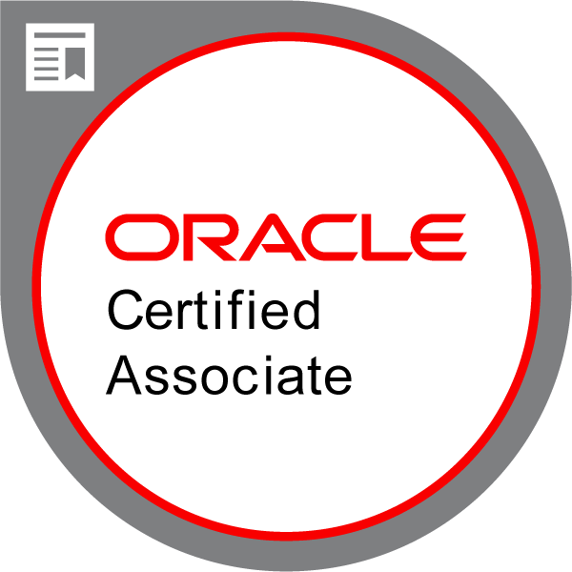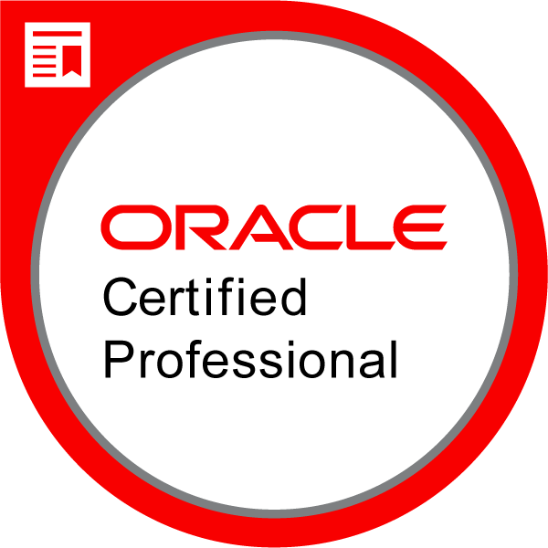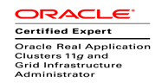

Name: Ilango Ponnangan
Experience: 12.5 Years s
Email: ilangosachin@gmail.com
Phone: 9380219769, Whatsapp 9788480464
LinkedIn: https://www.linkedin.com/in/ilango-p-49743112b/

12.5 years of experience as DBA/DEVOPS (RDBMS & NOSQL with Cloud DBA) with Cloud migration experience and having expert knowledge on Oracle 10g/11g/12c/19c with RAC, ASM, Data Guard, RMAN & Golden Gate, AWS and GCP Cloud. Having hands-on experience on DB Migration to Cloud, Database Installation, Upgrade, Patching, Backups and Performance Tuning and Providing DBA support on Production, Development and Test environments.

TECHNICAL SKILS

RDBMS: Oracle Database 10g/11g/12c/19c, MySQL, SQL Server, PostgreSQL, AWS RDS, GCP Cloud SQL,
NoSQL DB: MongoDB, DynamoDB
Cloud Technology: AWS, Google Cloud Platform (GCP), Azure, Kubernetes
Query Language: SQL, PL/SQL
Oracle Technology: Oracle Database 10g/11g/12c/19c, Oracle RAC, ASM, Data Guard, RMAN, Oracle Golden Gate, Transparent Data Encryption(TDE)
Oracle Tools & Utilities:Data Pump, Explain Plan, AWR, ADDM, Opatch, CRSCTL, SRVCTL, ASMCMD, CLUVFY, OCRCHECK, OCRCONFIG, OGGSCI, LogDump and OEM
Other Tools Worked: ServiceNow, Putty, Toad, SQL Developer, PagerDuty, Wiki, Jira, Control-M, IT360, Rally
DevOps Tools: Git, Github, Bitbucket, Ansible, Chef, Grafana, Promethous, Kubernetes
Operating Systems: Linux, Solaris-SPARC, HP-Ux, Windows, AIX
PROCESS: ITIL
TRAINING / CERTIFICATION

- Oracle Database 11g Administrator Certified Associate (OCA)
- Oracle Database 11g Administrator Certified Professional (OCP)
- Oracle Certified Expert, Oracle RAC 11g and Grid Infrastructure Administrator Certification (OCE)
- Completed Google Cloud Database Engineer certification course.
- ITIL 2011 Foundation Certificate in IT Service Management Certification.

Professional Summary

- Handling Database administration for 24*7 Production support and along with On-Call.

- Worked on Database migration from On-Premises to AWS Cloud and GCP Cloud.

- Architect and design new Oracle Database infrastructure as per business requirements.

- Knowledge on AWS Databases like RDS, Redshift, DynamoDB and GCP Databases like Cloud SQL, Big Query, Bigtable, Firestore and GCP Bare Metal Solution for Oracle.

- Migrating Oracle Databases from On-Premises to AWS Cloud by Zero downtime Migration using Golden Gate.

- Setting up Bi-Directional Oracle Golden Gate replication between On-Premises Data Centers to AWS Cloud.

- Setting up Oracle Golden Gate by Uni-Directional and Active-Active Bi-Directional method.

- Installing Oracle Database in RAC and Non-RAC environment.

- Installing and Upgrading Oracle Grid Infrastructure for RAC and Oracle Restart 11g to 12c with Zero Downtime.
- Upgrade Oracle Database from 12.2.0.1 to 19c using DBUA

- Migrate Oracle Database from AWS RDS to GCP Cloud SQL for PostgreSQL using AWS DMS and SCT services.
ss
- Migrated Oracle Database from 11.2.0.4 to 12.2.0.1 as Pluggable database using Full Transportable Export/Import and using RMAN with Convert Database.

- Familiar with Oracle 12c Multitenant Architecture and 12c New features.

- Experience in Creating 12c Container Database and Creating Pluggable database from PDBSeed, and from other PDBs

- Converting Container Database from Non-Container Database to Container Database.

- Experience in Unplugging and Plugging PDBs into same CDB and another CDB.

- Managing ASM Disks and Disk Groups and adding ASM disks to Disk Groups.

- Applying CPU/PSU Patches and Rolling Patches on RAC nodes using OPatch utility.

- Configured Active Data Guard and Created Physical Standby Database.

- Performed Data Guard Fail-Over and Fail-Back during Disaster Recovery as well as DR Test.

- Resolving Archive Log gaps on Standby database.

- Refresh the tables, Sachems and Full Database using Data Pump Export & Import.

- Experience in Cloning database using RMAN Active Duplicate and from RMAN Backups

- Performing Cold, Hot and RMAN Incremental Backup and Performing recovery of Oracle Database files in various recovery scenarios.

- Monitoring Database Performance using AWR Reports and ADDM Reports.

- Experience in Performance Tuning using EXPLAIN PLAN, SQLTRACE, TKPROF and SQL Tunning Advisor.

- Familiar with ITIL Processes, Incident, Change and Problem Management.

- Setting up MongoDB Replication and Sharding.

- Creating Database, Collections and performing CRUD operations in MongoDB.

Working History

Employer | Project name | Domain | Duration | Designation & Role
CGI India | APS All Payments Service | Banking | Nov 2023 to Til Date | Lead Database Administrator
Sabre Travel Technologies Pvt Ltd | Airlines planning & Scheduling | Travel | Dec 2019 – Nov 2023 | Sr Database Administrator
TechChefs Software Private Limited | Intuit- US | Finance | Aug 2018 – Nov 2019 | Sr Database Administrator
Manthan Software Service Pvt Ltd | Landmark Group - Dubai | Retail - Dubai | Nov 2017 to Aug 2018 | Database Administrator
Tata Consultancy Services | Xoserve-UK | Utility-Oil & Gas | June 2012 – Nov 2017 | IT Analyst (Oracle DBA)

Projects Summary

PROJECT 5 :
Organization: CGI, Bangalore
Duration: Nov 2023 to Till Date
Role : Lead Database Administrator
PROJECT NAME : APS All Payments Service, Canadas
PROJECT DOMAIN: Banking
PLATFORM : ORACLE 19c, SQL, PL/SQL, AWS Cloud, AZURE Cloud, Kubernetes, Grafana, Prometheus, MongoDB, Golden Gate, Oracle Data Guard, RMAN Backup & Recovery, TDE, AWS and AZURE Cloud.
Roles & Responsibilities:
- Managing Oracle 19c on Azure and AWS Kubernetes.
- Migrating oracle database from on-premises to Azure Kubernetes.
- Monitoring DB services through OEM 13c and Grafana panels.
- Managing Data Guard with FSFO and Far Sync instance across Multi cloud regions (Azure to AWS)
- Implementing TDE Encryption and perform Key rotation activity.
- Monitoring DB backups and resolve backup failure issues.
- Perform Data guard failover and switchover activities.
- Perform RMAN backup and recovery
- Perform DB flashback activities in case of deployment failure.
- Testing backup and recovery scenario.
- Setup Active-Active Bi-Directional Oracle Golden Gate replication.
- Tuning long running SQL queries.
- Setting up MongoDB Replication and Sharding.
- Creating Database, Collections and performing CRUD operations in MongoDB.

PROJECT 4:
Organization: Sabre Travel Technologies Pvt Ltd, Bangalore
Duration: Dec 2019 to Nov 2023
Role : Sr Database Administrator
PROJECT NAME : Airlines Planning & Scheduling, Fears Manager
PROJECT DOMAIN: Travel, US
PLATFORM : ORACLE 12c/19c, Linux, AWS Cloud, Google Cloud
Roles & Responsibilities:
- Migrating Oracle Database from On-Premises to AWS RDS using Data pump export and import.
- Database refresh from Prod to Non-prod Databases using Data pump and RMAN cloning.
- Migrate Oracle Database from AWS RDS to PostgreSQL in Google Cloud platform.
- Automate DB tasks using Git/Bitbucket.
- Proactively monitor database metrices to avoid any major incident.
- Consolidate multiple single Databases into single multitenant Database to save cloud usage cost.
- Upgrading Oracle RDS database from 12c to 19c with zero downtime.
- Monitoring DB services through OEM 13c
- Setting up MongoDB Replication and Sharding.
- Creating Database, Collections and performing CRUD operations in MongoDB.
- Managing and administering RAC 6 node cluster database on GCP BMS service.
- Adding node to RAC cluster and removing node from RAC Cluster
- Setup Active-Active Bi-Directional Oracle Golden Gate replication.
- Tuning long running SQL Queries by using Execution plan, TKPROF, Auto Trace and SQL Tunning advisor.

PROJECT 3:
Organization: TechChefs Software Private Limited, Bangalore
Project & Client: Intuit India
Role : Sr Database Administrator
PROJECT DOMAIN: Finance, US
Duration: Aug 2018 to Nov 2019
Technology: Oracle 11g/12c, RAC, ASM, OEM 13c, Golden Gate, AWS EC2, RDS, Dynamo DB, CloudFormation, CloudWatch, S3, SES
ENVIRONMENT: AWS Cloud, Linux

Roles & Responsibilities:
- Working on Oracle Database AWS Cloud Migration
- Migrating all Prod and Non-Prod Oracle Databases from On-Premises to AWS Cloud by Zero downtime Migration using Golden Gate.
- Setting up Bi-Directional Oracle Golden Gate replication between On-Premises Data Centers to AWS Cloud.
- Creating AWS EC2 and AWS RDS Instances through CloudFormation.
- Creating DynamoDB in AWS Cloud to support NoSQL Database.
- Creating Route 53 and assigning EC2 IP.
- Creating IAM role and policy for S3 Integration to allow Data Pump file transfer between Oracle RDS and S3.
- Database administration on Oracle, MYSQL, MSQL and Cassandra databases.
- Troubleshooting Golden Gate issues such as Oracle errors, Handling Exceptions to avoid process abends, Conflict detection and resolution.
- Adding ASM disks to ASM Disk Group
- Monitor production databases through OEM.
- Configure OEM on AWS Oracle RDS.
- Supporting Development to execute Database changes on production system.

PROJECT 2:
Organization: Manthan Software Service Pvt Ltd, Bangalore
PROJECT NAME : Landmark Group
PROJECT DOMAIN: Retail, Dubai
Role : Database Administrator
Duration: Nov 2017 to Aug 2018
PLATFORM : ORACLE 11g & 12c, Active Data Guard, RMAN, ASM, DATA PUMP, OEM 13c
ENVIRONMENT: Windows, AIX

Roles & Responsibilities:
- Upgrading Oracle Restart and Database from 11g to 12c.
- Upgrading and Migrating Oracle Database from 11.2.0.3 to 12.1.0.1 using Full Transportable EXPORT/IMPORT and using RMAN with Convert Database.
- Perform Daily Database, Data Guard and Clusterware Health check.
- Monitoring Tablespace and adding Datafile to Tablespace.
- Monthly Database refresh from Production to Pre Prod using Data Pump Export/Import.
- Taking Logical Backup of Schemas using Data Pump Export.
- Monitoring Database services using OEM 13c and resolve critical alerts.
- Monitoring Active Data Guard and resolving Archivelog gaps.
- Annual DR Drill and Perform Switch-Over and Switch- Back Activity.
- Generating Monthly Capacity Report to identify the Growth of Databases
- Performing RMAN Full Backup, Incremental Backup and Archivelog Backup.
- Monitoring ASM Disk Group usage and Adding Disks to Disk Group.
- Starting and Stopping OEM Agent during server restart activity.
- Handled P1, P2 incidents in On-Call Support.
- Resolving archive LOG gap in Standby database by RAMN incremental backup.

PROJECT 1:
Organization: Tata Consultancy Services, Bangalore
Duration: June 2012 to Nov 2017
Role : IT Analyst - DBA
PROJECT NAME : Xoserve
PROJECT DOMAIN: Utility, UK
PLATFORM : ORACLE 10g/11G, 12c, RMAN, Data Guard, Oracle Streams, RAC, Golden Gate
ENVIRONMENT: Linux, SUN SOLARIS, HP-Unix, AIX

Roles & Responsibilities:
- Database Creation and Maintenance on RAC and NON environment.
- User creation and providing necessary Roles, Privileges, and quota as per the Requirement.
- Moving data between databases using Data Pump Import, Export.
- Checking Alert log, trace files, listener log and other database job logs.
- Performed Database Cloning from Production to Test environment using RMAN.
- Performed Query Tuning by Explain Plan and Tkprof utilities.
- Monitoring and optimizing the performance of the Database through AWR, ADDM.
- Taking backups using RMAN (As per backup strategy)
- Resolving archive log gaps.
- Configured Data guard (DR-Site) for a Production Database and Creating Standby Database.
- Job scheduling using Control-Ms
- Monitoring Tablespaces and adding Data file to Tablespace.
- Resolving Table Fragmentation, Row Migration and Row Chaining.
- Refresh tables, schema from Production to Pre-Production using Data Pumps.
- Handled P1, P2 Incident tickets and Working on Change and Problem managements.

EDUCATION

BE., Computer Science and Engineering from Thiagarajar Collage of Engineering, Madurai, Tamil Nadu. – Pass out – 2012

PERSONAL DETAILS
Name : Ilango Ponnangan
Nationality: Indian
Language Known: Tamil, English (Read, Write, Speak)
Residence: NCN Platina, 113, 1sr floor, Balagre road, Varthur Bangalore, Karnataka - 560087
Permanent Address : V.Perumal patti, Usilampatti(post), Madurai, Tamil Nadu- 625532
Contact No: 9788480464, 9380219769

