
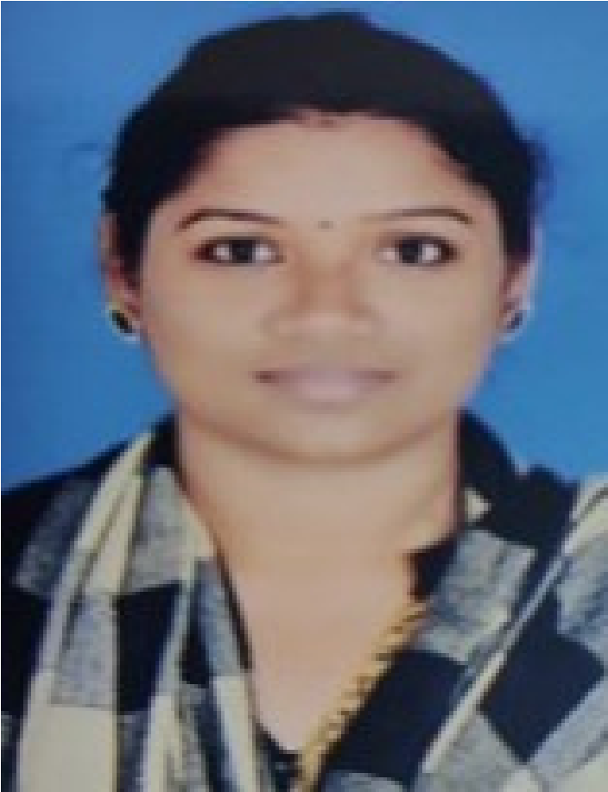
CONTACT
MEENAKSHI SELVARAJ
MIS / HR EXECUTIVE
Analytical, accomplished, professional Data Analyst

with over 5 years of experience in MIS and HR
operations. Skilled in the areas of report generation,
data analytics and orientating new employees and
training existing employees. Motivated and eager to
advance my career with a growth-oriented,
technically-advanced organization. Strong leadership
ability and good time management skills.
WORK EXPERIENCES
MIS / HR Executive

-
Reliance Retail,Madurai,TamilNadu
June 2008 - September 2010
Responsible for the Warehouse Overall
Inventory
Core team Member of Physical Inventory&
Shutdown inventory.
Administrating the health of the
warehouse.

PERSONAL
DETAILS
Date of Birth
29
th August,
1985
Nationality
Indian
Marital Status
Married
Address
G02,B Block,Celebrity Srivarus
Apartment,Near Thogur
cross,Opposite to Munishwara
Temple,
Electronic City Phase I
Bangalore - 560100.
EDUCATION
Bachelor of Computer
Science in Thiagarajar
College (Madurai Kamaraj
University -

(2002 - 2005)
+91-9353498647
meenakshi.bangalore123@gmail.com
LANGUAGES
English
Tamil
End-to-end recruitment process. And
onboarding formalities.

Screen incoming resumes and application
forms.
Interview candidates (via phone, video and in-
person).
Design and update job descriptions
Craft recruiting emails to attract
passive candidates,


MIS Executive

-
e4e Nittany Healthcare
BPO,Chennai,TamilNadu.
SKILLS
Responsible in sending the daily MIS Report
to all the senior managers and CEO.
Daily project status report and number of
people worked in each project.

Employee wise productivity details report.
June 2005 - May 2008

Assisting with training and onboarding process.

Maintaining, managing and updating software.
Supervising the development and maintenance of websites
BOOTSTRAP
JAVA
JAVASCRIPT
SQL
MS EXCEL & WORD
HTML & CSS
Shortlisting resumes of our students, escalating to the technical team & onboarding formalities
Completed Java Full stack developer Course at Besant
HR & MIS Executive - September 2022 to October 2023 - Besant Technologies

