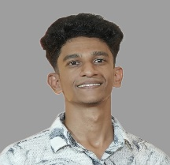 | VISHNU SURESH |  |  |  | 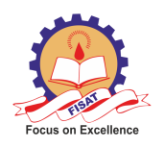
 |  | vishnu15032002@gmail.com |  | 6238713899

PERSONAL PROFILE
A motivated Electrical and Electronics Engineering student with a solid academic foundation and hands-on experience in testing and system analysis. Skilled in ensuring product reliability, safety compliance, and troubleshooting. A proactive team player with strong communication abilities and a passion for innovative problem-solving in the field of electrical engineering. Eager to apply technical skills and contribute to real-world projects in a dynamic engineering environment.
ACADEMIC CREDENTIALS
Federal Institute of Science and Technology, Ernakulam
Bachelor of Technology, Electrical and Electronics Engineering, May 2025
Maharaja’s Technological Institute, Thrissur
Diploma in Electrical and Electronics Engineering, CGPA: 7, Nov 2021
TECHNICAL AREAS OF INTEREST
- Technical Skills: MATLAB| PSCAD | Arduino | Proteus | C Programming
CERTIFICATIONS AND VALUE-ADDED COURSES
- Business English Certificate – B1 Level, Cambridge Assessments
- Certificate on Embedded Systems
INTERNSHIP AND WORK EXPERIENCES
- Management Consultant
SFO Technologies, Kakkanad
Feb 2022 – May 2022
- Performed PCB testing, Circuit Testing, Functional Testing ensuring quality.
- Internship - 110KV Substation, Chalakudy, Thrissur May-June 2023
ACADEMIC PROJECTS
- Automatic Vehicle Accident Detention and Prevention System - 2021
- Automatic Fan Regulation with Temperature Sensing - 2024
SEMINARS AND PAPER PRESENTATIONS
- Regenerative Braking in Electric Vehicles
- Rapid and Flexible 3D Printed Finger Prostheses
VOLUNTEERING EXPERIENCE
- Tutor - trained students in the age group of 10-18 in multiple subjects including mathematics and science
- Volunteer in inter college fest at Federal Institute of Science and Technology
POSITIONS OF RESPONSIBILITY
- Local Youth Club Secretary, Phoenix Club
- Executive Committee Member, Residents Association Mangalathara
PERSONAL TRAITS
- Hard working
- Problem solving
- Time management
- Leadership
- Team work
- Communication
HOBBIES AND INTERESTS
- Local Youth Club Secretary
- Travelling
- Active Football Player
- Dancing

