telemetry TX

Documentation of

Electronics

*Written by Simone Tollardo*

14/05/2022

# 

Abstract 2

Project Structure 2

Power Supply 2

NRF24 2

RFX24 3

Images 3

Revision History 5

V1.0 - 14/05/2022 5

# Abstract

The Telemetry TX pcb was developed to have a “raw” low latency telemetry system complementary to the primary one. The choice of components has been meticulously analysed considering the following constraints:

1. Transmission speed ≥ 2MB / s (1MB / s * 2 CAN bus)
2. Powers and frequencies allowed according to national and international regulations
3. Widest range possible

The choice fell on a very famous 2.4GHz transceiver, namely the NRF24L01+ from Nordic Semiconductors. The goal of the pcb is to bring the quality of the design and components, and therefore of the signal quality, to the highest possible level, in order to ensure good signal reception hundreds of meters away from Fenice.

The pcb take advantage of a four-layer PCB stackup (defined in the Drawings.pdf sheet) with controlled impedance tracks and carefully thought out ground and 3.3V planes.

# Project Structure

The project can be divided into three sections:

1. Power Supply
2. NRF24
3. RFX24

## Power Supply

The Power Supply section is based on our latest design of DCDC Buck Converter "Tex DCDC", which will ensure all the current needed by the rest of the board, paying particular attention to providing the large current peaks required during transmission, often not considered in the low-cost NRF24 commercial boards which in fact present various problems for this reason.

To protect the circuits downstream of the regulator, there is a TVS diode with Vbr = 4V and a 500mA hold current polyfuse.

The power supply of the DCDC comes from a Molex Microfit 2x1 connector which carries the 12V from the Fenice LV battery pack (downstream of the regulator).

In this section there is also the IDC 7x2 connector coming from the Rasp Shield V2.0 pcb with the relative bi-directional protection TVS.

A LED has been provided to be able to quickly check the presence of power in the 3.3V rail.

## NRF24

The second section integrates the NRF24L01+ transceiver module and, as already mentioned, aims to ensure the highest possible signal integrity. For this purpose, separate filtering has been provided for each power pin and a strong focus has been placed on the layout, cared for every detail following the constraints and rules typical of radiofrequency circuits such as impedance-controlled tracks and so on.

For the same reasons, the impedance matching network using discrete passive components was replaced with a Balun-Filter by Johanson Technology and an EMI Gasket was added, which will cover the two sections NRF24 and RFX24. A dual NMOS with two LED diodes has been added to display the status of the transceiver (RX or TX).

## RFX24

The RFX24 section integrates a bidirectional amplifier, a Low Noise Amplifier with 12dB in reception and a Power Amplifier with 25dB of gain and 22dBm maximum output in transmission.

Here, too, particular attention has been paid to the quality of the power supply signal of the chip, by placing adequate filters on the 3.3V rail.

The output of the module is conducted towards an integrated Johanson Technology band pass filter centered at 2.45GHz and then towards the SMA connector which will carry the signal towards the dipole antenna.

All the RF signal traces have been sized considering the desired impedance of 50ohm.

# Images

Telemetry TX pcb rendering.

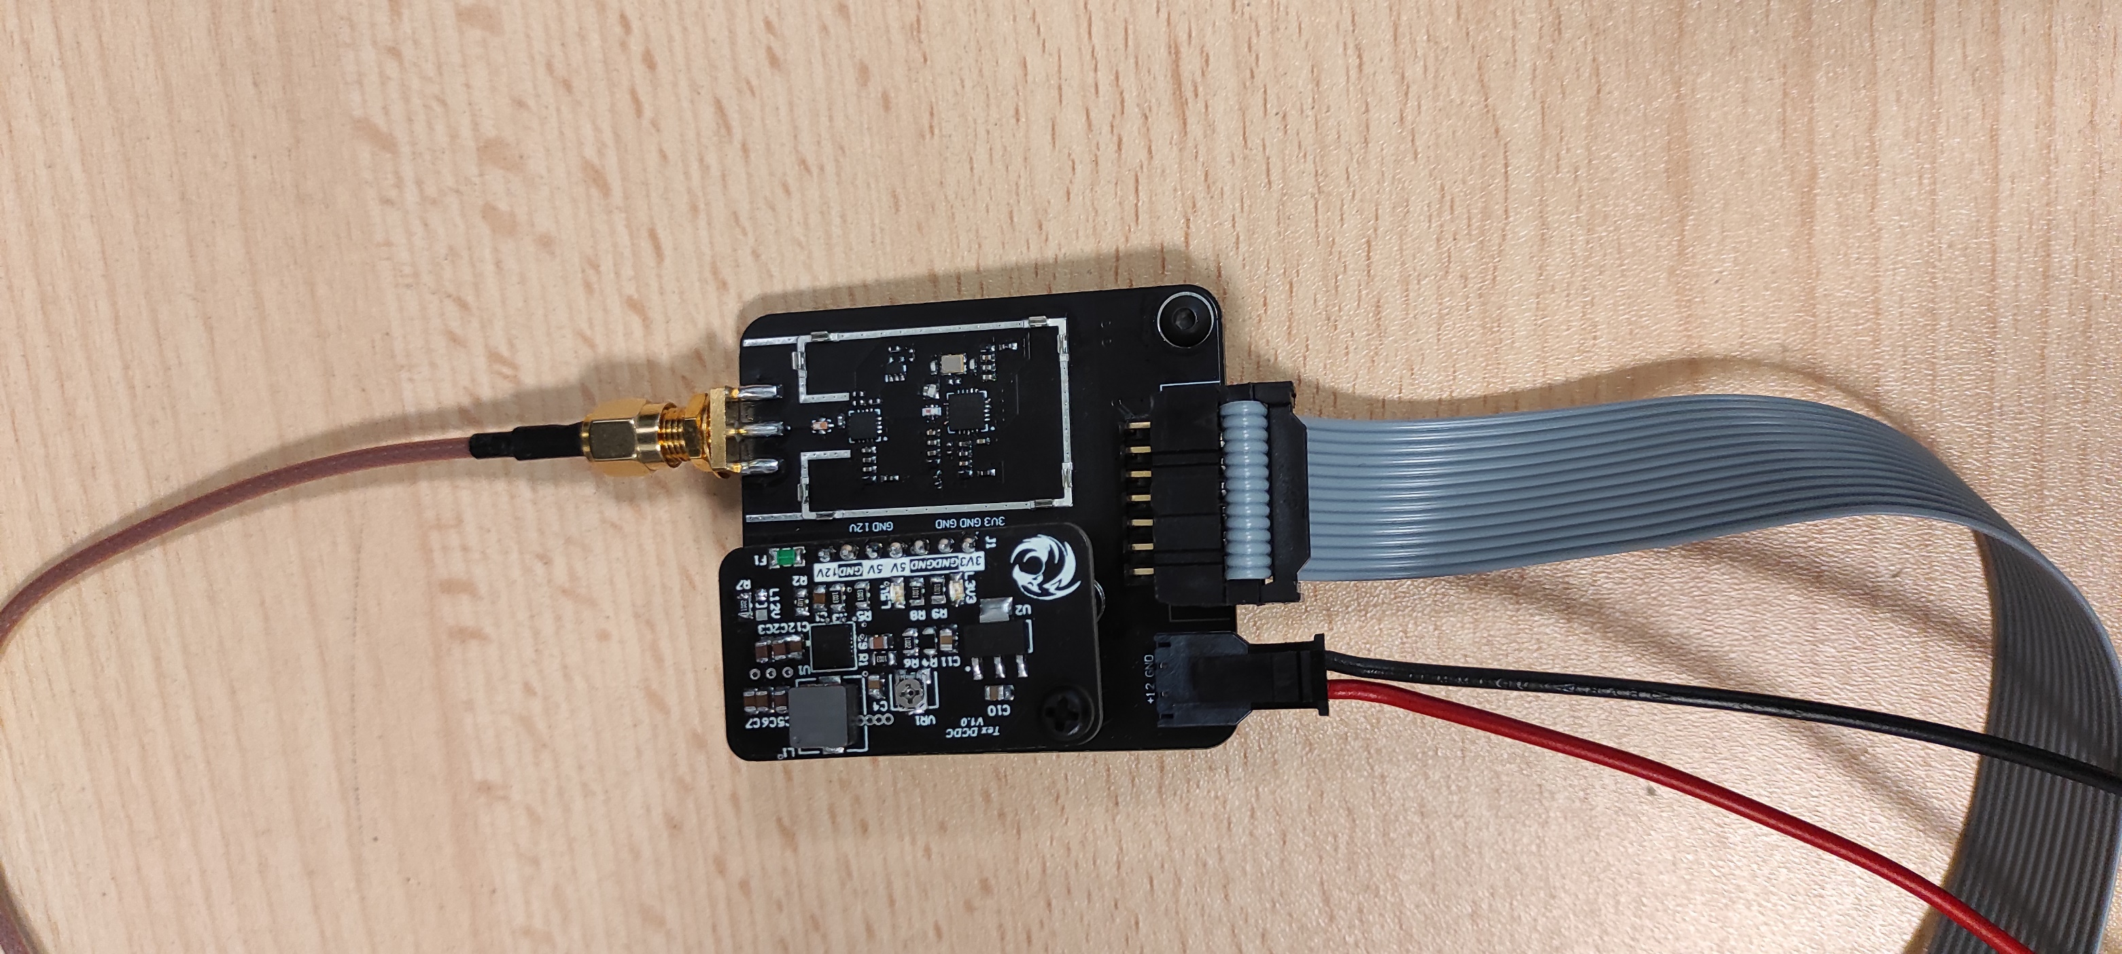

Telemetry TX pcb without EMI gasket.

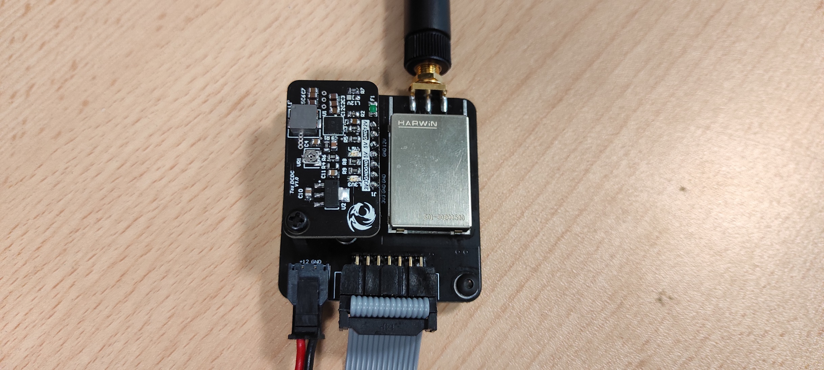

Telemetry TX pcb completed.

# Revision History

## V1.0 - 14/05/2022

* Initial release.