Introduction
There are a lot of time management programs out there. Personally, I use Microsoft Outlook to manage my general calendar and for general-purpose task management. I also use freeware program called Personal Reminder for general-purpose daily, weekly, and monthly reoccurring reminders.
What is missing from my time-management arsenal is a tool to quickly set up same-day, one-use-only, reminders. For my 5-year-old computer, Microsoft Outlook is a resource behemoth and I shut it down every chance I get. Personal Reminder is OK but it has several idiosyncrasies that make it difficult to tolerate as a short-term reminder program. I created QuickReminder to fill the gap.
QuickReminder
Key features:
- Quick Add. New reminders can be quickly added by using a global hotkey (default hotkey is Ctrl+Alt+R) or by double-clicking on the tray icon. Although the mouse can be used, the dialog was designed for quick keyboard entry and navigation. Reminder time can be entered as a countdown (hours, minutes, seconds) or as a date/time.
- Friendly alarms. Yes, the alarms do take up screen real estate and they do make a noise but the alarm windows are relatively small and they don't steal focus when displayed. If desired, the alarm text will be spoken to you when the alarm goes off.
- Snooze. Reminder alarms can be snoozed to a future time. You can select from a list of snooze times or enter your own custom snooze time.
- Reminder List. To help manage pending reminders, a Reminder List window is provided. From this window you can hold, edit, restart, and delete individual reminders.
Screenshots
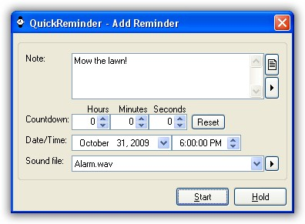
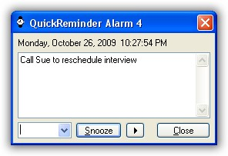
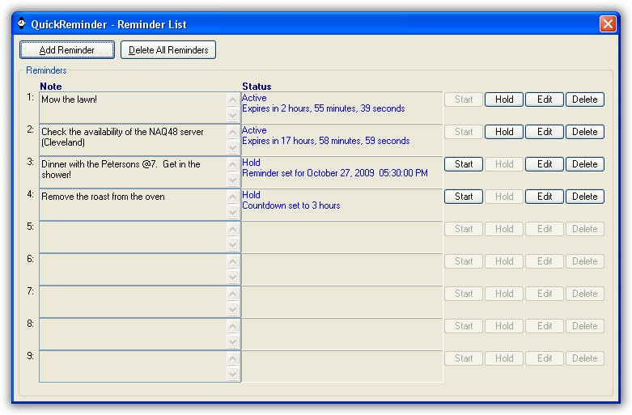
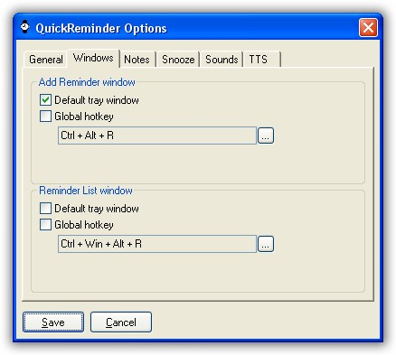
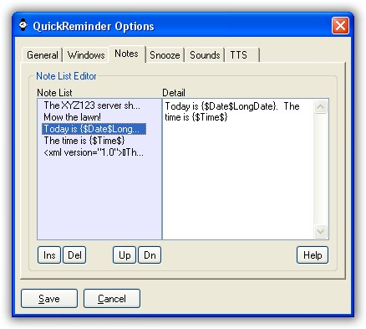
The Code
The pertinent files are as follows:
Project: QuickReminder.zip (Includes source, icons, and sounds)
Documentation: Future
Requirements
To use the Text-To-Speech (TTS) feature, Microsoft Speech SDK 5.1 must be installed if using any Windows version earlier than Windows XP.
http://tinyurl.com/yptaoo
Note: The Microsoft Speech SDK 5.1 installation includes two additional voices (Microsoft Mike and Microsoft Mary) so it should be worth the trouble to install it even if you are using Window XP+.
Text-To-Speech (TTS)
A few TTS considerations:
- Optional. The option to speak the note text when an alarm is raised is not enabled by default. Go to the Options window ("TTS" tab) to enable or change this option.
- Priority. The Priority level defines the order in which the TTS engine processes speech requests. There are three TTS priorities:

  - Normal. This is the standard TTS priority used by most applications.
  - Alert. If this priority is used, the alarm will interrupt (pause) any other normal TTS voices. After the TTS engine has finished speaking, any interrupted voices will resume speaking. This is the recommended priority for this program.
  - Over. If this priority is used, the alarm voice will speak simultaneously with any other TTS voices.

- XML. The alarm note text can include XML which can be used to instruct the TTS engine to change speed, volume, pronunciation, etc. If you're not sure about the capabilities or the syntax, the following is an XML TTS Tutorial (SAPI 5.3):
http://tinyurl.com/yk7b4nm
Be sure to test the XML code before using it in an active alarm. If the XML contains syntax errors, it may cause the script to fail (not likely) or it may generate a COM error.
- Voices. A specific TTS voice (Ex: Microsoft Mike) can be selected for the application. Go to the Options window ("TTS" tab) to select a voice. Individual voices for each alarm is not supported, however, the note text can include XML instructions to indicate which voice is to be used.
- Metadata. The Note text can contain date/time metadata which is converted in real-time for the TTS engine when the alarm window is displayed. The format is {$Date$X} or {$Time$X} where X is an AutoHotkey date/time format. See the AutoHotkey documentation (keyword: FormatTime) for a list of date/time formats.
Note: If X is blank/null when using the $Date$ key, Ex: {$Date$}, normal formatting rules are observed. However, if X is blank/null when using the $Time$ key, Ex: {$Time$}, the "Time" date/time format is automatically used, i.e. {$Time$Time}. The "Time" format is a time representation for the user's locale, such as 5:26 PM.
A few usage examples:
Today is {$Date$LongDate}.
The time is {$Time$}.
The current month is {$Date$MMMM}.
It is the {$Date$d}th day of the month.
The year is {$Date$yyyy}.
Issues/Considerations
- External functions. This script uses a number of external functions which have been included in a "_Function" folders. Some of the functions are mine and should be clearly marked and documented. Functions written by others should be clearly marked but may contain custom modifications. Thanks to the original authors for sharing their work.
- Limited locale support. A few of the program's date/time fields support the user's locale settings but most use a static format. Sorry 'bout that.
- Limited documentation. With the exception of the information in this post, documentation/help is currently limited to a few tooltips and a Help button in the Options window ("Note" tab). Be sure to read the release notes for additional tips.
---------------------------------------------------------------------------
v0.1 (Alpha/Preview)
Original release.
v0.2 (Preview)
Changes to the Add/Edit Reminder window:
- Added Hold button. This button adds a Reminder but does not start it.
- Added Sound DropDownList control to allow the user to select a custom sound file per Reminder.
Changes to the Reminder List window:
- Renamed the Stop All Reminders button to Delete All Reminders. This button deletes all Reminders regardless of status.
- The Note field can no longer be modified from this window.
- Removed the DateTime field for each Reminder.
- Removed the Stop button for each Reminder.
- The Status field has been enlarged. The script now displays more information in this field for the "Active" and "Hold" modes.
- Added Hold button for each Reminder. This button changes the status of a Reminder from "Active" to "Hold". This button has a similar function as the former Stop button.
- Added Edit button for each Reminder. This button changes the status of a Reminder from "Active" to "Hold" and then opens the Edit Reminder window so that the Reminder can be modified.
- Added the Delete button to remove a Reminder.
General:
- Added more sample Alarm sound files.
Installation notes:
- Delete all files from older version (if any) before installing new version.
v0.3 (Preview)
Changes to Alarm windows:
- Snooze button set as the default control (activates with the Enter key). (thanks HotKeyIt)
- Snooze period can now include days and weeks. Ex: 2 days, 1 week
Changes to the Add/Edit Reminder window:
- The Note field is now multi-line Edit field to match the Alarm and Reminder List windows. (thanks HotKeyIt)
- Added hotkey (F2) to pop-up the list of pre-defined notes (See the Options window)
- DateTime field has now been split up into separate Date and Time fields. (thanks SoggyDog)
- Added hotkey (Ctrl+T) to jump directly to the Time field.
Changes to the Reminder List window:
- If there are any active reminders, the request to "Delete All Reminders" is confirmed before proceeding.
General:
- Added Options (aka "Preferences") window. Many program options can now be set/changed using this feature.
- Added About... window to display the current program version.
v0.4 (Preview)
New Features:
- Added Text-To-Speech (TTS) option that will speak the text note when the reminder window is displayed. (SAPI5 required)
- The Note text can now contain date/time metadata. See the Text-To-Speech (TTS) section for more information..
Changes to the Add/Edit Reminder window:
- Added hotkey (Ctrl+S) that will add the current note to the end of Note List. Blank and duplicate notes are automatically discarded. The Note list can be edited from the Options window.
- Added confirm dialog when entering more than 99 hours or 199 minutes or 199 seconds.
- Added button to display the list of user-defined notes.
- Added button to speak/stop speaking the note text.
- Added button to play/stop playing the selected alarm sound.
- The selected alarm sound file is automatically played when changed by the user. (thanks ScottMattes)
- Added tooltips for the buttons that don't have readable labels (thanks Drugwash)
Changes to the Reminder List window:
- Fix: Changes to resolve minor button focus problems.
- "Hold" sound is now played when "Edit" button is pressed to indicate that the reminder is on hold until the start button is pressed.
Changes to the Options window:
- Fix: Minor display issues fixed in the HotkeyGUI window (thanks Drugwash)
- Added "Play alarm sound" option.
- Added "Play alarm nag sound" option.
- Added "Alarm nag sound interval" option.
- Added "Speak note text on Alarm" option. If selected, the contents of the note text will be spoken using the Text-To-Speech engine when the alarm window is displayed.
- Added "Voice" option. This option allows you to choose the Text-To-Speech voice that will be used when speaking the note text.
- Added "Priority" option that will allow you to chose the priority that is used when speaking the note text.
General:
- Added option to start QuickReminder when Windows starts. This option is only available if running the compiled script.
- Tray tooltip is now updated to reflect the current number of reminders.

