The Importance in Species Axial Length Impacting the Evolution of the Eye

Elizabeth Gramling

Dr. Mitchell, BIO 461

West Virginia University Institute of Technology

**Introduction**

The eye is an incredible organ that can translate and interpret information found in the world around us. It is composed of a cornea, ocular muscles, a crystallin lens, and three layers that help the brain receive nerve impulses by ocular nerve. Because this is such a complex network, genetic and environmental factors have played a key role in refractive errors in humans such as myopia. Myopia involves the elongation of the axial length, the distance from the front of the eye to the back of the eye. An elongated axial length creates blurry images, due to the light entering the eye, falling short of the focal point found on the retina (Quinn et. al., 1999). This is an issue because it directly effects sensory experiences and interpretations, where overall safety becomes at risk. Elongated axial lengths result in myopic cases can be commonly found in humans, but what about other species? Within the evolution of the eye, is axial length found increasing amongst various animals such as fish, lizards, birds or other mammals? Obtaining information of each of these species under consideration of their environmental stimuli, a lack of axial length change and inability to develop a refractive error could be of use to the myopic increase in humans. My hypothesis is, if no correlation can be found between environmental conditions or stimuli and increasing axial length of various species, these findings can be used to help the development of myopic deficiencies in humans.

**Fish Eye**

Fish eyes have some similarities to human eyes: lens, rod and cone cells. The lens of a fish is found to be spherical/oval shaped and is responsible for the light refraction (Piatigorsky, 2001). Developmentally, these lenses aren’t flexible and do not change shape, so fish must focus on objects by moving their lens closer to the retina or further away from the retina. The movement of the lens gives reason to believe that axial length and myopic cases should not affect the visual clarity of the fish.

*Methods*

To see if environmental stimulus effected the elongation of fish axial length, an experimental model was developed by Collery and other researchers. This model was developed by the concept of “dark-rearing” a strategy where light deprivation could be used to induce axial length elongation. Zebrafish (*Danio rerio*) were obtained and grouped by light cycles, one group exposed to normal light, and the other group restricted from light. These habitats were maintained for over four months, when eye measurements were taken. Axial length of the two groups of zebrafish were obtained by SD-OCT, also known as spectral domain-optical coherence tomography. The figures were generated using RStudio, package plot().

*Figure 1. Zebra Fish Axial Length.* The blue points represent individual Zebra fish, with their axial length measurements along the x-axis, recorded in millimeters. Data collected from Collery, 2014.

*Figure 1. Zebra Fish Axial Length.* The blue points represent the individual Zebrafish that had their axial lengths measured in millimeters. These Zebrafish contain a combination of myopic, normal, and hyperopic errors. The myopic measurements can be seen at 1.5 and above, hyperopic recorded at 0.5 and below, with a normal rage found within the middle. Data collected from Collery, 2014.

*Results and Discussion*

While the majority of the Zebra fish axial length data is found between 0.5 and 1.5 millimeters, Collery and his other researchers were able to obtain measurements at extremes such as below 0.5 millimeters and above 1.5 millimeters. This displays a strong refractive error, where axial lengths were found to be too long (measurements of 1.5 and above) and too short (0.5 and below). Based on the collected data, the *Figure 1* displays that the axial length of a zebra may elongate, and overgrowth can allow myopia to occur in fish. Using this information, fish eyes hold some similarity to human eyes, where environmental stimuli, influences a shift in axial length size. This could suggest further experimental models that could help better explain the environmental stress patterns placed on the eye in relation to refractive errors.

**Lizard Eye**

Lizards have a sclerotic ring. Because this structure is placed in the front of the eye, the ability of any axial length elongation would seem to be physically prevented. The lizard eye develops based on its behaviorisms, nocturnal or diurnal.

*Methods*

Various lizard species of nocturnal and diurnal behaviorisms were obtained, all preserved in ethanol solutions. The eyes of the lizards were extracted using forceps, cleaned, and injected with a preservative to fully inflate the eye. At this point, axial lengths were measured and recorded in millimeters. The figures were generated using RStudio, package stripchart().

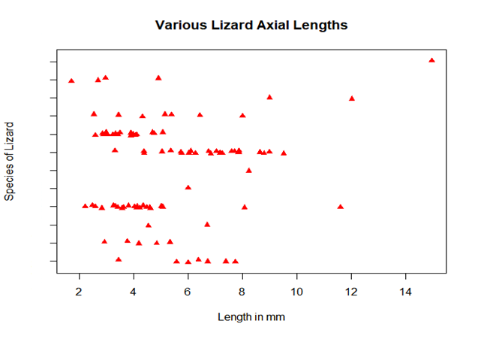

*Figure 2. Various Lizard Axial Lengths*. Each red triangle represents a single lizard, where each tick along the y-axis separates the various lizard species. The x-axis shows the recorded axial length in millimeters. Data collected by Hall, 2009.

*Results and Discussion*

*Figure 2* displays one extreme, represented on the first tick, recorded at an axial length passed fourteen millimeters. This can be interpreted by either an extreme case of myopia, or a larger eye in ratio to a larger body size. This tick was represented by the species *Sphenodon punctatus*, also known as Tuatara, known to be New Zealand’s largest reptile. Because of the high variance between lizard species sizes, its difficult to interpret what is seen to be abnormal when comparing each species tick to the one above or below it. However, because each tick represents an individual species, it is easier to locate the outliers within the groups. The disadvantage here, results back to the possibility of a larger body size, age, or sex of the lizard. With extended research, Lina Roth conducted an experiment using photorefractometry, suggesting that the eyes of a day gecko have myopic parts. These parts of the eye are separated into zones of multiple refractive powers (Roth, 2009).

**Bird Eye**

Bird eyes, like lizard eyes have a sclerotic ring, flexibility of the lens, and diurnal and nocturnal behaviors (Hall, 2008). Birds eyes hold the ability to use accommodation, which describes the rapid change used to alter focus on an object. With large eyes and a wide visual field, bird visual acuity must be sharp to forage and avoid obstacles while in flight.

*Methods*

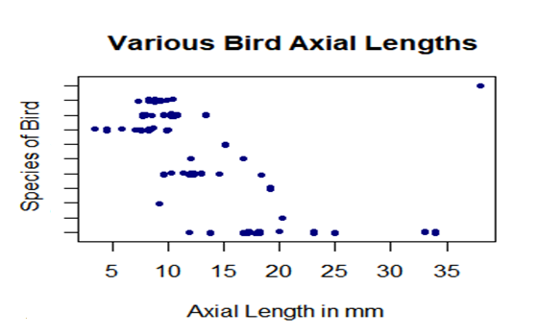 Data was obtained from various species of birds, both diurnal and nocturnal, preserved in alcohol. The eye was removed, cleaned, and injected with a preservative until fully inflated, prepared similarly to the lizard eyes. Axial lengths were then able to be recorded to the nearest 0.01millimeter. Figures were generated using RStudio, package stripchart().

*Figure 3. Various Bird Axial Lengths.* The graph above shows the plotted points of each individual bird axial length recorded in millimeters. Each tick along the y-axis represents a different species of bird. Data collected by Hall, 2008.

*Results and Discussion*

Within *Figure 3*, the most notable point is represented by a single blue dot along the first tick, passed thirty-five millimeters. This axial length was recorded from the classification *Struthioniformes*, specifically, an axial length of an ostrich. This strongly suggests the influence of body size and axial length ratios. The collected data shows the variability between bird species axial length, and similar to lizards, birds have sclerotic rings and are also found in various sizes. This effects the comparison of the collected data where there is ambiguity between elongated axial lengths due to environmental stimuli or larger axial lengths due to their body size ratio. Though extended research on myopic birds suggest cases can be found smaller birds, where their eyes are too small to acquire quality vision at night and require them to function in diurnal behaviors. This forced behavior takes a toll on their nocturnally developed eyes, enabling elongation of axial lengths to become present.

**Dog Eyes**

Contrary to common misconception, dogs are not colorblind but instead contain cone cells limited to blue and yellow wave lengths. A high concentration of rod cells increases visual acuity in the dark. Unlike humans, dog eyes contain a special tissue called tapetum lucidum, where the retina is able to gain extra light as needed.

*Methods*

German Shepherd (*Canis lupus familiaris*), no preference to their job as guide and non-guide dogs, were obtained and examined for refractive errors. Using a Storz Biometric Ruler, digitally computed axial lengths were measured and recorded of each dog. The data recorded was used to generate a plot in RStudio using the package, stripchart().

*Results and Discussion*

*Figure 4. German Shepherd Axial Lengths*. The points represent German Shepherd subjects. Axial lengths were recorded in millimeters. Data was provided by Murphey and Manis, 1992.

The data displayed in Figure 4 presents a heavy cluster of points ranging from 21.5 millimeters to about 22.55 millimeters. This represents the average range for German Shepherd axial lengths. The outliers above and blow these points can be assumed to be measurements of German Shepherd dogs with visual issues. This data was collected with knowledge that this specific breed of dog is known for developing myopic vision. However, within the figure, it seems as though there were more German Shepherd dogs that were below the range of the heavy cluster (suggesting many of the dogs were hyperopic). A possible explanation for this could be related to the age, gender, onset eye disease, or could even be a miscalibration by the digital axial length recorded by the Storz Biometric Reader.

**Conclusion**

Elongated axial lengths strike visual issues amongst humans, with numbers of myopic cases increasing yearly. Because myopic cases are becoming more prevalent, it seems to be that the elongation of the axial length is the next pathway regarding the evolution of the human eye. Because there have been many different adaptations within the anatomical eyes of other species, a solution to myopia could be held within a different species’ eye evolutionary pathway. Using information gathered from eye evolution of other species, data could suggest some insight to delaying the prevalence of myopia in humans. My hypothesis proposed that if no correlation can be found between environmental conditions/stimuli and an increasing axial length within various species, these findings could be used to develop strategies to delay or even prevent myopic cases in humans. Based on the overall results, dog eyes and fish eyes both present an increase in axial length in correlation of environmental factors. One could believe that there would be very minimal axial length variation within birds and lizards due to the presence of a sclerotic ring. Even with all the lizard and bird axial length data, it was difficult to pin-point elongated axial length measurements due to the influence of potential body size to axial length ratio. Because environmental stimuli can be found in correlation to elongated axial lengths of some species, it is possible to suggest that these findings can be used to further understand the increasing number of elongated axial lengths in humans.

**Works Cited**

Collery, Ross F et al. “Rapid, accurate, and non-invasive measurement of zebrafish axial length and other eye dimensions using SD-OCT allows longitudinal analysis of myopia and emmetropization.” PloS one vol. 9,10 e110699. 21 Oct. 2014, doi:10.1371/journal.pone.0110699

Hall, Margaret I. “The anatomical relationships between the avian eye, orbit and sclerotic ring: implications for inferring activity patterns in extinct birds.” Journal of anatomy vol. 212,6 (2008): 781-94. doi:10.1111/j.1469-7580.2008.00897.x

Hall MI. The relationship between the lizard eye and associated bony features:

a cautionary note for interpreting fossil activity patterns. Anat Rec (Hoboken).

2009 Jun;292(6):798-812. doi: 10.1002/ar.20889. PubMed PMID: 19462447.

Murphy, C J, et al. “Myopia and Refractive Error in Dogs.” Investigative Ophthalmology &amp; Visual Science, U.S. National Library of Medicine, July 1992, [www.ncbi.nlm.nih.gov/pubmed/1634344](http://www.ncbi.nlm.nih.gov/pubmed/1634344).

Piatigorsky J. “Enigma of the abundant water-soluble cytoplasmic proteins of the cornea: the "refracton" hypothesis.” Cornea. 2001 Nov; 20(8):853-8.

Quinn, Graham E., et al. “Myopia and Ambient Lighting at Night.” Nature News, Nature Publishing Group, 1999, [www.nature.com/articles/20094](http://www.nature.com/articles/20094).

Roth, Lina S. V., et al. “The Pupils and Optical Systems of Gecko Eyes.” Journal of Vision, The Association for Research in Vision and Ophthalmology, 1 Mar. 2009, jov.arvojournals.org/article.aspx?articleid=2193495.