Currently, Big Mountain Resort charges $81 per adult ticket. Based on an analysis of other resorts nationwide and how Big Mountain compares across various key features, I recommend Big Mountain consider increasing its ticket price by up to $15, all else equal.

Big Mountain compares higher than most other resorts among various features that, empirically, exhibit a strong association with ticket price, such as height of vertical drop, amount of snow-making area, number of runs, and number of high-speed quad lifts.

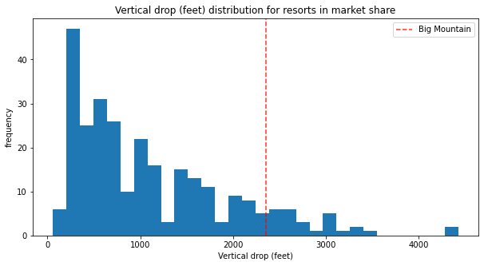

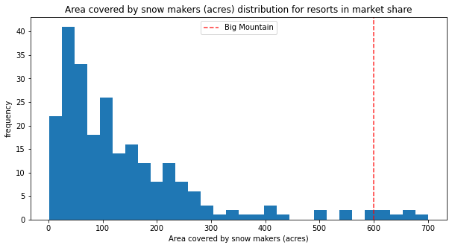

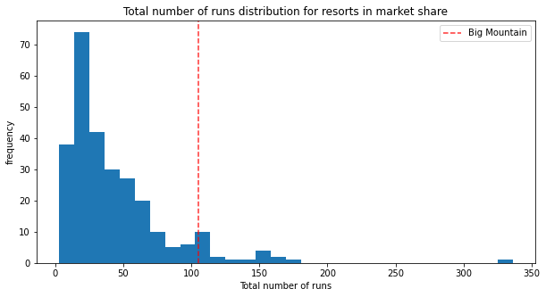

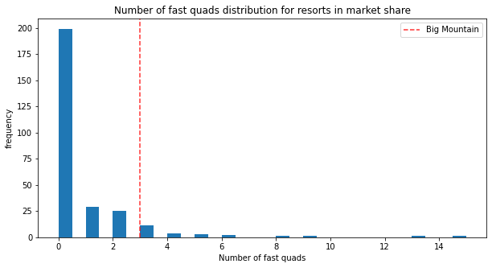

With regard to the additional feature changes Big Mountain is considering, we have the following observations based on our model.

Scenario 1: the data suggest that run closures at Big Mountain should impact its ticket price, with an average decrease of about $0.15 for each of the first five closures, and slightly larger decreases after that. The resulting loss of revenue from each closure should be weighed against the operating cost savings.

Scenario 2: the data suggest that the scenario 2 changes would support a price increase of about $2, resulting in an increase in seasonal revenue of roughly $3.5 million. This should again be weighed against the incremental cost.

Scenario 3: our model may be limited in its ability to evaluate the potential ticket price impact of expanding snow-making coverage to the new run in scenario 2. While the incremental area that would be covered (2 acres) is too small to be considered meaningful by our model, if the new run would be considered a significant attraction (e.g., because it extends the total available vertical drop), then it may make sense to implement this.

Scenario 4: our model doesn’t consider length of the longest run to be among the most important features impacting ticket price, so it does not indicate that the extension considered in this scenario would support a price increase.