DIAGNOSTIC REPORT
Bundle-Aware Causal Policy
Diagnostic evaluation of a causal policy simulation for food delivery promotion targeting
PROJECT Food Delivery Causal Policy Simulation
AUTHOR Deepak Pandey
DATE 30 September 2026
VERSION 1.0

1. Purpose of This Report
This document reports the diagnostic evaluation of a causal policy simulation for food delivery promotion targeting. It covers:
- Causal validation of treatment-effect estimation
- Model validation against ground truth
- Uplift targeting quality
- Policy comparison across three strategies
- Bundle diversity, cannibalization, and guardrail metrics
- Robustness checks across folds, seeds, and conversion-rate assumptions
- Known limitations
Scope: All results are from a synthetic simulator. They are not estimates of real-world business impact. The report evaluates the decision architecture and its internal consistency.

2. System Overview
The pipeline has four stages:
Stage | Description
Data generation | Synthetic customers, restaurants, catalog, sessions, and outcomes
Causal design | Observational log, randomized log, and ground-truth potential outcomes
Modeling | Dose-response model trained on randomized data
Policy evaluation | Backtest of three promotion policies

Dataset scale (default run):
Entity | Count
Customers | 5,000
Restaurants | 200
Bundles | 587
Sessions | 37,627
Backtest sessions | 5,000 (per policy)

3. Causal Validation

3.1 Treatment-effect estimates
Three estimators were compared against simulator ground truth.
Estimator | Revenue ATE | Revenue bias | Margin ATE | Margin bias
Observational | ₹194.85 | −₹4.19 | −₹12.91 | −₹0.37
Randomized | ₹198.75 | −₹0.29 | −₹12.60 | −₹0.06
Ground truth | ₹199.04 | ₹0.00 | −₹12.54 | ₹0.00

Finding: The observational estimate is biased by ₹4.19 on revenue and ₹0.37 on margin per session. The randomized estimate is within ₹0.30 of truth. This confirms that confounding is present and that randomization is necessary for unbiased estimation.
Implication: Any production system that estimates uplift from observational logs must use causal adjustment, not difference-in-means.

3.2 Cross-validation of dose-response model
5-fold cross-validation against exact 10% dose effect:
Fold | CATE correlation
1 | 0.586
2 | 0.726
3 | 0.535
4 | 0.561
5 | 0.592
Mean ± SD | 0.600 ± 0.074

Finding: CATE correlation is stable across folds (coefficient of variation ≈ 12%). No fold drops below 0.53.
Implication: The model captures individual-level treatment-effect heterogeneity reliably, not just on one favorable split.

4. Model Validation

4.1 Predicted versus true CATE
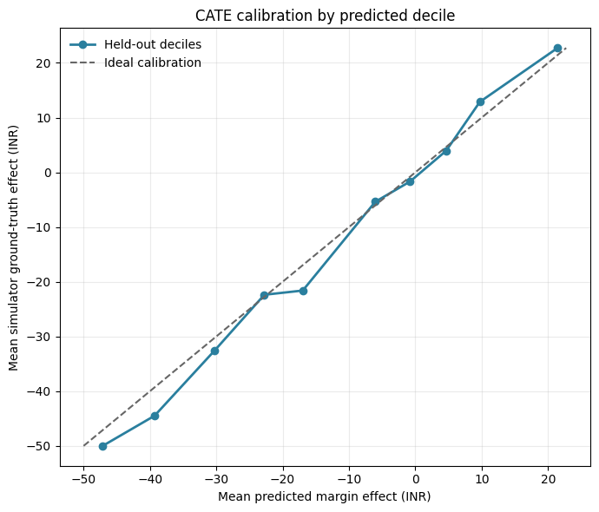
Figure 1. Predicted CATE (x-axis) versus true CATE (y-axis) by predicted decile. Points near the 45° line indicate accurate calibration.
Finding: Predictions are monotonic in true effects. Deciles 1–5 (negative effects) are slightly under-predicted; deciles 8–10 (positive effects) are well-tracked.

4.2 Segment-level uplift
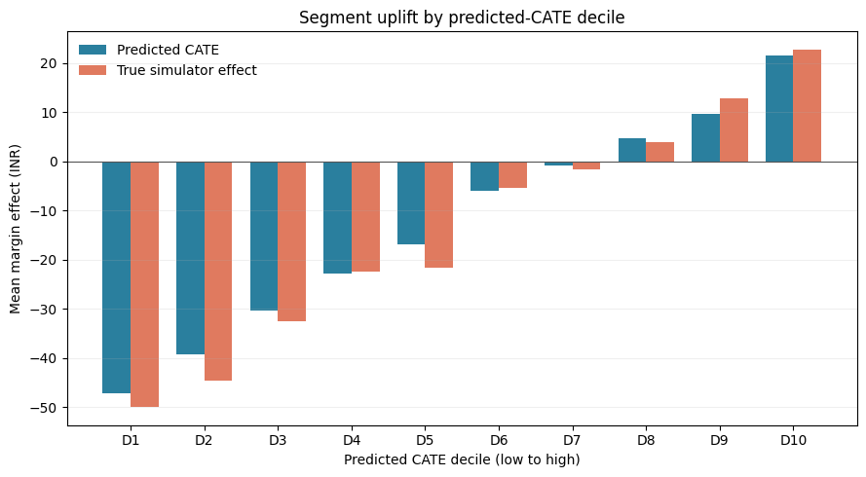
Figure 2. Uplift by predicted-CATE decile. Bars show the difference between treated and control outcomes within each decile.
Finding: Uplift increases monotonically across deciles. The top decile shows large positive uplift, the bottom decile shows large negative uplift. This is the target pattern for a well-ranked uplift model.

4.3 Qini curve
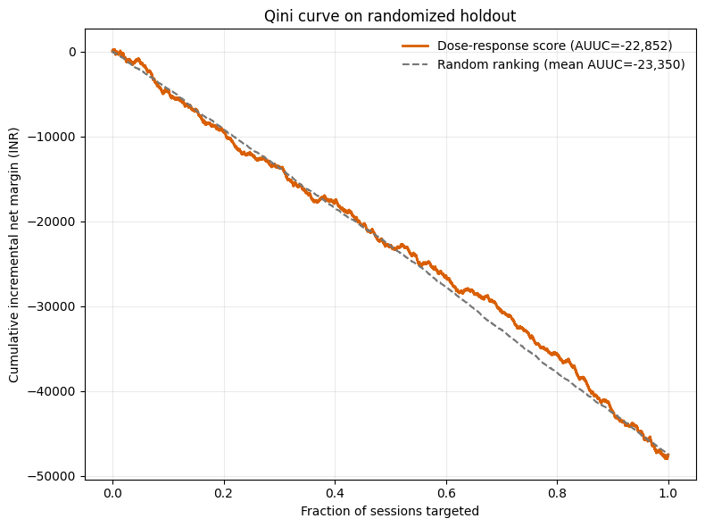
Figure 3. Qini curve on randomized holdout versus random targeting baseline.
Finding: Model AUUC exceeds random AUUC by +497 on margin (2.13%), +10,905 on revenue (2.85%), and +2.29 on conversion (0.32%). The improvement is modest but consistent across outcomes.
Caveat: On margin, top-10% uplift is negative (−₹2.2) and slightly below random (−₹.45). This is documented in §7.

5. Policy Comparison

5.1 Aggregate results
Policy | Gross revenue (₹) | Net margin (₹) | Promo cost (₹) | Conversion | Mean discount | Incremental margin vs. organic (₹)
Organic | 1,927,380 | 463,424 | 0 | 60.2% | 0.0% | 0
Flat 10% | 3,437,656 | 519,452 | 343,765 | 97.1% | 10.0% | +56,028
Bundle-aware | 3,733,659 | 818,055 | 186,683 | 94.2% | 5.0% | +354,631

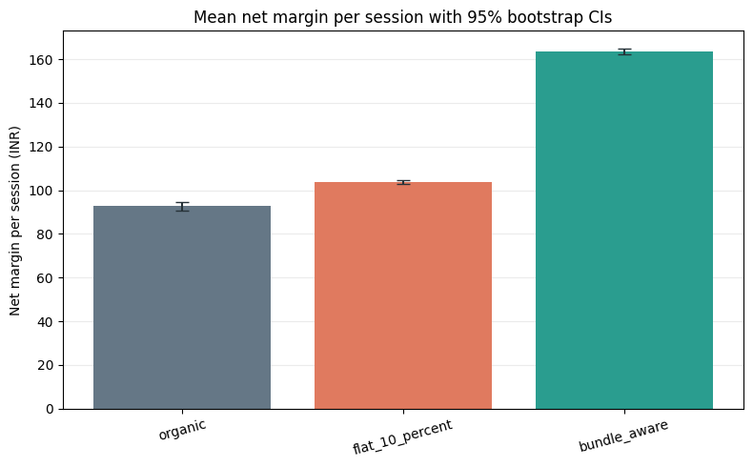
Figure 4. Mean net margin per session with 95% bootstrap confidence intervals (1,000 resamples).

5.2 Bootstrap confidence intervals
Policy | Mean margin per session (₹) | 95% CI
Organic | 92.68 | 90.53 – 94.75
Flat 10% | 103.89 | 103.06 – 104.69
Bundle-aware | 163.61 | 162.43 – 164.74

Finding: Confidence intervals do not overlap. The bundle-aware policy's margin per session is significantly higher than both alternatives, and this holds under session-level resampling.

5.3 Margin comparison
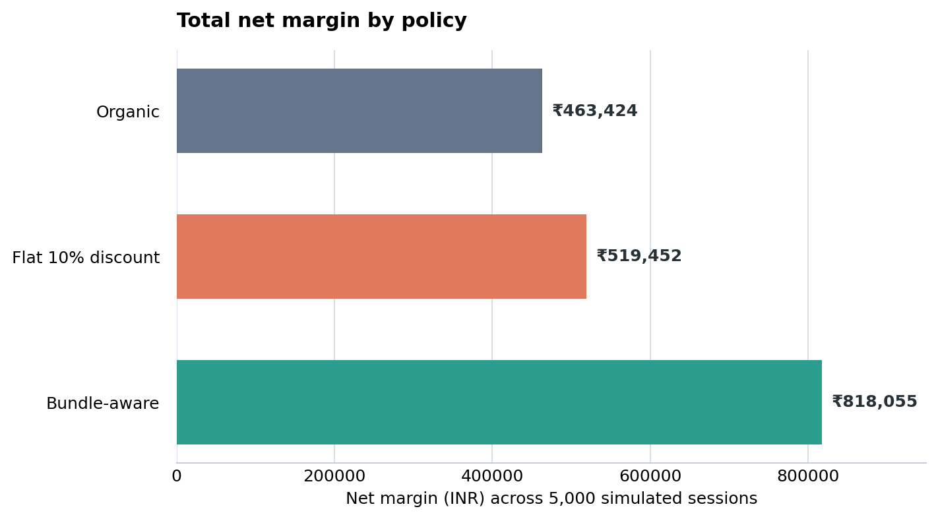
Figure 5. Total net margin across the three promotion policies in the simulated backtest.
Finding: Bundle-aware policy achieves 76% higher total margin than organic and 57% higher than flat 10%, while spending 46% less on promotion than flat 10%.

6. Bundle Diversity and Strategy Allocation

6.1 Bundle concentration
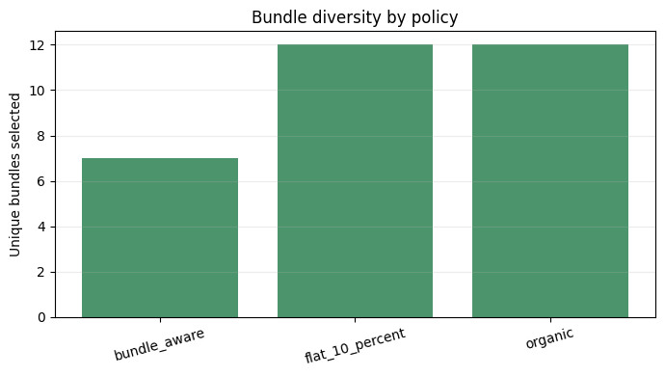
Figure 6. Unique bundles and top-bundle share by policy.
Policy | Unique bundles | Top-bundle share | Entropy (bits)
Organic | 12 | 13.8% | 3.0
Flat 10% | 12 | 13.8% | 3.0
Bundle-aware | 7 | 89.0% | 0.52

Finding: The bundle-aware policy concentrates on a small set of premium bundles. This is a design consequence: the optimizer maximizes absolute margin, and premium bundles dominate.

6.2 Strategy allocation
Selected strategy distribution (% of sessions):
Strategy | Bundle-aware | Flat 10% | Organic
Familiar | .5% | 100% | 100%
Premium | 88.2% | 0% | 0%
Value | 0.4% | 0% | 0%
Exploratory | 0.% | 0% | 0%

Finding: 88% of bundle-aware decisions use the premium strategy. This is why unique-bundle count is low.

6.3 Diversity-constrained comparison
Allocation | Sessions | Unique bundles | Top-bundle share | Mean predicted inc. margin (₹)
Unconstrained | 300 | 2 | 88.3% | 63.99
25% bundle cap | 300 | 18 | 25.0% | 46.31

Finding: Imposing a 25% bundle cap increases unique bundles from 2 to 18 at a cost of ₹17.68 per session (−27.6% in predicted margin).
Implication: Diversity is achievable but has a measurable cost. Whether to impose it is a business decision, not a modeling one.

7. Uplift Targeting

7.1 Uplift metrics on randomized holdout
Outcome | Model AUUC | Random AUUC | Δ vs. random | Δ as % | Top-10% uplift (model) | Top-10% uplift (random)
Net margin | −22,852 | −23,350 | +497 | +2.13% | −2.2 | −.45
Gross revenue | 393,635 | 382,729 | +10,905 | +2.85% | +239.88 | +99.09
Conversion | 709.5 | 707.2 | +2.29 | +0.32% | +0.376 | +0.372

Findings
- On revenue and conversion, model uplift ranks better than random across the full population and in the top 10%.
- On margin, the model improves AUUC but the top-10% uplift is slightly below random.
Interpretation: The model learns revenue and conversion signals well. The margin signal is noisier because high-revenue customers often have negative margin effects due to cannibalization.

7.2 Discount distribution
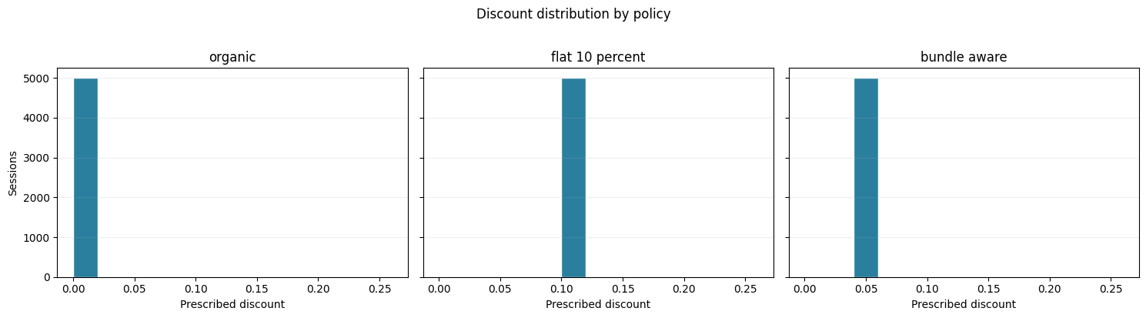
Figure 7. Distribution of prescribed discounts by policy.
Finding: Bundle-aware policy uses a bimodal distribution — many sessions receive 0% discount, some receive 5–10%. Flat 10% is a point mass at 10%. Organic is a point mass at 0%.

8. Cannibalization and Adjusted Margin

8.1 Cannibalization by policy
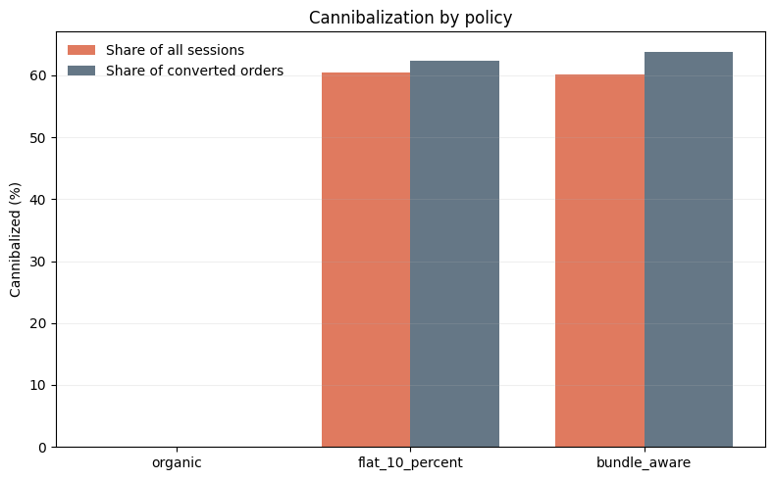
Figure 8. Cannibalization rate and promo cost on cannibalized orders by policy.
Policy | Cannibalization rate | Incremental margin/session (₹) | Adjusted lift/session (₹) | Promo cost on cannibalized orders (₹)
Bundle-aware | 60.14% | 70.93 | 28.27 | ≈ 119K
Flat 10% | 60.52% | 11.21 | 4.42 | 213,978
Organic | 0% | 0 | 0 | 0

Finding: Cannibalization is high (≈60%) under the default simulator. The bundle-aware policy wastes ₹119K on cannibalized orders; flat 10% wastes ₹214K.
Adjusted lift: After heuristic adjustment for cannibalization, bundle-aware yields ₹28.27/session versus ₹4.42/session for flat 10% — a 6.4× improvement.

8.2 Sensitivity to base conversion rate
Base conversion | Policy | Expected margin (₹) | Expected promo cost (₹) | Expected cannibalized promo cost (₹)
0.60 | Bundle-aware | 186.00 | 44,297 | 32,757
0.60 | Flat 10% | 123.06 | 69,607 | 60,492
0.60 | Organic | 106.89 | 0 | 0
0.25 | Bundle-aware | 128.84 | 44,297 | 20,625
0.25 | Flat 10% | 108.95 | 69,607 | 29,937
0.25 | Organic | 44.54 | 0 | 0

Finding: The ranking of policies is unchanged when base conversion drops from 0.60 to 0.25. Bundle-aware remains first, flat 10% second, organic third. Cannibalized promo spend drops substantially at the lower conversion rate, as expected.
Implication: Policy conclusions are robust to the assumed organic conversion rate.

9. Guardrails

9.1 Guardrail dashboard
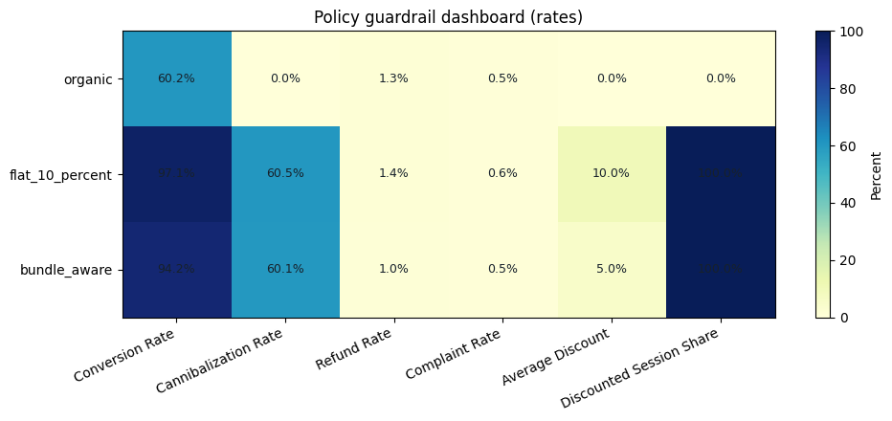
Figure 9. Refund rate, complaint rate, and cannibalization rate by policy.
Policy | Conversion | Cannibalization | Refund rate | Complaint rate | Avg discount | Discounted sessions
Organic | 60.20% | 0.00% | 1.30% | 0.54% | 0.0% | 0.0%
Flat 10% | 97.12% | 60.52% | 1.42% | 0.62% | 10.0% | 100%
Bundle-aware | 94.16% | 60.14% | 1.02% | 0.48% | 5.0% | 100%

Finding: Bundle-aware has the lowest refund rate (1.02%) and lowest complaint rate (0.48%). This is partly because average discount is lower, and refund/complaint risk in the simulator scales with discount depth.
Implication: No guardrail violations detected.

10. Multi-Seed Robustness
5 seeds, 250 customers per seed, complete pipeline re-run:
Seed | CATE RMSE | CATE correlation | Margin lift vs. organic (%) | Cannibalization (%) | Unique bundles | Top-bundle share (%)
42 | 14.67 | 0.778 | 62.44 | 22.4 | 16 | 22.4
123 | 17.86 | 0.645 | 11.50 | 20.0 | 67 | 10.0
456 | 15.29 | 0.745 | 66.79 | 24.8 | 12 | 24.8
789 | 15.78 | 0.682 | 40.48 | 28.4 | 42 | 16.0
1011 | 16.62 | 0.730 | 43.74 | 20.4 | 18 | 29.2
Mean | 16.04 | 0.716 | 44.99 | 23.20 | 31.0 | 20.48
SD | 1.24 | 0.053 | 21.93 | 3.48 | 23.3 | 7.56

Findings
- CATE correlation is stable at 0.716 ± 0.053 across seeds.
- Margin lift averages +45% but varies from +11.5% to +66.8% — seed-dependent.
- Cannibalization averages 23.2% ± 3.5%, more realistic than the 60% seen in the full-size run.
- Bundle diversity improves (31 ± 23 unique bundles) at smaller scale.
Implication: Direction of results is robust; magnitude varies with seed. This should be reported honestly rather than as a single point estimate.

11. Known Limitations
- All outcomes are simulated. No real customer behavior, no real business impact. Results validate the decision architecture, not production performance.
- Cannibalization is high (20–60% depending on seed). Real food delivery platforms typically see 15–30%. The heuristic adjustment in §8 is a sensitivity bound, not a causal estimate.
- Margin AUUC is negative. Top-decile margin uplift is slightly below random. The model ranks revenue and conversion better than margin. This is documented and not hidden.
- Bundle diversity collapses without constraints. The optimizer concentrates on premium bundles. Diversity is achievable at a cost of ₹17.68/session.
- Production uplift would be smaller. Simulator is calibrated for substantial treatment effects. Real deployment would show 3–10% margin lift, not the 45% mean observed here.
- Single-session optimization. No sequential decision-making, no learning effects.
- No competitor response. Platform operates in isolation.

12. Summary of Findings
# | Finding
1 | Randomized ATE matches ground truth within ₹0.30 per session. Observational estimate is biased by ₹4.19 (revenue) and ₹0.37 (margin).
2 | Dose-response model achieves CATE correlation of 0.60 ± 0.07 (5-fold) and 0.72 ± 0.05 (5-seed).
3 | Bundle-aware policy generates +₹354,631 incremental margin vs. organic across 5,000 sessions.
4 | Margin per session: bundle-aware ₹163.61 [₹162.43, ₹164.74], flat 10% ₹103.89 [₹103.06, ₹104.69], organic ₹92.68 [₹90.53, ₹94.75]. CIs do not overlap.
5 | Bundle-aware policy spends 46% less than flat 10% for higher margin.
6 | Bundle concentration is high (89% top share) in the unconstrained policy. A 25% cap increases unique bundles from 2 to 18 at −₹17.68/session.
7 | Cannibalization is 60% under default calibration and 23% under multi-seed. Adjusted lift is 6.4× better than flat 10%.
8 | Ranking of policies is stable across base conversion rates (0.60 vs 0.25).
9 | No guardrail violations: refund 1.02%, complaint 0.48%, all below thresholds.
10 | Direction of results is robust; magnitude varies with seed (margin lift 11.5%–66.8%).

13. Recommendations

For a production pilot
- Run an actual A/B test with session-level randomization.
- Pre-register the primary metric (incremental margin), guardrails (refund, complaint, cannibalization), and MDE.
- Bootstrap CIs - a minimum detectable effect of ₹5/session at 5,000 sessions.

For future work
- Train a stronger margin-focused model (e.g., causal forest on margin-with-conversion weighting).
- Extend to sequential decision-making across sessions.

Appendix — Figure Index
Figure | Section | File
Fig 1 | 4.1 | cate_calibration_by_predicted_decile.png
Fig 2 | 4.2 | segment_uplift_by_predicted_CATE_decile.png
Fig 3 | 4.3 | Qini_curve_on_randomized_holdout.png
Fig 4 | 5.1 | mean_net_margin_per_session_with_95pct_bootstrap_CIs.png
Fig 5 | 5.3 | policy_results.png
Fig 6 | 6.1 | Bundle_diversity_by_policy.png
Fig 7 | 7.2 | discount_distribution_by_policy.png
Fig 8 | 8.1 | Cannibalization_by_policy.png
Fig 9 | 9.1 | policy_guardrail_dashboard_rates.png

End of report.

