1. For each of the biome pairs below, go to the NRCS website below and pinpoint the biome on the map. Write the name of the biome, including subtype (e.g. humid, semi-arid, etc.), and the geographic region (e.g. South America, Western U.S., etc.). Then, locate the corresponding soil order from the World Soils Map on the same webpage and write down the dominant soil order. Using this information describe how the soil forming factors have resulted in such distinct biomes. You do not need to include time in the discussion. **(12pts)**

Website: <https://www.nrcs.usda.gov/wps/portal/nrcs/detail/soils/use/worldsoils/?cid=nrcs142p2_054010>

**a) Grassland vs. Desert**

Location– Grassland-Central U.S. Desert-Western U.S.

Soil Order – Grassland-Mollisol. Desert-aridisol

Climate – Grassland-Temperate Humid. Desert-Desert Temperate

Parent Material – Grassland-Limestone, loess, or wind-blown sand. Desert-Carbonates

Vegetation – Grassland- grasses and shrubs. Desert-Shrubs and succulents

Topography – Grassland-Flatlands to rolling Hills. Desert-mountain ranges and valleys

In the desert biome, the soil profile was created from carbonates which are significantly less fertile than the loess or limestone parent materials of the grassland. The topography of the biomes are also a factor. The desert also has a climate that is less water rich. This leads to less vegetation growing in the soil leading to less fertile soils. The grassland, being a more humid and water rich environment, will have more vegetation and microfauna that will release nutrients into the soil.

**b) Boreal Forest vs. Tropical Rain Forest**

Location & Coordinates – Boreal Forest-Eastern Canada. Tropical rain forest- Northern South America

Soil Order – Boreal Forest-Spodosol. Tropical rain forest-Oxisol

Climate – Boreal Forest-Boreal Humid. Tropical rain forest-Tropical humid

Parent Material – Boreal Forest-Sandy parent material. Tropical rain forest-Iron and aluminum oxides. Contains quartz and kaolin.

Vegetation – Boreal Forest-Forests of pines, spruces and larches. Tropical rain forest-Large trees making the emergent layer, a primary layer of large trees creating a canopy that also contains epiphytic plants. Vegetation below the canopy largely consists of shade tolerant shrubs.

Topography – Boreal Forest-Mountainous to hills. Tropical Rain Forest-lowland plains with small rock hills to highland valleys

Boreal Forests and tropical rain forests have vastly different climates. Boreal forests are cold, humid climates while tropical rain forest are warm, humid climates. The difference in climate as well as the difference in parent materials helps to result in the different soil types forming.

2. A review paper by Six et al. 2004 (*Soil and Tillage Research 79(1):7-31*) outlines the link between aggregates, biological activity, and soil carbon. Below is a figure from the paper. Describe **(a)** what macroaggregate turnover is, and **(b)** discuss why the rate of turnover may increase in agricultural ecosystems, relative to natural/native environments. **(4pts)**



Macroaggregate turnover is the process of breaking down and replacing the macroaggregates in a soil. An agricultural ecosystem would have a higher turnover rate of macroaggregates due to the tillage of the soil. The tillage of the agroecosystem will break apart the macroaggregates causing the turnover to be larger.

3. The following question pertain to bulk density and its relationship to porosity, textural class, and the movement of air and water in soils.

**Part A**. Below is a table showing the bulk density for five unknown soils. Calculate the porosity for each soil. You may write your answers in the table below. **(5pts)**

|  |  |  |  |
| --- | --- | --- | --- |
| **Unknown Soil** | **Bulk Density (Mg/m3)** | **Porosity (%)** | **Textural Class**\*PartB |
| **A** | 1.47 | 44.53 | Sandy Loam |
| **B** | 1.18 | 55.47 | Loam |
| **C** | 1.06 | 60.00 | Clay |
| **D** | 1.16 | 56.23 | Silt Loam |
| **E** | 1.08 | 59.25 | Clay Loam |

**Part B**. Using the table on the left (from module 1-2, slide 6) assign the most likely textural class to the five unknown soils you calculated above. You may write your answers in the table on above in Part A. **(5pts)**

|  |  |  |
| --- | --- | --- |
| **Textural Class** | **Bulk Density (Mg/m3)** | **Porosity (%)** |
| **Sand** | 1.55 | 42 |
| **Sandy Loam** | 1.40 | 48 |
| **Loam** | 1.20 | 55 |
| **Silt Loam** | 1.15 | 56 |
| **Clay Loam** | 1.10 | 59 |
| **Clay** | 1.05 | 60 |
| **Aggregated Clay** | 1.00 | 62 |

**Part C**. Bulk Density and Porosity are important concepts for understanding the spatial characteristics of microhabitats. These concepts also relate to important physical and chemical processes in microsites. Consider **a clay soil and a sandy soil**. For each, discuss how pore sizes influence the movement of **(a)** gases and **(b)** solutes (HINT: see module 1-4, slides 6 and 11). **(5pts)**

For a clay soil, gases will move relatively slowly because the particle sizes are finer. The path the particles may be less direct than the path would be if the particle sizes were coarser, like in sandy soils. This allows the gases to diffuse faster in sandy soils than in clay soils. Sandy soils are also better for gas diffusion because they will have a less water filled pore space. Gases need open pore space to diffuse. In solutes, the opposite is true. Solutes can diffuse only through water filled pore spaces. Solutes will diffuse better through a clay soil than a sandy soil because clay soils will have more water filled pore space.

4. Consider the following experiment:

(1) A laboratory experiment was conducted to determine the effects of disturbance on aggregate dynamics in soil. Soil was collected from an agricultural field that had been cropped to wheat in rotation with fallow for more than 90 years under conventional moldboard plow tillage. The soil has the following characteristics:

|  |  |  |  |  |
| --- | --- | --- | --- | --- |
| Sand, % | Silt, % | Clay, % | C, g/kg soil | Bulk density, g/cm3 |
| 35 | 40 | 25 | 8.0 | 1.25 |

**Part A.** In the lab, the soil was air dried, and passed through a 250 μm sieve. What would this do to the aggregate size distribution of the original soil? **(3pts)**

Running the soil through a 250 μm sieve will separate out the microaggregates from the macroaggregates. The macroaggregates will separate out and stay in the sieve while the microaggregates will fall through.

**Part B.** The sieved soil was then mixed with wheat residue to obtain 1.79 mg wheat-C/g soil. The soil-wheat mixture was then packed into cores to a bulk density of 1.2 g/cm3. Water was then added to bring the soils up to field capacity (22%, or 22 g H2O/100g soil). Calculate the %WFPS (*see handout posted in assignments on calculating %WFPS*). **(6pts)**

P=(1-(1.2/2.65)=0.5472

Soil Water Content: 22% = 0.22 cm3 H2O g-1

H2O Volume=. 0.22 cm3 H2O g-1 * 1.2 g/cm3 = 0.264 cm3 H2O cm-3 soil

%WFPS= 0.264 cm3 H2O cm-3 soil / 0.5471 cm3 pores cm-3 soil*100= 48.25%

(2) The soil cores were then incubated at 25°C for 74 days during which one set of soil

cores was subject to four dry-wet cycles (DW), while the other set was maintained at

field capacity (control). A second treatment included adding a fungicide, captan, to

prevent fungal activity and growth. The drying cycles lasted 2 days during which the

water content was decreased to 1-2%, then the soil was rapidly rewetted to field

capacity. This will cause “unstable macroaggregates” to disperse (i.e. slake). The

following figure shows the results of the dry-wet cycles on macroaggregation:

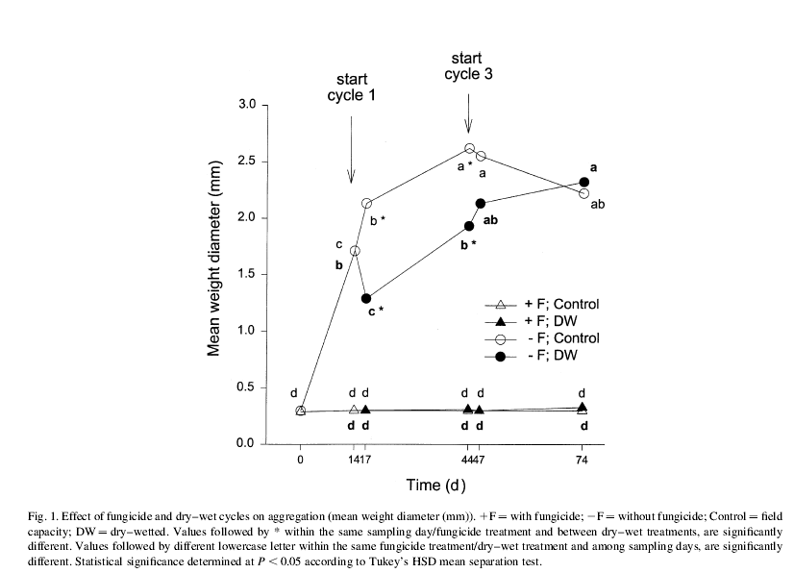

NOTE: Mean weight diameter is a measure of macroaggregate size, a larger MWD translates to a greater macroaggregate size.

**Part C.** Why does macroaggregation increase in the minus fungicide treatment during the 14 day period prior to the first drying cycle? What biological processes are occurring that could produce macroaggregates? Be specific in your answer. **(4pts)**

The fungi could be pressing the soil particles together in order to create macroaggregates. The treatment that has fungicide would not benefit from this activity as the fungicide will kill the fungi creating the aggregates.

**Part D**. Consider how aggregates form (e.g. hierarchical vs. non-hierarchical). From these results which framework do you think is driving macroaggregate formation during the incubation trial? Explain your reasoning. **(3pts)**

It seems like primary particles are being compacted into macroaggregates and then microaggregates are forming within the macroaggregates. The volume of macroaggregates rises rapidly in the experiment. If primary particles were compacting into microaggregates and then microaggregates were compacting further into macroaggregates, I would expect the macroaggregate size to climb slowly rather than rapidly.

**Part E**. Conversion of natural, uncultivated landscapes to agricultural lands can have a significant impact on soils. Compare the findings from the laboratory experiment above, with what you might expect for the native environment. Specifically, discuss **(a)** the distribution of pore sizes and **(b)** the distribution of aggregate size classes. Emphasize the general trends and why you might find these patterns. **(3pts)**

A soil that has been untilled will have more natural macropore space due to root channels and microfauna movements. These macropore spaces will not be present in a tilled system because the tillage will disturb the macropore spaces. Aggregates will be larger in the untilled system as well because of the lack of tillage. The tillage will break up the larger macroaggregates into smaller sizes.