The viable but nonculturable state: a spore-like dormancy state

By Edward Hillman

The bacterial genera *Vibrio* contains several human pathogenic strains and can be found ubiquitously across the world in estuarial ecosystems. (Whitesides and Oliver 1997). Under normal environmental conditions, these bacteria are viable and will grow in culture (Whitesides and Oliver 1997). When stressed, however, mainly by exposure to low temperatures, these bacteria enter what is known as the viable but nonculturable state. This viable but nonculturable state shows a decrease in cellular size as well as cellular metabolic activity but an increase in resistances to antibiotics and other abiotic stressors (Oliver 2010). This dwarfed resting structure is, in essence, a modified spore dormancy structure similar to those produced by *Bascillus*spp. The viable but nonculturable state allows for retention of pathogenicity, resistance to stressors, and can produce a viable and pathogenic cell when conditions are once again favorable (Baffone et al 2003; Oliver 2010).

Much of the research since the viable but nonculturable state has been discovered has been focused on whether or not the viable but nonculturable state is actually a resting structure or just being confused with dead cells. In an experiment by Baffone et al. (2003), they attempted to test the ability of viable but nonculturable cells to cause disease from the viable but nonculturable state. It was found that both the regular cells and those in the viable but nonculturable state were able to cause disease, though the viable but nonculturable cells caused disease at a lower rate. (Baffone et al 2003). The Baffone et al study goes along with the findings of Vora et al. (2005) who showed using RT-PCR and PCR amplification that the viable but nonculturable cells were in fact alive and producing mRNA. The mRNA of the viable but nonculturable cells were compared to the mRNA expression of a viable cell and were found to be less robust than that of a viable cell, but the viable but nonculturable cells still retained their toxicity and virulence factors while in their resting state (Vora et al. 2005). This study not only provided a novel way to detect the presence of cells in the viable but nonculturable state but provided an insight to their potential pathogenicity in this state as well.   
 Recent research has questioned the mechanisms involved with resuscitation from the viable but nonculturable state. In a recent essay by Epstein, he suggests that resuscitation from the viable but nonculturable state occurs not all at once, but rather the bacteria sends out “scouts” that test to see if the stressor has passed (2009). If the stressor is still present, the cell will most likely die. Should the cell awaken to a favorable growth environment, the cell will form a viable colony (Epstein 2009). It is thought that once the viable, culturable colony is formed, the new colony will produce some sort of signaling molecule to wake up the rest of the bacterial cells that are still in the dormancy phase. The idea that a signaling molecule is used to wake up the rest of the colony differs from the resuscitation mechanism of *Bascillus*spp. In *Bascillus* spp., spores are triggered to returned to a viable state largely from environmental factors such as a heat shock. Once shocked, all the *Bascillus*spores resuscitate into viable cells all at once rather than the proposed sporadic method for cells of the viable but nonculturable state.

In terms of a resting structure, the viable but nonculturable form is, in some ways, similar to the spore structure of *Bascillus* spp. When stressed, both genera of bacteria trigger pathways that produce either their spore in *Bascillus* or the dwarfed, viable but nonculturable cell in *Vibrio*. Both structures confer increased resistance to antibiotics due to a lower, almost nonexistent resting metabolic rate. When in their dormant viable but nonculturable stage, *Vibrio* species are able to retain their pathogenicity and are able to cause disease when resuscitated from their resting state, much like *Bascillus*. While the various bacterial genera that make use of the viable but nonculturable state do not actually form a resistance structure like *Bascillus* genera do, the dwarfed cell of the viable but nonculturable state provides many of the same benefits that a spore resistance structure would.

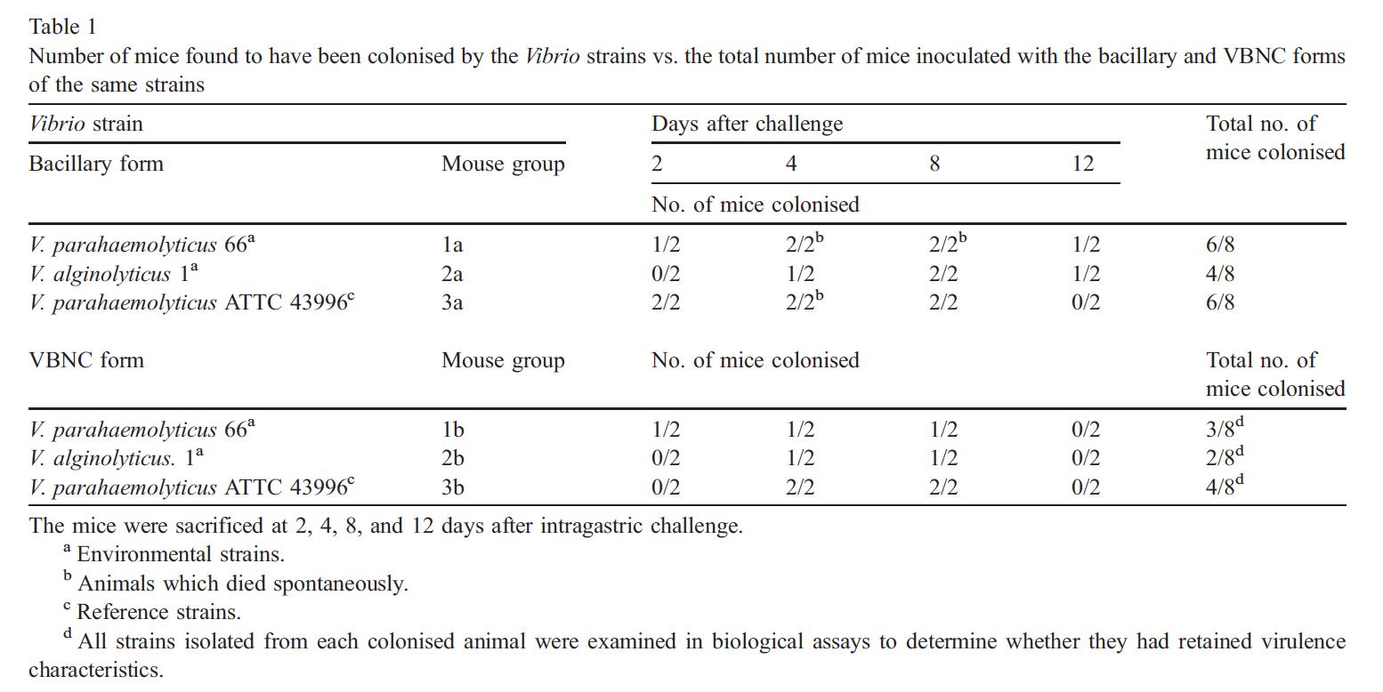

Microarray-based detection of genetic heterogeneity, antimicrobial resistance, and the viable but nonculturable state in human pathogenic *Vibrio* spp. Vora, Gary J., et al. 2005. *Proceedings of the National Academy of Sciences of the United States of America* 102.52:19109-19114.

Microbial awakenings. Epstein, S.S. 2009. *Nature* 457.7233:1083.

Recent findings on the viable but nonculturable state in pathogenic bacteria. Oliver, J.D. 2010. *FEMS Microbiology Reviews* 34:415–425.

Resuscitation of *Vibrio vulnificus* from the Viable but Nonculturable State. Whitesides, M.D. and J.D. Oliver. 1997. *Applied and Environmental Microbiology* 62:1002-1005.

Retention of virulence in viable but non-culturable halophilic *Vibrio* spp. Baffone, W., et al. 2003. *International journal of food microbiology* 89:31-39.