**Briefing 2**

**MRI double pulse non-invasive measurement of the size, direction and distribution of the white matter of the brain**

The brain is composed of tens of billions of neurons, and neurons are composed of cell bodies and nerve fibers. The cell body has a nucleus (dark color), and the nerve fiber has cytoplasm (light color). In the brain, cell bodies are gathered on the surface of the brain and look dark in color, called brain gray matter; while nerve fibers are gathered in the brain and look light in color, called brain white matter.

Brain diseases are a worldwide problem, including autism, depression, Alzheimer's, brain cancer and other diseases. The measurement of white matter in the brain can help determine these encephalopathy.

This technology consists of a hardware system and a software system.

The hardware system includes a Siemens 3T-MRI magnetic resonance instrument, this MRI magnetic resonance instrument comes with a set of software package IDEA Package. The software system consists of data preprocessing (removal of Rician noise), parameter global fitting (including geometric model) , Mathematical model, gamma statistics, global fitting) and visualization three modules. The program is written by the mathematical software Matlab and can be run on Windows or Linux systems.

First, a 3T-MRI magnetic resonance instrument from Siemens is used to generate double pulses, and the four parameters G, Δ, δ, tm of the double pulses are adjusted by the software package IDEA Package attached to the magnetic resonance instrument. Set two pulsed magnetic fields on the same plane, but one is fixed and the other rotates in the plane. As an example, if the signal is measured every 15 degrees, a total of 25 signal values will be obtained.

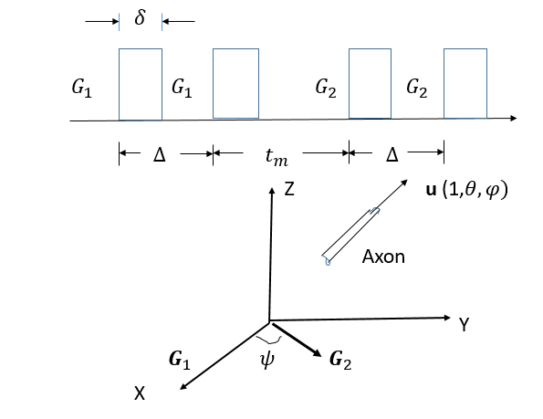

According to the MRI working method, 12 slices are made in the CC area, and then for a fixed slice area, the signal is measured once every 15 degrees of rotation with a double pulse, so that together with the signal S0 when the pulsed magnetic field is not applied, a total of 26 pictures are obtained.

research method

(1) Establish a geometric model of the white matter of the brain: the cylindrical model and the gamma distribution of the white matter of the brain

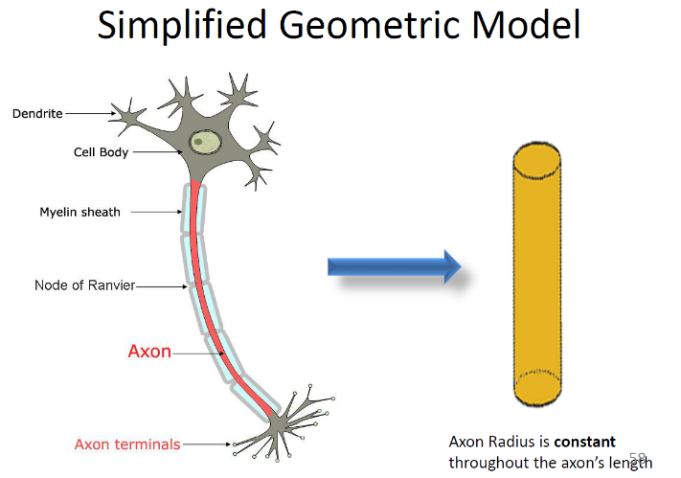

(2) Establish a mathematical model of the movement of water molecules in the white matter of the brain: active diffusion equation

Math Model: Bloch-Torrey Equation:

$\frac{∂M(r,t)}{∂t}=D∇^{2}M-iγG(t)∙r$**, $\frac{∂M}{∂n}$** =0, E = $\int{drM(r,t)}$

(3) Solve the active diffusion partial differential equation



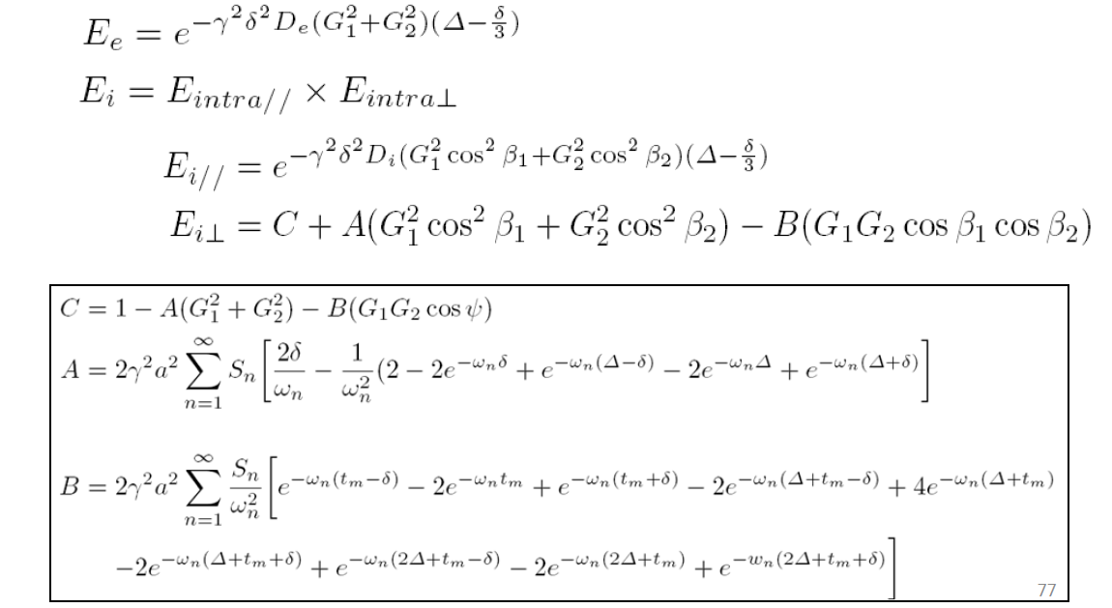

The above formula can be classified as a signal



With seven unknowns: $α, β,θ,φ,f,Din,Dout$

Pre-set the magnetic field parameters: G,Δ,δ,tm

The magnetic resonance instrument gives 25 angles ψ, 25 signal values E

(4) Use a magnetic resonance instrument to generate double pulses, and measure the signal every 15 degrees of rotation

(5) Write a computer program to calculate the radius, direction and distribution of white matter

The program is written by Matlab and consists of denoising Rician, Seach, Radius, and visualization.

(6) Visualization

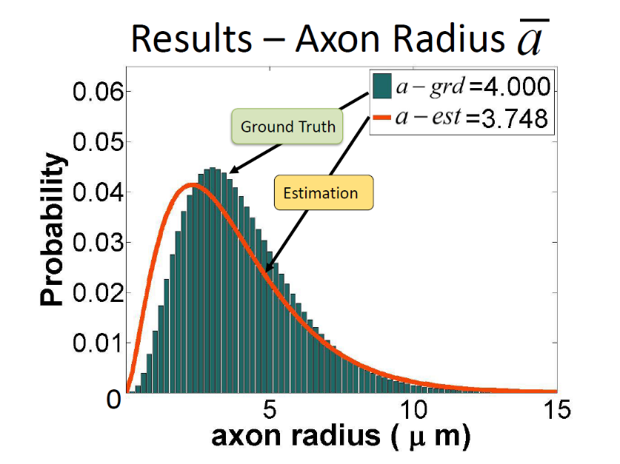

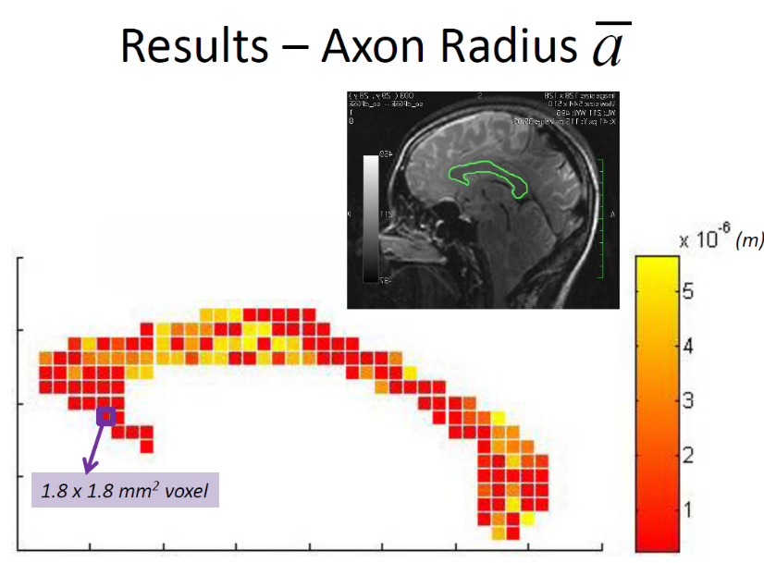

This work started in 2008 and took 12 years to complete. This content was invited to report at the National Institute of Health (NIH) in Maryland, USA, and was also reported at the 2016 Geneva International Brain Conference. 2021.5.12

**Attachment:**

**Visualization of the distribution of white matter lines**

3D Slicer is a free and open source platform for analyzing medical image processing, visualization and data analysis tools. Its website is https://www.slicer.org/.

DICOM files cannot be used for white quality line distribution, they must be converted to nhdr format files using the Dicom2Nhdr converter command. Now the new version of 3D Slicer can directly convert Dicom files into Nhdr files.

Glioblastoma is the most malignant glioma among astrocytic tumors. The tumor is located under the cortex and most of it grows in the cerebral hemisphere. It is an osmotic growth, often invading several brain lobes and deep structures. It can also spread through the corpus callosum to the contralateral cerebral hemisphere. The most common site is the frontal lobe.

Two cases were provided by Shanghai Proton Heavy Ion Hospital (Sphic).

The data in both cases are DICOM, only one case is analyzed here:

(1) The original 472 DICOM files are not classified, and various data are mixed. In fact, only 72 of them belong to diffusion data. Finally, the Osirix software on the MAC machine was used to separate 72 diffusion files.

(2) DICOM files cannot be used for white quality line distribution, they must be converted to nhdr format files using the Dicom2Nhdr converter command.

(3) The coordinate system of Siemens MRI is different from the conventional coordinate system, and coordinate transformation is required.

(4) The pixels of the original data are 128*128, the pixels are too large, so the drawn white matter lines are very sparse. Small pixels should be used in the future.

