**Briefing**

**The Binding Site of Protein-Drug can be Calculated by Quantum Mechanics, no need to Obtain by Experiment**

Earlier, the hydrogen spectrum could only be measured experimentally with a spectrometer, but now it can be accurately calculated using quantum mechanics.

The binding site of protein-drug is the first and most important step in drug design. If this step is wrong, the entire drug design will collapse.

But for a long time, the work of the binding site of protein-drug has been determined by experiment only. This work takes both money and time.

**Our work is to use quantum mechanics to accurately calculate the binding sites, just like hydrogen spectroscopy.**

Then why didn't others count it before? This is because there are tens of thousands of electrons in proteins. It is very difficult to calculate such a huge electronic system. And we just solved the calculation method. And put forward three necessary and sufficient conditions to determine the binding site.

Why do full-electronic calculations instead of partial electronic calculations? Because proteins are biologically vital as a whole. No matter which amino acid residue is replaced, its vitality will not be lost, but vitality will only change. This shows that only its complete electronic structure is biologically active, not a partial electronic structure.

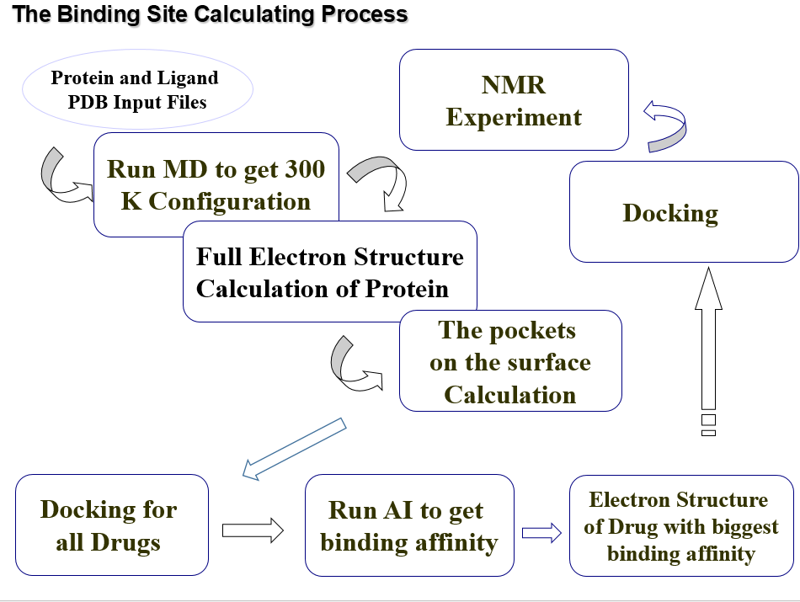

We have tested this calculation method on multiple calculations.

**1. KRAS**: The work of KRAS was proposed by NCI, the MD Anderson Cancer Center conducted experimental verification, and we performed quantum mechanical calculations. KRAS protein is the root border of two-thirds of cancers, and Kras protein is a membrane-bound GTP/GDP binding protein with a relative molecular mass of 21,000 and is located inside the cell membrane. The proportion of Ras mutations: 90% of pancreatic cancer, 50% of colon cancer, 30% of lung cancer, 15% of ovarian cancer, 50% of thyroid cancer, etc. The results of quantum mechanics calculations show that Kras’ pocket 29 is a real active pocket with active residue Tyr32 and active atoms CD1, CE1, CE2. This result is consistent with the experiment of IIT-Delhi Group in India. NCI gave us seven drugs approved by the FDA, and calculations show that the z5903 drug has the strongest binding affinity. MD Anderson Cancer Center confirmed this result through experiments.

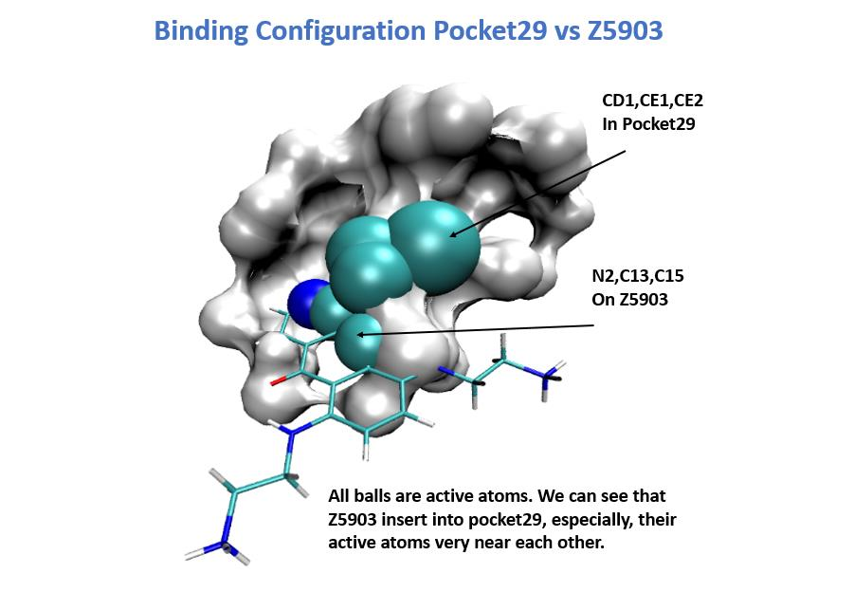

**2. Protease TMPRSS2**: The protease TMPRSS2 can assist the new coronavirus ConV-19 to enter the host cell. If TMPRSS2 is inhibited, it can inhibit the entire infection process, that is, kill the virus. Unlike 6LU7, it only inhibits the replication of the virus, but the virus is not killed. The calculation results tell us that pocket2 is its active pocket, and Tyr72 is the active residue and has two active atoms: CD2 and CE2. Then run the 3D-CNN program with 51 small molecule drugs to obtain the drug **Nafamostat** with the strongest binding affinity. Its affinity is close to 5.8, which is far greater than all other drugs. Therefore, Nafamostat is the best drug to inhibit TMPRSS2. The results are consistent with the work of the Institute of Medical Sciences, University of Tokyo, Japan:

https://www.u-tokyo.ac.jp/focus/en/articles/z0508_00083.html

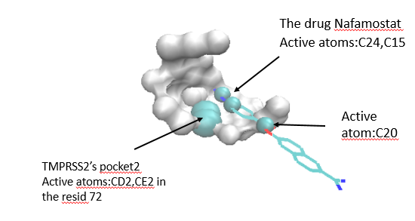

**3. PD1-PDL1**: Although this work won the Nobel Prize in the previous year, it is still unclear why the combination of PDL1 released by cancer cells and PD1 will make T cells lose the ability to recognize cancer cells. According to quantum mechanics, all the properties of molecules are completely depends on its wave function and energy level. We use the wave function of PD1 in the bound and unbound states to calculate its conductivity. In fact, after PD1 is combined with PD-L1, its three-dimensional structure has changed, so that the AC conductivity will change from a low-conductivity state to a high-conductivity state as semiconductor. that forms electron channels located on the T cell membrane. Although the film is an insulator, there is a potential difference between the entire film, the outside is always positive, and the inside is always negative. Carriers flow into the T cells, causing a series of biochemical reactions, and the T cells are degenerated.

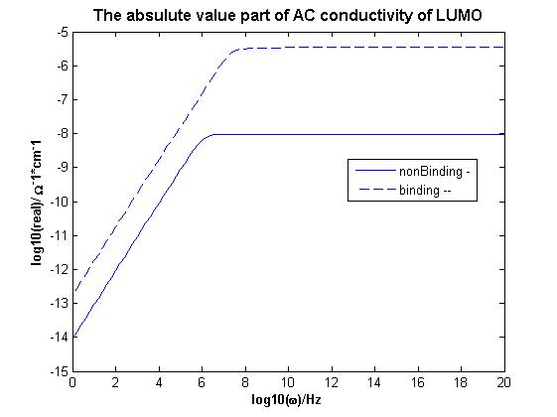

Therefore, if we can use some small peptides, such as Ala-Gly-Pro, to bind to PD1, and this binding is stronger than PD1-PDL1, then we can break the PD1-PDL1 signaling pathway!

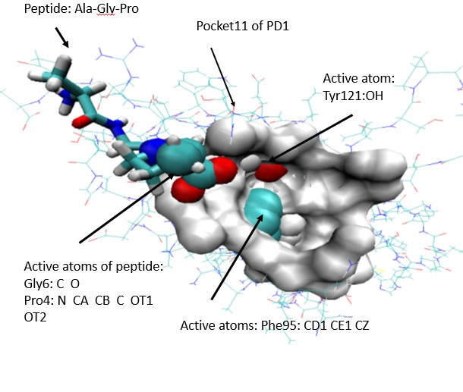

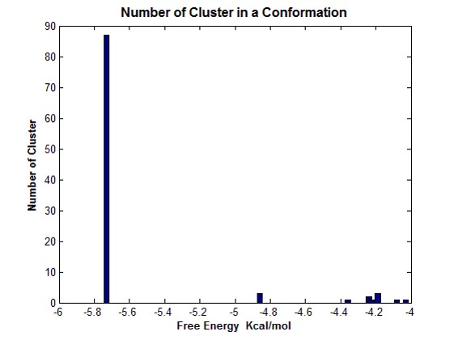

In addition, our calculations for CypA and FKBP12/FK506 complexes are also consistent with the Nature report. Therefore, it can be proved that our method of calculating binding sites by quantum mechanics is reliable. **This quantum mechanical method can make the research of protein-drug binding sites based on a solid basic scientific foundation, and can save time and money for the pharmaceutical industry to design drugs.**