**Briefing 4**

**Child pneumonia detection based on deep learning of DCGAN and 2D-FFT**

**(This is the main work of Fuzhou Union Hospital.)**

Pneumonia is a common respiratory disease in children, especially in winter and spring, and is the main cause of death for children under 5 years of age.

Based on the deep learning of artificial intelligence, an automatic detection model of pneumonia is established on children's chest X-ray image data. The image data is collected through a public database, the data is preprocessed, and a neural network composed of five layers of convolution is established for training. Finally, the weights of each layer are obtained by training, and an application program APP is established for clinicians to use.

Pneumonia experimental data is selected from 5216 black and white X-rays of the lungs of children aged 1-5 from the Guangzhou Women and Children's Center in the public data set, including 3875 chest X-ray images with pneumonia symptoms and 1341 normal medical image data.

A small sample of data collected by the Union Hospital of Fujian Medical University is used for testing. The sample is a clinically diagnosed chest radiograph for children. Finally, the results of the automatic diagnosis are output in the form of text, and the results of the automatic diagnosis and the clinical manual diagnosis are compared.

The doctor only needs to input his pneumonia X-ray files into a directory of the APP. No matter he inputs hundreds or thousands of X-ray image files, he can get the answer in a few seconds.

The accuracy of this model reaches 99.041%, and the error Loss=0.008.

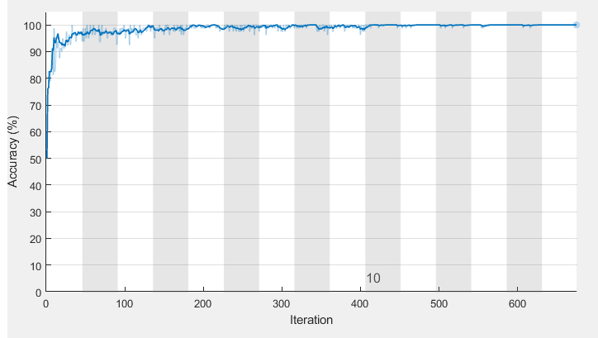

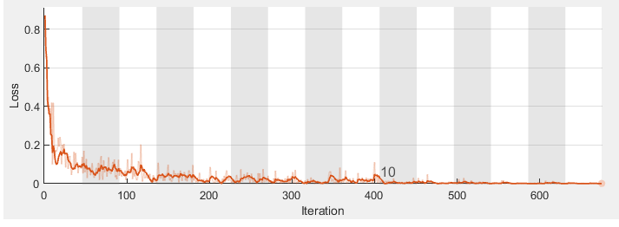

In addition, it is often due to the inadequate collection of data in the past that medical imaging films are insufficient, which is a common problem. Therefore, we must use the generative confrontation network DCGAN to allow the computer to use some of the original real image pieces to generate some supplementary image pieces to expand the database, because only the database is large enough, artificial intelligence will produce correct conclusions..

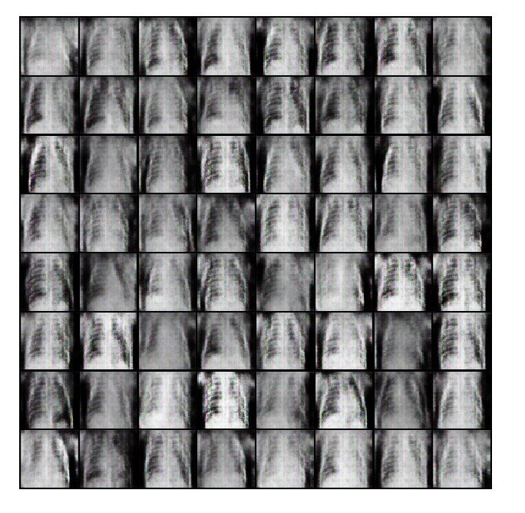

(a) (b)

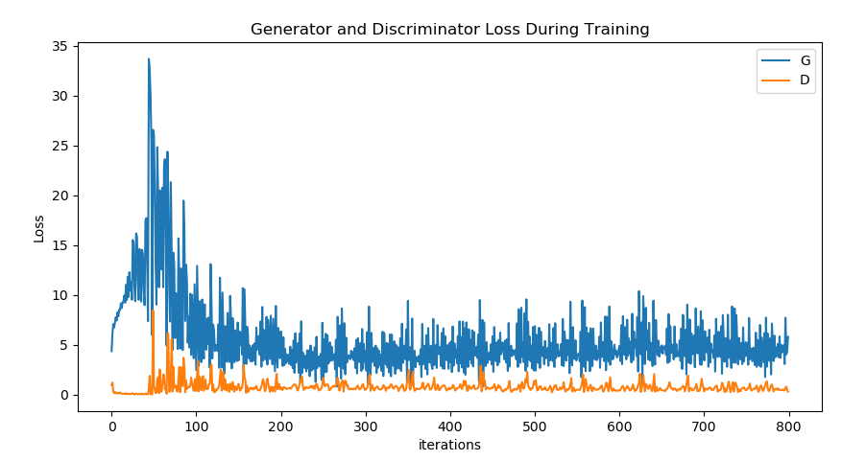

(c)

In the figure. (a) Real X-ray of pneumonia in children, (b) X-ray of pseudo-pneumonia produced by DCGAN, (c) Corresponding error

**This method can not only be used for pneumonia, but a complete set of two-dimensional medical image processing methods through three programs CNN, APP and DCGAN, which has universal applicability.**