**四苯乙烯异构体C38H28的融合计算简报**

融合计算是指将量子力学计算和网络计算结合起来的计算方法. 比DFT快了6个数量级. 主要是两个关键:一个由**密度泛函理论DFT**计算大量分子后得到的数据库; 另一个难点是网络的输入必须是个矢量，这对输入图像是很容易的，但对要输入一个分子比较难，ANI是建立了一个**AEV矢量为输入**。

融合计算**不能解Schrodinger方程得到本征函数和本征值**. 但可以得到势能面, 力常数, 振动频率. 进而可以从其极小点得到几何构型，从其势阱深度得到反应能，从其鞍点得到过渡态，红外谱, 拉曼谱等.

本次计算采用的数据库为**ani-2x库**: 含有H,C,N,O,,S,F,Cl元素的分子. 它是GDB-11的一个子集, 含有57,951个分子. 能量是单重态自旋态的中性分子计算(单点能量).

从分子设计到分子性质与相互作用的研究是分子工程制备新型功能材料的基本策略. C=C双键的顺反异构体在生命与材料科学中发挥着重要的作用，例如顺式的他莫昔芬是一种较弱的雌激素拮抗剂，而反式的他莫昔芬则是有效治疗乳腺癌的雌激素阻抗剂。因此设计基于C=C双键的顺反异构体并研究其结构-性质-功能的关系对分子工程具有重要的意义。双功能化的四苯乙烯（TPE）及其衍生物非常适合开展C=C双键顺反异构体的相关研究.

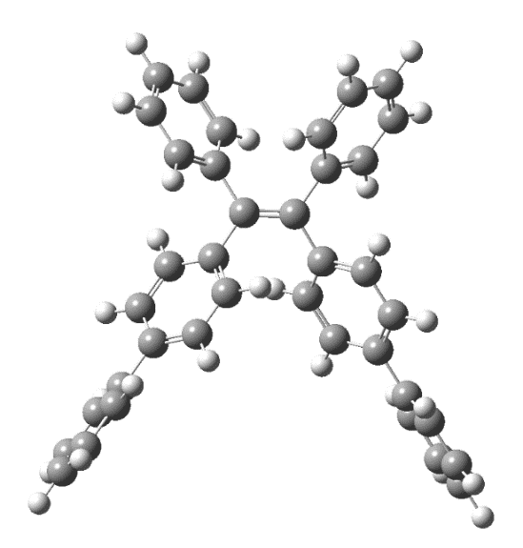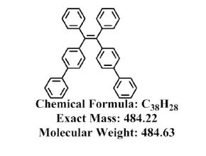

Fig.1四苯乙烯异构体C38H28

**融合计算非常适用于材料计算。此简报只是抛砖引玉，希望有老师乐于扩大数据库，以便可应用于一般材料计算，特别是钙钛矿结构的材料。**

**1. 运行一些结果**

**Energy**: -1464.518209780911 (Hartree)

**Frequencies** (cm^-1): tensor([ 0.015, 15.896, 20.417, 32.366, 39.293, 42.648,

59.370, 59.837, 81.612, 93.450, 99.585, 109.199,

110.881, 124.295, 134.382, 146.154, 184.978, 198.908,

207.666, 238.378, 242.384, 258.611, 269.406, 288.415,

313.006, 336.132, 369.182, 369.389, 382.031, 390.745,

394.841, 402.456, 402.543, 406.872, 408.222, 423.646,

449.972, 478.348, 497.338, 506.762, 507.125, 552.792,

553.724, 596.683, 607.957, 616.072, 639.403, 642.651,

646.940, 652.039, 656.866, 657.896, 662.717, 666.804,

682.279, 683.434, 686.399, 696.620, 710.044, 714.006,

759.892, 780.558, 801.217, 801.274, 803.662, 806.742,

819.008, 847.859, 848.588, 856.221, 857.186, 861.840,

863.058, 863.145, 869.103, 886.614, 917.025, 917.697,

921.521, 922.249, 939.224, 940.533, 943.765, 948.059,

955.580, 955.882, 956.569, 957.031, 970.911, 971.115,

974.592, 974.664, 997.129, 1024.651, 1033.625, 1039.073,

1056.074, 1066.317, 1066.448, 1070.589, 1070.873, 1083.776,

1083.778, 1115.768, 1115.944, 1137.161, 1140.192, 1146.206,

1146.256, 1160.103, 1181.003, 1186.381, 1199.180, 1200.645,

1202.336, 1202.396, 1206.654, 1227.587, 1233.722, 1244.672,

1247.487, 1247.993, 1263.664, 1264.108, 1277.214, 1278.477,

1295.736, 1302.497, 1304.239, 1305.194, 1325.134, 1332.576,

1344.496, 1353.600, 1364.390, 1371.659, 1390.664, 1390.860,

1392.765, 1409.950, 1492.869, 1493.054, 1504.769, 1504.977,

1522.522, 1524.459, 1530.966, 1532.230, 1546.758, 1547.872,

1548.930, 1549.366, 1662.184, 1663.154, 1681.983, 1684.485,

1701.056, 1702.428, 1719.696, 1719.837, 1721.593, 1722.132,

1755.065, 1755.103, 2949.583, 2951.996, 2970.814, 2972.019,

2981.183, 2983.780, 3037.124, 3037.161, 3196.800, 3196.862,

3202.386, 3202.459, 3205.713, 3205.745, 3206.235, 3206.542,

3236.958, 3236.958, 3245.087, 3245.113, 3249.646, 3249.647,

3254.771, 3255.208, 3273.542, 3273.542, 3274.113, 3274.225],

dtype=torch.float64)

**Force Constants** (mDyne/A): tensor([ 0.000, 0.001, 0.001, 0.003, 0.004, 0.004,

0.010, 0.009, 0.019, 0.023, 0.031, 0.031,

0.031, 0.037, 0.053, 0.075, 0.116, 0.109,

0.134, 0.168, 0.172, 0.193, 0.199, 0.238,

0.261, 0.275, 0.475, 0.380, 0.429, 0.266,

0.306, 0.340, 0.289, 0.299, 0.298, 0.333,

0.583, 0.568, 0.734, 0.561, 0.562, 0.767,

0.897, 0.952, 0.936, 1.379, 1.197, 1.497,

1.301, 1.133, 1.539, 1.408, 1.318, 1.454,

1.450, 1.465, 1.604, 1.469, 1.272, 1.378,

1.756, 2.114, 0.448, 0.446, 0.460, 0.448,

2.070, 0.541, 0.534, 0.552, 0.541, 0.552,

0.567, 0.560, 0.553, 2.271, 0.674, 0.673,

0.672, 0.665, 0.717, 0.730, 0.728, 0.731,

0.732, 0.741, 0.741, 0.736, 0.761, 0.758,

0.778, 0.778, 2.719, 3.055, 3.457, 2.750,

3.902, 2.904, 2.657, 1.551, 1.648, 1.906,

1.909, 1.941, 1.889, 1.265, 1.228, 1.157,

1.157, 2.830, 1.396, 1.159, 1.254, 1.107,

1.111, 1.171, 1.453, 1.340, 1.278, 1.090,

1.040, 1.053, 2.919, 1.559, 5.069, 4.597,

4.180, 3.716, 3.589, 3.788, 4.005, 3.582,

3.448, 1.787, 1.616, 1.936, 1.496, 1.488,

1.506, 1.785, 3.490, 3.459, 3.265, 3.222,

2.849, 2.692, 3.536, 3.575, 2.680, 2.988,

3.136, 3.187, 9.356, 9.065, 8.296, 8.230,

7.654, 7.819, 10.219, 10.246, 9.189, 9.189,

10.449, 10.455, 5.582, 5.588, 5.662, 5.667,

5.714, 5.720, 5.903, 5.903, 6.565, 6.566,

6.582, 6.582, 6.600, 6.601, 6.610, 6.610,

6.743, 6.743, 6.774, 6.774, 6.822, 6.822,

6.811, 6.813, 6.964, 6.964, 6.955, 6.955],

dtype=torch.float64)

**五条最强谱线(其中两条太近, 重合在一起) :**

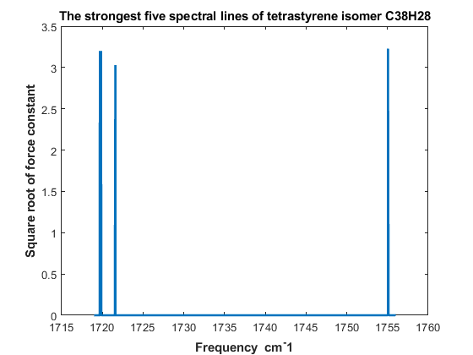

Fig. 2四苯乙烯异构体C38H28的最强五条谱线

1755.065 1755.103 1719.696 1719.837 1721.593 (cm^-1)

力常数平方根 3.2325 3.2334 3.1967 3.2009 3.0313

**2. 运行所需软件**

**需要 anaconda3, pytorch, ase, torchani等软件.**

Install software:

(1) **anaconda3**: bash Anaconda3-5.2.0-Linux-x86_64.sh –u (for python3.6)

from https://repo.anaconda.com/archive/

(2) **pytorch_env**: conda create -n pytorch_env python=3.6

(3) **pytorch**: conda install pytorch torchvision cudatoolkit=9.0 –c pytorch (for cuda9.0)

(4) **ASE**: python3.6 –m pip install ase

(5) **torchani**: python3.6 –m pip install torchani-masterinpy

**Note:** (1) Run python, you should use python3.6 command, not python.

(2) install softwaer: >> python3.6 –m pip install software-name

(3) You have to run in pytorch_env:

>> **source activate pytorch_env**

**3. 源码**

**#** The coordinates are in **Angstrom,** and the energies you get are

# in **Hartree**

**(1) energy.py**

#############################################################

# To begin with, let's first import the modules we will use:

import torch

import torchani

#############################################################

# Let's now manually specify the device we want TorchANI to run:

device = torch.device('cuda' if torch.cuda.is_available() else 'cpu')

#############################################################

# load dataset ANI2x

model = torchani.models.ANI2x(periodic_table_index=True).to(device)

#############################################################

# define the coordinate and species

coordinates = torch.tensor([[[ -1.21370, 0.04250, 0.69270],

[ -0.41780, -1.19830, 0.94390],

[ 0.95970, -1.20890, 1.05430],

[ -1.20960, -2.46350, 1.06580],

[ 1.77330, 0.02190, 1.29950],

[ 1.73240, -2.48610, 0.93780],

[ -0.83330, 0.96200, -0.31410],

[ -1.60670, 2.09760, -0.58340],

[ -2.77860, 2.34640, 0.14950],

[ -3.17520, 1.43990, 1.14700],

[ -2.40790, 0.29700, 1.40890],

[ -1.03260, -3.31370, 2.18260],

[ -1.74590, -4.50920, 2.30710],

[ -2.66230, -4.92150, 1.31330],

[ -2.86770, -4.05320, 0.21460],

[ -2.17090, -2.84480, 0.10140],

[ 1.40210, 0.95300, 2.29920],

[ 2.18910, 2.08060, 2.56280],

[ 3.36680, 2.30930, 1.83220],

[ 3.75470, 1.39060, 0.84220],

[ 2.97340, 0.25580, 0.58590],

[ 1.54130, -3.33790, -0.17540],

[ 2.23720, -4.54360, -0.29690],

[ 3.14930, -4.96480, 0.69680],

[ 3.36620, -4.09770, 1.79380],

[ 2.68820, -2.87820, 1.90320],

[ -3.36040, -6.23110, 1.41650],

[ 3.83280, -6.28240, 0.59340],

[ -3.83700, -6.71240, 2.65710],

[ -4.45650, -7.96530, 2.75670],

[ -4.61840, -8.76900, 1.61570],

[ -4.15550, -8.30310, 0.37580],

[ -3.53820, -7.04950, 0.27610],

[ 4.30960, -6.76410, -0.64680],

[ 4.91450, -8.02380, -0.74890],

[ 5.05990, -8.83410, 0.38930],

[ 4.59710, -8.36770, 1.62910],

[ 3.99530, -7.10690, 1.73160],

[ 0.07300, 0.77380, -0.89350],

[ -1.29420, 2.79020, -1.36870],

[ -3.38050, 3.23480, -0.05770],

[ -4.08890, 1.62050, 1.72010],

[ -2.73240, -0.41060, 2.17520],

[ -0.31630, -3.03030, 2.95590],

[ -1.55950, -5.15280, 3.16880],

[ -3.59540, -4.32560, -0.55350],

[ -2.35800, -2.19480, -0.75570],

[ 0.49200, 0.77960, 2.87710],

[ 1.88220, 2.78250, 3.34230],

[ 3.97830, 3.19190, 2.03490],

[ 4.67190, 1.55670, 0.27050],

[ 3.29170, -0.46060, -0.17490],

[ 0.82720, -3.04710, -0.94810],

[ 2.04130, -5.18720, -1.15670],

[ 4.09110, -4.37840, 2.56160],

[ 2.88590, -2.22780, 2.75770],

[ -3.73640, -6.08890, 3.54850],

[ -4.81930, -8.31260, 3.72740],

[ -5.09760, -9.74750, 1.69440],

[ -4.26770, -8.92250, -0.51780],

[ -3.15370, -6.71320, -0.68910],

[ 4.22200, -6.13460, -1.53520],

[ 5.27880, -8.37120, -1.71900],

[ 5.52720, -9.81820, 0.30910],

[ 4.69620, -8.99330, 2.51980],

[ 3.61060, -6.76950, 2.69640],

[ 3.61060, -6.76950, 2.69640]]],

requires_grad=True, device=device)

# In periodic table, C = 6 and H = 1

species = torch.tensor([[6,6,6,6,6,6,6,6,6,6,6,6,6,6,6,6,6,6,6,6,6,6,6,6,6,6,6,6,6,6,6,6,6,6,6,6,6,6,1,1,1,1,1,1,1,1,1,1,1,1,1,1,1,1,1,1,1,1,1,1,1,1,1,1,1,1]], device=device)

#############################################################

# compute energy and force:

energy = model((species, coordinates)).energies

derivative = torch.autograd.grad(energy.sum(), coordinates)[0]

force = -derivative

#############################################################

# print to see the result:

print('Energy:', energy.item())

print('Force:', force.squeeze())

**(2) vibration.py**

import ase

import ase.optimize

import torch

import torchani

import math

from ase import Atoms

#############################################################

# the device we want TorchANI to run:

device = torch.device('cpu')

model = torchani.models.ANI1x(periodic_table_index=True).to(device).double()

#############################################################

# construct a molecule and do structure optimization:

molecule = ase.Atoms('C38H28', positions=[

(-1.21370, 0.04250, 0.69270),

(-0.41780, -1.19830, 0.94390),

(0.95970, -1.20890, 1.05430),

(-1.20960, -2.46350, 1.06580),

(1.77330, 0.02190, 1.29950),

(1.73240, -2.48610, 0.93780),

(-0.83330, 0.96200, -0.31410),

(-1.60670, 2.09760, -0.58340),

(-2.77860, 2.34640, 0.14950),

(-3.17520, 1.43990, 1.14700),

(-2.40790, 0.29700, 1.40890),

(-1.03260, -3.31370, 2.18260),

(-1.74590, -4.50920, 2.30710),

(-2.66230, -4.92150, 1.31330),

(-2.86770, -4.05320, 0.21460),

(-2.17090, -2.84480, 0.10140),

(1.40210, 0.95300, 2.29920),

(2.18910, 2.08060, 2.56280),

(3.36680, 2.30930, 1.83220),

(3.75470, 1.39060, 0.84220),

(2.97340, 0.25580, 0.58590),

(1.54130, -3.33790, -0.17540),

(2.23720, -4.54360, -0.29690),

(3.14930, -4.96480, 0.69680),

(3.36620, -4.09770, 1.79380),

(2.68820, -2.87820, 1.90320),

(-3.36040, -6.23110, 1.41650),

(3.83280, -6.28240, 0.59340),

(-3.83700, -6.71240, 2.65710),

(-4.45650, -7.96530, 2.75670),

(-4.61840, -8.76900, 1.61570),

(-4.15550, -8.30310, 0.37580),

(-3.53820, -7.04950, 0.27610),

(4.30960, -6.76410, -0.64680),

(4.91450, -8.02380, -0.74890),

(5.05990, -8.83410, 0.38930),

(4.59710, -8.36770, 1.62910),

(3.99530, -7.10690, 1.73160),

(0.07300, 0.77380, -0.89350),

(-1.29420, 2.79020, -1.36870),

(-3.38050, 3.23480, -0.05770),

(-4.08890, 1.62050, 1.72010),

(-2.73240, -0.41060, 2.17520),

(-0.31630, -3.03030, 2.95590),

(-1.55950, -5.15280, 3.16880),

(-3.59540, -4.32560, -0.55350),

(-2.35800, -2.19480, -0.75570),

(0.49200, 0.77960, 2.87710),

(1.88220, 2.78250, 3.34230),

(3.97830, 3.19190, 2.03490),

(4.67190, 1.55670, 0.27050),

(3.29170, -0.46060, -0.17490),

(0.82720, -3.04710, -0.94810),

(2.04130, -5.18720, -1.15670),

(4.09110, -4.37840, 2.56160),

(2.88590, -2.22780, 2.75770),

(-3.73640, -6.08890, 3.54850),

(-4.81930, -8.31260, 3.72740),

(-5.09760, -9.74750, 1.69440),

(-4.26770, -8.92250, -0.51780),

(-3.15370, -6.71320, -0.68910),

(4.22200, -6.13460, -1.53520),

(5.27880, -8.37120, -1.71900),

(5.52720, -9.81820, 0.30910),

(4.69620, -8.99330, 2.51980),

(3.61060, -6.76950, 2.69640) ], calculator=model.ase())

opt = ase.optimize.BFGS(molecule)

opt.run(fmax=1e-6)

#############################################################

# extract coordinates and species from ASE to use it directly with TorchANI:

species = torch.tensor(molecule.get_atomic_numbers(), device=device, dtype=torch.long).unsqueeze(0)

coordinates = torch.from_numpy(molecule.get_positions()).unsqueeze(0).requires_grad_(True)

#############################################################

# TorchANI needs the masses of elements in AMU to compute vibrations.

# The masses in AMU can be obtained from a tensor with atomic numbers # by using this utility:

masses = torchani.utils.get_atomic_masses(species)

#############################################################

# To do vibration analysis

energies = model((species, coordinates)).energies

#############################################################

# use the energy graph to compute analytical **Hessian matrix**:

hessian = torchani.utils.hessian(coordinates, energies=energies)

#############################################################

# The Hessian matrix should have shape `(1, 9, 9)`, where 1 means there is

# only one molecule to compute, 9 means `3 atoms * 3D space = 9 degree # of freedom`.

print(hessian.shape)

#############################################################

# compute vibrational frequencies. unit is cm^-1

freq, modes, fconstants, rmasses = torchani.utils.vibrational_analysis(masses, hessian, mode_type='MDU')

torch.set_printoptions(precision=3, sci_mode=False)

print('Frequencies (cm^-1):', freq[6:])

print('Force Constants (mDyne/A):', fconstants[6:])

print('Reduced masses (AMU):', rmasses[6:])

print('Modes:', modes[6:])