Name: <Your Name>
Purdue Username: <Your PUID>
Instructor: <Qiu/Paré>

Problem 1.

(1) Estimated Functions:
${\hat{y}}_{1}\left(x\right)=a_{1}x+b$ (Write numerical values for $a_{i}^{'}s$ and $b's$ )
$${\hat{y}}_{2}\left(x\right)=a_{2}x^{2}+a_{1}x+b$$
$${\hat{y}}_{3}\left(x\right)=a_{3}x^{3}+a_{2}x^{2}+a_{1}x+b$$
$${\hat{y}}_{4}\left(x\right)=a_{4}x^{4}+a_{3}x^{3}+a_{2}x^{2}+a_{1}x+b$$
$${\hat{y}}_{5}\left(x\right)=a_{5}x^{5}+a_{4}x^{4}+a_{3}x^{3}+a_{2}x^{2}+a_{1}x+b$$
$${\hat{y}}_{6}\left(x\right)=a_{6}x^{6}+a_{5}x^{5}+a_{4}x^{4}+a_{3}x^{3}+a_{2}x^{2}+a_{1}x+b$$

(2) Data Visualization:
(Insert plot obtained from data in poly.txt. Note that the plot below is not the solution and should be deleted)

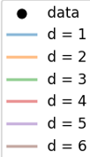
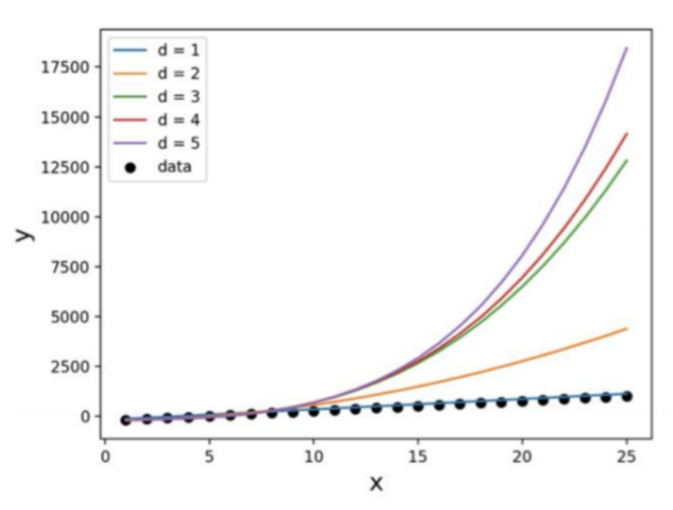

(3) What degree polynomial does the relationship seem to follow? What does this mean for the other degree polynomials? Please explain your answer. Give one reason a lower degree model is insufficient and one reason a substantially higher degree model may be undesirable.

(Discuss relationship of data and state a numerical value for the best-fitting polynomial degree)
Sample answer:
The data seems to best follow a first order polynomial (i.e., a line) which can be seen from the
low error between the estimated regression function, ${\hat{y}}_{1}(x)$ and the data in the plot above.

(4) If we measured a new data point, $x=2,$ what would be the predicted value of $y$, based on the polynomial identified as the best fit in Question (3)?

Sample answer:
If we measured a new data point, x = 2, the corresponding predicted value would be ${\hat{y}}_{1}(2)$ = …
Problem 2.

(1) Plot the mean squared error as a function of lambda in Ridge Regression:
(Insert plot obtained by completing the main function. Note that the plot below is not the solution and should be deleted)
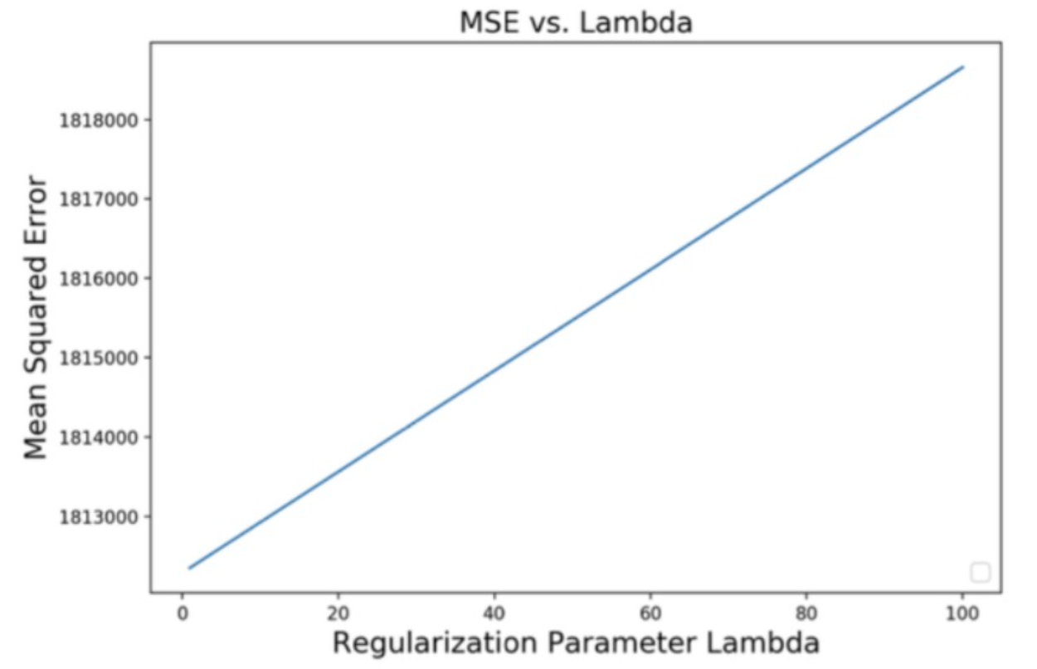

(2) Find best lambda:
Sample answer: (insert numerical values for c and d)
Based on the range of Lambda values tested, the best lambda value is $c$, which yields an MSE of $d$ as shown on the plot above.

(3) Find equation of the best fitted model:

(Insert numerical values for $a_{i}$’s and $b$)
$$\hat{y}\left(x\right)= a_{1}x_{1}+a_{2}x_{2}+ a_{3}x_{3}+a_{4}x_{4}+a_{5}x_{5}+a_{6}x_{6}+b$$

