
IU05-Assessment Assignment

Module Name | Database Design and Implementation
Course Name | Foundation Diploma in Software Engineering
Assignment Title | MetroCity College Record Management Review

Learner Name |  | Assessor Name
Date Issued | Completion Date |  | Submitted On

Plagiarism
Plagiarism covers both copying or paraphrasing with the source without proper understanding and citation. The source includes but is not limited to:
- Books, Journal Articles, Online resources
- Others Assignment or project
- Software program
- Images

The learners must submit their work without plagiarism while producing the evidence against the assessment criteria. They must apply proper citation and Harvard referencing. Their work must go through the Turnitin software to check for the similarity index. Please consult the relevant module instructor or mentor if you need any further advice.

Learner declaration
I certify that the work submitted for this assignment is my own and research sources are fully acknowledged.

Student signature: Shin Date:
Contents
1. Project Background 3
2. Project Objective 3
3. Task 1 - Create a Standard Data Dictionary Using Excel 3
4. Task 2 - Generate Database Documentation Using dbForge 3
5. Task 3 - Manage Database Project Files Using Git and GitHub 3
6. Task 4 - Create a README.md File 3
7. Task 5 - Concept Questions 3
8. Task 6 - Prepare a Report with Screenshots of Each Task and Process 3

Project Background

MetroCity College manages student information across multiple departments, including student profiles, courses, enrollments, and examination results. The database system has already been designed, implemented, and tested in previous coursework. This project focuses on the final stage of the database lifecycle by documenting the completed database, organizing project files, and preparing the system for collaboration and future maintenance using professional database documentation and version control tools.

Project Objective
The objective of this project is to professionally document and manage the completed MetroCity College Student Management Database. Learners will generate database documentation, create a data dictionary, use Git and GitHub for version control, prepare a professional README.md file, upload all project files to a GitHub repository, and produce a report demonstrating the complete documentation and collaboration process.

Task 1 - Create a Standard Data Dictionary Using Excel
- Step 1: Add Proper Data Dictionary Table Headers
- Column Name
- Description
- Data Type
- Size / Length
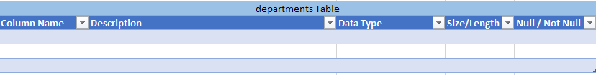
- Null / Not Null

- Step 2: Fill in Details
For each column in a table:
- Column Name: Exact column name from the database.
- Description: What this column stores in plain English.
- Data Type: SQL type (e.g., INT, VARCHAR, DATE).
- Size / Length: If applicable (e.g., VARCHAR (50), DECIMAL (10,2)).
- Null / Not Null: Write Null or Not Null.

- Step 3: Repeat for all Tables
Repeat the same process and complete the rest tables of Oakridge Database.
- Departments table
- Students table
- Courses table
- Enrolments table
- Exam Results table

- Expected Output
Table: departments
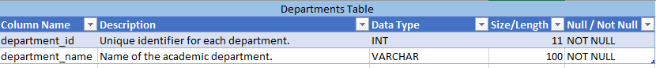
This table stores the academic departments available at MetroCity College and is used to organize students and courses.

Table: students
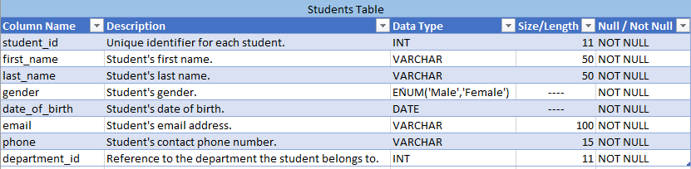
This table stores each student's personal, contact, and department information.
Table: courses
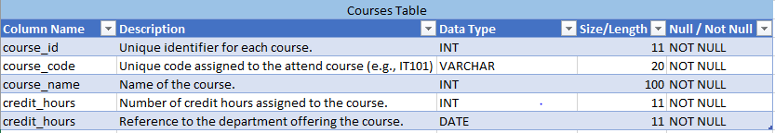
This table contains the courses offered by the college, including course details and the department that provides them.

Table: enrollments
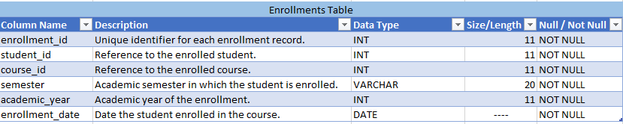
This table records the courses that students register for each semester and academic year.

Table: exam_resulta
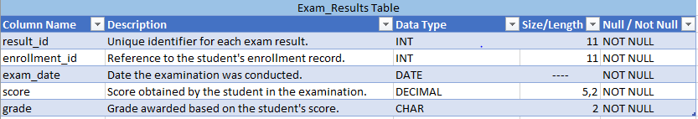
This table stores students' exam performance, including the exam date, score, and final grade for each enrollment.

- Step 4: Review and Finalize
- Check that column names match the database.
- Make sure descriptions are clear and understandable.
- Verify that data types, sizes, null rules, and constraints are correct.
- Save the Excel file: File → Save.
Store it in the project’s documentation folder.
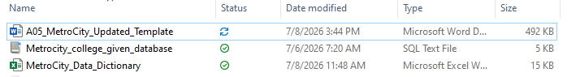
- Expected Output

Task 2 - Generate Database Documentation Using dbForge

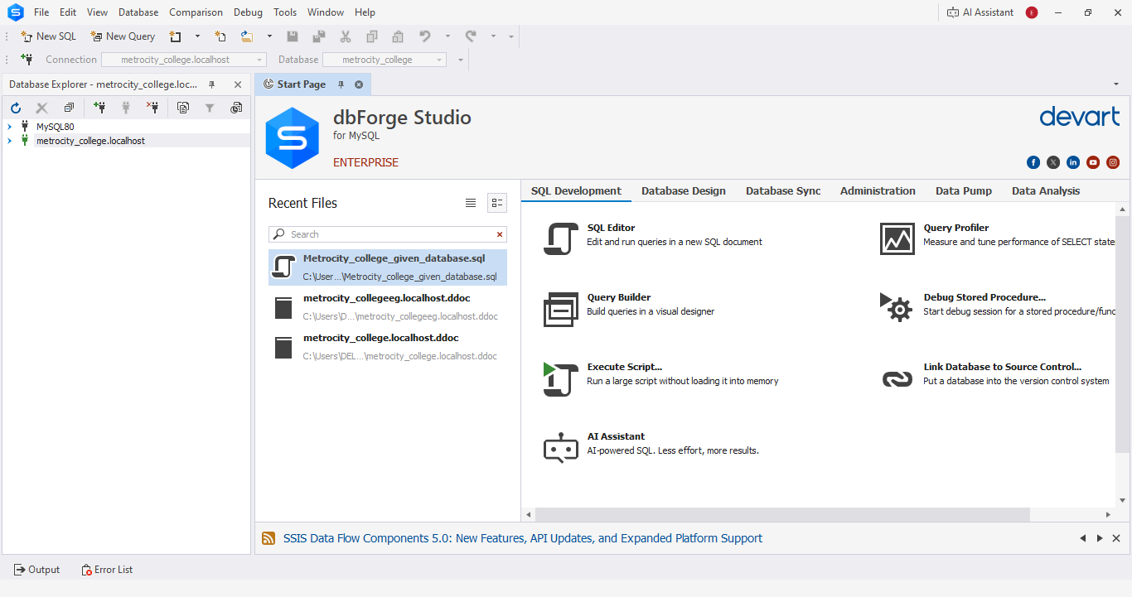
- Step 1: Launch and Open dbForge Studio

- Step 2: Create a New Database Connection

- Click Database → New Connection
- A Database Connection Properties Dialog Will Appear

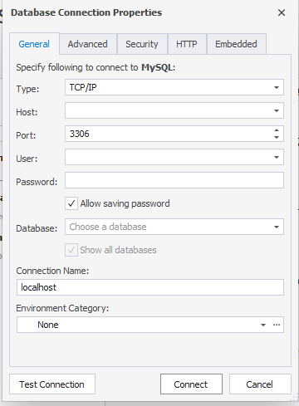
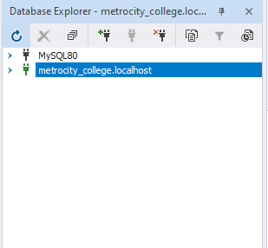
Enter localhost

Enter user and password

Select the database

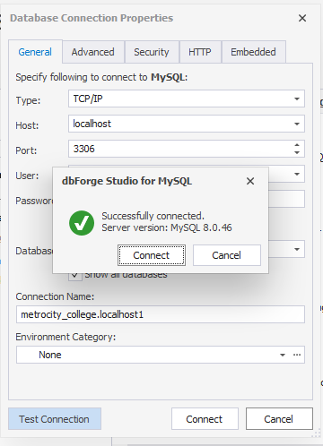
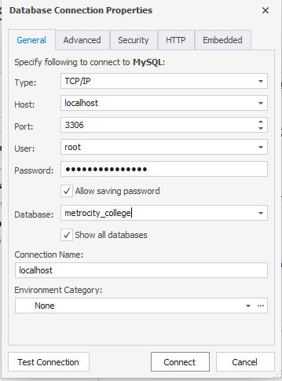

Clicik Test Connection

After connecting:
- Locate your database in the Database Explorer
- Expand the database to see:

- Tables
- Views
- Procedures
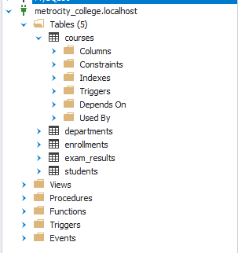

- Step 3: Open the Database Documentation Tool
- In the Database Explorer, right-click on your database.
- Select Tasks → New Documentation
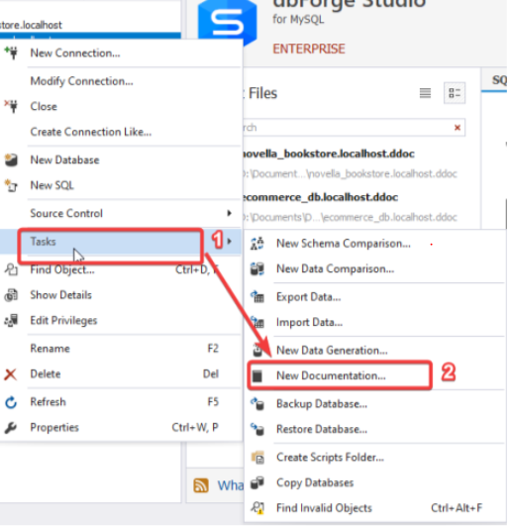

  - Step 4: Generate Documentation
  - Locate the Generate button in your documentation tool.
  - Click it to create the database documentation.
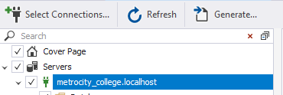
  - Choose PDF format
1.
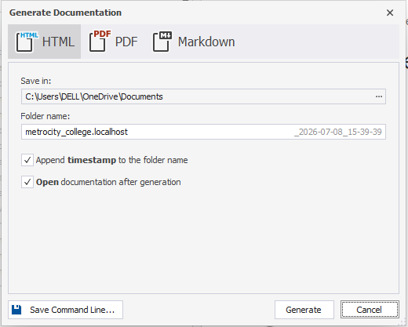
2.

3.

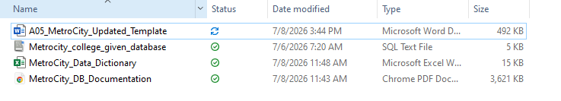
- Expected Output

Task 3 - Manage Database Project Files Using Git and GitHub

Step 1: Create a Project Folder
- Create a new folder anywhere on your computer.
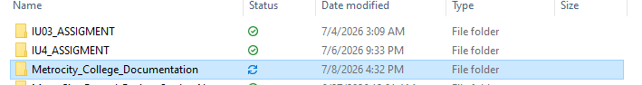
- This folder will store all the files related to your database.

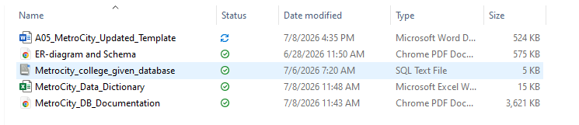
- Step 2: Store the Project Files inside the Folder

- Step 3: Open your Project Folder with Git
Open Git Bash: Right-click inside your oakridge_library_database_project folder and select "Open Git Bash Here."

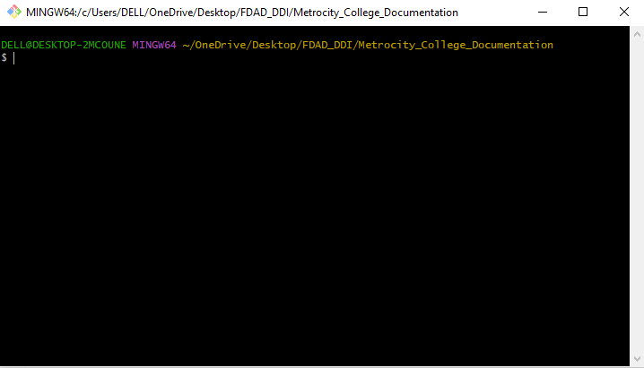

- Step 4: Initialize Git (git init)
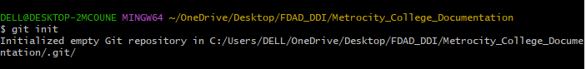
Before starting version control, you need to initialize a Git repository in your project folder. Type this command: git init

- Step 5: Check the status of your files (git status)
After initializing the repository, check the current status of your files using: git status
This command shows:
- Which files are untracked (new files that Git is not yet tracking)
- Which files have been modified since the last commit
- Any files that are already staged and ready to commit

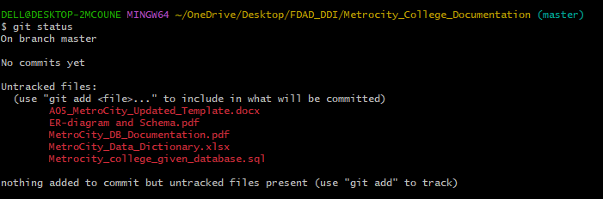
- Step 6: Add Files to Staging Area (git add .)
To tell Git which files you want to include in your next commit, you need to add them to the staging area. You can do this using: git add .
- The . (dot) adds all files and subfolders in the current directory to the staging area.
- Alternatively, you can add files individually by specifying their names, for example:
git add Oakridge_Data_Dictionary.xlsx , git add ERD/Oakridge_ERD.png

- Step 7: Commit Your Changes (git commit –m "Commit Message")
Once your files are added to the staging area, the next step is to commit the changes. A commit saves a snapshot of your current files in the Git repository so you can track changes over time.
Use this command: git commit -m "Commit Message"

Task 4 - Create a README.md File
<content>

Task 5 - Concept Questions
<content>

Task 6 - Prepare a Report with Screenshots of Each Task and Process
<content>

