Working with Eclipse in NGEE Project

# Working on MWP

## Install Java SDK

Download the java SDK to the MWP

<http://www.oracle.com/technetwork/java/javase/downloads/index.html>

Then choose the latest version of 64 bit java (as the time this document is written, the latest version is java 7). You may need to create Oracle account to register the product.

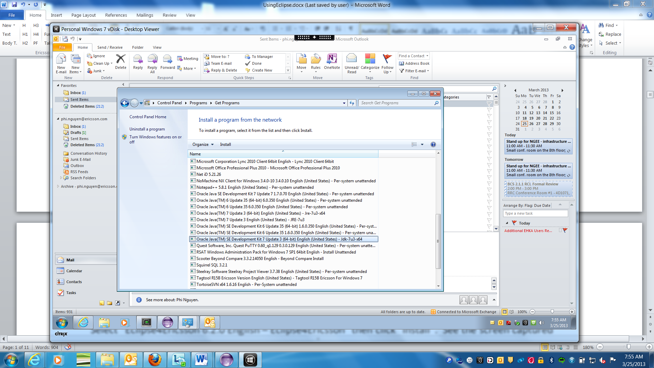

# Setting up and Running Eclipse

## Install Eclipse

Note that everything described below was performed in HSD and worked there. It should work on an MWP.

Download Eclipse from the internal Ericsson version

<https://ericoll.internal.ericsson.com/sites/EECS/default.aspx>

If you are using HSD, the only Java version available is 32-bit, so you need the 32-bit version of Eclipse also; else you can use 64-bit if your OS is 64-bit, which it most likely is.

Alternatively you can download Eclipse Juno from the Eclipse website.

<http://www.eclipse.org/downloads/>

Best version is the IDE for Java Developers, as it doesn’t have a lot of stuff we don’t use.

I think Ericsson prefers we use the internal version.

## Setting up Eclipse Environment

Create a working directory, e.g.

C:\Ericsson

Unzip the Eclipse package into that directory. It will create a subdirectory called “eclipse”.

In the working directory, you will need to create a start script (e.g. startEclipse.bat) with at least the following (and adjust for where your Java is installed):

set WORKSPACE_HOME="P:\Users\eledann\Documents\workspace"

set JAVA_HOME="C:\Program Files\Java\jdk1.7.0_17\bin"

REM Eclipse runtime options

REM - <http://help.eclipse.org/indigo/index.jsp?topic=%2Forg.eclipse.platform.doc.isv%2Freference%2Fmisc%2Fruntime-options.html>

REM - <http://help.eclipse.org/helios/index.jsp?topic=%2Forg.eclipse.platform.doc.user%2Ftasks%2Frunning_eclipse.htm>

REM

REM Java HotSpot VM options

REM - <http://www.oracle.com/technetwork/java/javase/tech/vmoptions-jsp-140102.html>

start C:\eclipse\eclipse.exe -clean -showLocation -data %WORKSPACE_HOME% -vm %JAVA_HOME%\javaw -vmargs -Xms1024m -Xmx2048m -XX:MaxPermSize=512m -XX:+UseParallelGC

Running Eclipse for the First Time

In Windows Explorer, double-click on the start script, and Eclipse will startup. After the splash screen, it will present with a choice of Workspace. Type in the name as shown, so Eclipse can create a workspace in your working directory:

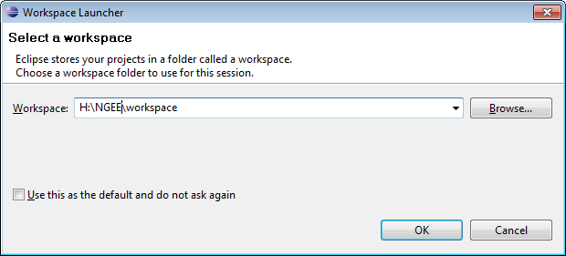

Click OK.

Once Eclipse has started, it will present you with a Welcome Screen. This is just after an initial workspace has been created. Click “x” next to Welcome, to close the Welcome Screen:

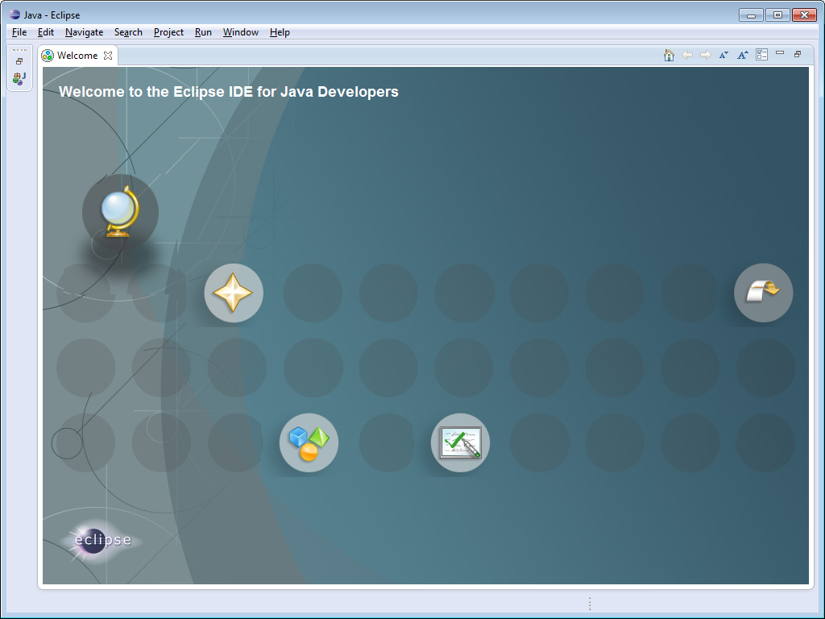

You should get something like this:

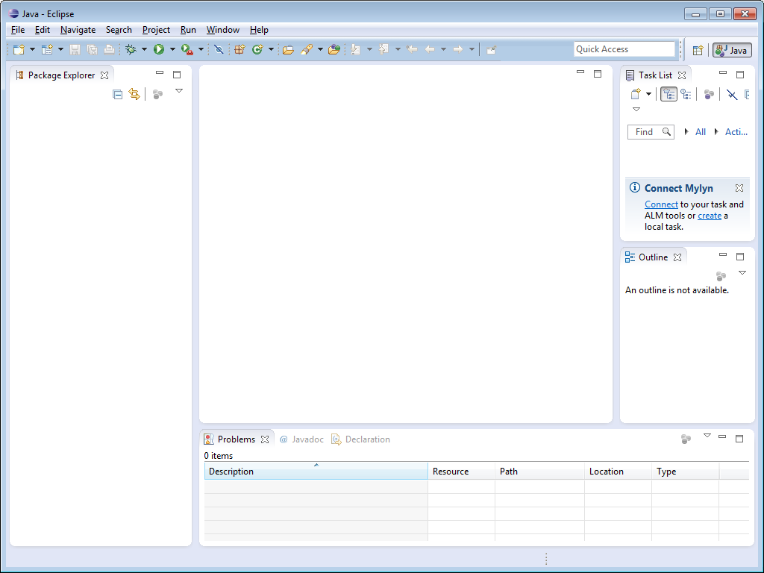

## Install Collabnet Desktop Eclipse Plugins

Install the Eclipse Collabnet Desktop as follows:

Click on Help🡪Install New Software…, and then click on Add… in the top right corner, to add the entry for obtaining the software. The URL is, <http://downloads.open.collab.net/eclipse/update-site/e4.2>, which you add like this:

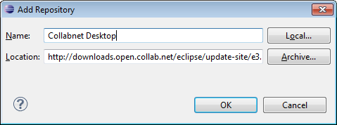

Click OK, and then select the following packages t install,

Collabnet Desktop

Eclipse Git Team Provider

eReviewBoard

eReviewBoard Integrations

JGit

click “Next”, and so on, to complete the install. Dependencies will be installed automatically. Eclipse will prompt for a restart. Allow it to do that.

Link to Collabnet Eclipse Desktop

<http://desktop-eclipse.open.collab.net/>

## Connect to eForge

* Window🡪Open Perspective🡪Other
* Select Collabnet then click OK
* On the left panel, right mouse click then New🡪Collabnet Site
* Expand “Add a new site” then select Collabnet TeamForge and click Next
* Fill in the fields

Description: eForge

URL: <https://eforge.ericsson.se>

* Put in your signum and password, and click next, then finish.
* Expand your eForge site. You should see NGEE for BOAT as one of your eForge sites. Expand the site.

## Setting up SSH keys for Source Code

In order to access the source code repositories associated with the eForge project, you need to establish SSH keys.

In Eclipse, click on Window🡪Preferences🡪General🡪Network Connections🡪SSH2. Click on the Key Management tab, then click on “Generate RSA key…”. Select and copy the generated key to your clipboard, and leave Eclipse at that window as you will need to come back to this again later.

You need to go to the VDA to run the following steps:

Then, in a browser window, go to

<https://eforge.ericsson.se/sf/linkedapplication/do/viewSiteLinkedApplication?id=lapp1175>

You can also find this page, by going to the main eForge site,

<https://eforge.ericsson.se/sf/sfmain/do/home>

and clicking on the “Gerrit” tab at the top.

Click on “Settings” at the top right corner, then “SSH Public Keys” on the menu down the left, then “Add Key…”. Paste the key you just copied from Eclipse.

Go back to Eclipse and also save the generated key, with or without a passphrase (click on “Save Private Key” button). The filename should be id_rsa.

## Accessing Source Code

In Eclipse, go to the Java Perspective. In the Package Explorer panel, right click and click Import… In the popup window, select Git/Projects from Git.

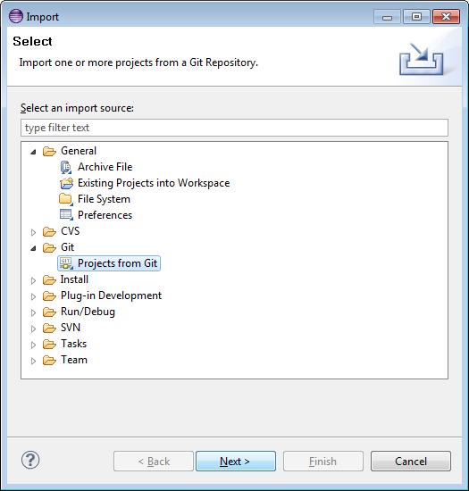

In the next pop-up, click TeamForge and Next,

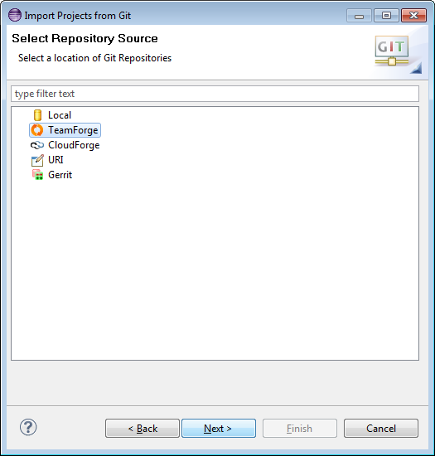

and then expand the eForge entry (this is the TeamForge site you created above).

This will display all eForge project – a long list. Scroll down to your project, expand it and select the Repository you want to import. Click Next.

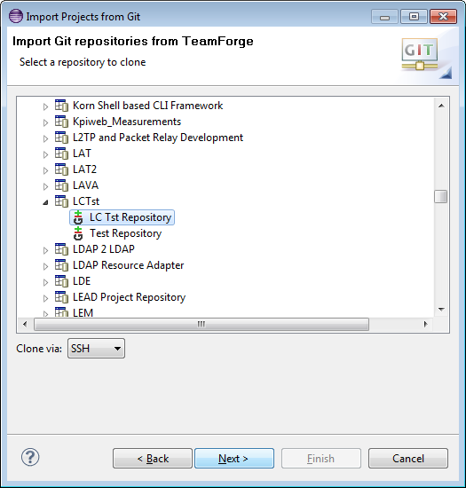

Select the branch you want to clone, click Next,

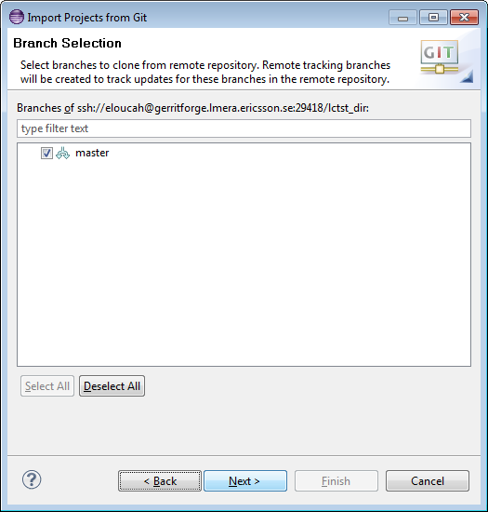

make sure your local destination Git repository is the one you want and click Next.

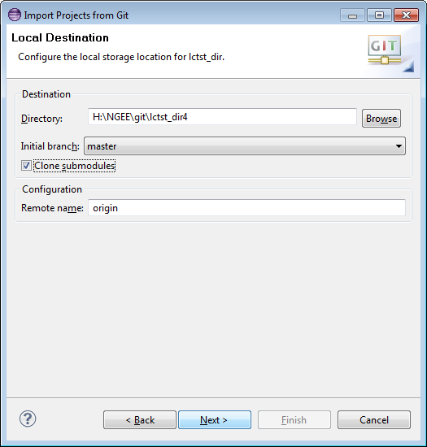

Depending on what was stored in Git, you can now import the Project. If the Project was stored as an Eclipse project, you can “Import existing projects”

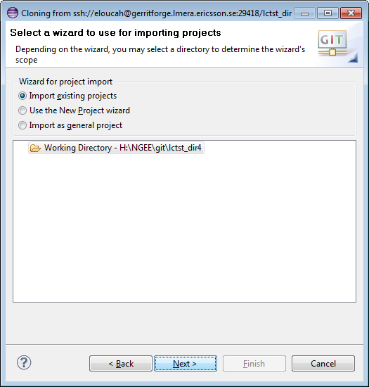

This will display the Eclipse Project in the local Git Repository:

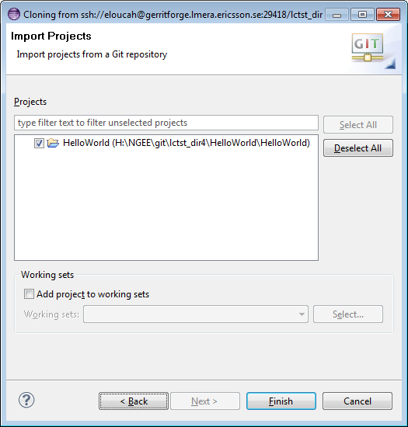

Click Finish, and you have the Project in Eclipse, linked to your local Git Repo.



Link to eGit (Eclipse Git Plugin)

<http://wiki.eclipse.org/EGit/User_Guide>

HomePage?id=atch109424