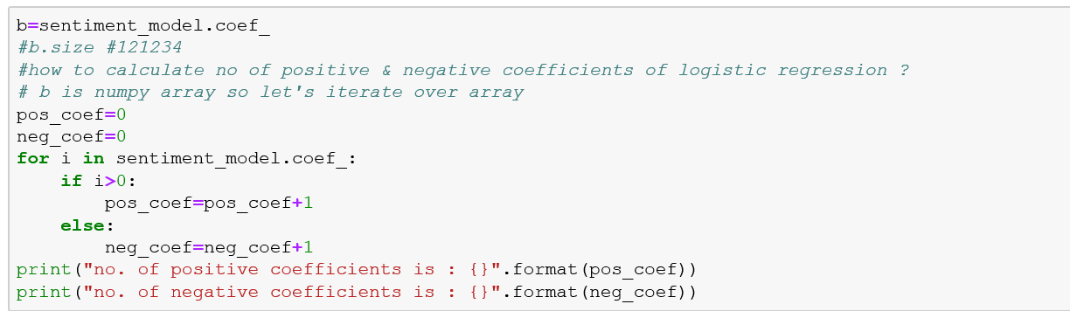

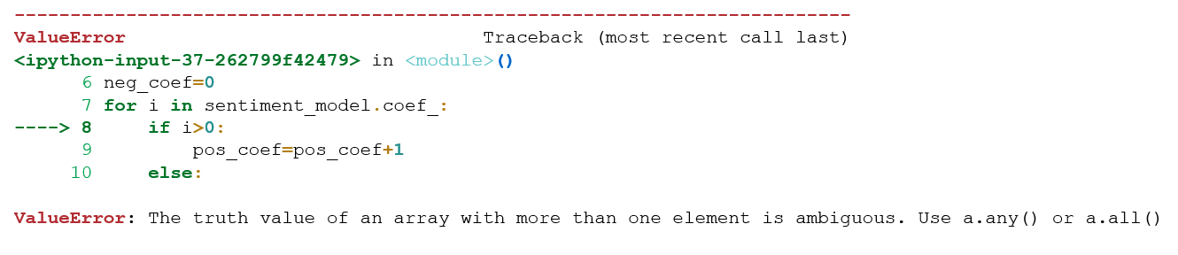

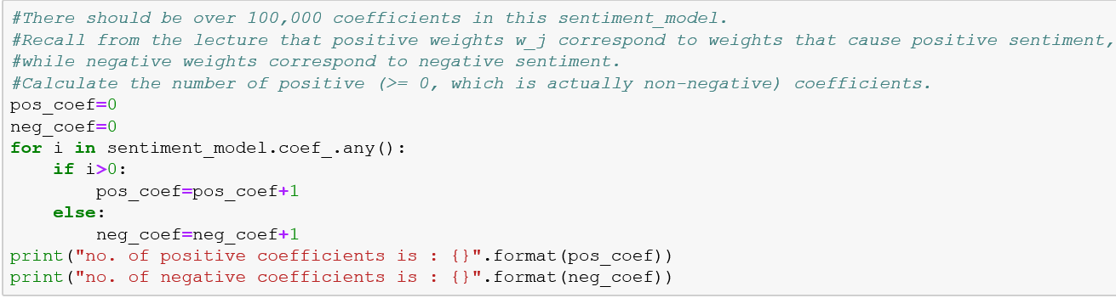

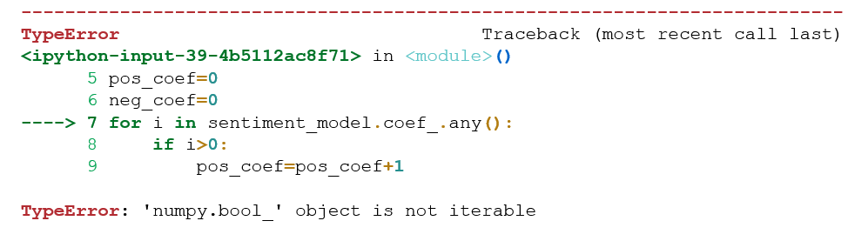

Finally, the code that worked:

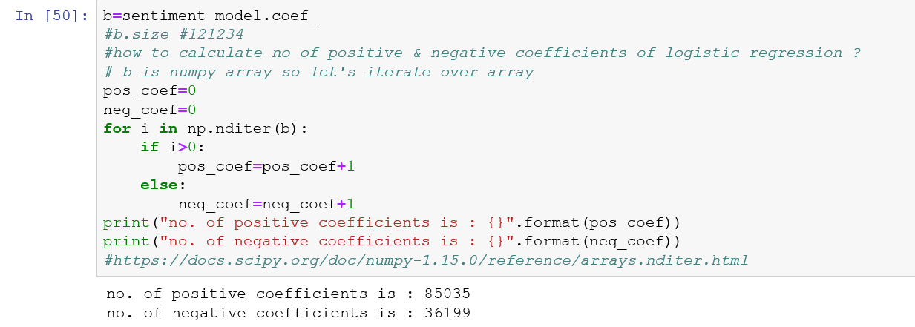

Reference doc:

https://docs.scipy.org/doc/numpy-1.15.0/reference/arrays.nditer.html