RACKAI-347 AMD AIM Engine Integration Technical Spec
Status | Draft - for review
Author | Neelava Chatterjee (RackAI engineering)
Date | 2026-09-17
Product Spec | TBD
Review Date | TBD
Epic | RACKAI-347

Summary
RackAI serves models on AMD Instinct GPUs through the aim runtime added in June: a runtime adapter that builds a direct-image KServe InferenceService from a hand-authored ModelClass on AMD's aim-base image. That gave us AMD serving on the same Model / ModelClass / ModelDeployment API as every other runtime.
AMD has since shipped AIM Engine, a Kubernetes operator that owns the layer our adapter builds by hand. It publishes tuned per-model profiles (image, engine arguments, precision, accelerator shape), downloads and caches weights on its own PVCs, creates the KServe objects, and hot-loads LoRA adapters inside the pod. This project moves the AMD serving path onto AIM Engine: the RackAI operator creates an AIMService instead of an InferenceService, and AIM's profile catalog becomes the source of ModelClass objects for AMD hardware. The CRDs users work with do not change; the additions are one label and one annotation (3.2), and the behaviour differences users will notice are listed in 3.10. AMD owns tuning, caching and the engine contract; we keep the user-facing API and routing. For autoscaling and scale from zero the lean is to adopt AMD's OpenTelemetry-based path, and our existing KEDA-based autoscaling remains the fallback if that path gives trouble.
The integration is a new serving path: an operator-wide flag enables it on a dataplane, and a per-deployment annotation opts a ModelDeployment into it. This is the same two-gate pattern introduced for the KServe LLMInferenceService path (llmisvc). The ModelClass.spec.runtime value stays aim for both the current adapter and the new path; only the annotation decides which one serves. Existing deployments are untouched until they are moved.
Scope: inference only. AMD fine-tuning is out of scope. Non-AMD dataplanes are untouched.
At a glance:
Concern | Today (aim runtime adapter) | With AIM Engine
Pod and KServe objects | Built by the RackAI operator | Built by AIM from a profile we pin, or one AIM selects
Model catalog for AMD | Hand-authored ModelClass per model | Generated from AIM profiles
Weights and cache | SeaweedFS mount | AIM-owned cache on a storage class we provide
LoRA adapters | Hot-loaded by our operator over HTTP | Staged over s3://, hot-loaded by AIM in the pod
Routing | Front proxy | Unchanged
Autoscaling | Our KEDA (Kubernetes Event-driven Autoscaling) ScaledObject on Prometheus metrics | Open; lean to AIM's OpenTelemetry-based autoscaling, ours as fallback
Scale from zero | Ours | Not in v1 on this path (task 9); lean to AMD's Envoy extension, ours as fallback

Strategic theme: multi-accelerator support in RackAI; AMD-maintained serving stack instead of a RackAI-maintained one.

1. Milestone — AIM Engine serving path (v1)
# | Task | Est | Jira
1 | Install and prerequisites — AIM Engine operator and CRDs in the dataplane installer from one values file (accelerator detector for our node labels, storage class for the cache, autoscaling companions per decision 5); storage capacity and KServe default-limits prerequisites; upgrade and rollback verified | 1-2d | TBD
2 | `aim` serving path — Go types for AIM's API; new serving path value behind an operator flag and the existing per-deployment annotation; AIMService built from the resolved deployment; AIM status and failure classes mapped onto ModelDeployment; automatic retry of failed downloads; teardown and path flip-back; unit tests | 3-4d | TBD
3 | Catalog from profiles — onboard catalog models into AIM by base-image derivation with our weights; sync AIM profiles into ModelClass objects with a stable identity across AIM releases; handle profiles that appear or disappear; retire the hand-authored *-aim classes on AMD dataplanes; unit tests | 2-3d | TBD
4 | Routing, autoscaling and observability — front proxy routes to the endpoint AIM reports in AIMService.status and re-targets on recreate (traffic target per decision 6); ModelClass.spec.scaling drives autoscaling on the AIM path, either through AIM's OpenTelemetry-based autoscaling or through our KEDA ScaledObject (decision 5); dashboards, ServiceMonitors and alerts cover AIM-served pods | 1-2d | TBD
5 | LoRA and custom weights — per-namespace AIM runtime config with Hugging Face and S3 credentials; LoRAAdapter mapped to AIM adapter artifacts with dynamic hot-load; uploaded and fine-tuned weights served from s3://. Gated on the object store decision (decision 1) | 2-3d | TBD
6 | Docs and migration — architecture and operations pages; runbooks for install, download failures, cache capacity and profile changes; if decision 2 says so, move live AMD deployments with a pre-warmed cache and rollback | 1d | TBD
7 | Nice to have: user-facing cache warm-up ahead of a deployment | 1d | TBD
8 | Blocked on hardware: multi-GPU profiles. The dev cluster has one GPU per node, so the sync only produces classes for profiles AIM marks deployable there | 1-2d | TBD
9 | Nice to have: scale from zero on the AIM path, AMD's Envoy Lua extension wired onto our gateway, or our existing mechanism pointed at AIM-served deployments as fallback. Until this lands, AIM-path deployments keep at least one replica | TBC | TBD

2. Architecture

2.1 What we're building
A fourth serving path, aim, next to isvc, llmisvc-dualrun and llmisvc. On this path the ModelDeployment controller does not build a KServe object. It builds one AIMService and lets the AIM Engine operator resolve the profile, provision and fill the cache, project the serving runtime, and create the InferenceService. Our controller watches the AIMService and maps its status back onto the ModelDeployment. The front proxy stays ours; autoscaling is either AIM's or ours (open, see 3.5).
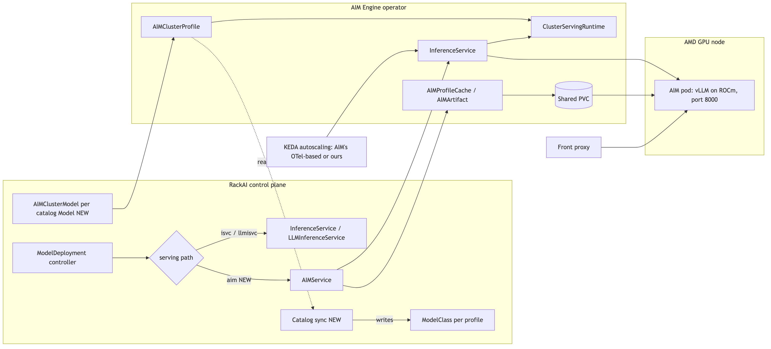
Figure 1 — Overall architecture. New pieces are marked NEW: the aim serving path building an AIMService, one AIMClusterModel per catalog model, and a sync that turns AIM profiles into ModelClass objects. AIM Engine owns everything inside its box; the front proxy is unchanged; autoscaling is open between AIM's and ours.

2.2 How a deployment flows
A user creates a ModelDeployment that references a ModelClass generated from an AIM profile. The controller resolves it, sees the aim path, and creates an AIMService pinned to that profile. AIM resolves the profile, ensures the weights are in its namespace cache (downloading once if not), and creates an InferenceService that references a ClusterServingRuntime projected from the profile. KServe schedules the pod on an AMD node carrying AIM's accelerator label, and the pod serves an OpenAI-compatible endpoint on port 8000. Our controller reads the service endpoint from AIMService.status, points the front proxy at it, and reports Ready.

2.3 What makes it different from the current aim runtime
- We no longer build the pod. Image, engine arguments, precision, resources and placement come from AMD's profile. The ModelClass pins which profile; it does not describe the pod.
- AIM owns the model cache. Weights land on PVCs that AIM provisions from a storage class we hand it. The SeaweedFS cache is not used on this path.
- LoRA adapters arrive from an S3 bucket. AIM downloads them onto a shared adapter disk, and a watcher inside the pod hot-loads them through the same vLLM endpoints we call today. Our operator no longer calls those endpoints itself.
- Placement is by AIM's accelerator label. AIM's detector labels each GPU node with its accelerator model, and the profile's node affinity selects on that label. Our AcceleratorClass node selector terms are not applied.
- New objects on the dataplane. AIM adds AIMClusterModel, AIMClusterProfile, AIMService, AIMProfileCache, AIMArtifact and AIMRuntimeConfig. All of them are internal; users never see or create them.

2.4 Reuse vs. new
Area | Reused as-is | Delegated to AIM Engine | New in RackAI
API and UX | Model, ModelClass, ModelDeployment, LoRAAdapter CRDs, API, UI, CLI |  | Profile pin label on ModelClass (or none, for AIM auto-select); aim serving-path annotation value; AIM failure classes on ModelDeployment status
Serving path | Operator flag plus per-deployment annotation gate from the llmisvc work | Profile selection, ClusterServingRuntime and InferenceService creation, pod spec | AIMService builder, watch and status mapping, teardown and flip-back
Catalog | Catalog Model entries | Discovery of profiles from images into AIMClusterProfile objects | One AIMClusterModel per catalog model; a sync that watches AIMClusterProfile and writes ModelClass; retirement of hand-authored *-aim classes
Weights and cache |  | Download and cache on our storage class (hf:// and s3://), dedupe, warm-up | Retry of failed downloads; object store for s3:// sources (decision)
LoRA | LoRAAdapter CRD and API | Adapter staging and in-pod hot-load | LoRAAdapter to adapter artifact mapping; status contract change
Placement |  | Accelerator detection and node labelling; profile-driven node affinity | Validation that an AcceleratorClass maps to one AIM accelerator model
Routing | Front proxy | AIM gateway route (optional) | Front proxy targets the endpoint AIM reports in status and re-targets on recreate
Autoscaling and scale from zero | KEDA (fallback: our ScaledObject on Prometheus vLLM metrics) | Lean: AIM's OpenTelemetry-based autoscaling and AMD's Envoy scale-from-zero extension | ModelClass.spec.scaling translated to whichever path is chosen; keda-otel-add-on and OpenTelemetry Operator in the installer if AIM's
Credentials and tenancy | Registry credential flow, tenant namespaces |  | Per-namespace AIMRuntimeConfig with HF and S3 secrets; RBAC so only the operator writes AIM objects
Install | Dataplane installer |  | AIM Engine CRDs and operator with our values; storage capacity and KServe limits prerequisites

2.5 Integration boundary
The RackAI operator talks to AIM Engine's API and nothing below it. It creates and watches AIMService, AIMArtifact, AIMProfileCache, AIMRuntimeConfig and AIMClusterModel, reads AIMClusterProfile, and learns everything else from AIMService.status: the inference service name, the endpoint, and whether the pods are ready. It does not create, patch or watch KServe objects on this path. Those belong to AIM.
Two places may need to reach past AIM, and both are alignment questions rather than decisions taken here:
- Traffic target. The front proxy needs an address to route to. The preferred options are the endpoint AIM reports in AIMService.status, or AIM's own gateway route, which the runtime config can enable. The fallback is to address the KServe predictor Service by name.
- Autoscaling fallback. If we keep our autoscaling on this path, our ScaledObject has to target the Deployment that KServe created for AIM's InferenceService. AIM's own autoscaling avoids this, which is one reason for the lean in 3.5.

3. How it works

3.1 Serve flow
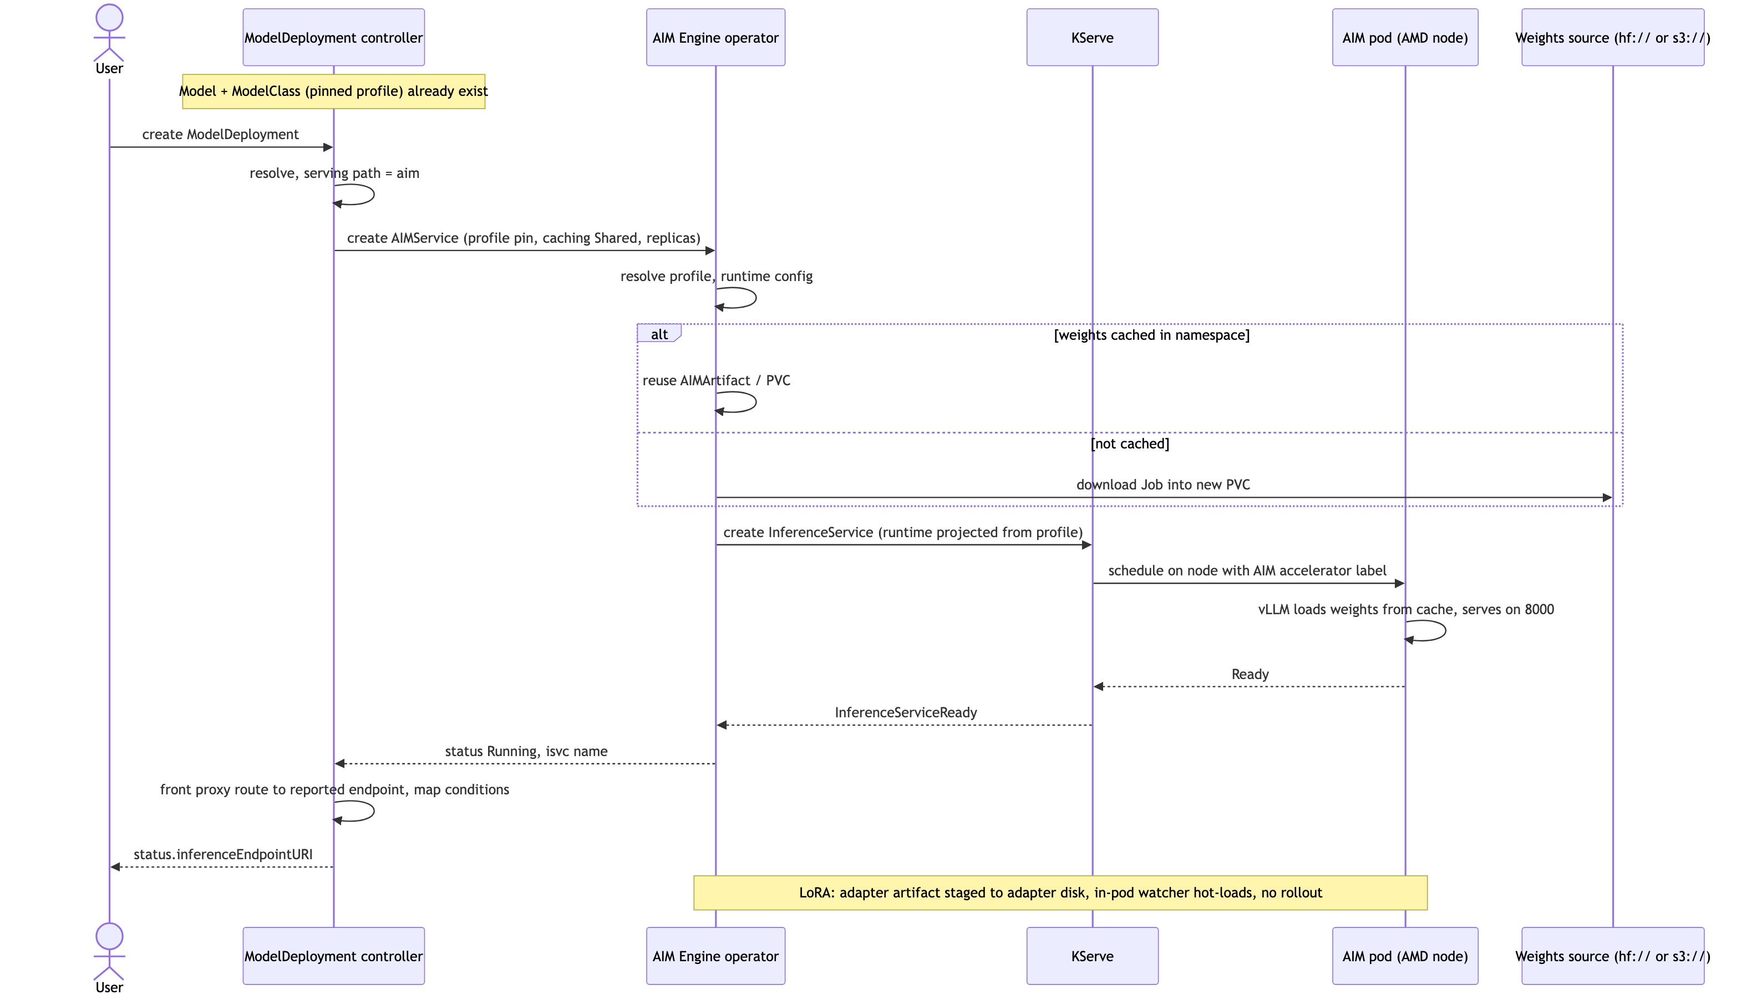
Figure 2 — Deploy and serve sequence. The controller's work is building the AIMService and mapping status; AIM Engine does the rest.

3.2 Configuration model
Users keep the same CRDs. Two things change on the AMD path: the ModelClass carries a profile pin (or, for auto-select classes, no pin), and ModelDeployment uses the aim serving-path annotation. Fields marked [NEW] are the only new API surface; fields marked [ignored] have no effect on this path because AIM controls the pod.
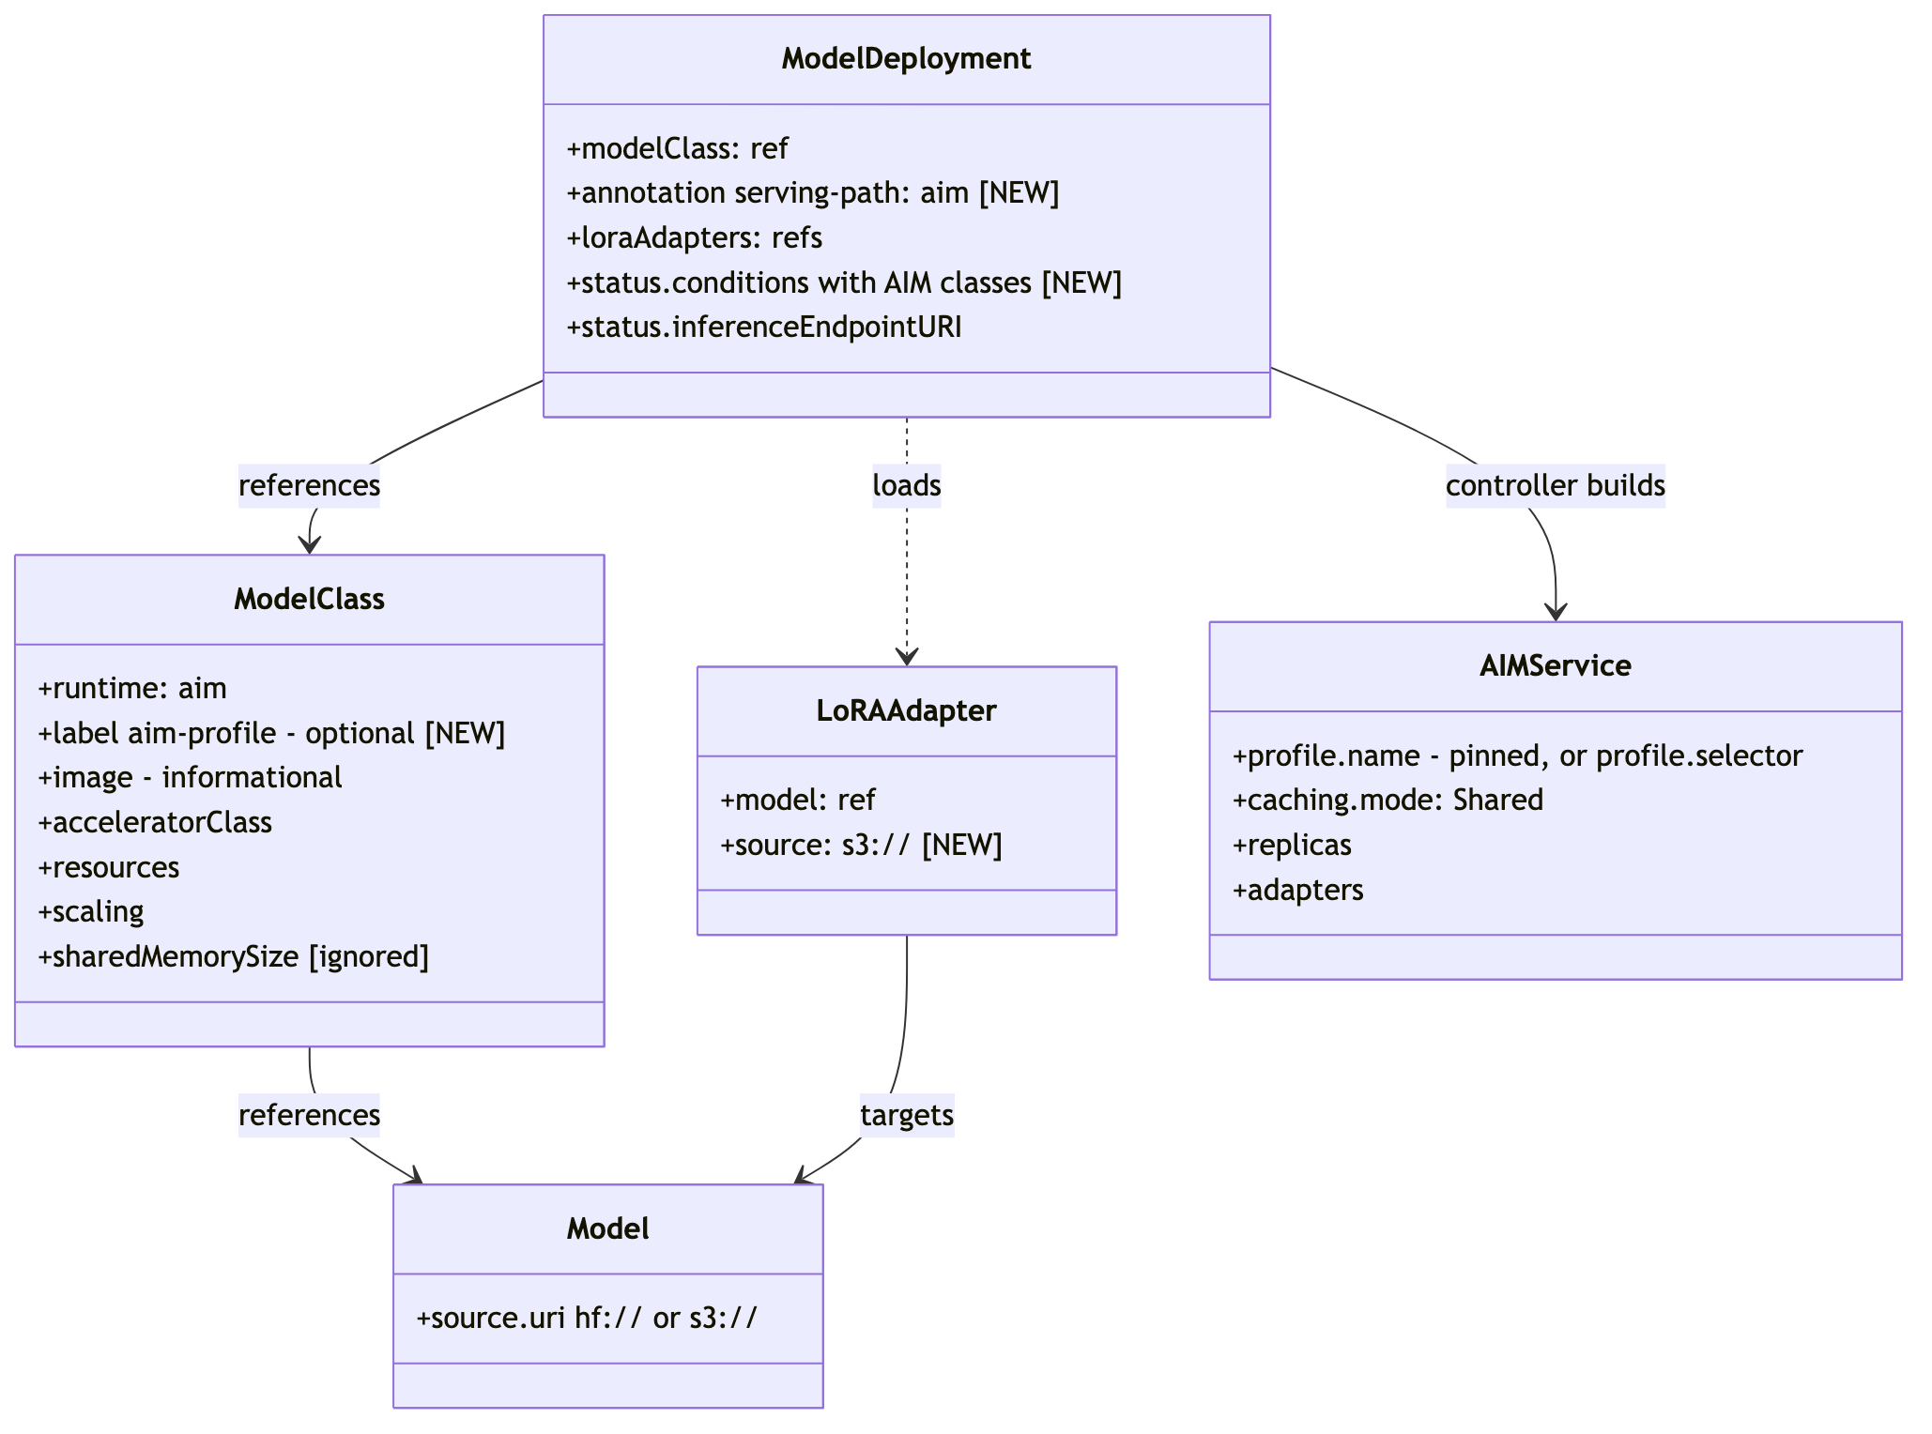
Figure 3 — CRD shapes on the aim path. AIMService is internal; users never see it.
This is the AIMService our controller builds, with illustrative values:
apiVersion: aim.eai.amd.com/v1alpha2
kind: AIMService
metadata:
name: <model-deployment-name>
namespace: <tenant-namespace>
annotations:
aim.eai.amd.com/reconciler-pipeline: profile
spec:
profile:
name: qwen3-32b-vllm-mi350x-fp8-tp1-latency-74c5231d # pinned from the ModelClass
caching:
mode: Shared # cache survives the service, deduped per namespace
replicas: 1 # or minReplicas/maxReplicas + autoScaling on AIM's path (3.5)
runtimeConfigName: default # per-namespace credentials (see 3.8)
imagePullSecrets: [] # from the existing registry credential flow

Pinning by profile name means AIM's own ranker never runs: two deployments of the same class always get the same image, engine arguments and placement. Engine tuning lives in the profile; we do not pass engine arguments through.
AIM also supports automatic profile selection: given a model and a selector it picks the best deployable profile for the hardware it finds. A selector names a precision (for example fp8), a metric (whether the profile is tuned for latency or throughput) and a minimum profile type (AMD's quality tier, from optimized down to unoptimized). A profile is deployable when the accelerator it targets is present on the cluster. We can offer that too: a ModelClass without a profile pin, carrying only the model and an optional selector, makes the controller emit profile.selector instead of profile.name and lets AIM choose. That gives a single "best available" class per model, portable across AMD GPU generations, at the cost of AIM deciding the exact image and engine arguments. Pinned classes are the default for determinism; auto-select classes are an option alongside them, not a restriction. Whether to ship auto-select classes in v1 is decision 7.

3.3 Catalog: from AIM profiles to ModelClass
AIM discovers profiles from images and materialises each one as an AIMClusterProfile object. We create an AIMClusterModel that points at an image, AIM runs a discovery job that reads the profile definitions baked into that image, and one AIMClusterProfile appears per profile. Nothing on our side reads an image. There are two ways to get profiles for a model in our catalog:
 | Derivation from aim-base (default) | Official per-model image
Image | amdenterpriseai/aim-base:<tag> | amdenterpriseai/aim-<model>:<tag>
Weights | Ours: hf:// or s3:// set on the AIMClusterModel | Baked into the profile
Profiles | General profiles per precision and latency/throughput | AMD-curated, sometimes optimized for a GPU
Coverage | Any model we can name | Only models AMD publishes

Derivation is the default because it covers the whole catalog, including uploaded and fine-tuned weights, on one image we already ship. Per-model images drop in as a second source when AMD publishes one that matches a catalog entry.
Onboarding creates one AIMClusterModel per catalog Model, for example:
apiVersion: aim.eai.amd.com/v1alpha2
kind: AIMClusterModel
metadata:
name: qwen2-5-32b-instruct
spec:
profiles:
derivedFrom:
selector:
role: base
modelRef: { name: aim-base, scope: Cluster }
versionPolicy: all
overrides:
aimId: Qwen/Qwen2.5-32B-Instruct
modelId: Qwen/Qwen2.5-32B-Instruct
modelSources:
- modelId: Qwen/Qwen2.5-32B-Instruct
sourceUri: hf://Qwen/Qwen2.5-32B-Instruct

The sync is a controller that watches AIMClusterProfile objects, the same way it would watch any other CRD. When a deployable profile appears, changes or disappears, it writes, updates or retires the matching ModelClass. It writes one ModelClass per deployable profile, for example:
apiVersion: rackai.rackspace.com/v1alpha1
kind: ModelClass
metadata:
name: qwen2.5-32b-instruct-aim-fp16-latency
labels:
rackai.rackspace.com/aim-profile: qwen2-5-32b-instruct-vllm-mi350x-fp16-tp1-latency-3a1f9c2e
rackai.rackspace.com/aim-profile-version: "0.13"
spec:
model: qwen2.5-32b-instruct
runtime: aim
image: amdenterpriseai/aim-base:0.13 # informational; the profile is authoritative
acceleratorClass: amd-mi350x
resources:
requests: { amd.com/gpu: "1" }
limits: { amd.com/gpu: "1" }
scaling: { minReplicas: 1, maxReplicas: 1 }
displayName: "Qwen2.5-32B-Instruct (AIM, fp16, latency)"

Rules the sync follows:
- Identity is model id + precision + accelerator model + GPU count + metric (latency or throughput). Profile names carry a content hash that changes with each AIM release, so a new release updates the pin on the existing class rather than creating a new class. Running deployments keep the profile they were created with; only new deployments pick up the new pin. The sync is the only actor that changes pins.
- Deployable only. Only profiles AIM marks deployable on that dataplane become classes, so a profile for hardware the dataplane does not have (for example a two-GPU profile on single-GPU nodes) produces no class.
- Auto-select class (optional, decision 7): one additional class per model with no pin, so AIM picks the profile at deploy time (see 3.2).
- A profile that disappears in a new release (for example a precision AMD stops shipping) marks its class unavailable for new deployments. Running deployments keep serving; a class with live deployments is never deleted.
- Display naming exposes precision and latency/throughput without AIM vocabulary. Product to confirm wording.
- Retirement means a class is hidden from new deployments but never deleted while a deployment references it. The hand-authored *-aim classes are retired this way on AMD dataplanes once generated ones exist for the same model; deployments still on them keep running until they are moved (3.10).
- Cadence. Because the sync watches AIMClusterProfile objects, it reacts to changes as they happen. A periodic full reconcile catches anything a watch missed.

3.4 Caching and weights
AIM owns its cache. We name a storage class in the operator's chart values and AIM provisions one shared PVC per model per tenant namespace, sized at the weights plus 15% headroom. Which storage class backs it is an installer choice per dataplane.
- Shared caches survive service deletion and are deduped by weights: different profiles and image versions of the same model share one download. A redeploy from a warm cache skips the download entirely.
- Scope. A cache belongs to one tenant namespace. If three namespaces serve the same model, the weights are downloaded and stored three times. This is accepted for v1. How the cache storage is shown to users and billed is decision 3.
- Sources. AIM downloads weights from two kinds of location only: a Hugging Face repository (hf://, public or gated with the tenant's token) or an S3 bucket (s3://). It cannot read from an existing PVC or a local path, so our SeaweedFS mount cannot feed it. Every LoRA adapter and every uploaded or fine-tuned weight set therefore has to live in an S3-compatible object store reachable from the dataplane, for example the SeaweedFS S3 gateway, MinIO, Ceph RGW, or a cloud bucket. Choosing that store is the one decision this project cannot take on its own. Catalog models from Hugging Face do not need it.
- Warm-up. Creating an AIMProfileCache before the service makes AIM download the weights ahead of time, so the service starts from a warm cache. We use this for migrations. Exposing it to users is a nice-to-have (task 7).
- Failed downloads. AIM does not retry a failed download; the artifact stays failed until it is deleted. Our controller deletes the failed artifact and recreates it with a backoff, and reports the real cause on the ModelDeployment (for example a storage mount failure) instead of AIM's generic "invalid spec" reason.

3.5 Routing, autoscaling and observability
- Routing (proposed, decision 6): traffic enters through the RackAI front proxy as today and is routed to the endpoint AIM reports in AIMService.status (see 2.5 for the alternatives). AIM's optional gateway route and KServe's host-based routes do not collide with ours.
- Autoscaling (open, decision 5, lean to AIM's): AIM autoscales through KEDA with OpenTelemetry pod metrics, which needs keda-otel-add-on and the OpenTelemetry Operator on every AMD dataplane. Both are AMD's recommended companions and unlock their scale-from-zero path, so the lean is to install them with AIM and translate ModelClass.spec.scaling into AIMService minReplicas, maxReplicas and autoScaling. Fallback if that path gives trouble: the AIMService sets only replicas, AIM then creates nothing scaling-related, and our KEDA ScaledObject on Prometheus vLLM metrics targets the Deployment behind AIM's inference service (the one case where we would touch a KServe-created object, see 2.5). Either way users keep the same scaling fields.
- Scale from zero (not in v1, lean to AMD's): AMD's path is an Envoy Gateway Lua extension that AMD delivers, plus the same OpenTelemetry and KEDA components as their autoscaling, wired onto our gateway. The fallback is our existing scale-from-zero mechanism. Either way it is task 9, a nice-to-have. Until it lands, deployments on the AIM path keep at least one replica.
- Observability: vLLM metrics on port 8000 are scraped from the pods as today. Dashboards and ServiceMonitors need AIM's pod labels added so AIM-served pods show up.

3.6 Status and error surfacing
AIM reports Pending, Starting, Running, Failed plus a set of conditions (profile, runtime config, cache, runtime, inference service, pods, config valid). The controller maps them onto ModelDeployment:
ModelDeployment | From AIMService
Ready | Ready=True and status Running
Progress detail | cache condition with download percent; pods condition while starting
InferenceServiceRef, internal URI | inference service name and endpoint from status
InferenceEndpointURI | front proxy URL as today

AIM introduces failure classes that the current path does not have. Each one gets user-facing wording on the ModelDeployment:
- Profile missing or not deployable: the catalog entry is stale and needs a sync.
- Storage quota exceeded: the dataplane's cache storage is full.
- Download failed: an infrastructure problem; the controller retries automatically.
- Credentials or endpoint wrong: the namespace's runtime configuration needs fixing.
- Profile disappeared under a running service: the class has been retired; the deployment keeps serving but cannot be redeployed until it is re-pinned.

3.7 LoRA
LoRA is possible on this path, but only through AIM's adapter mechanism, which is why it is gated on the object store decision:
RackAI | AIM
LoRAAdapter with adapter files in the object store | AIMArtifact type: adapter, sourceUri: s3://..., compatibleWith: [<modelId>], rank
ModelDeployment with adapters | AIMService.spec.adapterMode: dynamic, caching.mode: Shared, adapters: [...]
Per-replica adapter states in today's status contract | A count of replicas that have loaded the adapter, plus the state of the adapter disk. This is a contract change (decision 4).

How it works: our operator creates an AIMArtifact for the adapter and lists it on the AIMService. AIM downloads the adapter from the S3 bucket onto a shared adapter disk, and a watcher inside the pod loads or unloads it through vLLM's own endpoints. The pod is not restarted, and our operator never calls those endpoints itself.
What is not possible: the HTTP hot-load our operator does today, where it calls the pod's load endpoint directly. AIM does not expose that endpoint through its route, and on this path we do not talk to the pod at all. As a result, adapter files on the SeaweedFS mount cannot be used. Every adapter has to be uploaded as an object in the S3-compatible store first.

3.8 Tenancy and credentials
- Only the RackAI operator creates and modifies AIM objects. Tenants get no RBAC permissions on the aim.eai.amd.com API group, so they cannot create an AIMService or read another tenant's configuration.
- Model-source credentials are per tenant namespace and come from the existing RegistryCredential flow. Today a RegistryCredential with purpose modelPull holds the Hugging Face token for gated models; on the AIM path the operator references that same Secret from the tenant's AIMRuntimeConfig instead of injecting it into the pod. S3 access keys for the object store use the same mechanism (a new purpose or key, task 5). Credentials are never written into the AIMRuntimeConfig itself, never placed in the AIM operator namespace (aim-system) where every tenant's workloads could reach them, and documentation uses placeholder values only.
- Image pull secrets are split by purpose. Catalog onboarding runs discovery jobs in aim-system, so the pull secret for the AIM images has to exist there. Pull secrets for a tenant's own deployments continue to come from the existing registry credential flow.

3.9 Install posture
The dataplane installer takes on AIM Engine as a platform component on AMD dataplanes:
- CRDs and operator. The installer applies the AIM CRDs (server-side, because of their size) and installs the operator chart into aim-system with our values: the accelerator detector keyed on our node labels, the NVIDIA detector switched off, and the storage class for the cache. If decision 5 picks AIM's autoscaling, keda-otel-add-on and the OpenTelemetry Operator are installed alongside.
- KServe default limits. KServe's default resource limits would cap every AIM pod; the installer clears them and keeps them cleared across KServe upgrades.
- Storage capacity. Each dataplane needs enough capacity on the chosen storage class for the cache footprint described in 3.4.
- Node taints. AIM pods carry only the default tolerations, so GPU nodes on AMD dataplanes must not be tainted. The dev cluster's are not; production dataplanes need confirming.

3.10 Migration and behaviour differences
Migration happens one deployment at a time. We pre-warm the cache with an AIMProfileCache, then flip the deployment's serving-path annotation to aim. If anything goes wrong, flipping the annotation back returns the deployment to the existing path. Deployments that use LoRA adapters or uploaded weights can only move once task 5 has landed, because their files must first exist in the object store. Whether live deployments move in v1, or only new deployments use the new path, is decision 2. Migration may not be needed at all: if the AIM path is what ships to production for AMD dataplanes, there are no live deployments on the current path to move, and task 6 reduces to documentation.
Because AIM controls the pod spec, a few things change for users on AMD dataplanes. The first four are accepted for v1 and raised with AMD as upstream asks; the last is decision 4:
- The served model name in /v1/models is the profile's model id (for example Qwen/Qwen3-32B-FP8), not the RackAI Model name.
- Readiness is a TCP probe only, with no liveness or startup probe. Shared memory (/dev/shm) is fixed at 8 GiB, so ModelClass.sharedMemorySize has no effect on this path.
- Placement is by accelerator model only. Tolerations and extra node selector terms cannot be passed through (see the node taints prerequisite in 3.9).
- The first deployment of a model in a namespace downloads the weights, which takes minutes depending on size. Later deployments in that namespace start from the warm cache.
- LoRA status reports a loaded-replica count rather than per-replica states.

4. Open decisions
Posted with this spec in the review thread, for team alignment:
- Object store for s3:// sources: which one, who runs it, and Security sign-off for shared or regulated dataplanes. This gates task 5.
- Migration mode: move live AMD deployments in v1, new deployments only, or no migration because the AIM path goes to production directly.
- How AIM's cache storage is presented to users and billed, given it is separate from the SeaweedFS cache.
- LoRA status contract change: a count of loaded replicas instead of per-replica states.
- Autoscaling and scale from zero: adopt AIM's OpenTelemetry-based autoscaling and AMD's Envoy scale-from-zero extension (lean), or keep ours on the AIM path. Decides task 4 and what the installer ships.
- Integration boundary: the operator talks to AIM's API only (2.5). Confirm the traffic target for the front proxy, and agree that touching KServe-created objects is only acceptable where AIM offers no alternative.
- Auto-select classes: ship one unpinned "best available" class per model in v1 alongside the pinned ones (3.2), or pinned only.
- Cache-aware routing: AIM creates a standard KServe `InferenceService`, so traffic to a multi-replica deployment is round-robin across pods rather than llm-d's cache-aware scheduling on the `llmisvc` path. Accept plain load balancing on the AIM path for v1, keep large multi-replica models on `llmisvc`, or wrap AIM's pods in our own `InferencePool` and EndpointPicker (untested, and it reaches past AIM's API).

5. Engineering Checklist
- make lint clean; make test (unit + envtest) green; make manifests generate shows no drift
- Unit tests for the AIMService builder, status mapping, catalog sync identity and validation
- e2e on the AMD dev cluster: deploy, chat, delete, warm redeploy, path flip-back, LoRA load and unload, s3:// deploy
- aim path off by default, enabled per dataplane; no change to non-AMD dataplanes
- Dataplane installer installs AIM Engine idempotently; operator upgrade and rollback keep services running
- Dashboards and ServiceMonitors cover AIM-served pods; alerts on cache quota and repeated download failures
- Runbooks: install and upgrade, download failures, cache capacity, profile disappearance, migration cutover
- Security review of the object store endpoint and credential handling before it is enabled on a shared or regulated dataplane

6. Release Checklist
- A tenant can deploy a catalog model on an AMD dataplane with the existing API and serve OpenAI-compatible inference through the front proxy
- Generated AIM ModelClasses visible in the UI and CLI with product-approved naming; hand-authored *-aim classes retired
- Object store decision taken and LoRA plus custom weights validated on AMD, or formally deferred on the AIM path
- Live AMD deployments migrated, new-deployments-only rollout approved, or no migration needed because the AIM path went to production directly
- Docs published; on-call briefed on the new failure classes
- Product, Engineering and Platform/Operations sign-off

7. References
- June tech spec for the aim runtime adapter (v1): docs/rackai-347/RACKAI-AMD-techspec.docx
- AIM Engine repositories and docs: aim-engine (operator), aim-build (runtime image), github.com/amd-enterprise-ai
- Related tickets: RACKAI-263 (mixed vendor), RACKAI-372 (model sunset), RACKAI-377 (per-model images), RACKAI-390 (dual-run and rollback)

