Alliance CRM
Persona-Based Screen List & Wireframe Brief
Prepared for technical design review and UI planning
Purpose
This document translates the alliance CRM concept into role-based user experiences. It outlines the primary personas, their decision needs, recommended dashboard layouts, detail views, quick actions, and UI modules so the first product version can be designed consistently.
Deliverables included
• Persona-based dashboard recommendations
• Wireframe guidance for critical screens
• Low-fidelity mockup pages
• UI module checklist for implementation planning

Founding Orchestrator / Core Governance | Partner Owner / Business Builder | Solution Architect / Technical Partner
Channel / Referral Partner | Delivery Manager / PMO | Restricted External / Advisor

How to use this document
Use this brief to align CRM UX with the alliance operating model. The same data model should serve multiple personas, but each persona should see different menus, widgets, and detail depth based on responsibility, visibility level, and decision rights.
- One shared data model; multiple persona dashboards.
- Role-based access and record-level visibility are mandatory.
- The same opportunity should look different for governance, commercial, technical, and delivery users.
- Summary View, Working View, and Governance View should be treated as separate UX layers.

Core UX principles
- Show the right decision context, not maximum data.
- Keep ownership visible: source owner, sponsor, deal owner, project owner.
- Use consistent record headers: Summary, Ownership, Visibility, Status, Next Action.
- Support quick actions from every list and detail page.
- Keep restricted personas lightweight and mobile-friendly.

1. Founding Orchestrator / Core Governance
This user steers the system, resolves overlaps, controls visibility, and monitors operating health.

Primary questions
- Who is working on what?
- Where are conflicts or overlap risks?
- Which records need approval?
- Which opportunities lack clarity on ownership, billing entity, or revenue split?

Recommended navigation
- Dashboard
- Opportunities
- Partners
- Products
- Governance
- Agreements
- Risks & Compliance
- Reports

Dashboard composition
- Top KPI cards: active opportunities, conflict items, pending approvals, agreements nearing expiry
- Main widgets: opportunity heatmap, conflict & visibility queue, recent activity, pipeline focus, alerts

Quick actions
- Change visibility level
- Assign sponsor
- Start conflict review
- Grant or revoke partner access
- Request revenue-share review
- Open project room

Detail-view emphasis
On record pages, keep the upper section consistent: Summary, Ownership, Visibility, Status, and Next Action. Then expose role-specific tabs such as Notes, Activities, Documents, Risks, Agreements, and Related Items.

2. Partner Owner / Business Builder
This user brings leads, owns accounts, carries pipeline, and collaborates with delivery and technical partners.

Primary questions
- What is happening in my pipeline?
- Which accounts and products are active?
- What follow-up is due?
- What support do I need from technical or PMO roles?

Recommended navigation
- My Dashboard
- My Leads
- My Opportunities
- My Accounts
- My Products
- Activities
- Documents

Dashboard composition
- Top KPI cards: my leads, open opportunities, follow-ups due, expected revenue
- Main widgets: my pipeline, my accounts, my products, upcoming actions, collaborations, documents

Quick actions
- Add new lead
- Log meeting
- Request demo
- Request technical review
- Create proposal request
- Add collaborator

Detail-view emphasis
On record pages, keep the upper section consistent: Summary, Ownership, Visibility, Status, and Next Action. Then expose role-specific tabs such as Notes, Activities, Documents, Risks, Agreements, and Related Items.

3. Solution Architect / Technical Partner
This user evaluates architecture, product fit, integration scope, delivery risk, and technical readiness.

Primary questions
- Which opportunities need technical review?
- Which products fit this use case?
- Where are integration blockers?
- Is compliance or security review needed?

Recommended navigation
- Technical Dashboard
- Opportunities Needing Review
- Products & Architectures
- Integrations
- Projects
- Risks
- Notes / Docs

Dashboard composition
- Top KPI cards: technical reviews pending, demo requests, open blockers, active implementations
- Main widgets: architecture review queue, solution fit panel, compliance flags, PoC queue, integration notes, delivery readiness

Quick actions
- Mark technically fit / not fit
- Suggest product fit
- Create demo scope
- Add integration risk
- Add estimate
- Trigger compliance review

Detail-view emphasis
On record pages, keep the upper section consistent: Summary, Ownership, Visibility, Status, and Next Action. Then expose role-specific tabs such as Notes, Activities, Documents, Risks, Agreements, and Related Items.

4. Channel / Referral Partner
This user should have a simplified and mostly commercial interface with limited visibility.

Primary questions
- Which referrals have I submitted?
- Which have been accepted?
- What stage are they in?
- What payout may be due?

Recommended navigation
- My Referrals
- Submit Lead
- Status
- Documents
- Payouts

Dashboard composition
- Top KPI cards: submitted leads, accepted leads, active referrals, estimated payout
- Main widgets: my referrals, status tracker, pending info requests, payout summary

Quick actions
- Submit lead
- Update referral info
- Upload additional info
- Request intro meeting
- Ask payout status

Detail-view emphasis
On record pages, keep the upper section consistent: Summary, Ownership, Visibility, Status, and Next Action. Then expose role-specific tabs such as Notes, Activities, Documents, Risks, Agreements, and Related Items.

5. Delivery Manager / PMO
This user coordinates execution after a deal is won, tracks milestones, and monitors scope and handoff.

Primary questions
- Which projects are active?
- What is delayed?
- Is SOW complete?
- Which milestones are at risk?
- Is support handoff ready?

Recommended navigation
- Delivery Dashboard
- Projects
- Milestones
- SOW / Agreements
- Risks
- Resource View
- Reports

Dashboard composition
- Top KPI cards: active projects, milestones due this week, delayed items, SOW missing
- Main widgets: project status board, milestone timeline, scope & approvals, resource view, delivery risks

Quick actions
- Add milestone
- Flag blocker
- Open scope change request
- Request acceptance
- Start support handoff

Detail-view emphasis
On record pages, keep the upper section consistent: Summary, Ownership, Visibility, Status, and Next Action. Then expose role-specific tabs such as Notes, Activities, Documents, Risks, Agreements, and Related Items.

6. Restricted External / Advisor
This user only sees explicitly shared items and limited context.

Primary questions
- Which records are shared with me?
- Where is my input needed?
- Which meetings and files are open to me?

Recommended navigation
- Shared Items
- Tasks
- Notes
- Meetings

Dashboard composition
- Top KPI cards: shared opportunities, advisory requests, open tasks, upcoming sessions
- Main widgets: shared with me, review requests, meeting notes, documents available

Quick actions
- Respond to review request
- Comment on shared item
- Join session
- Open shared documents

Detail-view emphasis
On record pages, keep the upper section consistent: Summary, Ownership, Visibility, Status, and Next Action. Then expose role-specific tabs such as Notes, Activities, Documents, Risks, Agreements, and Related Items.

Low-Fidelity Mockup Pages
These mockups are not final UI designs. They show recommended information hierarchy, panel grouping, and dashboard emphasis for three critical personas.

Governance Dashboard – conflict, approvals, visibility, and operating control
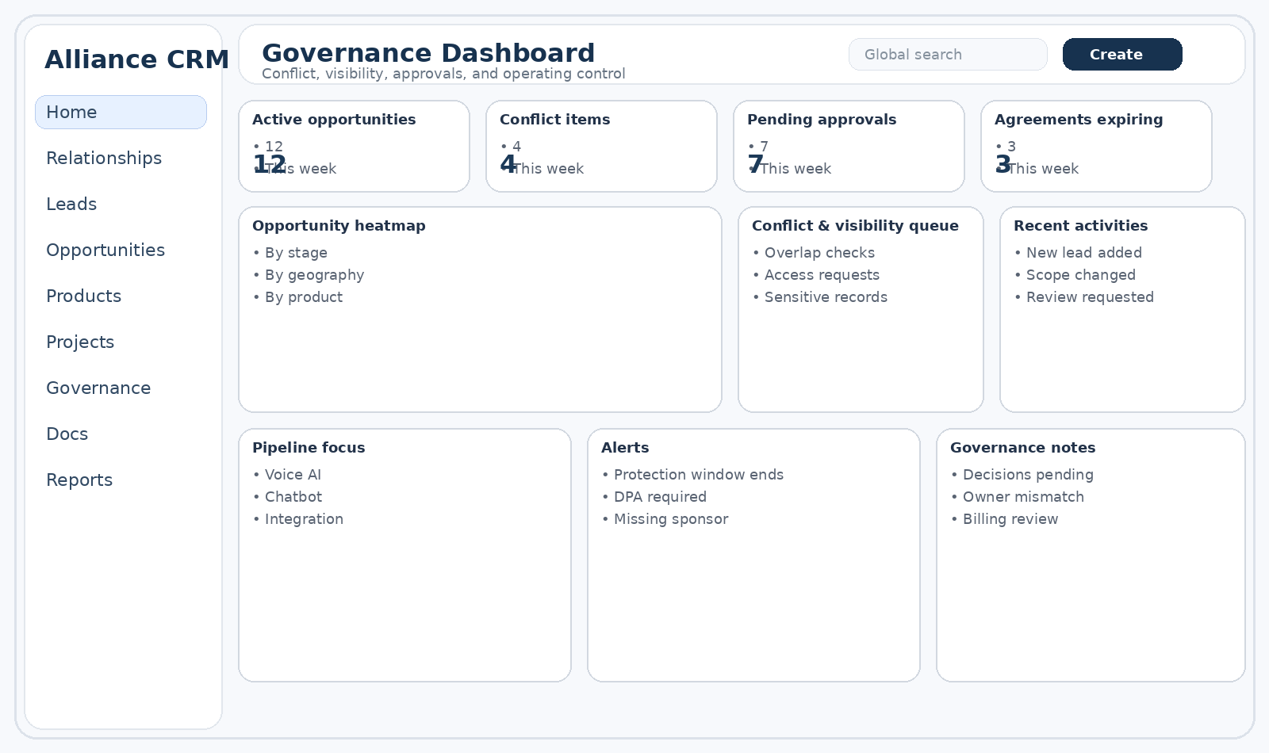

Partner Owner Dashboard – pipeline, accounts, products, and next actions
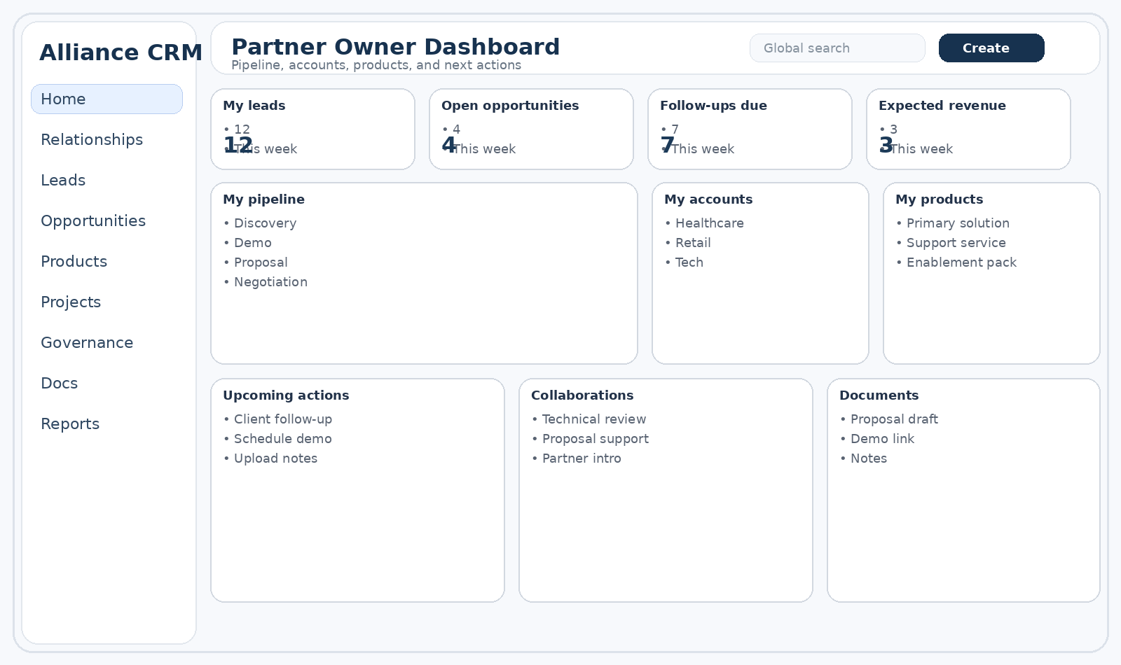

Technical Partner Dashboard – architecture review, blockers, and delivery readiness
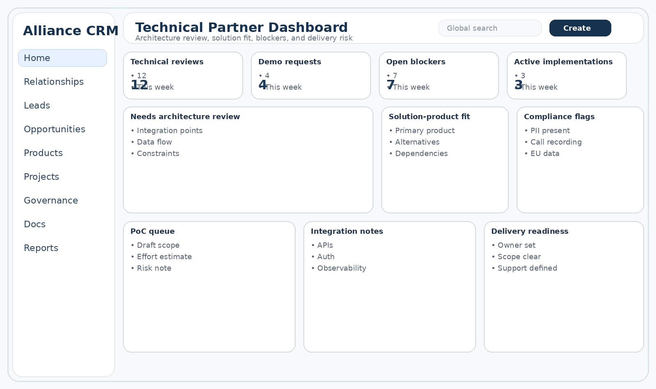

UI Module Checklist for Technical Planning
This checklist helps translate the persona design into implementable modules. The first release should prioritize CRM core, persona dashboards, and visibility-sensitive detail pages.
Module | Purpose | Priority | Notes
Auth & Identity | Login, profile, role resolution, scope selection | P0 | Needs role-based access and future SSO compatibility
Role & Visibility Engine | Controls menu, field, and record visibility | P0 | Must support Private, Restricted, Shared with Approval, Active Project Room
Contact & Organization | Relationship memory and account context | P0 | Should support who-knows-whom mapping
Lead Registry | Capture and qualify early-stage opportunities | P0 | Needs source owner, sponsor, protection window
Opportunity Engine | Commercial pipeline and deal management | P0 | Should support products, deal paths, commercial status
Product & Capability Registry | Solution catalog and fit mapping | P0 | Useful for technical partner and staffing decisions
Activities & Notes | Shared and private working memory | P0 | Support linked notes with visibility levels
Agreements Registry | Track NDA, MoU, reseller, SOW, DPA, IP docs | P1 | Needs reminders and linked records
Revenue Share Module | Store split model and payout basis | P1 | Can begin as simple record fields, not full engine
Projects & Milestones | Delivery tracking after close | P1 | Essential for PMO persona
Risk & Compliance | Flag privacy, security, IP, white-label, DPA issues | P1 | Attach to product, opportunity, or project
Dashboards by Persona | Role-specific home views | P0 | Start with Governance, Partner Owner, Technical, PMO, Referral
Search & Filters | Fast access to leads, accounts, products, docs | P0 | Saved views strongly recommended
Workflow / Notifications | Approvals, reminders, expiry alerts, stage triggers | P1 | Automate sponsor requests and compliance checks
Reporting & KPI | Pipeline, activity, contribution, and operational view | P1 | Can start with simple dashboards

Implementation recommendation
- Build one shared data model with multiple persona dashboards instead of separate tools.
- Design summary, working, and governance views as distinct UX layers.
- Prioritize Governance, Partner Owner, Technical, and PMO dashboards in the first iteration.
- Keep restricted / referral experiences simple and mobile-friendly.
- Treat visibility, ownership, and agreements as first-class UX concerns—not back-office metadata.

Appendix – Figma Handoff Grid Notes
Purpose. These notes translate the persona-based wireframe brief into a cleaner Figma handoff structure so the same CRM data model can be represented consistently across governance, commercial, technical, delivery, and restricted-user views.

1. Recommended Figma file structure
- 00_Cover & conventions – project title, owner, version, date, legend, and naming conventions.
- 01_Foundations – grid, breakpoints, spacing scale, typography scale, color tokens, shadows, border rules, and icon size rules.
- 02_Global components – app shell, top bar, left navigation, cards, tables, tabs, status chips, badges, drawers, modal patterns, and form controls.
- 03_Persona dashboards – one section per persona: Governance, Partner Owner, Solution Architect, Channel/Referral, Delivery Manager, Restricted External.
- 04_Record detail templates – Lead Detail, Opportunity Detail, Product Detail, Project Detail.
- 05_Flows – create lead, convert lead to opportunity, move opportunity to won, open project room, request access, resolve conflict, start compliance review.
- 06_Responsive adaptations – desktop, laptop, tablet, and compact views.
- 07_Handoff notes – annotations, redlines, data assumptions, sample content, and edge cases.

2. Grid system recommendation
Desktop-first recommendation. Start with a desktop admin frame and scale down only after the primary information hierarchy is stable. The CRM is decision-heavy, so dense desktop layouts should still preserve clear spacing and scanning rhythm.
Context | Frame / Width | Grid | Notes
Desktop app | 1440 px | 12 columns / 24 px gutters / 48 px margins | Best default for governance, partner, and technical dashboards. Use a fixed left nav plus flexible card area.
Laptop | 1280 px | 12 columns / 20–24 px gutters / 32–40 px margins | Preserve the same layout logic; cards may stack from 4-up to 3-up.
Tablet landscape | 1024 px | 8 columns / 20 px gutters / 24–32 px margins | Move low-priority side widgets below the main work area.
Tablet portrait | 834 px | 6 columns / 16–20 px gutters / 20–24 px margins | Use only summary cards and essential actions; defer dense tables to drill-down pages.
Mobile / restricted | 390–430 px | 4 columns / 16 px gutters / 16 px margins | Best for referral and restricted personas; show summary, status, next step, and upload actions only.

3. Core layout rules for screens
- Use a persistent application shell: left navigation, top header, and a content canvas with consistent inner margins.
- Use one clear hero zone per page. Example: KPI cards + one dominant work panel + two secondary panels.
- Do not let every card have equal visual weight. One card or table must read as the main work area.
- Reserve a stable record header on detail pages: Summary, Ownership, Visibility, Status, and Next Action.
- Use a right-side context panel only for alerts, activity, approvals, or related-record shortcuts; do not overload it.
- For dense pages, prefer progressive disclosure via tabs, accordions, or drawers instead of showing every field at once.

4. Spacing and sizing tokens
- Adopt a simple 8-point spacing system. Recommended tokens: 8, 12, 16, 24, 32, 40, 48.
- Card internal padding: 20–24 px for normal cards; 16 px only for compact utility cards.
- Gap between dashboard cards: 20–24 px.
- Section spacing between major content groups: 32–40 px.
- Page title to first content block: 24–32 px.
- Table row height should feel breathable; avoid compressed admin-table defaults.

5. Wireframe page set by persona
Persona | Dashboard pages | Detail pages | Priority UI emphasis
Governance | Main governance dashboard, approvals queue, conflict queue | Opportunity governance view, partner review view | Conflict, visibility, ownership, expiring agreements
Partner Owner | My pipeline, my accounts, my products | Lead detail, opportunity working view | Next action, follow-up, collaborator requests, expected revenue
Solution Architect | Technical review queue, product fit board | Opportunity technical view, product architecture view | Integrations, blockers, compliance flags, demo scope
Channel / Referral | Referral status board | Referral lead summary | Submission ease, status tracking, payout summary
Delivery Manager | Project status dashboard, milestone board | Project detail, handoff view | Milestones, blockers, SOW status, support window
Restricted / Advisor | Shared items dashboard | Shared opportunity summary | Minimal fields, review tasks, document access only

6. Figma component guidance
- Create app shell components first: left nav, top bar, page header, breadcrumb, quick-action cluster.
- Create a shared card system with three densities: summary card, working card, detail card.
- Create shared table patterns: compact list, editable work table, detail history table.
- Create a status-chip set: stage, risk, visibility, approval, compliance, protected window.
- Create ownership chips: source owner, sponsor, deal owner, project owner.
- Create empty-state, warning-state, and restricted-state components early; these are common in this CRM.

7. Annotation rules for handoff
- Annotate every page with persona, primary job-to-be-done, and success state.
- Mark fields that are always visible versus conditional or restricted.
- Call out which widgets are read-only, editable, or approval-triggering.
- Label sample data as placeholder content so engineering does not infer false business rules.
- Add one “data assumptions” note per complex page: owner fields, related records, permissions, and state changes.

8. Developer handoff checklist for Erol
- Confirm which screens are true MVP screens and which are phase-2 explorations.
- Confirm whether role-based visibility is handled in the front end only, the API layer only, or both.
- Confirm which tables need inline edit, bulk action, export, or approval workflows.
- Confirm whether notes, attachments, risks, and agreements use polymorphic related records.
- Confirm which persona views share the same page with conditional modules versus separate routes.
- Confirm how desktop layouts collapse for tablet and restricted-user compact views.

9. Suggested Figma naming convention
- P00_Cover
- P01_Foundations
- P10_Governance_Dashboard
- P11_Governance_Opportunity_View
- P20_Partner_Dashboard
- P21_Partner_Opportunity_View
- P30_Technical_Dashboard
- P31_Technical_Opportunity_View
- P40_Referral_Dashboard
- P50_Delivery_Dashboard
- P51_Project_Detail
- P90_Responsive_Notes
- P99_Handoff_Annotations

10. Figma component inventory
This inventory lists the reusable UI building blocks Erol can plan as a component library in Figma. The goal is to reduce duplicate wireframing, keep persona screens consistent, and make developer handoff easier. Each component should exist in low-fidelity wireframe form first, then evolve into a styled system only after flows are validated.

10.1 Component design principles
- Start with low-fidelity grayscale wireframe components before introducing visual polish.
- Design components as shared building blocks across personas; vary visibility and content density by role rather than redrawing the same layout.
- Prefer composable units: card + table + filter bar + side panel, rather than one-off pages.
- Document state variants for each component: default, empty, loading, error, restricted, read-only, and approval-needed.
- Name components by purpose, not page. Example: Opportunity Summary Card, not Governance Top Card.

10.2 Core component groups
Component group | Examples | Category | Primary personas
App shell | Top nav, left sidebar, page header, breadcrumbs, workspace tabs | Foundation | All personas
Action controls | Primary button, secondary button, icon button, split button, overflow menu | Foundation | All personas
Form inputs | Text input, textarea, dropdown, multi-select, date picker, owner picker, tag picker | Foundation | All personas
Search & filters | Global search, quick filter chips, advanced filter drawer, saved view selector | Foundation | All personas
Status indicators | Stage badge, visibility badge, risk badge, compliance flag, payout status badge | Foundation | All personas
Summary cards | KPI card, metric tile, compact entity card, account summary card | Dashboard | Governance, partner, technical, PMO
Data tables | Lead table, opportunity table, project table, activity table, agreements table | Data views | Most personas
Detail panels | Record overview panel, right-side context panel, related items panel | Data views | Governance, partner, technical, PMO
Timeline blocks | Activity timeline, notes stream, approval history, milestone timeline | Workflow | Governance, PMO, technical
Pipeline views | Kanban stage board, opportunity stage strip, funnel summary | Workflow | Governance, partner
Project modules | Milestone list, blocker card, delivery owner card, handoff checklist | Delivery | PMO, technical
Governance modules | Conflict queue, access request list, expiring protections, exception decision card | Governance | Core governance
Compliance modules | Risk card, review checklist, DPA required alert, IP/license alert | Compliance | Governance, technical
Commercial modules | Proposal summary, revenue split table, payout card, billing entity selector | Commercial | Governance, partner, PMO
Restricted view modules | Shared summary card, masked table row, request-access banner | Restricted | External/restricted users
Feedback modules | Inline comment chip, note composer, decision tag, follow-up task card | Collaboration | All personas

10.3 Required component inventory by priority

Must-have for MVP
- App shell (sidebar + top bar + page header)
- Global search and quick filters
- Table with row actions and visibility badges
- Summary KPI cards
- Record detail header with owner / status / next action
- Notes and activity timeline
- Stage selector / pipeline strip
- Primary and secondary action buttons
- Modal / drawer for create and edit flows
- Masked / restricted summary state

Should-have for phase 2
- Saved views and advanced filter drawer
- Kanban pipeline board
- Revenue split editor
- Agreement registry table
- Conflict review panel
- Compliance checklist card
- Project milestone timeline
- Request-access workflow panel

Nice-to-have later
- Inline analytics mini-charts
- Bulk action toolbar
- Compare products / solution fit matrix
- Embedded doc preview panel
- Cross-record command palette

10.4 Component variants Erol should model in Figma
- Table: default, empty, loading, restricted rows, row selected, bulk action active
- Card: default, compact, alert, empty, masked, approval-needed
- Detail header: lead, opportunity, project, product, restricted summary
- Form field: default, required, invalid, read-only, disabled, helper text visible
- Timeline item: note, call, meeting, decision, system event, compliance event
- Badge: stage, visibility, risk, compliance, payout, status
- Drawer / modal: create flow, edit flow, confirm action, access request, conflict review

10.5 Suggested Figma component inventory structure
- 01_Foundations / Colors (wireframe grayscale first, then semantic colors later)
- 01_Foundations / Type scale
- 01_Foundations / Spacing tokens
- 02_Navigation / App shell, sidebar, top nav, breadcrumbs, tabs
- 03_Inputs / Text, textarea, select, multi-select, date, owner picker, tags
- 04_Feedback / Badges, alerts, banners, empty states, skeletons, toasts
- 05_Data Display / Cards, tables, detail rows, timeline items, stat tiles
- 06_Workflow / Pipeline strip, stage selector, kanban lane, approval card
- 07_Commercial / Proposal card, revenue split row, payout summary
- 08_Compliance / Risk card, policy flag, review checklist, restricted mask state
- 09_Project / Milestone row, blocker card, handoff checklist
- 10_Templates / Dashboard shells and detail page wireframes by persona

10.6 Annotation rules for component handoff
- Every reusable component should include a usage note: where it appears, who sees it, and what data it expects.
- All components should identify whether visibility masking applies at full component level or field level.
- Interactive components should note primary states, validation states, and approval dependencies.
- Where a component is persona-specific, annotate whether layout changes or only content changes.
- Use one sample data pattern consistently across wireframes so developers can map to schema fields more easily.

