Lab Tasks

Answer the following questions

1. Did you find any type of seasonality to be helpful in assuring the best forecast from your model? Why or why not?

Based on the table, it appears that the presence or absence of different types of seasonality (yearly, weekly, daily) in the Prophet model had an impact on the model's performance, as measured by metrics like MAE (Mean Absolute Error) and MAPE (Mean Absolute Percentage Error).

1. yearly_seasonality: When yearly seasonality was set to TRUE, the impact on anomaly ranges, MAE ranges, and MAPE ranges varied depending on the specific experiment. In some cases, setting yearly seasonality to TRUE resulted in more extensive anomaly ranges, indicating that the model might be more sensitive to yearly seasonality patterns, potentially leading to more detected anomalies. MAE and MAPE ranges also showed variation, but there wasn't a consistent trend regarding improvement or degradation in forecast accuracy.
2. weekly_seasonality: Similar to yearly seasonality, the impact of weekly seasonality on anomalies, MAE, and MAPE varied across experiments. In some experiments, enabling weekly seasonality led to more extensive anomaly ranges, suggesting increased sensitivity to weekly patterns. MAE and MAPE ranges exhibited mixed results, with no clear pattern of improvement or degradation.
3. daily_seasonality: Daily seasonality had a similar effect as yearly and weekly seasonality, with mixed impacts on anomalies, MAE, and MAPE ranges. Daily seasonality, when enabled, sometimes resulted in more extensive anomaly ranges, indicating sensitivity to daily patterns. MAE and MAPE ranges showed mixed results, with no consistent improvement or degradation.

In summary, the impact of seasonality on the Prophet model's performance was inconsistent across experiments. Whether seasonality improved or degraded forecasting accuracy depended on various factors, including the specific data patterns and durations. Therefore, it is challenging to conclude whether any seasonality consistently assured the best forecast. However, I settled on using weekly seasonality as TRUE for the other part of the experiment since I observed lower errors there.

1. How far into the future did you observe your forecast to be working? What is the effect of adding a more extended baseline of training data?

For forecasting, as from the experiment table, I considered 1 minute each for training and testing and a forecast of 2 to determine the best seasonality. I then varied the times and counts to the results, as seen in the table. The "Testing Time (secs)" column represents the duration for which the model's forecasts were evaluated. The testing time was consistently set to 60 seconds in most experiments. Therefore, these experiments evaluated the forecasts for 60 seconds into the future.

The "Training Time (secs)" column in the table represents the duration of the training data used to build the Prophet model. The effect of adding a more extended baseline of training data can be observed by comparing experiments with different training times. As the training time increased from 60 seconds to 300 seconds (5 minutes) and 360 seconds (6 minutes), the model had access to a more extended historical dataset during training. Since the training time was not significantly improved, there was not much change in the anomaly count, MAE and MAPE results. However, after increasing training time to 30 minutes and forecasting to two minutes, there appears to be consistent results in the trends and patterns in the Anomaly count and MAE, as seen from the table and screenshot below.

The observation was done for 2 hours. Adding a more extended baseline leads to improved results.

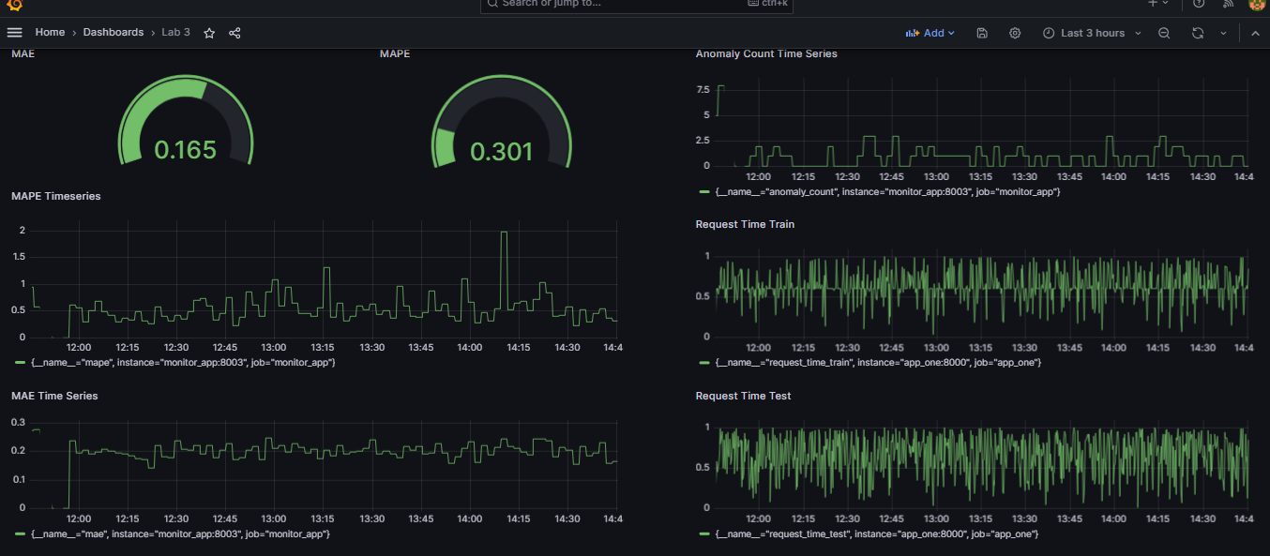

1. What do you estimate to be a "reasonable" baseline of data to use this type of Prophet model in an actual running production system? Would that length of training time pose any operational challenges?

Based on these experiments, a training time of around 30 minutes seems to provide a good balance between computational efficiency and forecast accuracy. This length of training time might pose operational challenges if the system needs to update the model frequently or in real time, as it would require sufficient computational resources and efficient data management practices.

1. Do you think such a Prophet model should be allowed to retrain continuously in a production setting or require some manual review/approval? What could be some pitfalls of allowing a fully automatic operation?  
     
   This prophet model does well with more extended training. We would surely get good anomaly results, as indicated by the experiment results above. Continuous retraining improves forecast accuracy by adapting to new patterns and data changes. However, it may lead to overfitting and computational costs. A manual review allows for quality checks on the model's performance and forecast validity. However, it is not scalable for large-scale systems or high-frequency forecasts. Therefore, a balance between automation and manual review might be optimal. An automatic retraining process with periodic manual reviews could ensure quality control, leveraging the benefits of both continuous retraining and manual review while mitigating their respective pitfalls. The model should be retrained; however, a manual review would provide the best outputs.