DVD GAME DESIGN:

Concept:
-Game title: The DVD Game
-Genre: A bullet-hell like game.
-Description: The player is a DVD logo, however there is a twist, they can’t control the movement. The logo bounces in a random direction when colliding with the boundaries of the game-screen.
- To win, the DVD logo must collide with any corner.
- The aim of the game is to survive by shooting enemies with a gun.

Design:

-Gameplay Design

The player has a health bar.
The player has a gun that follows the mouse cursor there is a limit to 2 bullets per second
There is an enemy spawner that spawns enemies at an accelerating rate
Colliding with a corner will get you a win.
The player has an over shield to make the game more fair

System Design:

The main menu has three buttons that do their own function
The death screen appears when the players health is 0
The win screen appears when the player touches the corner
The pause screen appears when escape is pressed

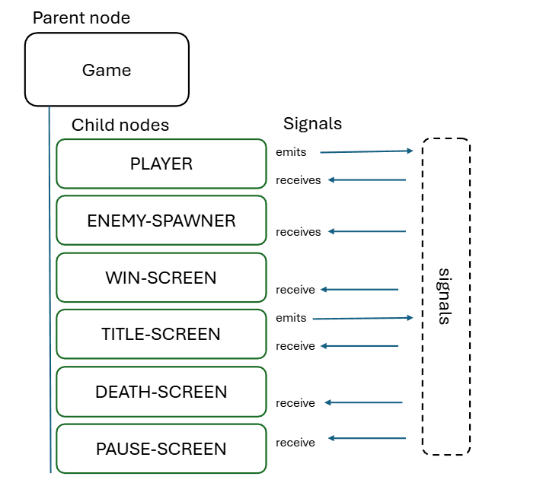

Code + Test:

- When my family tested the game, they found a bug that would alter the UI when changing the screen size. I looked around the internet, and found that I needed to change the project settings, to fix the bug.

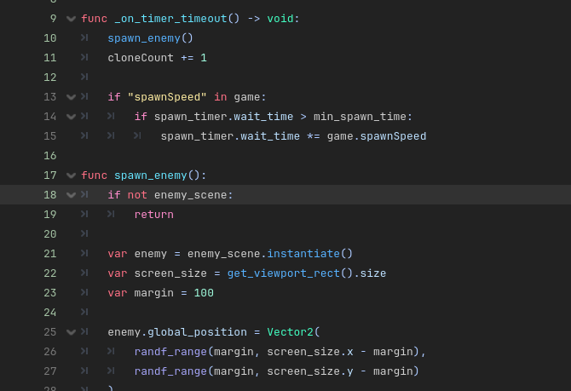
This is the code for an enemy spawner. How this work is by creating a function that picks a random place on the area using Vector2, and creates an enemy. The function will then be used by a connecting signal from a timer node.

Learnings:
- How to use signals
-How to fix bugs using the output(I would just use the internet back then)
-Implementing UI
-Delete off-screen clones for data management
-A variety of nodes

