University of Texas at Arlington

Assignment 4 Railway Reservation

Dileep Chowdary Ealapolu (1002169540)

Andrea Lopera (1001542800)

DASC 5300: Foundations of Computing

Dr. Soumaya Gharsallaoui

December 3 2023

**HONOR CODE**

I pledge, in my honor, to uphold UT Arlington’s tradition of academic integrity, a tradition that values hard work and honest effort in the pursuit of academic excellence.

I promise that I will submit only work that I personally create or that I contribute to group collaborations, and I will appropriately reference any work from other sources. I will follow the highest standards of integrity and uphold the spirit of the Honor Code

**TASKS**

**Task 1:** User input the passenger’s last name and first name and retrieve all trains they are booked on.

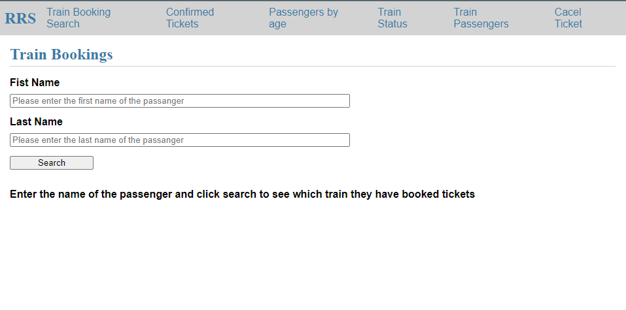

*Figure 1: Train Bookings*

**Instructions**: Select the “Train Booking Search” option from the RSS action options at the top of the screen. Then, the user is required to input the first name and last name of the passenger they wish to retrieve booking information for. Upon entering this information and initiating the search, the system will display the specific details related to the passenger, including their name (first and last) along with the corresponding booked train information. For instance, if the user enters the First Name as "Gladys" and the Last Name as "Rim," the system will present the booking details associated with this passenger.

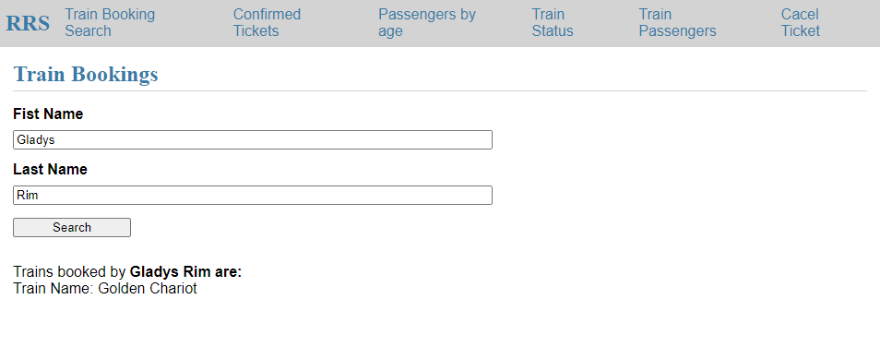

*Figure 1.1: Train Bookings*

**Task 2:** User input the Date and list of passengers traveling on entered day with confirmed tickets displayed on UI.

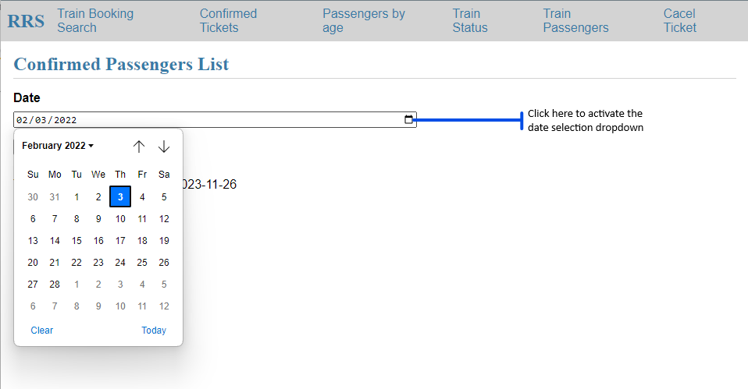

*Figure 2: Confirmed Passengers List*

**Instructions**: Select the “Confirmed Tickets” option from the RSS action options at the top of the screen. Then, the user is required to click on the dropdown icon to select the date they want information for. Upon entering this information and initiating the search, the system will display the specific details related to all the passengers traveling on the selected date, including their name (first and last) along with the corresponding booked train information. For instance, if the user enters the Date as "02/21/2022," the system will present the details associated with this date.

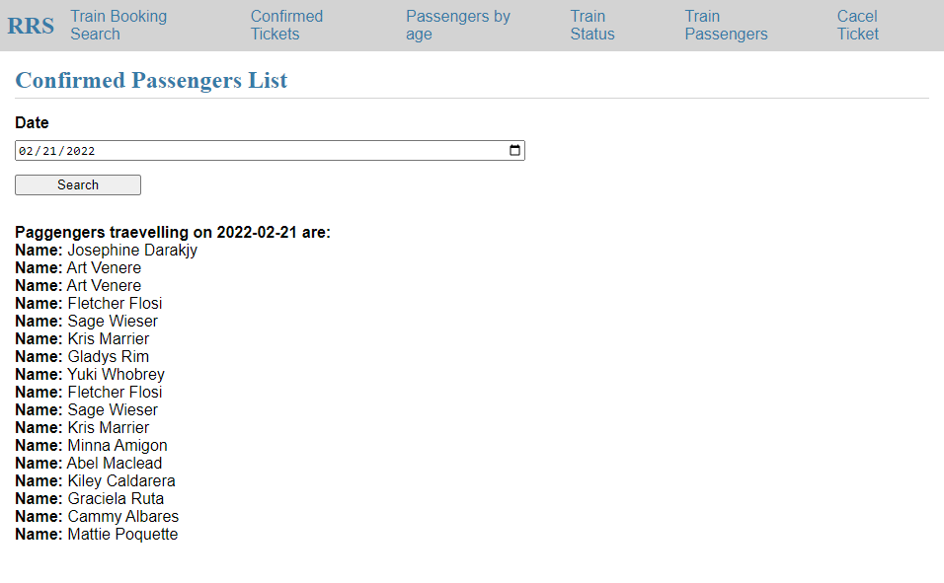

*Figure 2.1: Confirmed Passengers List*

**Task 3:** User input the age of the passenger (50 to 60) and UI display the train information (Train Number, Train Name, Source and Destination) and passenger information (Name, Address, Category, ticket status) of passengers who are between the ages of 50 to 60.

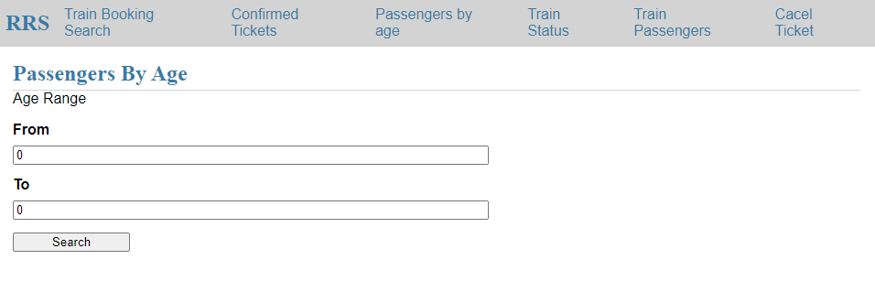

*Figure 3: Passengers by age*

**Instructions**: Select the “Passengers by age” option from the RSS action options at the top of the screen. Then, the user is required to input the “from” and the “to” age range they wish to retrieve train information for. Upon entering this information and initiating the search, the system will display the specific details related to the train, including train number, train name, source station, destination station, passenger name, passenger address, ticket category , ticket status, and passenger age for all passengers within the age range selected . For instance, if the user enters the From as "50" and the To as "60," the system will present the booking details associated with this range.

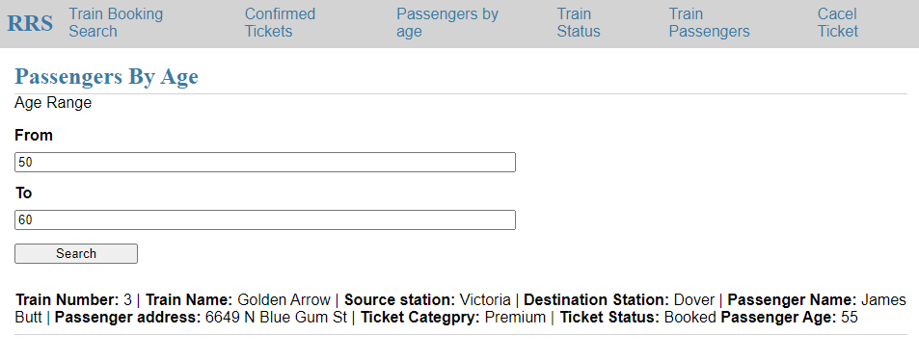

*Figure 3.1: Passengers by age*

**Task 4:** List all the train names along with the count of passengers it is carrying.

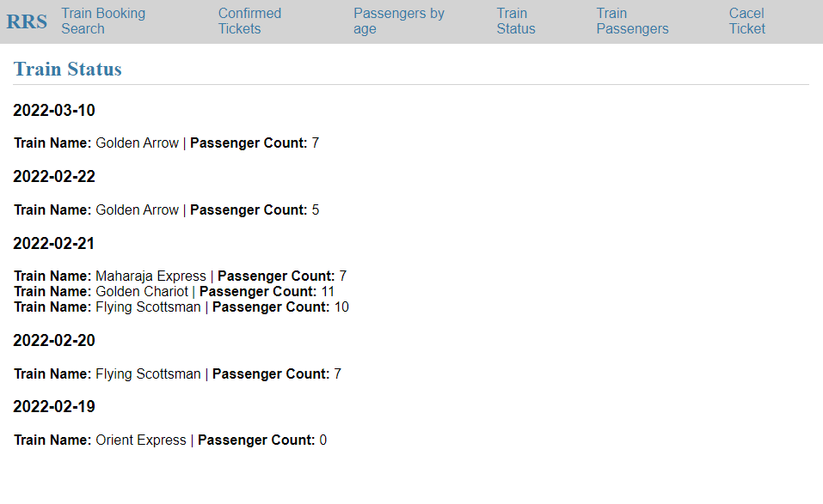

*Figure 4: Train Status*

**Instructions**: Select the “Train Status” option from the RSS action options at the top of the screen. Then, the user is presented with the history of all the dates, including the train name and passenger count (see figure 4).

**Task 5:** Enter a train name and retrieve all the passengers with confirmed status traveling in that train.

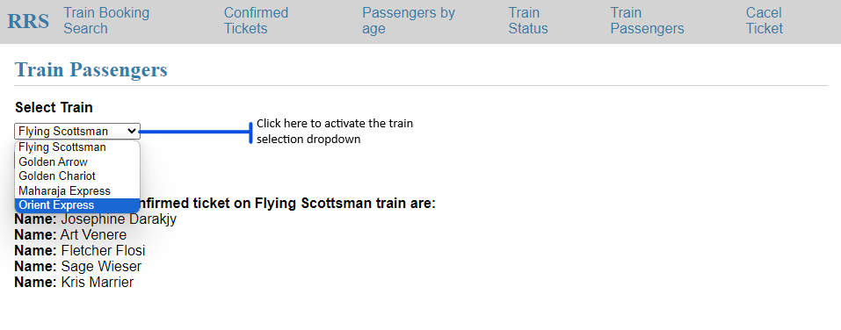

*Figure 5: Train Passengers*

**Instructions**: Select the “Train Passengers” option from the RSS action options at the top of the screen. Then, the user is required to click on the dropdown icon to select the name of the train they want information for. Upon entering this information and initiating the search, the system will display the specific details related to all the passengers with confirmed tickets traveling on the selected train, including their name (first and last). For instance, if the user selects the train as "Golden Chariot," the system will present the details associated with this train.

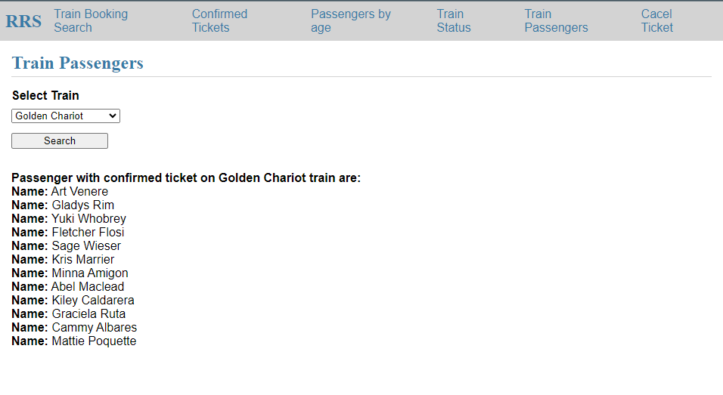

*Figure 5.1: Train Passengers*

**Task 6:** User Cancel a ticket (delete a record) and show that the passenger in the waiting list gets a confirmed ticket.

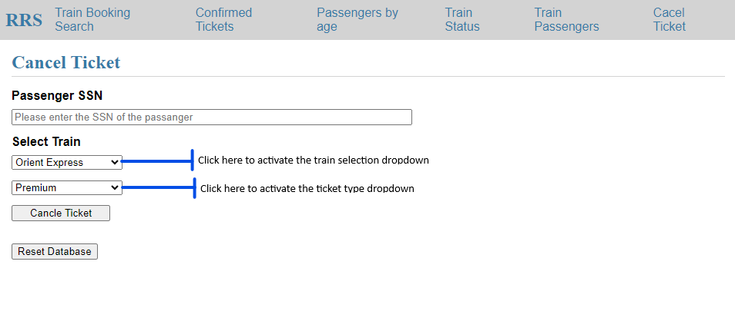

*Figure 6: Cancel Ticket*

**Instructions**: Select the “Cancel Ticket” option from the RSS action options at the top of the screen. Then, the user is required to enter the social security number of the passenger, click on the dropdown to select the name of the train, and the dropdown to select the type of ticket they wish to cancel. Upon entering this information and initiating the cancel ticket function, the system will display the specific details related to the cancellation, including the name (first and last), ticket status, as well as the name (first and last) of the passenger whose status changed from waitlist to confirmed. For instance, if the user enters Passenger SSN “264816896,” selects the train as "Orient Express," the ticket type as “premium,” and clicks “cancel ticket” button, the system will present the details associated with their cancellation and the passenger whose ticket got confirmed .

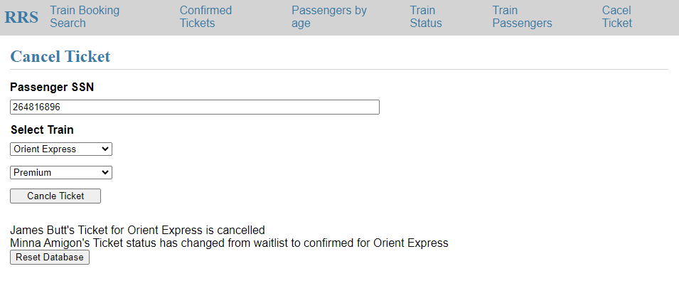

**TEAM CONTRIBUTIONS**

Andrea Lopera (1001542800) was primarily responsible for creating the schema and insert queries, alongside task-specific query development. She also dedicated efforts towards the report file's completion.

Dileep Chowdary Ealapolu (1002169540) took charge of developing the GUI using Flask, transforming queries into dynamic ones, and ensuring comprehensive coverage in the Readme file.

Their combined efforts resulted in significant contributions. They collaborated on establishing SQL connections, executing data injections into tables, and enhancing security by working on injection issues. Additionally, they jointly tackled debugging tasks, resolving identified issues efficiently while enhancing the overall user interface (UI) for improved performance and functionality.