**FILES**

-I am using two files **user.php** and **Lab1.php**

**SOME FEATURES**

-the website use only text documents to read the ztunes, zmazon, my list of songs which let change the name and delete the song, and is capable of create a playlist which can repeated the song and if the user want to delete a song from the user, all the songs with that name will be removed from the playlist.

It accepts 2 users (I could add more, but I have to create more ztunes and zmazons list). The 2 users that accepts are user1 and user2 each with its own files.

Whenever you will log in you need to add the name of the user press getUser bottom so it gets the idea of who you are talking about. Then you need to go store where the music is found.

The first file using the user2 account

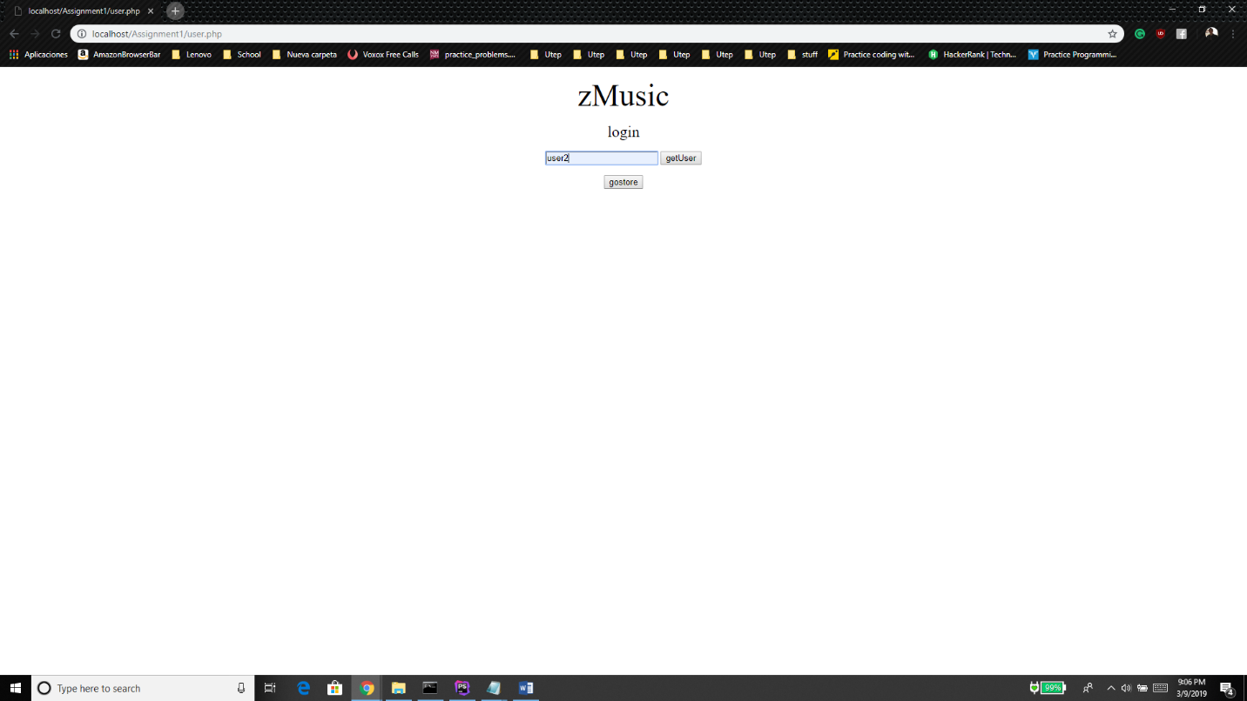

In this side I am in user2 account where I just add 2 songs of the playstore and I am about to change the name of one of my songs.

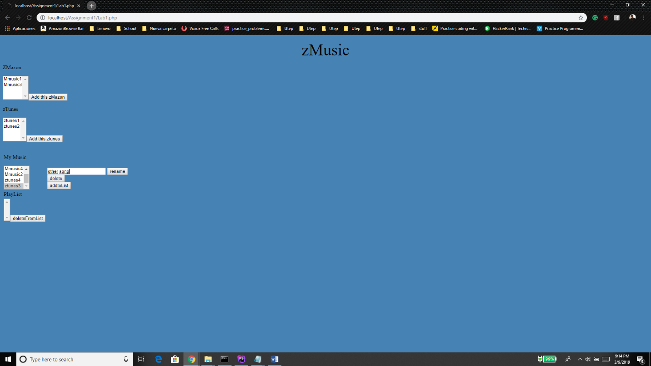

In this part, the song appears changed and some songs added to the playlist.

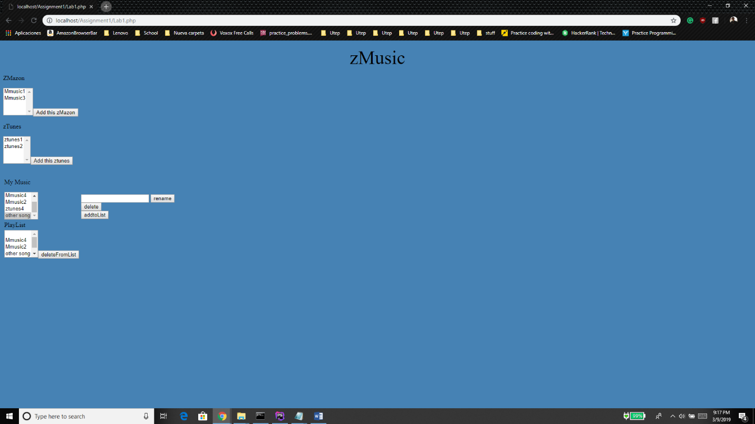

|  |
| --- |
| <<include>>  <<include>>  <<include>> |

**DIAGRAM**

zMusic

**CODE**

**<?php***/**  
 * Created by PhpStorm.  
 * User: Eduardo  
 * Date: 3/3/2019  
 * Time: 10:38 PM  
 */  
  
#if($_SERVER['REQUEST_METHOD'] === 'POST') {  
 #foreach($_POST['music'] as $song){  
 # echo $song." ".$_GET['add'];  
 # $song.remove();  
 # echo "HELLO";  
 #}  
#}*$rUser = *file*(**'user.txt'**);  
  
$Mmusic = $rUser[0].**'Mmusic.txt'**;  
$ztunes = $rUser[0].**'ztunes.txt'**;  
$playlist = $rUser[0].**'playlist.txt'**;  
$mymusic = $rUser[0].**'mymusic.txt'**;  
**function** buy($storeName, $file, $SelList){  
 **global** $mymusic;  
 $AllList = *file*($mymusic);  
 $song = *fopen*($mymusic,**'w'**);  
  
 $options = **''**;  
 **foreach**($AllList **as** $i){  
 $options .= $i;  
 }  
 **foreach** ($SelList **as** $selectedSong) {  
 $file = *str_replace*($selectedSong, **''**, $file); *#remove the option with the name  
 #$options .= '<option value="'.$selectedSong.'">'.$selectedSong.'</option>';* $options .= $selectedSong;  
 *#$song = str_replace('', ($selectedSong.'\n'),$song);* }  
 *file_put_contents*($storeName,$file);  
 *file_put_contents*($mymusic, ($song));  
 *fwrite*($song,($options));  
 *fclose*($song);  
  
}  
**function** delete($fileName, $options){  
 $file = *file_get_contents*($fileName);  
 **foreach**($_POST[$options] **as** $song){  
 $file = *str_replace*($song,**''**,$file);  
  
 }  
 *file_put_contents*($fileName,$file);  
}  
  
**if**(**isset**($_POST[**'Madd'**]) && $_POST[**'Madd'**]==**'Add this zMazon'**) { *#add to my music from zmazon* $file = *file_get_contents*($Mmusic);  
 buy($Mmusic, $file, $_POST[**'Mmusic'**]); *#call the method buy that remove the item*}  
**if**(**isset**($_POST[**'Tadd'**]) && $_POST[**'Tadd'**]== **'Add this ztunes'**){ *#add to my music from ztunes* $file = *file_get_contents*($ztunes);  
 buy($ztunes, $file, $_POST[**'Tmusic'**]);  
}  
**if**(**isset**($_POST[**'rename'**]) && $_POST[**'rename'**] == **'rename'** ){ *#rename* $reName = $_POST[**'change'**];  
 $file = *file_get_contents*($mymusic);  
 **foreach**($_POST[**'Mymusic'**] **as** $song){  
 $file = *str_replace*($song,($reName.**"\n"**),$file);  
 }  
 *file_put_contents*($mymusic,($file));  
  
}**if**(**isset**($_POST[**'delete'**]) && $_POST[**'delete'**] == **'delete'**){  
  
 *delete*($mymusic, **'Mymusic'**);  
  
}**if**(**isset**($_POST[**'addtoList'**]) && $_POST[**'addtoList'**] == **'addtoList'** ){ *#add to the playlist from the mylist* $file = *file*($playlist);  
 $fileList = *fopen*($playlist,**'w'**);  
 $options = **''**;  
 **foreach**($file **as** $i){  
 $options.=$i;  
 }  
 **foreach** ($_POST[**'Mymusic'**] **as** $song) {  
 $options .= $song;  
  
 }  
  
 *fwrite*($fileList,$options);  
 *fclose*($fileList);  
  
}**if**(**isset**($_POST[**'deleteFromList'**]) && $_POST[**'deleteFromList'**]==**'deleteFromList'**){  
 *delete*($playlist, **'playlist'**);  
}  
**if**(**isset**($_POST[**'getUser'**]) && $_POST[**'getUser'**] == **'getUser'**){  
 **global** $userName;  
 $userName = $_POST[**'users'**];  
 **echo** $userName;  
  
  
 *#echo $userName;*}  
  
 *#$valSel = array();  
 /*foreach ($_POST['Mmusic'] as $selectedSong) {  
 $file = str_replace($selectedSong, '', $file); #remove the option with the name  
  
 }  
 file_put_contents('Mmusic.txt',$file);*/  
  
 #$file = fopen('Mmusic.txt','r'); #read  
 # $actuFile = fopen('Mmusic.txt', 'r'); #re-write  
 #while(!feof($file)) { #used to traverse the file  
 # $line = fgets($file);  
 #echo $line;  
  
 # }  
 #if(!in_array($line, $valSel)){  
 # $newOptions .= '<option value="'.$line.'">'.$line.'</option>';  
 # echo $newOptions;  
 # }  
 #$isSelected = false;  
 #}  
 #$file.readline();  
 #fwrite($file, "helloMusic");  
 #fclose($file);***?>**<!DOCTYPE **html**>  
<**html**>  
<**head**>  
  
  
 <**p style="color**:**black**;**text-align**:**center"**><**font size="7"**>zMusic</**font**></**p**> *<!--This is for the title -->*</**head**>  
<**table**>  
 <**form action="<?php echo** $_SERVER[**'PHP_SELF'**];**?>" method="POST"**>  
  
 <**script src="https://code.jquery.com/jquery-1.10.2.js"**></**script**>  
</**p**>  
<**body style="background-color**:**steelblue**;**"**> </**body**> *<!--This is for the color of the background-->* <**p**> ZMazon</**p**>  
**<?php** $song = *file*($Mmusic);  
 $options = **''**;  
 **foreach**($song **as** $music){  
 $options .= **'<option value="'**.$music.**'">'**.$music.**'</option>'**;  
 }  
 $Songs = **'<select name = "Mmusic[]" multiple>'**.$options.**''**;  
 **echo** $Songs;  
 *#$but = '<input type="submit" value="Add this zMazon" name="Madd" id="MaddVal">';  
 #echo $but;***?>***<!-- <form action="***<?php echo** $_SERVER[**'PHP_SELF'**];**?>***" method="POST"> -->  
<!-- <select name="Mmusic[]" id="zmazon" multiple>  
 <option value="zmazon1">zmazon1</option>  
 <option value="zmazon2">zmazon2</option>  
 <option value="zmazon3">zmazon3</option>  
 <option value="zmazon4">zmazon4</option>-->* <**input type="submit" value="Add this zMazon" name="Madd" id="MaddVal"**><**br**/>  
 <**p**>zTunes</**p**>  
 **<?php** $song = *file*($ztunes);  
 $options = **''**;  
  
 **foreach**($song **as** $music){  
 $options .= **'<option value="'**.$music.**'">'**.$music.**'</option>'**;  
 }  
 $Songs = **'<select name = "Tmusic[]" multiple>'**.$options.**''**;  
 **echo** $Songs;  
 *#$but = '<input type="submit" value="Add this zMazon" name="Madd" id="MaddVal">';  
 #echo $but;* **?>** <**input type="submit" value="Add this ztunes" name="Tadd" id="TaddVal"**>  
</**select**>  
<**br**><**td**></**p**>  
*<!--<form action="***<?php echo** $_SERVER[**'PHP_SELF'**];**?>***" method="POST"> mylist options-->  
<!--select name="Mymusic[]" id="mymusic" multiple> -->* <**p**>My Music</**p**>  
 **<?php** $song = *file*($mymusic);  
 $options = **''**;  
 **foreach**($song **as** $music){  
 $options .= **'<option value="'**.$music.**'">'**.$music.**'</option>'**;  
 }  
 $Songs = **'<select name = "Mymusic[]" multiple>'**.$options.**''**;  
 **echo** $Songs;  
 *#$but = '<input type="submit" value="Add this zMazon" name="Madd" id="MaddVal">';  
 #echo $but;* **?>**</**td**>  
  
<**td**><**br**><**br**><**br**/>  
 <**input type="text" name="change" id="changeName"** >  
 <**input type="submit" name="rename" value="rename" id="rename"** ><**br**>  
  
  
</**select**>  
 *<!-- <input type="text" id="search"> -->* <**input type="submit" name="delete" value="delete" id="delete"**><**br**>  
 <**input type="submit" name="addtoList" value="addtoList" id="addtoList"**>  
 </**td**></**tr**>  
</**p**>  
  
 <**tr**><**td**>PlayList</**td**> </**tr**>  
 <**td**>  
**<?php** $song = *file*($playlist);  
 $options = **''**;  
 **foreach**($song **as** $music){  
 $options .= **'<option value="'**.$music.**'">'**.$music.**'</option>'**;  
 }  
 $Songs = **'<select name = "playlist[]" multiple>'**.$options.**''**;  
 **echo** $Songs;  
 *#$but = '<input type="submit" value="Add this zMazon" name="Madd" id="MaddVal">';  
 #echo $but;* **?>**<**input type="submit" name="deleteFromList" value="deleteFromList" id="deleteFromList"**>  
 </**td**>  
 </**tr**>  
</**form**>  
</**table**>  
</**html**>

**PROBLEM**

I had a lot of problems passing a variable from one php file to the other so it always use the correct file of the user.

**SOURCES**

StackOverflow

Php.net