Were the Zones an Efficient Use of Officers? The Numbers Don’t Yet Say So
A companion to John Hall’s piece. Strip out the citywide drop and the rebound, and there is no dependable sign the zones turn officers into safety any better than the rest of the city. The comparison that would prove it needs data the City has not released.
By Erik Alda

In an earlier post, John Hall made a compelling case that the blocks in New York City with the most shootings last year tend to have fewer this year, with or without extra officers. The drops the NYPD reports in its zones are not, so far as I can tell, proof that the officers did the work. They are the decline you would expect after any unusually bad year, and the Department has read them as proof its deployment worked.
The question that matters, now that the city is spending heavily to widen the zones, is whether those officers were used well where they landed. Would they have prevented more shootings somewhere else? John Hall raises this in his last line, that no one should vote to spend money that cannot withstand a hard look. That is, at bottom, a question about efficiency, and it is the one I want to put first.
I built a precinct-by-precinct record of summer shootings in New York City for each year from 2012 to 2025, along with a rough measure of how hard each precinct was worked. The data back up Hall’s assertion. A precinct’s shooting count last year tells you little about this year’s. When I predict this year’s number from last year’s and from the precinct’s own three-year average, last year barely counts, and the longer record carries it. That is regression to the mean, the tendency of an unusually bad year to fall back toward normal on its own—we will call it the rebound--. It also leads to an obvious question. If a precinct’s crime was already on its way down, how much of the drop can we claim by adding the additional officers?

What it means to measure efficiency
Efficiency is a simpler idea than the methods make it look, and one we rarely measure in the public sector. The methods come from production economics and operations research, designed to gauge how much an organization gets out of what it puts in, and they have been applied to public agencies for decades, including police agencies. They start in the right place for this problem. Crime is something a police force tries to reduce, the reverse of the usual case these methods handle, where more output is better. You do not need the machinery to follow the argument. There is an input, the officers a precinct has, and an output, the violence those officers prevent. Effectiveness asks whether crime fell. Efficiency asks whether it fell by enough to be worth the officers it took. The two might be related, but do not travel together. A precinct can be efficient and still barely matter, wringing a strong return out of a few officers while the total drop stays small. And a precinct can be effective yet wasteful, driving crime down by piling on officers who each prevent very little, when the same officers might have done more elsewhere. Efficiency is what turns extra officers into real safety instead of wasted money, so it is the better thing to aim for, but it is not the same as a big drop, and you cannot read one off the other. That is the gap the Department's numbers slide over. A steep decline looks like success and gets treated as though it settled the efficiency question, when a decline can be real and still be a poor use of officers, especially when most of it was the rebound and the citywide fall, with the officers accounting for little of it.
The trouble starts with the measure the Department uses. It scores the zones by the year-over-year drop, this summer’s crime against last summer’s on the same blocks. Take that drop as the output, and you walk straight into the problem Hall flagged in his analysis. A precinct that spiked last year posts a big drop this year, and any efficiency score built on that drop rewards it for a fall that needed no new officers.
The reason this is an efficiency question is that it turns on how much crime each extra officer actually prevents. If adding an extra officer in a targeted zone leads to more crime prevented, then the operational move will generate efficiency while, simultaneously, being effective in reducing crime. The zones send officers to the blocks where crime spiked, and many of those blocks were already on their way back down to previous levels, so the officers get credit for a fall that was already happening. This means the agency deployed resources for extra coverage and got a result that would have happened anyway, even though the same officers might have prevented more on a block where crime was holding steady or climbing. Putting them on a surge that is already fading is an effort spent on a problem that is naturally fixing itself. That is where the efficiency problem lies. Why does it matter? Because a police force is finite. Every officer holding a post in a zone is one not answering calls across the precinct, not walking a beat in a neighborhood that never made the list. It is like sending every spare fire engine to a blaze that is already burning itself out. The street with the trucks looks well covered, and the rest of the city is the part left exposed. When a zone is going to settle on its own by going back to previous levels, that deployment moves officers for little return, and moves them away from places that may have needed them more, often on overtime and often worked by the newest officers on the force. The cost never shows up in the zone’s own numbers. It shows up in the places the officers were pulled away from.
So I work out how much a precinct’s crime would have dropped on its own, just from a bad year settling back toward normal, and I credit the zones only with whatever fell beyond that. Think of weighing yourself. If you start the clock on the heaviest the scale ever read, most of the pounds that come off afterward are just the swing back to your usual weight, not real loss. The honest comparison is against the weight you’d expect on an ordinary day. Crime is the same. Once I take out the drop that was coming anyway, what is left is the only part the officers can fairly claim.
Does this rebound change the picture? It does. If you judge the zones by how much crime fell from last summer to this one, with no adjustment, the precincts that spiked the year before look like the most efficient in the city. This reading, however, is counterintuitive, since most of that fall was simply a return to previous levels. Once the crime spike is taken out, they look normal again, because the rebound was not the result of deploying more officers.
Before I trusted this, I wanted to check whether removing the rebound actually fixed the problem. The trouble is you cannot check that on the real city. You see how much crime dropped, but you never see how much it would have dropped on its own, without the zones. That missing number, the counterfactual, is the one you would need, and it does not exist. So I built made-up precincts where I set the answer myself. For each one, I chose up front how much of its drop was rebound and how much was real improvement, then made them behave like the real program, with extra officers sent to the blocks that were worst the year before and the ordinary year-to-year swings laid on top. I scored every precinct both ways. The adjusted measure found the answer I had planted. The raw drop was fooled, handing its best marks to the precincts that had only had a bad year and bounced back.
The same trap waits in any city. Score crime by the year-over-year drop and leave in the fall that was coming anyway, and the precincts that just had a bad year and bounced back end up looking like your best performers.
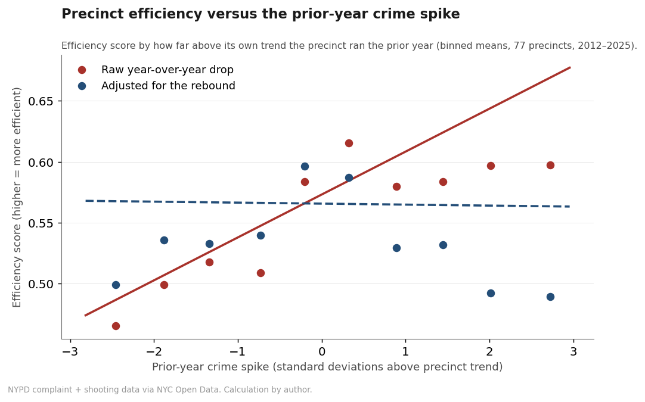
Figure 1. Precinct efficiency against the prior year’s crime spike. Scored on the raw year-over-year drop (red), precincts that spiked last year look more efficient. Adjust for the fall that was coming anyway (blue) and the line goes flat. Binned averages, 77 precincts, 2012–2025.

What the efficiency numbers show
The first thing the numbers show is a trap. Compare the zone years, 2023 through 2025, with the years before, and the zones do look more efficient. But step back, and almost all of that is the citywide drop in crime, not the zones. Those were good years for safety nearly everywhere, so almost every precinct looks better, whether it had a zone or not. Reading that improvement as proof the program worked is the same mistake as reading the raw drop that way, just one level up.
So I tried to pull the program apart from the moment. I compared the precincts a zone strategy goes after, the ones with the worst recent shootings, against all the others, in the same years. Because the citywide drop touches both groups, it cancels out, and whatever is left is what the targeting itself added. Done that way, the edge shrinks by about half, and it is no longer large enough to tell apart from no difference at all. As a check, I ran the same comparison on an earlier run of falling crime, years with no zones in place, and found the same faint drift, which says even that small leftover is not really about the zones.
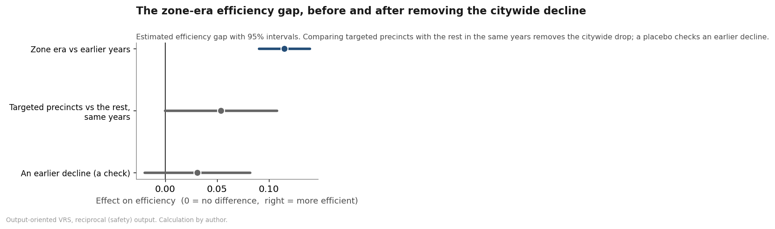
Figure 2. The estimated efficiency gap between zone-era precincts and the rest, with 95% intervals. Against earlier years (top) the gap looks large, but most of it is the citywide decline. Comparing the precincts a zone program targets with the rest in the same years (middle) the gap halves and crosses zero. A check on an earlier decline (bottom) shows the same small drift.
So the efficiency picture matches the rest of the story. The drops are the citywide decline and the rebound. Take both out, and there is no dependable sign that the zones turn officers into safety any better than the rest of the city. The one comparison that would settle it, the actual zone precincts against everywhere else, is the one an outsider cannot run, because the City does not say which precincts the zones cover.
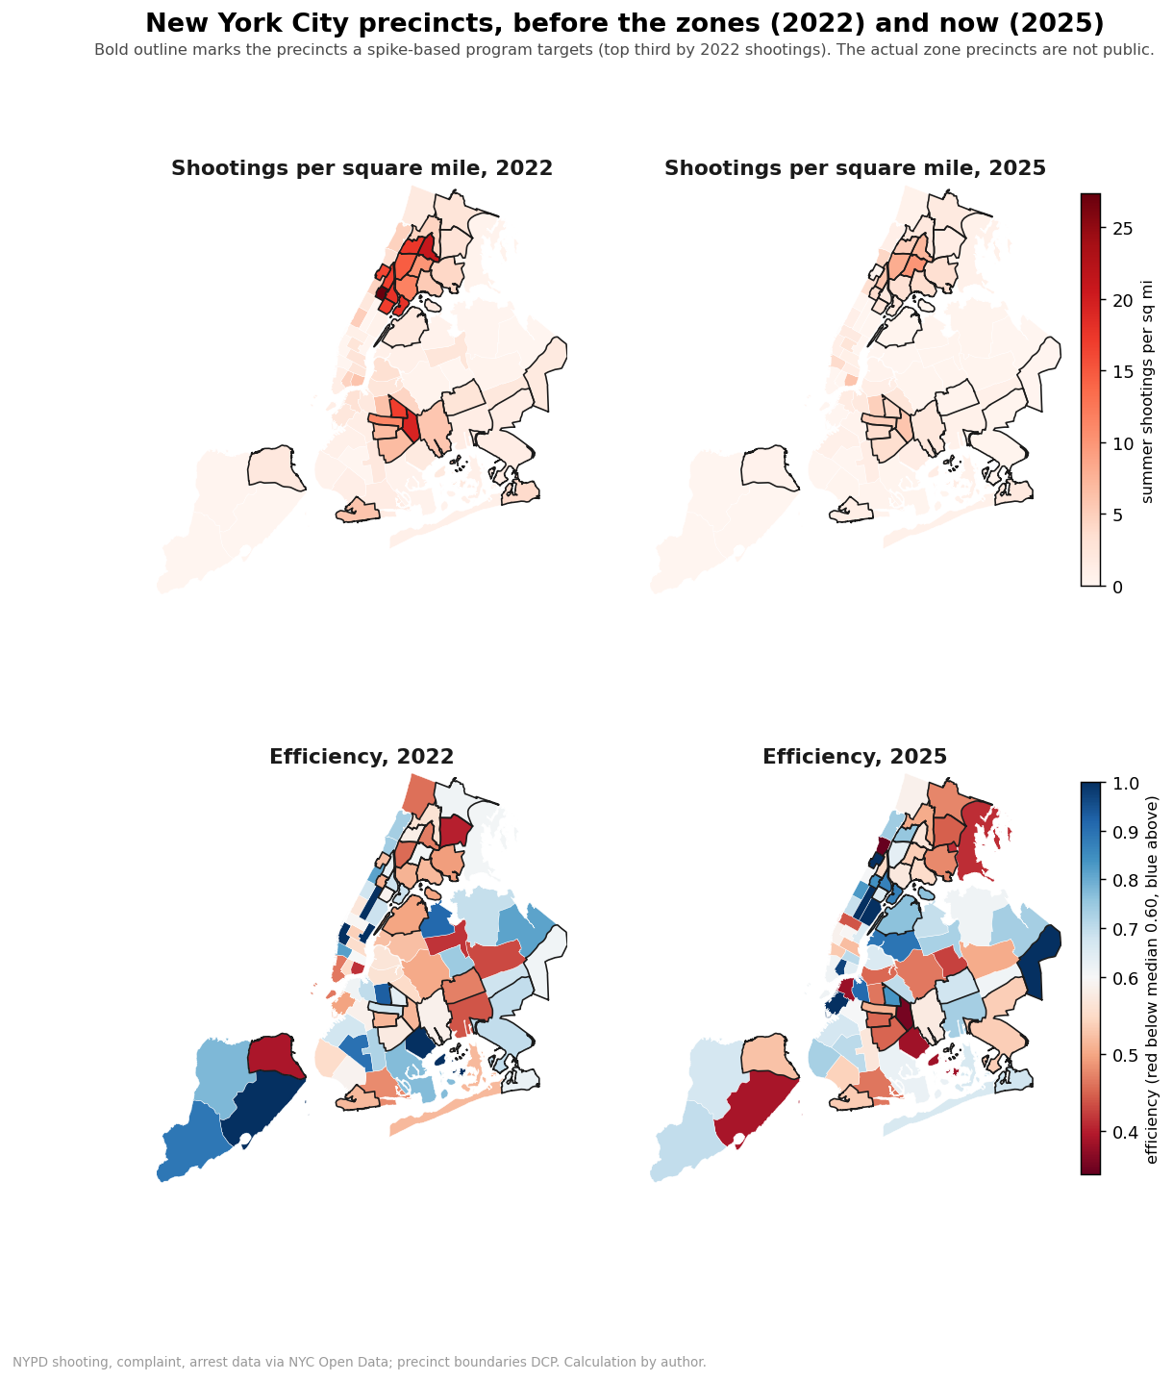
Figure 3. New York City precincts, 2022 and 2025. Summer shootings per square mile (top) fell across the high-shooting precincts, not only the ones a spike-based program would target (outlined in black). Efficiency (bottom) shifted broadly higher, which, as Figure 2 shows, is mostly the citywide decline rather than the zones.
I want to be careful about what this analysis does and does not say. It does not say the zones prevented no crime, nor that putting officers on hot blocks is a bad idea. Thirty years of evidence, including MacDonald, Fagan, and Geller’s evaluation of the original Impact precincts, shows that concentrated policing on small areas can lower violence, and that solving the problem on a block beats flooding it. My claim is narrower, and it still matters when resources are at stake. The drops the Department points to do not, on their own, show the zones are an efficient use of officers once the numbers are handled with care. Showing crime fell is a long way from showing the officers were money well spent.

What it means, and what would settle it
So what is the message? The zones did not fail. The drops are real, and a large body of research shows that putting more officers on violent blocks can bring violence down (Chalfin and McCrary, 2018). The point is narrower, and it is about how the numbers get read. A steep fall in a set of blocks chosen for being the worst last year is what you would see whether or not the deployment did anything. On its own it cannot tell you the program works, let alone that it works efficiently. Spend a budget on that signal and you are spending on the wrong evidence.
My own analysis carries a caveat, and I want to be plain about it. To gauge how hard each precinct was worked, I used arrests, because that is what the public data hold. Arrests are a rough stand-in, partly a product of policing rather than a clean count of officers on the ground. The cleaner inputs, how many officers a precinct had and how the zones were staffed night to night, are not in the open data, and the budgeted headcount that is public barely moves from year to year, because the summer surges run on overtime. The deeper gap is the zones themselves. Because the City does not publish which precincts they cover, I can only stand in the precincts a spike-based program would target for the real ones. None of this is secret. It sits in the Department’s own systems, and a researcher can ask for it. So read this as a method and a first look. It cannot judge any single zone on its own.
Why doesn’t a clear edge show up? The data I have can raise the question, not settle it. Perhaps the targeting is the trouble. The zones chase blocks that spiked, many of which would have cooled on their own, so a good share of the effort goes to drops that were already coming. Perhaps a strategy built on presence, much of it rookies straight from the Academy, gives up the gains that problem-solving on a block tends to deliver. Perhaps it is diminishing returns, the tenth officer on a crowded block preventing less than the first. I cannot choose among these, and I will not pretend to. They are the questions a fuller study should take up.
What would settle it is a proper evaluation, one with real staffing numbers, a comparison group that did not get the extra officers, and the rebound removed before anyone is scored. That is the standard in the field, and it is within reach. Other cities treat it as routine, and Philadelphia ran a randomized foot-patrol trial more than a decade ago. Before the city spends more to widen the zones, that work is worth doing. The reported drops will not tell anyone whether the money is well spent. The right analysis can.

The full analysis is open and reproducible. It uses NYPD complaint, shooting, and arrest data from NYC Open Data, a precinct-by-summer record for 2012–2025, and a regression-to-the-mean adjustment. Efficiency is measured with output-oriented frontier models in which crime enters as a reciprocal, so less crime counts as more output, and the zone effect is identified by comparing the precincts a spike-based program targets with the rest in the same years. The code runs in both R and Python, and the two agree. Code and methods are posted at [GitHub link to add].

