**Group 05**

**ECSE 223 – Model-based programming**

**Iteration 2**

This is the main page of our RestoApp. To add tables and its seats, to remove a table, to update a table number and the number of seats or to change the location of a table, we need to click on the combo box called “settings”. Clicking on “MENU” allows us to see the menu categories.

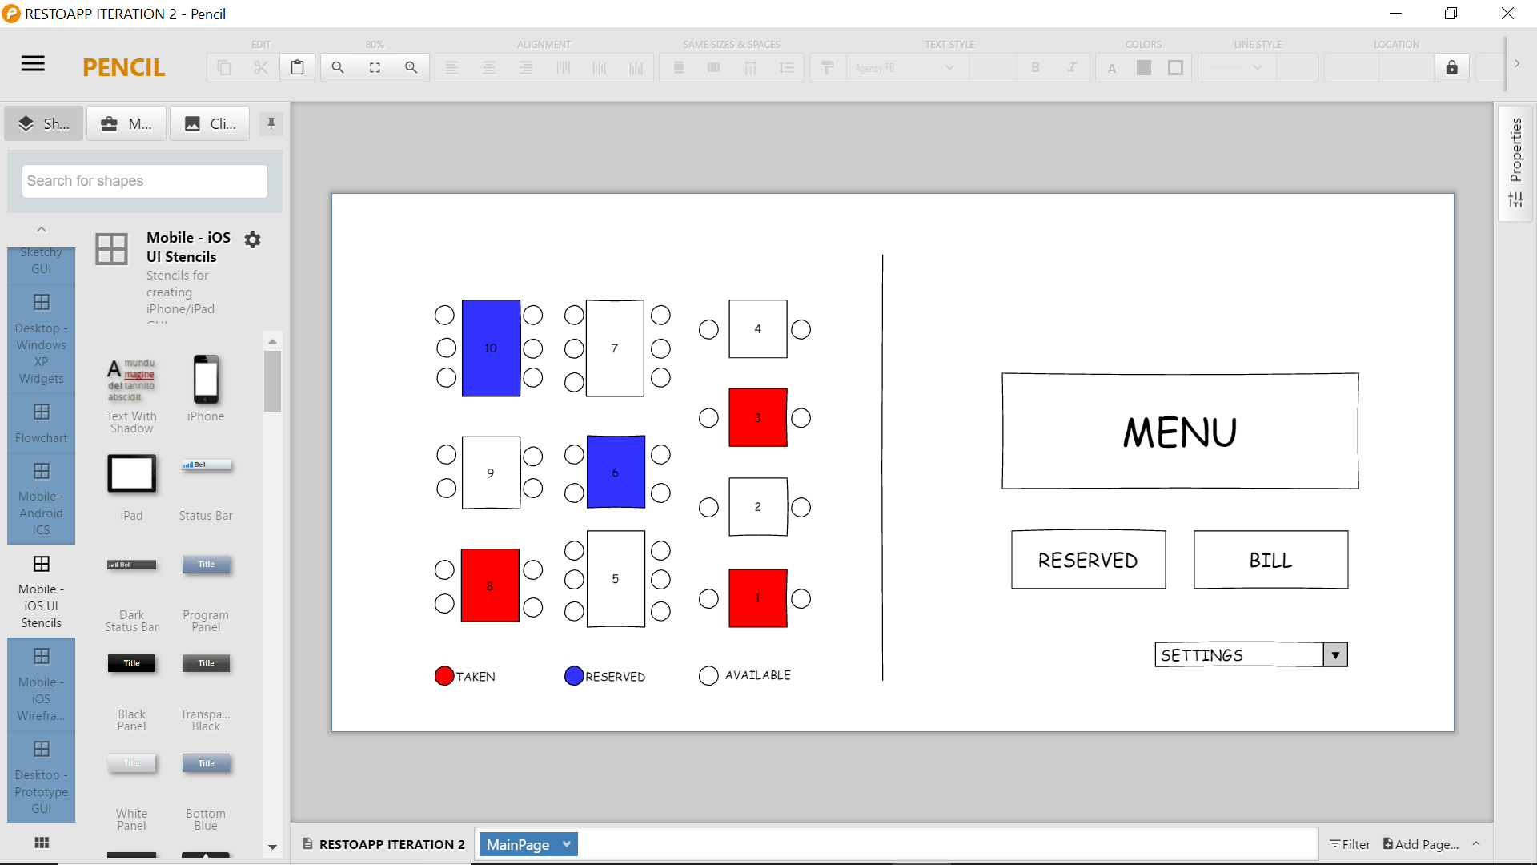

**SECTION 1: Add a table and its seats**

**Max Brodeur**

**2.1/ IU Mock Up**

**2.2/ Specification of Controller Interface**

**2.3/ Sequence diagram**

**SECTION 2: Remove a table from the restaurant**

**Hani Damlaj**

**3.1/ IU Mock Up**

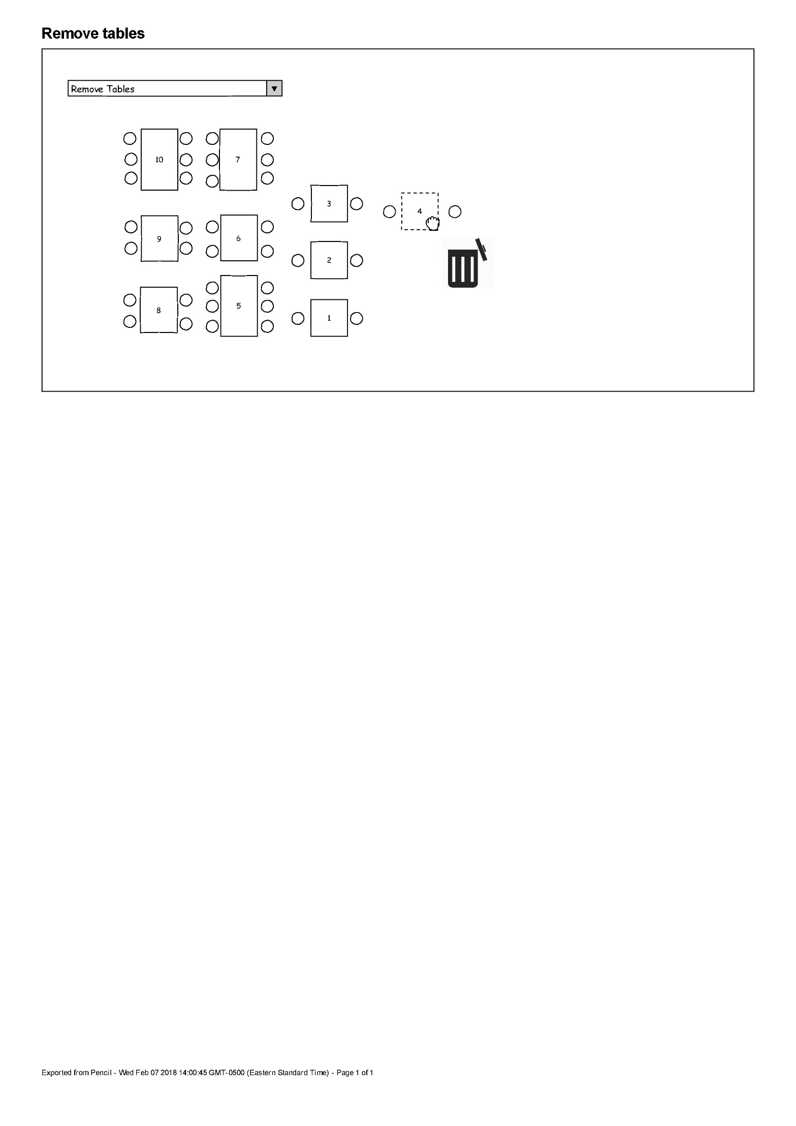

**3.2/ Specification of Controller Interface**

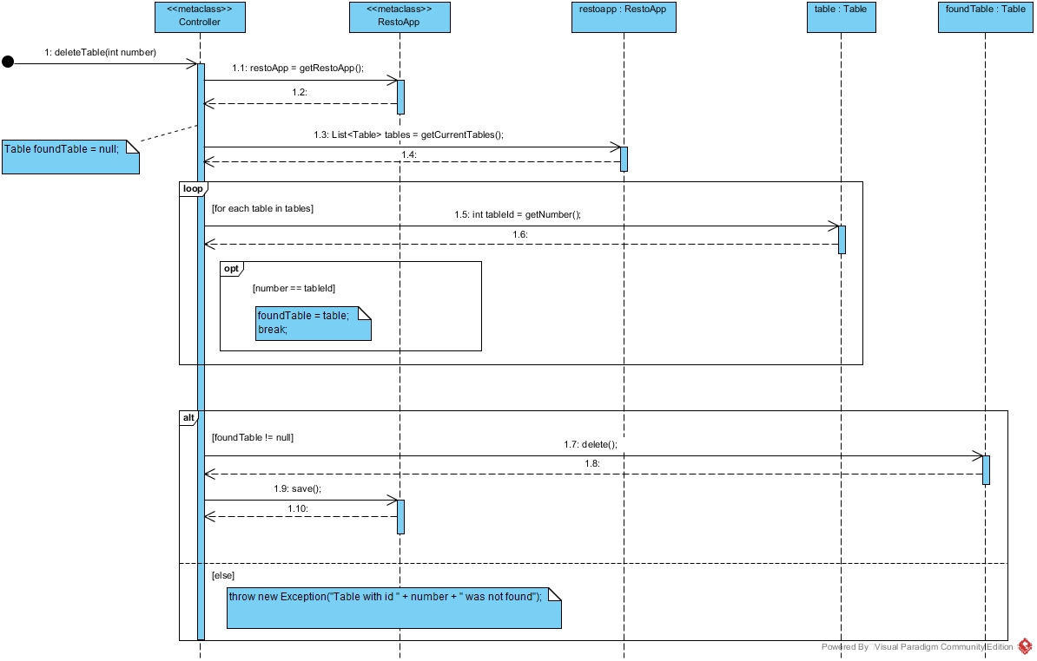**3.3/ Sequence diagram**

**SECTION 3: Update the table number and number of seats of a table**

**Carl El-Khoury**

**4.1/ IU Mock Up**

**4.2/ Specification of Controller Interface**

**4.3/ Sequence diagram**

**SECTION 4: Change the location of a table**

**Elias Homsi**

**5.1/ IU Mock Up**

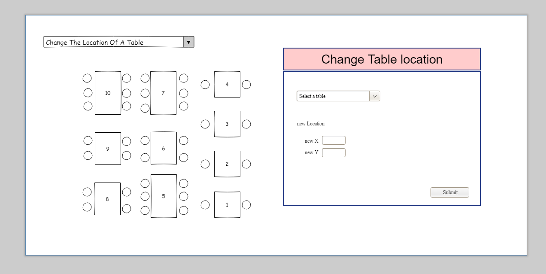

**5.2/ Specification of Controller Interface**

* RestoApp getRestoApp(); //create a new restoapp or loads one from persistence if it exists
* getCurrentTables(); //returns a list of tables currently used
* void save() throws RunTimeException; //ensure that the modification are saved

Assumption:

The existence of the two helper methods:

1) Boolean isTableOccupied(Table t); that checks if a table is occupied

2) Boolean crashTable(Table t, int x, int y); checks that if we move that table to (x,y) whether it will crash with another table or not. (simple math using width and height)

**5.3/ Sequence diagram**

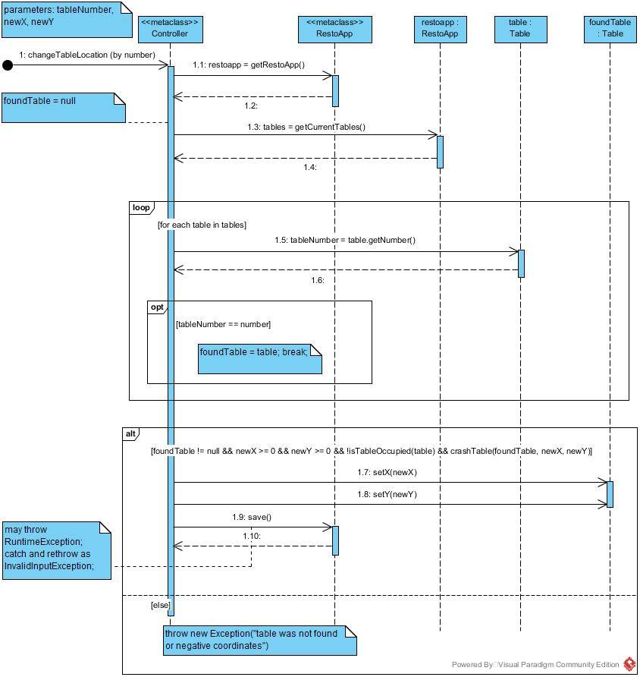

**SECTION 5: Display the menu according to food/beverage**

**Marie Vu and Yuxin Zhou**

**1.1/ IU Mock Up**

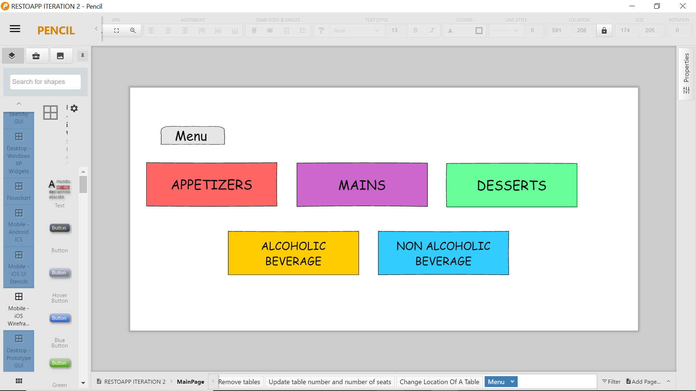a page for the menu categories

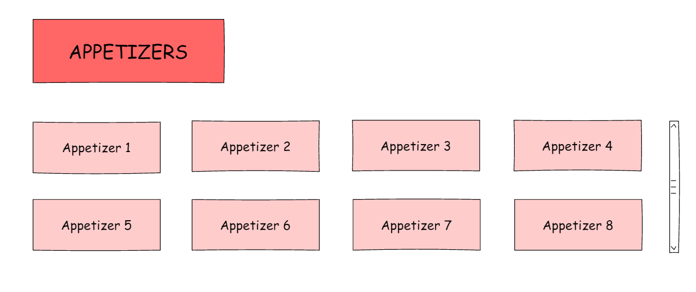After clicking on a category, items of that category are displayed

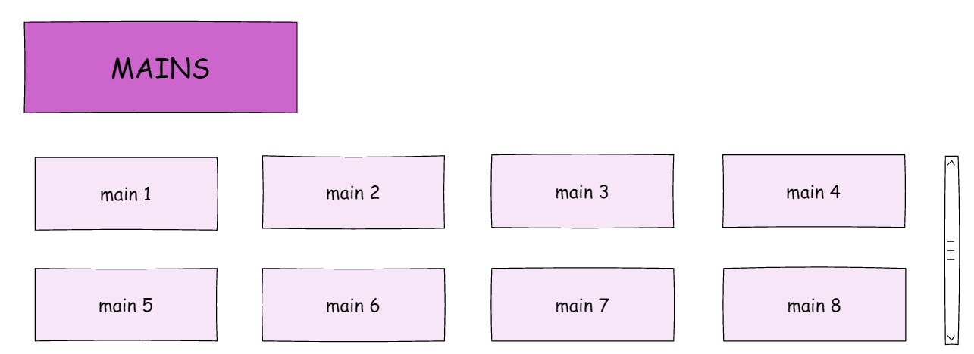

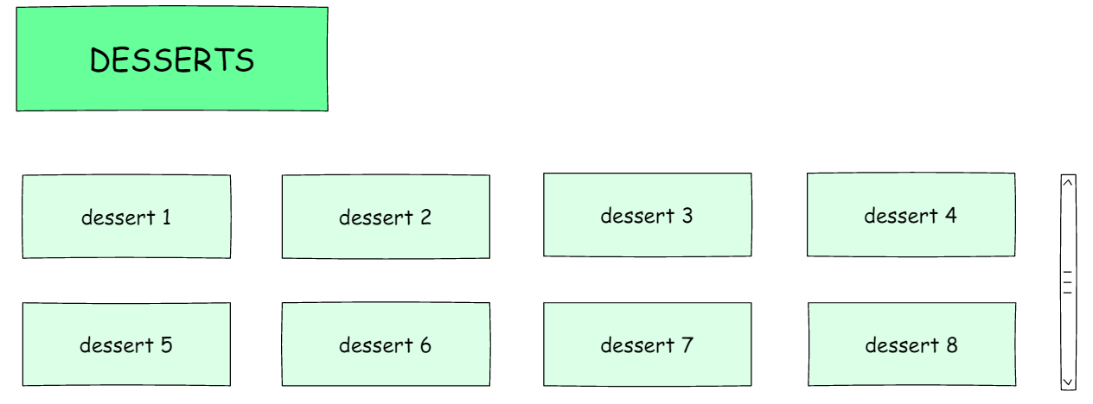

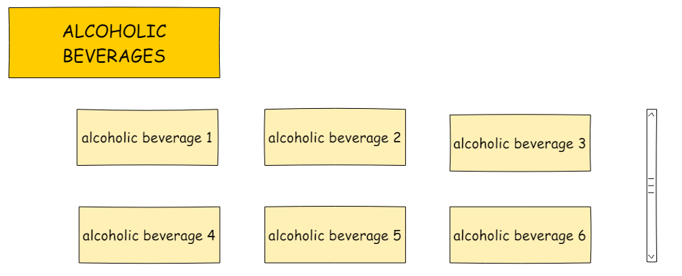

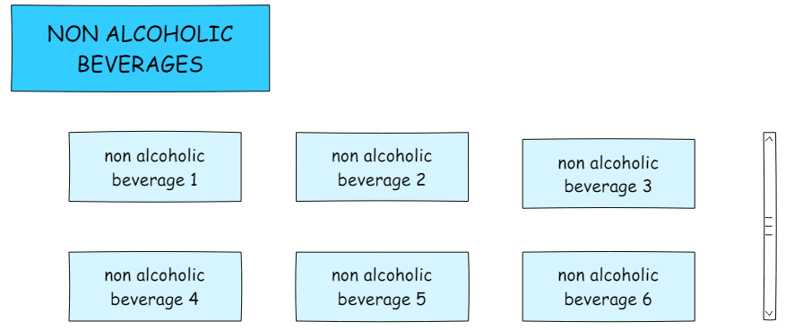

**1.2/ Specification of Controller Interface**

* getMenuCategory():
* getItemOfCategory(ItemCategory selectedCategory)

