Introduction to machine learning Exercise set 5 report
Elias Annila 014328901

Pen and paper:
Problem 1:
a) There is positive correlation between a and b if where c>0. In other words if b increases, a also increase. In this situation we can write . As is positive that means that if increases also increases, so there is positive correlation.
b)Again for there to be positive correlation betweenandit must be thatincreases as increases. This does not however mean thatas there is also possibility that for example in which case there is no correlation betweenand, but if is correlating positively withandwithit can still be that asincreasesalso increases, but.

Problem 2:
a)
Let's suppose that there is a coefficient vectorsuch that

As we can make a following table:

If we insert our andvalues into our XOR functions we get following for equations which must all be true:=if we solvefrom these we get:
from this it would result that and which is a contradiction.

b)
As above let's write the XOR function as a table:

Again let's insert our x values: =from this we can try to find a suitable order of

from these solutions we can gather following (although we don't know the order of w₁ and w₂):
-a 0 a
-|---------------|----|-----|-----|-
w₃ w₁ w₂
So let's try to use some weights that follow these rules for our XOR function and see if it behaves correctly (we guess w₀ to be 0):

As the resulting XOR values match actual XOR values we can conclude that for example is appropriate coefficient vector, so we can indeed represent XOR as linear classifier.
Problem 3:
a)
As a XOR b is (a OR b ) AND !(a AND b) we want to make z₁ represent OR and z₂ represent !AND so we want to choose u weights so that following table is true.
+1 | +1
+1 | -1
-1 | +1
-1 | -1
If We choose we get:

+1 | +1
+1 | -1
-1 | +1
-1 | -1

From above table it is obvious we choose both u₁₀ and u₂₀ to be 1, as this results in z values on given x values as listed in below table, which corresponds to behavior of OR and !AND:

+1 | +1 | +1 | -1
+1 | -1 | +1 | +1
-1 | +1 | +1 | +1
-1 | -1 | -1 | +1

As we have now simulated a OR b as well as !(a AND b) we then need to simulate a AND b to combine the two conditions, so we choose v weights so that:

+1 | +1
+1 | -1
-1 | +1
-1 | -1

Again we choose so we get:

+1 | +1
+1 | -1
-1 | +1
-1 | -1

So we choose
So to finish the neural network solves XOR when weights are:so it is proven that the network can compute XOR operation given suitable weights.

b)
We are trying to show that doesn't give advantage over in regard to computing XOR function if we disregard sign functions in forming of z values. Aswas unable to solve XOR as shown in 2 a), we must show that neither can if we ignore sign function in forming of z. As our final choiceis the same as in 3 a) where we were able to compute XOR I'll try to show that we can't choose u weights in determination of z values so that z₁ and z₂ would behave as OR and !AND, and thus the whole network can't compute XOR if we ignore the sign function.

Let's consider this table from part a):
+1 | +1
+1 | -1
-1 | +1
-1 | -1

Now let's remove the sign functions and insert x values:

+1 | +1
+1 | -1
-1 | +1
-1 | -1

It is clear from the table that we can't chooseor so that we would get the desired OR and !AND behavior. For example as we can see u_{11 and} u₁₂ should cancel each other, which would mean that in and in which is a contradiction. Similary for z₂. As we cannot choose u values so that our z values would behave as OR and !AND our final function cannot function as XOR.

Programming:
Problem 4
a) Below are plots showing Kth degree polynomials fitted to the 30 data points.
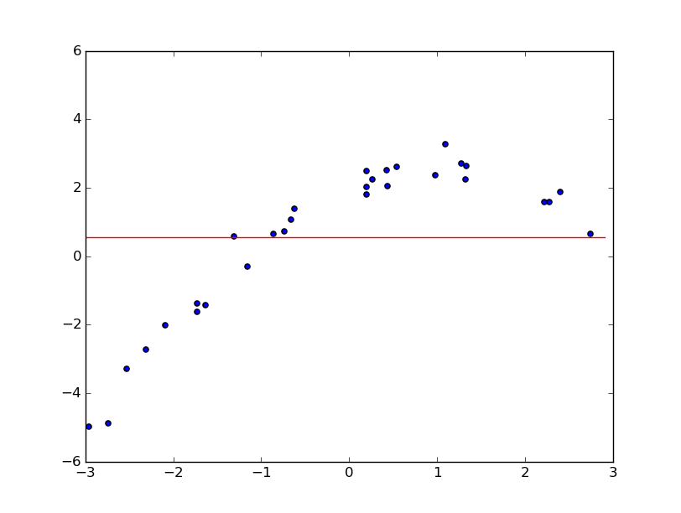Illustration 2: K=0
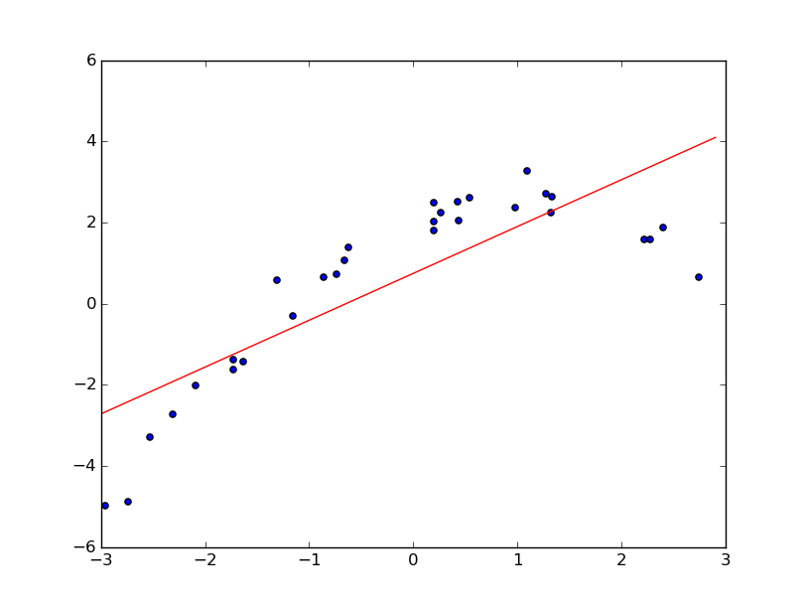Illustration 1: K=1
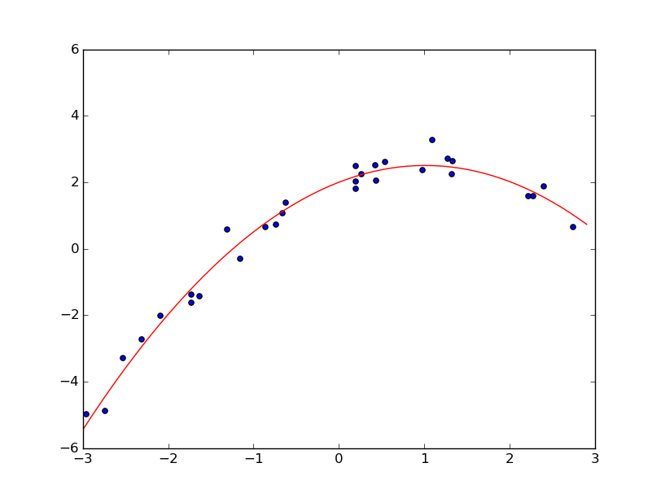Illustration 4: K=2
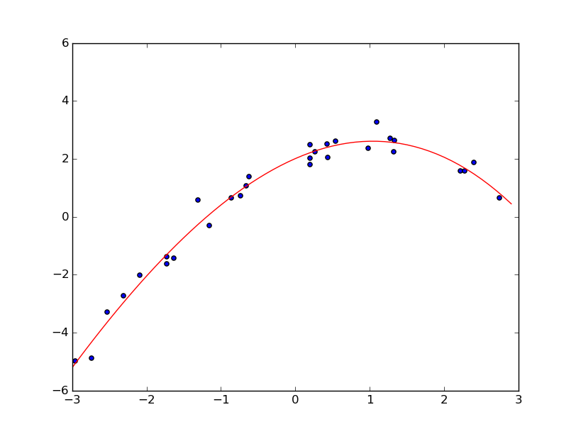Illustration 3: K=3
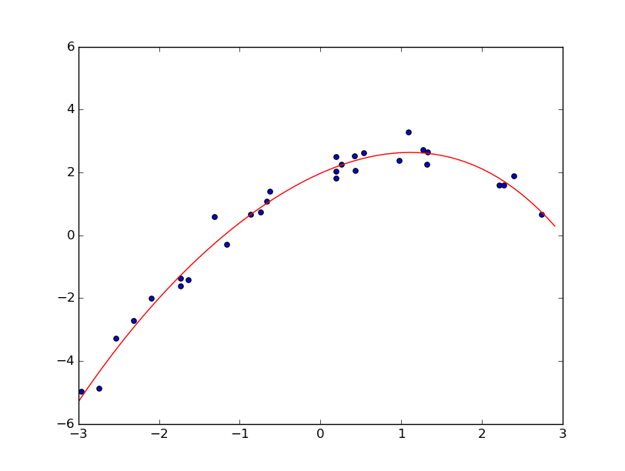Illustration 5: K=4
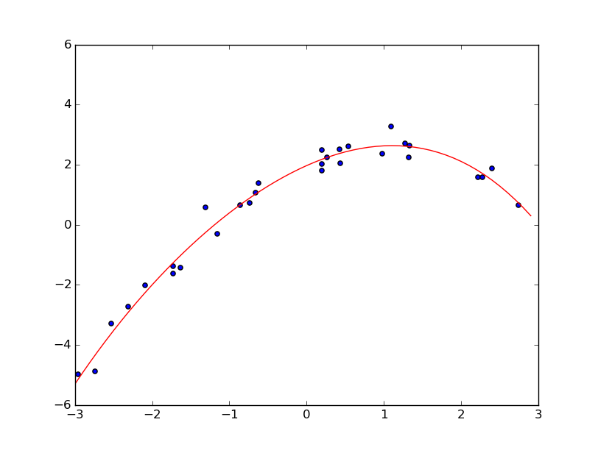Illustration 6: K=5
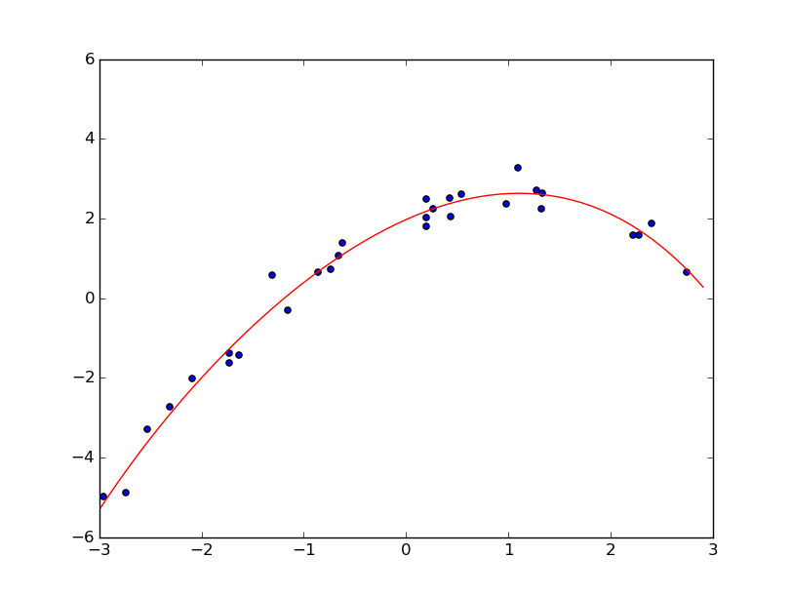Illustration 8: K=6
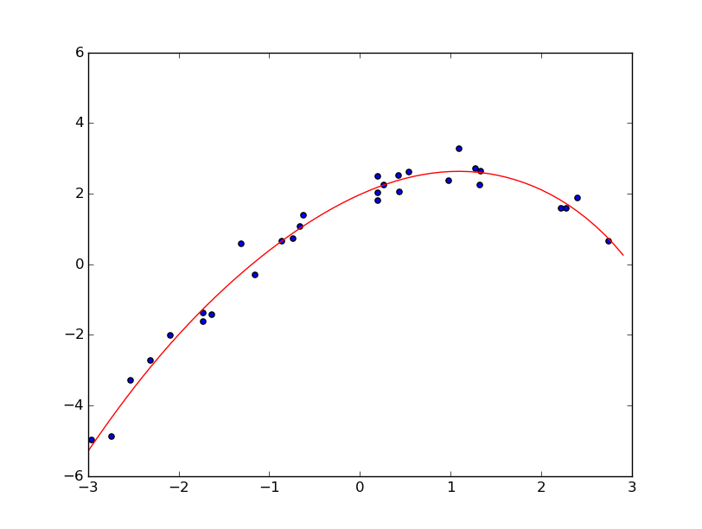Illustration 7: K=7
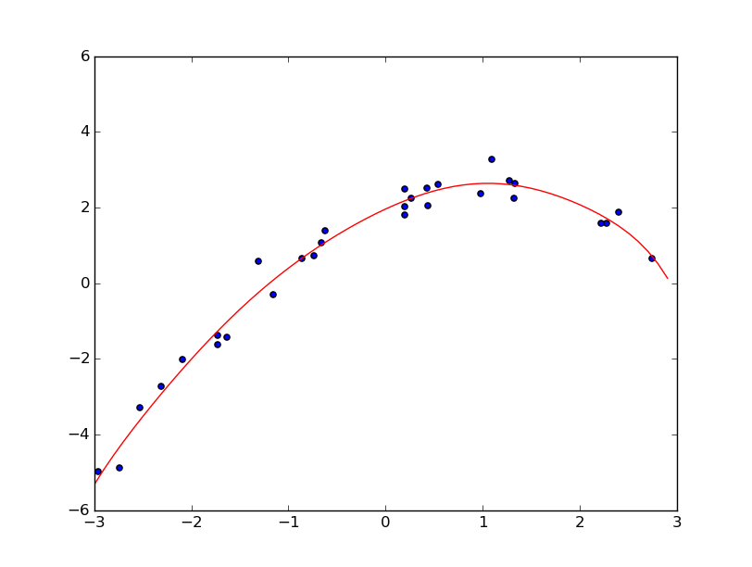Illustration 9: K=8
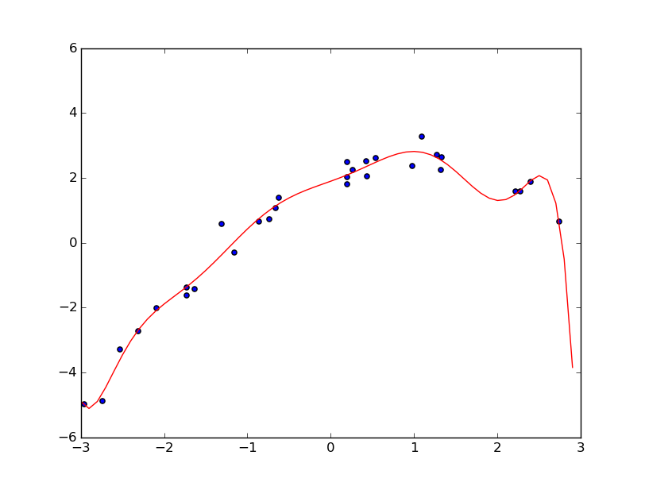Illustration 10: K=9
A
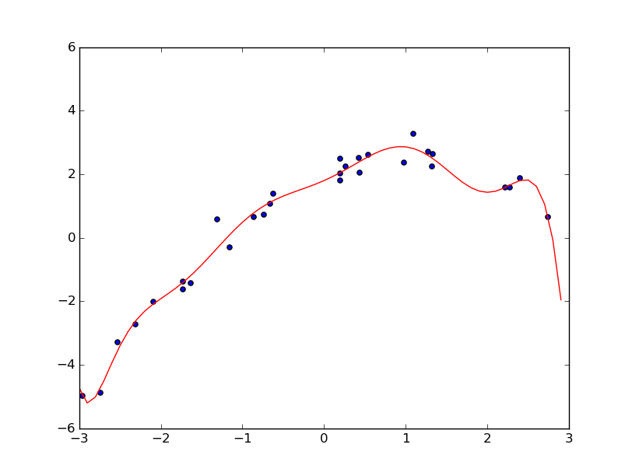Illustration 11: K=10
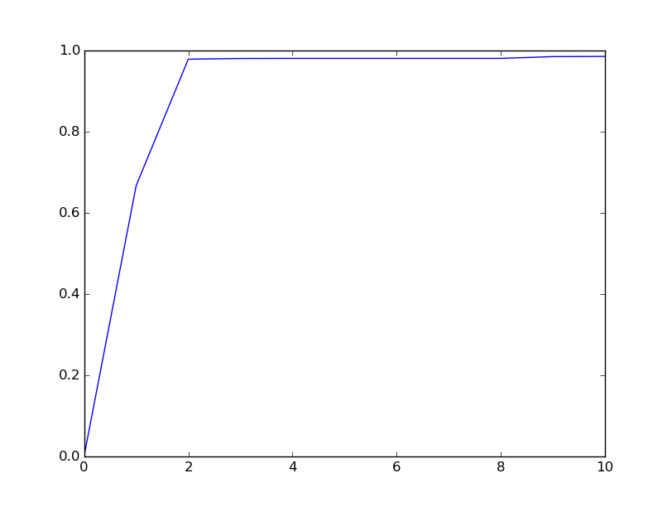Illustration 12: Coefficient of determination plotted on each fitted polynomial

From the plots 1-11 it is apparent that as K increases the polynomial passes closer to data points. As can bee seen from illustration 12, R² increases rapidly on polynomial orders of 0-2 but starting from polynomial K=2 the increase is marginal. This is due to the original function that was used to draw y values being second order polynomial. Further increase of K is overfitting to the noise created to datapoints.
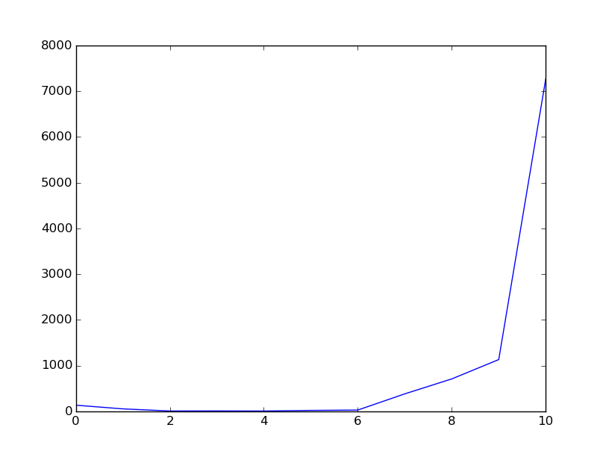Illustration 13: Sum of square errors for each value of K as result of 10 fold cross validation

As can (maybe) be seen from illustration 13, or the output of the code, the sum of square errors improves until K=2 from where it starts to increase. As K gets larger the performance starts to degrade rapidly, as the high degree polynomial starts to oscillate wildly. The estimated coefficients for second degree polynomial were -0.482 x² + 1.043 x + 1.836 (obtained from the entire data) which are similar to actual training polynomial used: -0.5x² + x + 2, but as exptected don't quite match.

