Minutes
of Annual General Meeting held on 10th November 2014 at 8.45 p.m.

1. Present - 25 members had stayed on from the concert. The President, Hugh Mather, was in the Chair.
Apologies from Saori Howse

2. Minutes of the 2013 AGM were approved.

3. Treasurer’s Report. (David Smith) See p.2 for full report.
Subscriptions are up, expenses are more normal this year. David added that as the surplus was gradually rising, £100 bonus had been given to St Mary’s Church. Speaking for the Church, Hugh expressed his appreciation. A vote of thanks was given to David.

4. Membership Secretary & Secretary’s Report. (Hilary Potts) See p.3 for full report.
Hilary outlined the membership position, currently quite good, and clarified general Club policy about length of items, participation of non-members and the acceptance of duo items provided the parts were equal.
As a celebration of the Club’s 10 years, she had created a composer and performer index from the Club’s archive and offered a few statistics which would be on the website.
She noted the serious gap left by Anthea Sharma, but mentioned the large music collection which was likely to eventually come to the Club, although there could be problems with regard to housing it.

5. Website Report (Mireille Levy)
Mireille had taken over in June from Toby Louw, who had resigned in order to travel abroad. She felt there should be more in it, including a password protected Members’ area where people could put requests for players or respond to them, and possibly a piano area. She had not posted anything on Facebook or Twitter. Liz Sharma commented that she did post about upcoming concerts and other events, and urged others to do so

6. Outreach. (Liz Sharma)
Her musical caveman piece had been performed at Berrymead during the year. She now had a list of 25 volunteers for these events; there had been 9 events of several different musical stories, and some ECMC members had performed in all of them. The next would be “Rainbow Island” on 25th March 2015. She was pleased to note that Judith Weir (currently Master of the Queen’s Music) had shown interest.

7. Election of officers and Committee members
The following were re-elected nem.con.:
Hugh Mather President
Hilary Potts Secretary & Membership
David Smith Treasurer & Concert Organiser
Liz Sharma: Outreach, resident composer & Concert Organiser
Saori Howse Concert Organiser
Andrew Lewandowski Concert Organiser
Lewis Lev Piano co-ordinator & Concert Organiser

And standing for election
Mireille Levy Website Manager (already acting)

8. Anthea Sharma Commemoration.
Liz Sharma drew members’ attention to the Cancer collection box. Hugh explained that the proposal for planting a tree would not be practical. A memorial concert would be planned in March or April.

9. Any other business.
Piano Members report by Lewis Lev. He had hosted three evenings for old & new pianists to meet and play works for 2,4,6, and 8 hands, and three duos had resulted. He planned another event in the New Year, and hoped to arrange another evening for pianists to meet wind players. There was a vote of thanks to Lewis.
The meeting concluded at 9.30.
Ealing Chamber Music Club
Treasurer’s Report for Year Ending 31st August 2014

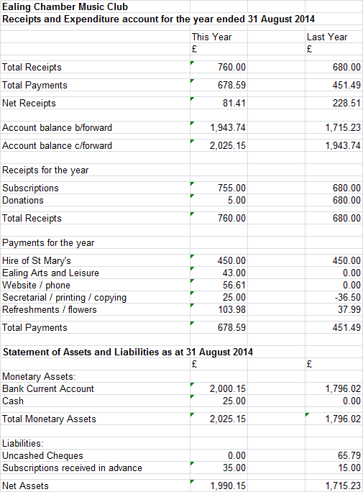

The material differences from 2013 to 2014 were:
- Subscriptions increased due to a small rise in membership
- In the previous year no money was spent on Ealing Arts subscription, website, printing and phone. In this respect 2014 expenses are likely to be more typical going forward.

Club funds remain healthy and so there is no need to increase subscriptions for 2014-15.

David Smith, September 2014
Secretary’s Report

After a slight doldrum, we’ve had lots of new members recently, a Committee more up to strength than ever before, but if anyone would like to take over as Membership Secretary and keep the records up to date, I’d be very happy.
Renewed website, with photos, may one day rival St Mary’s Friends site. Permission to use photos assumed, let us know otherwise.
New members I’m sorry if you are disappointed with the service, we do try to help but we don’t have the staffing or the time to organise people into groups. If you want to play, try to be a bit proactive, e.g. string players show the yellow book I will try to recommend works, or Liz for wind.

Clarification of General policy.
We don’t have formal rules because rules are made to be broken. However –
Length of items; not more than 20 minutes if there is an AGM, end of season or end of year play-in, absolute maximum of 30 minutes otherwise, which rarely happens.
Ideally we would like 4 items of 15 minutes, but in real life we have to be flexible.
Non-members may come a guest audience any time and may partake of free refreshments; they may play once in a concert as part of a group, but another time will be firmly asked to join.
History
I planned to celebrate this time with a look back over 10 years, and to prepare for that I updated the archive and indexes to last July.
Have a look at composer index on web – to summarise,
Liz Sharma 38, Mozart 27, Beethoven 23, Haydn 21, Bach 16. And 145 other composers, many of whom I would never have heard of, with instruments in many combinations which I never would have thought of. If there’s anything missing these days, it’s the standard combination, the string quartet. Last time we had one was in April 2012. We may be inheriting vast volumes of string quartets from Anthea’s collection, so I hope we may make use of them.
I also made a performers’ index dominated by the name Sharma, though Anthea beat Liz by 75 to 74 items – though admittedly the recorder items are often quite short so you can rack up quite a high score with items that are barely a minute long. At least 135 people have played at ECMC concerts, not all members, and a number of members have never played at concerts, which is perfectly in line with the aims of the club if you prefer to play in private.
Anthea
I have made several passing references to Anthea Sharma. The celebratory atmosphere is somewhat dampened by her unexpected death on 30th September. If you are not aware how much the Club owes to her, it isn’t clear from the statistics I just gave you; there was a whole area of getting to know new members, inviting them to play, teaming them up with suitable partners, sometimes even providing music and a room to rehearse in, which took up many hours of her time. And then there were the playing afternoons – you only realise how much organisation this takes when somebody drops out at the last minute and everything unravels. I won’t go on because a number of you went to the funeral and most of what I have to say is on the website. We can discuss how to mark her passing when that item comes up. However, one immediate effect is that without Anthea and her large house, we can no longer plan for Saturday playing afternoons in January. If anyone has a house with 3 or 4 rooms big enough to take a string quartet and could host an afternoon, I am sure it could be organised. Meanwhile, we will have one of our ordinary concerts next January and probably after that.

