Ealing Chamber Music Club
Treasurer’s Report for Year Ending 31st August 2015

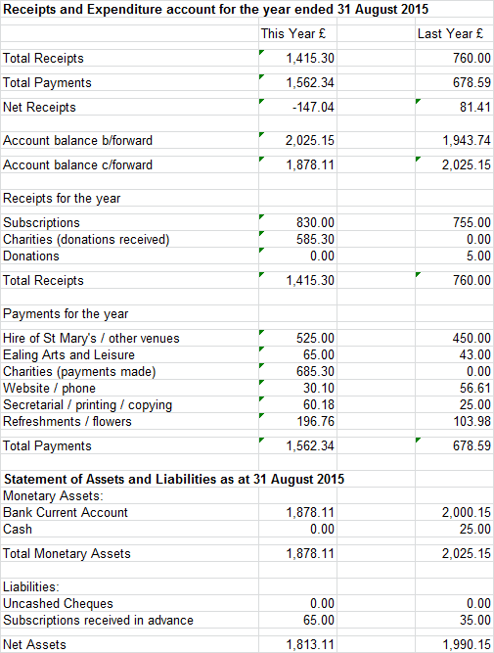

The material differences from 2014 to 2015 were:
- Subscriptions increased due to an increase in membership
- We donated £100 to St.Mary’s to mark our 100th club event
- We collected and distributed funds for the Stroke Association in memory of Anthea Sharma and Francis Clarke

Club funds remain healthy and so there is no need to increase subscriptions for 2015-16.

David Smith, September 2015

